**Name: كرم عبدالشهيد كرم يني**

**B.N: 594**

**Date: 2020/5/28**

**Topic:** **programming language**

**GitHub link:**

**GitHub page:**

**Application brief:**

Programming Language is important in our daily life to enhance and increase the power of computers, mobile solutions, and the internet. There are numerous examples you may come to know when you are going to learn a programming language. The actual power of the language is when the right programmer uses it with the right features to solve a problem or for any other specific purpose.

**Why we need for programming language?**

The programing language enables us to write efficient programs and develop online solutions such as- mobile applications, web applications, and games, etc. Programming is used to automate, maintain, assemble, measure and interpret the processing of the data and information.

**Types of Programming Language**

• There are three types of programming language:

– Machine language (Low-level language)

– Assembly language (Low-level language)

– High-level language

• Low-level languages are closer to the language used

**Best Programming Languages to Learn in 2020**

1)Python. Python is one of the most commonly used programming languages today and is an easy language for beginners to learn because of its readability. ...

2)Java. ...

3)JavaScript and TypeScript. ...

4)Swift. ...

5)C# ...

6)C (and C++) ...

7)Ruby.

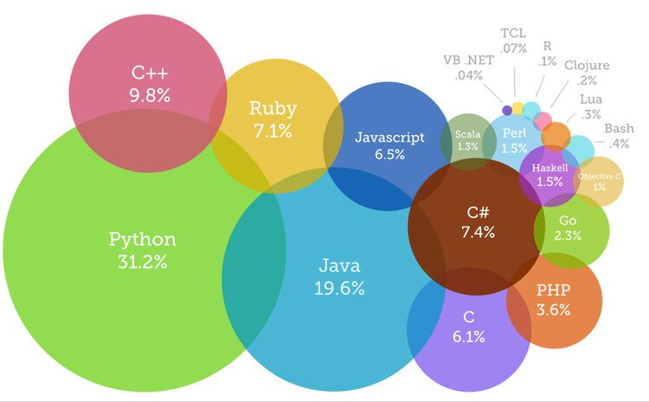

Best Programming Languages to Learn in 2020

**Screenshots:**

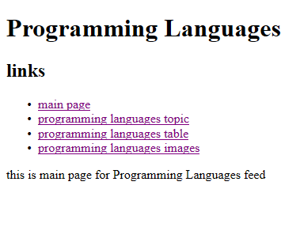

**Source code.**

