lab-04-solution
library(tidyverse)

Exercise 1
mcd <- read_csv("data/menu.csv")
mcd |>
slice(1:7)
# A tibble: 7 × 6
Category Item Oz Calories Fat Sugars
<chr> <chr> <dbl> <dbl> <dbl> <dbl>
1 Breakfast Egg McMuffin 4.8 300 13 3
2 Breakfast Egg White Delight 4.8 250 8 3
3 Breakfast Sausage McMuffin 3.9 370 23 2
4 Breakfast Sausage McMuffin with Egg 5.7 450 28 2
5 Breakfast Sausage McMuffin with Egg Whites 5.7 400 23 2
6 Breakfast Steak & Egg McMuffin 6.5 430 23 3
7 Breakfast Bacon, Egg & Cheese Biscuit (Regular Bi… 5.3 460 26 3
names(mcd)
[1] "Category" "Item" "Oz" "Calories" "Fat" "Sugars"

Exercise 2
mcd |>
count(Category)
# A tibble: 9 × 2
Category n
<chr> <int>
1 Beef & Pork 15
2 Beverages 27
3 Breakfast 42
4 Chicken & Fish 27
5 Coffee & Tea 95
6 Desserts 7
7 Salads 6
8 Smoothies & Shakes 28
9 Snacks & Sides 13
Most: Coffee & Tea.
Least: Salads.

Exercise 3
mcd_cal <- mcd |>
mutate(cal_oz = Calories/Oz)
mcd_cal |>
select(Category, Item, cal_oz) |>
slice(1:5)
# A tibble: 5 × 3
Category Item cal_oz
<chr> <chr> <dbl>
1 Breakfast Egg McMuffin 62.5
2 Breakfast Egg White Delight 52.1
3 Breakfast Sausage McMuffin 94.9
4 Breakfast Sausage McMuffin with Egg 78.9
5 Breakfast Sausage McMuffin with Egg Whites 70.2
Sausage McMuffin has the highest calories per ounce, out of these first five.

Exercise 4

a
# a.
mcd_cal |>
select(Item, Calories) |>
arrange(desc(Calories)) |>
slice(1:5)
# A tibble: 5 × 2
Item Calories
<chr> <dbl>
1 Chicken McNuggets (40 piece) 1880
2 Big Breakfast with Hotcakes (Large Biscuit) 1150
3 Big Breakfast with Hotcakes (Regular Biscuit) 1090
4 Big Breakfast with Hotcakes and Egg Whites (Large Biscuit) 1050
5 Big Breakfast with Hotcakes and Egg Whites (Regular Biscuit) 990

b
# b.
mcd_cal |>
select(Item, cal_oz) |>
arrange(desc(cal_oz)) |>
slice(1:5)
# A tibble: 5 × 2
Item cal_oz
<chr> <dbl>
1 Chocolate Chip Cookie 160
2 Oatmeal Raisin Cookie 150
3 Fat Free Chocolate Milk Jug 130
4 Cinnamon Melts 115
5 Sausage Biscuit (Regular Biscuit) 105.
- Chicken McNuggets highest total calories. Chocolate Chip Cookie had highest calories per ounce. Not surprised given amount of breading on McNuggets and amount of sugar/butter in a cookie.

Exercise 5
mcd_cal <- mcd_cal |>
mutate(prop_cal_fat = Fat*9/Calories)

Exercise 6
ggplot(data = mcd,
mapping = aes(y = Calories,
x = Category,
fill = Category)) +
geom_boxplot() +
theme(legend.position = "none",
axis.text.x = element_text(angle = 45, hjust = 1)) +
labs(title = "Distribution of Total Calories by Food Category in McDonald's Menu")
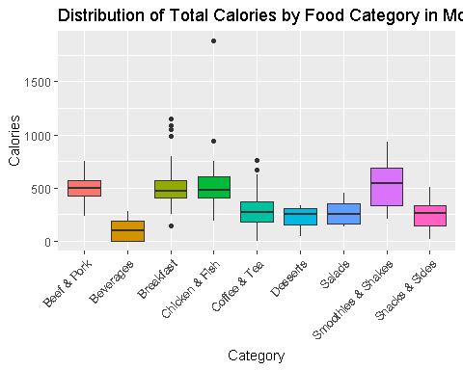

Exercise 7
ggplot(data = mcd_cal,
mapping = aes(x = cal_oz,
y = prop_cal_fat,
color = Category)) +
geom_point() +
labs(title = "Calories per Ounce by Calories from Fat (%) by Category",
x = "Calories per Ounce",
y = "Calories from Fat (%)")
Warning: Removed 16 rows containing missing values or values outside the scale range
(`geom_point()`).
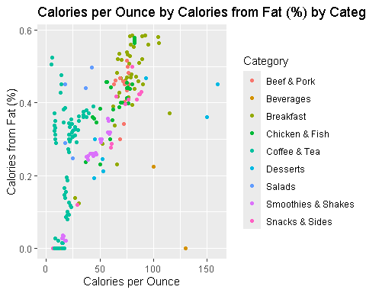
Breakfast has high calories per ounce and high calories from fat.
Coffee and tea has lower calories per ounce but higher calories from fat (somewhat).

