Lab 3 Solution
library(tidyverse)
ncbikecrash <- read_csv("https://karamccor.github.io/b6002/labs/data/bikecrash.csv")

Exercise 1

(a)
ncbikecrash |>
filter(development == "Residential") |>
filter(driver_age_group == "0-19")
There were 223 crashes in residential areas where the driver age group was under 0-19.

(b)
ncbikecrash |>
filter(development == "Residential") |>
count(driver_age_group)
# A tibble: 9 × 2
driver_age_group n
<chr> <int>
1 0-19 223
2 20-24 364
3 25-29 290
4 30-39 508
5 40-49 441
6 50-59 372
7 60-69 269
8 70+ 243
9 <NA> 457

Exercise 2
ncbikecrash |>
count(driver_est_speed) |>
arrange(n)
# A tibble: 17 × 2
driver_est_speed n
<chr> <int>
1 81-85 mph 1
2 >100 mph 2
3 66-70 mph 4
4 61-65 mph 10
5 56-60 mph 29
6 46-50 mph 142
7 36-40 mph 261
8 51-55 mph 338
9 26-30 mph 367
10 21-25 mph 525
11 16-20 mph 544
12 11-15 mph 552
13 <NA> 580
14 41-45 mph 670
15 6-10 mph 840
16 31-35 mph 846
17 0-5 mph 1756

Exercise 3
ncbikecrash |>
filter(county == "Durham" | county == "Orange" | county == "Wake") |>
group_by(county) |>
summarize(mean_driver_age = mean(driver_age, na.rm = T))
# A tibble: 3 × 2
county mean_driver_age
<chr> <dbl>
1 Durham 40.4
2 Orange 38.3
3 Wake 38.2

Exercise 4
ncbikecrash |>
filter(county == "Durham") |>
group_by(crash_month) |>
summarize(mean_crash_hour = mean(crash_hour)) |>
arrange(mean_crash_hour)
# A tibble: 12 × 2
crash_month mean_crash_hour
<chr> <dbl>
1 January 13.5
2 August 13.9
3 September 14.0
4 October 14.2
5 November 14.4
6 December 14.6
7 May 14.9
8 March 15.2
9 July 15.3
10 April 15.3
11 June 16.2
12 February 16.8

Exercise 5
ncbikecrash_time <- ncbikecrash |>
mutate(time_crash = case_when(
crash_hour < 7 ~ "Early Morning",
crash_hour >=7 & crash_hour < 12 ~ "Morning",
crash_hour >=12 & crash_hour < 18 ~ "Afternoon",
crash_hour >=18 ~ "Evening"
))
ncbikecrash_time |>
count(time_crash)
# A tibble: 4 × 2
time_crash n
<chr> <int>
1 Afternoon 3412
2 Early Morning 425
3 Evening 2270
4 Morning 1360

Exercise 6
ncbikecrash |>
summarize(mean_driver_age = mean(driver_age, na.rm = T))
# A tibble: 1 × 1
mean_driver_age
<dbl>
1 39.0
ncbikecrash |>
group_by(county) |>
summarize(mean_driver_age = mean(driver_age, na.rm = T)) |>
arrange(desc(mean_driver_age)) |>
slice(1:5)
# A tibble: 5 × 2
county mean_driver_age
<chr> <dbl>
1 Camden 57.8
2 Stokes 55.2
3 Mitchell 54
4 Anson 49.6
5 Polk 47

Exercise 7

(a)
ggplot(ncbikecrash, mapping = aes(x = region, y = bike_age)) +
geom_boxplot(fill = "khaki2") +
labs(title = "Biker Age by Region in North Carolina",
xlab = "Urban vs. Rural area",
ylab = "Driver age (years)")
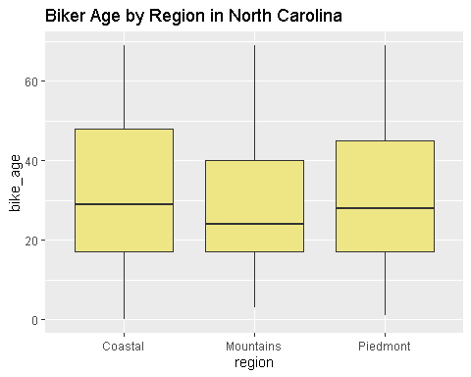
The biker ages seem to be relatively similar across groups.

(b)
ggplot(ncbikecrash, mapping = aes(x = rural_urban, y = driver_age, fill = weather)) +
geom_boxplot() +
labs(title = "Driver age (years) by speed limit by weather",
xlab = "Rural vs. Urban area",
ylab = "Driver Age (years)")
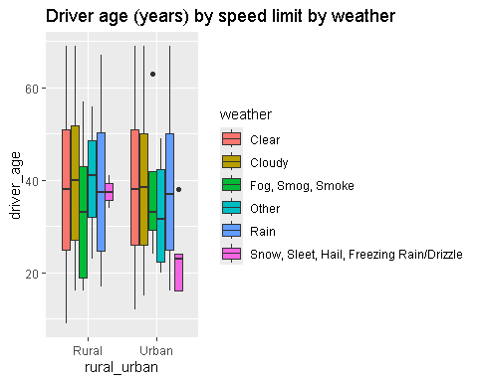
For Urban areas with Snow, Sleet, Hail, Freezing Rain/Drizzle, drivers involved in the crashes tended to be younger, with a median around 23 years old, compared to Rural areas where the same group was older (median age around 36 years.)

