1. (a) Create a new table for your analysis called “employee_sales”.

(b) Load the table “employee” into this table.

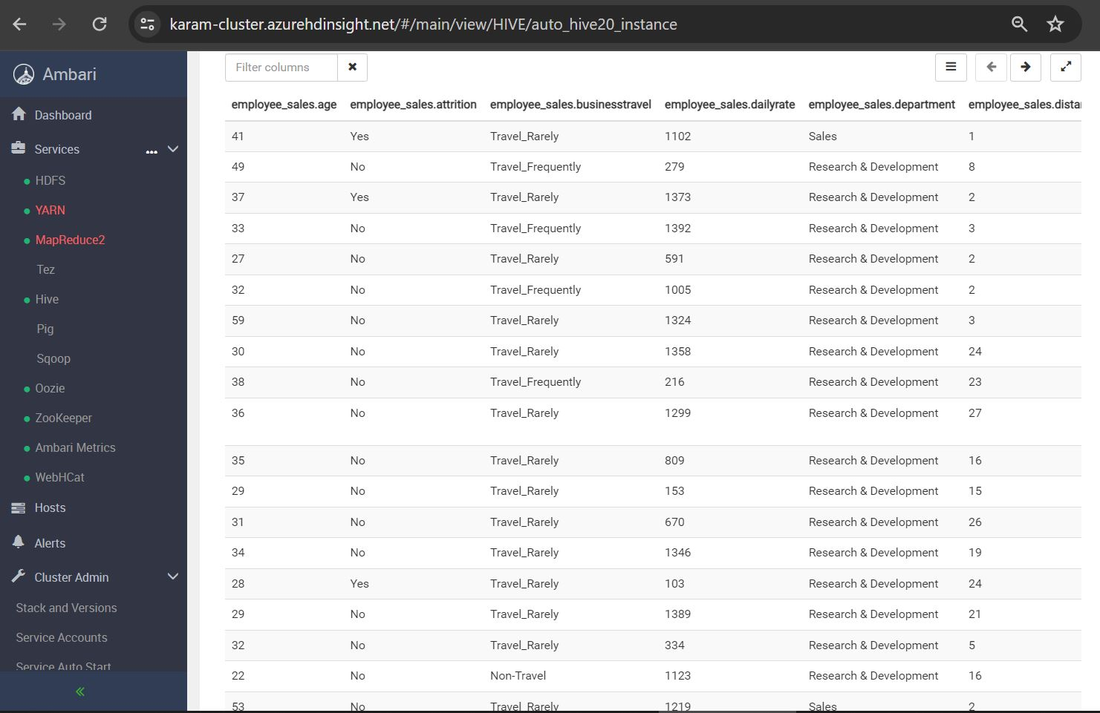

(c) Select these columns: Attrition, Department, JobSatisfaction & MonthlyIncome.

2) Round the data found in the “MonthlyIncome” column to the nearest $1000. (HINT: the SQL function to round a number is ROUND(obs, -3))

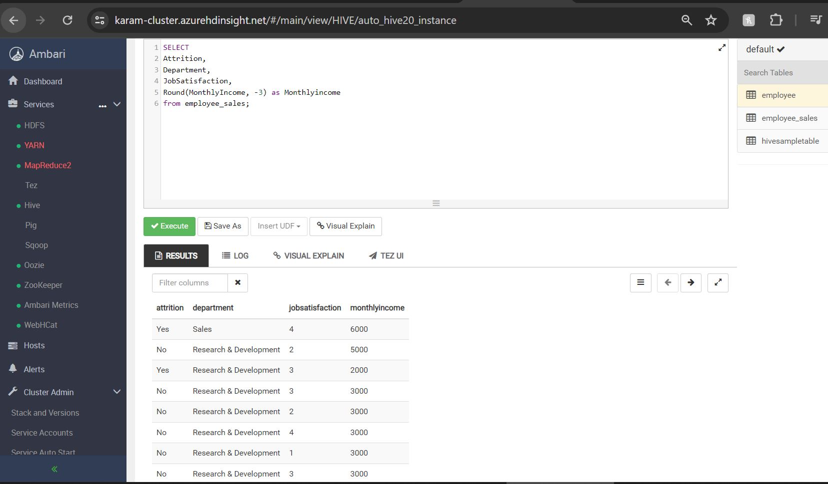

1. Filter the data to only look at those items in the “Sales Department”.

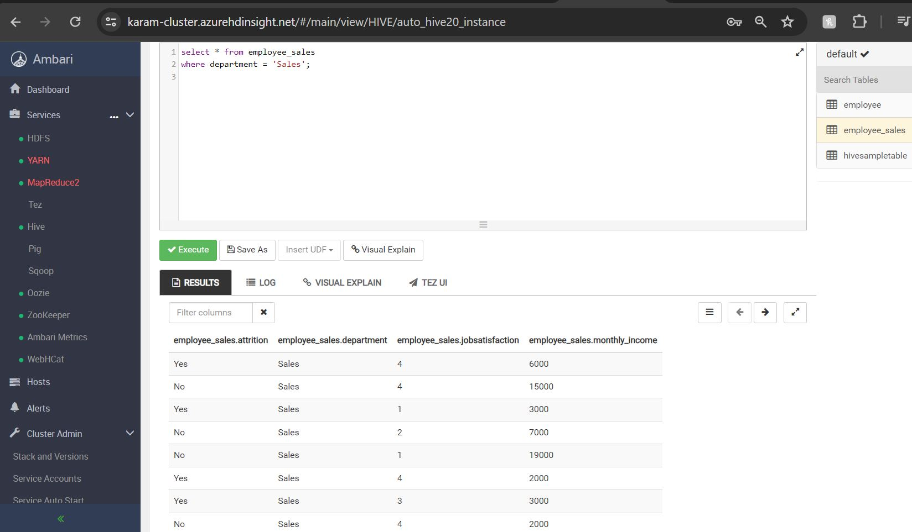

1. Order the data by “JobSatisfaction” from highest to lowest. (HINT: Use the DESC query)

