American Crime and Incarceration

STA 199 Final Project

Oliver Greenwald, Karam Oubari, Steven Powell, Emely Gutierrez

## Synopsis

This research project is aimed to further understand and analyze American prison incarceration and crime in the 50 states between 2001 and 2016. Analysis was done by focusing specifically on state prisoners (as opposed to federal) and the types of crimes that prisoners had been convicted of. The data set used observes 7 types of crimes that can be classified into violent crimes and property crimes.

## Introduction and Data

### (The introduction should introduce your general research question and your data (where it came from, how it was collected, what are the cases, what are the variables, etc.).)

The United States currently has the highest prison population in the world at around 2,094,000. This situation can be traced back to the 1970s, when politicians like Richard Nixon, Ronald Reagan, and more began the War on Drugs and their “tough on crime” agendas. Since then, rates of imprisonment have continued to increase under the guise of “public safety.” However, the reality is that the US’ crime rates are comparable to countries with similar economies, yet the rate of incarceration is significantly higher. The US has only 5% of the world’s population, and yet it houses 25% of the world’s incarcerated persons.

In this project we aim to understand the extent of the issue of mass incarceration, what sub-statistics can most explain the issue, how the numbers connect to public policy, and the future of the issue through basic predictive modeling.

### Data Description

“The Bureau of Justice Statistics administers the National Prisoners Statistics Program (NPS), an annual data collection effort that began in response to a 1926 congressional mandate. The Uniform Crime Report (UCR) has served as the FBI’s primary national data collection tool since a 1930 congressional mandate directed the Attorney General to ‘acquire, collect, classify, and preserve identification, criminal identification, crime, and other records.’ The FBI collects this information voluntarily submitted by local, state, and federal law enforcement agencies.”

The user who updated this data set used the raw data from the NPS and wrangled it in Python to create the variables and observations. Within the data set there are 816 rows and 17 variables. The variables included in the set are US state, whether or not the data for that entry includes jails, the year, prisoner count on December 31st, whether or not the state in the data entry changed their system for reporting crime in comparison to previous years, whether or not crime totals are estimated, and numbers of: total state population, violent crimes, murders or manslaughter, rapes (using the old definition), rapes (using the new definition), robberies, aggravated assaults, property crime, burglaries, larceny, and vehicle theft.

## Methodology

### (The methodology section should include the variables used to address your research question, as well as any useful visualizations or summary statistics. As well, you should introduce and justify the statistical method(s) that you believe will be useful in answering your research question.)

The following variables, from the original data set, were used to address the research questions above: • jurisdiction: a categorical variable for federal jurisdiction and the 50 states. • year: a numerical variable for the year of each observation, 2001 through 2016. • prisoner_count:a numerical variable for the number of prisoners in each state for the given year. • state_population: a numerical variable for the population of each state in a given year. • violent_crime_total: a numerical variable for the total number of violent crimes (equals the sum of murder_manslaughter, rape_legacy, rape_revised, robbery, and agg_assault). • murder_manslaughter: a numerical variable for the numbers of murders and manslaughters. • rape_legacy: a numerical variable for the number of rapes (using the old definition). • rape_revised: a numerical variable for the number of rapes (using the new revised definition). • robbery: a numerical variable for the number of robberies. • agg_assault: a numerical variable for the number of aggravated assaults. • property_crime_total: a numerical variable for the total number of property crimes (equals the sum of burglary, larceny, and vehicle_theft). • burglary: a numerical variable for the number of burglaries. • larceny: a numerical variable for the number of larcenies. • vehicle_theft: a numerical variable for the number of vehicle thefts.

### Statistical Methods

(We need to introduce and justify the statistical method(s) that we believe will be useful in answering the research question(s).)

### Summary Statistics and Visualizations

First, in this project we aim to understand the extent of the issue of mass incarceration through summary statistics and visualizations. In Figure 1, we visualize the total number of prisoners in the US from 2001 to 2016. As we can see the graph shows a steady incline from 2001 to 2008 and then a steady decline followed by a sharp decline thereafter. In Figure 2, we visualize the amount of crime in the US and notice that it decreases quite steadily between 2001 and 2016. In Figure 3, we examine the change in the proportion of the population that is imprisoned between 2001 and 2016. This shows us a steady increase between 2001 and 2007 before a steady decrease afterwards. In Figure 4, we mapped out the proportion of each state’s population that was imprisoned in 2016 to get a clearer idea of which states contribute most the issue of mass incarceration. Most noticeably, Delaware, Oklahoma, and Arizona have have much higher imprisonment proportions than the rest of the country.

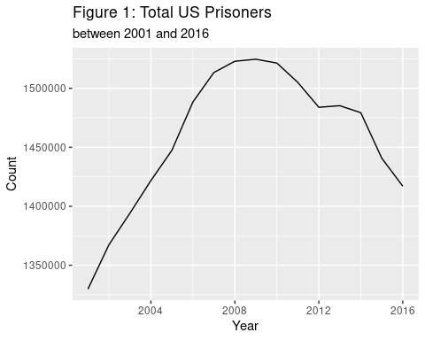

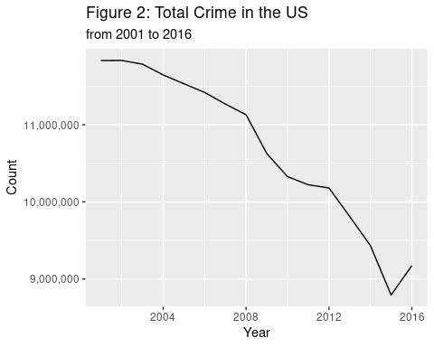

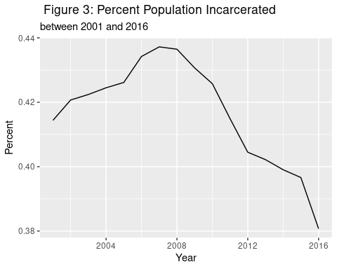

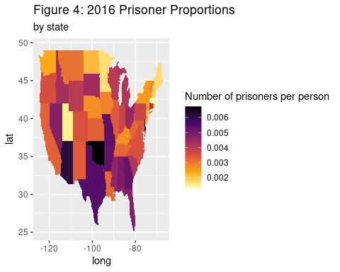

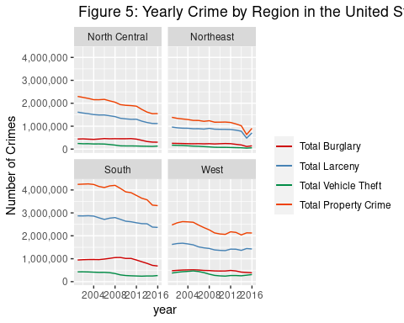 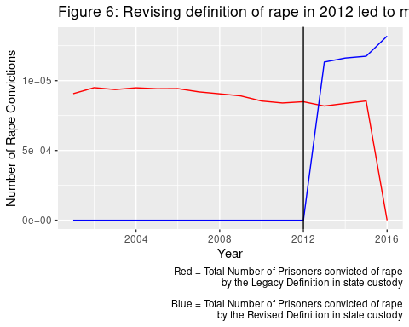

## Results

### (Showcase how you arrived at answers to your question using any techniques we have learned in this class (and some beyond, if you’re feeling adventurous). Provide the main results from your analysis. The goal is not to do an exhaustive data analysis (i.e., do not calculate every statistic and procedure you have learned for every variable), but rather let me know that you are proficient at asking meaningful questions and answering them with results of data analysis, that you are proficient in using R, and that you are proficient at interpreting and presenting the results. Focus on methods that help you begin to answer your research questions.)

(We can definitely use the linear regression methods we learned in the last unit here. Let’s discuss this when we meet.)

### Understanding the extent of the issue of mass incarceration:

Are the increasing incarceration numbers due to increasing crime rates?

Political rhetoric that has come to the forefront in recent decades is the idea of law and order, being tough on crime, and ensuring punishment to the fullest extent of the law. We went into this project knowing that the number of incarcerated individuals in the US is the highest of any other developed country with a similar economy and governmental system. Knowing this, we would assume that if the US has a strong belief that we need to be tough on crime, the high rates of incarceration are due to high crime rates, violent or otherwise. With this in mind, we wanted to find if the data would support this hypothesis.

Figure 1 and 2: What is immediately evident is that even when crime of all types was sharply increasing, the number of incarcerated individuals was still steadily decreasing. Based on this alone, though we cannot definitively draw this conclusion, it would appear that rates of incarceration are actually not due to how much or how little crime is being committed and is instead due to other factors which we will explore later in our analyses. Possible explanations might be policy changes, new sentencing guidelines, amount of policing, and a plethora of other reasons.

Figure 3 and 4: After drawing the previous conclusion, we thought there may be another explanation, even if crime was going down it could be that US population was increasing, when we graphed it above, it would appear that the percent of the US population which is imprisoned shows very strong similarities to the Total US Prison Population graph. However, that being said, even if the population is increasing, if the crime rate is staying the same, or decreasing as we observed previously, there is still no valid reason to incarcerate more people.

### Sub-statistics that can most explain the issue:

How does crime differ for different regions of the US?

Figure 5: To see how crime differs by region, we made a variable called region which splits up the United States into 4 distinct regions (North Central, Northeast, South, and West). We decided to look at only property crime (burglary, larceny, and vehicle theft) and so we plotted the total buglary, total larceny, total vehicle theft, and overall total property crime from 2000-2016 on each regional graph to see what the trends looked like.

One positive note with these graphs is that each region has a overall general decline in the amount of property crime throughout 2000-2016. This is only a speculation, but this would suggest that trends of property crime does not differ throughout each region but it does for each crime.

The south overwhelmingly has the total highest property crime total burglary, and total larceny.

An outlier seems to be in the northeast graph in 2015 when there was sharp decrease with larceny and burglary, and thus total property crime. There must have been policy that affected the Northeast only during that time period that lessened crime

Because of the high number of crimes in the south and the downward spime for the northwest graph that the north central and west regions are most similar in numbers of crimes committed over this 16 year span.

It is also interesting to see that the types of crimes themselves are seemingly related. But this we mean that for each graph, from the highest number to the lowest number, the crimes are larceny, burglary, then vehicle theft.

If you were looking at a region to live in the united states and buy a house or car, it seems that the best place to do that would be in the North East, followed closely by the north central and west region. Thus it would be advised to not choose the south, although they are on a decline in property crimes committed.

### How the results and the issue connect to non-statistical public policy

How does policy impact incarceration? This will be explored through the lens of changing definition of rape.

Figure 6: In 2012 the FBI changed their definition of rape from: “The old definition was ‘The carnal knowledge of a female forcibly and against her will.’ Many agencies interpreted this definition as excluding a long list of sex offenses that are criminal in most jurisdictions, such as offenses involving oral or anal penetration, penetration with objects, and rapes of males. The new Summary definition of Rape is: ‘Penetration, no matter how slight, of the vagina or anus with any body part or object, or oral penetration by a sex organ of another person, without the consent of the victim.’”

We wanted to see how the change in definition affected the number of prisoners convicted for rape. Based on the graph, it seems like after the new definition was implemented, the number of prisoners who are incarcerated for rape increased. We will perform tests to find the p-value and try to determine if this is a correlation relationship or a causal relationship.

This one change in policy had obvious impacts on the number of people incarcerated for the crime. While it is only a small example, it supports theories on incarceration that emphasize the role of laws and policies on the number of people incarcerated rather than the actual number of crimes committed. This is assuming a causal relationship between the policy change and the number of people incarcerated. The creation and enforcement of policy has a greater impact on who is incarcerated and how many people are incarcerated for each crime than the actual rate of crime. Despite public perception assuming the opposite relationship. Many times the policies can be used to adjust a narrative to support a political movement or idea at the time. Crime rates can increase when policy is adjusted to include more crime as seen with the change in defintion for rape. This is not to say that this change contributed significantly to mass incarceration or that the change in definition was unjust. Rather, this example in our data exemplifies the impact of policies on incarceration rather than crime rate.

### Future of the issue through basic predictive modeling:

Talk about it here…

## Discussion

### (This section is a conclusion and discussion. This will require a summary of what you have learned about your research question along with statistical arguments supporting your conclusions. Also, critique your own methods and provide suggestions for improving your analysis. Issues pertaining to the reliability and validity of your data and appropriateness of the statistical analysis should also be discussed here. A paragraph on what you would do differently if you were able to start over with the project or what you would do next if you were going to continue work on the project should also be included.)

Talk about the lack of observational data. These are already big picture statistics that don’t tell individual stories. Might have been interesting to see individual statistics of each conviction over a period of time to complement these base rates.

Discuss the inclusion of jails in different states, the change in crime reporting and the estimation of crime in some states. (includes_jails, crime_reporting_change, crimes_estimated)

## References

<https://www.prisonstudies.org/highest-to-lowest/prison-population-total?field_region_taxonomy_tid=All>

<https://www.aclu.org/blog/racial-justice/why-mass-incarceration-really-new-jim-crow>

<https://www.aclu.org/issues/smart-justice/mass-incarceration>

<https://www.kaggle.com/census/us-population-by-zip-code>

<https://www.bjs.gov/index.cfm?ty=tp&tid=131>

<https://www.kaggle.com/christophercorrea/prisoners-and-crime-in-united-states?select=crime_and_incarceration_by_state.csv>

<https://ucr.fbi.gov/recent-program-updates/new-rape-definition-frequently-asked-questions>