Ανάλυση δεδομένων

sample toluene c=0.2 energy=330.0

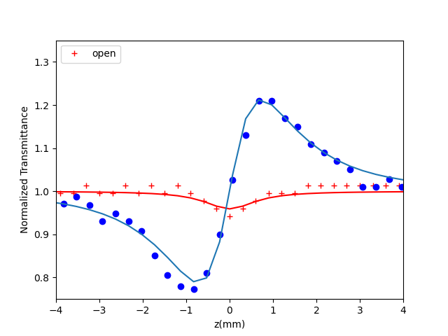

sample toluene c=0.2 energy=330.0

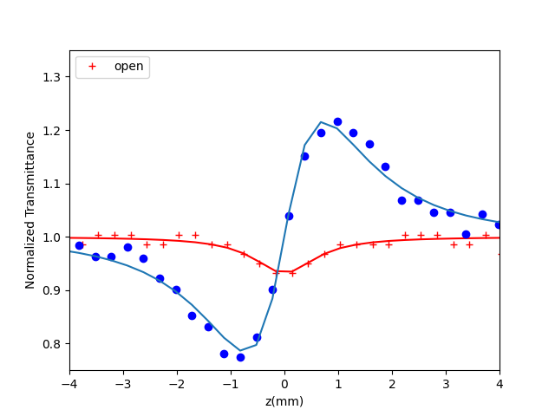

sample toluene c=0.2 energy=240.0

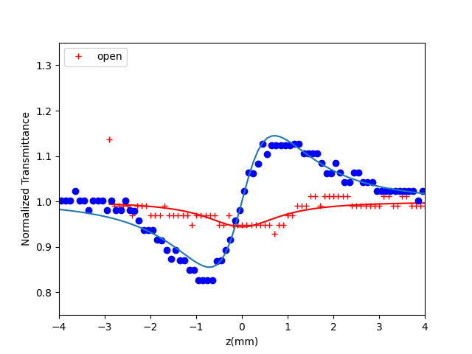

sample toluene c=0.2 energy=125.0

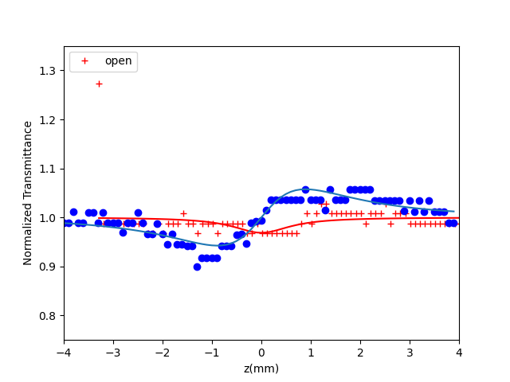

sample toluene c=0.2 energy=125.0

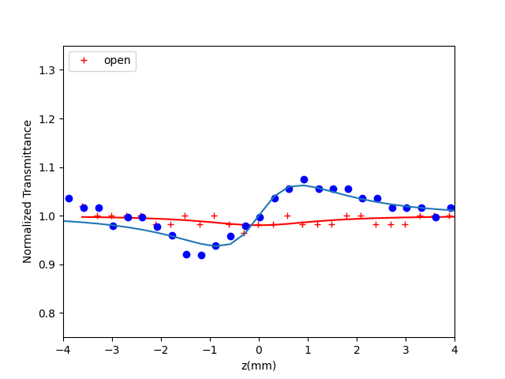

sample toluene c=0.2 energy=200.0

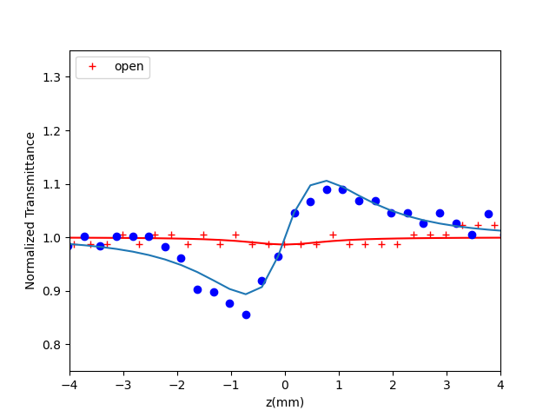

sample toluene c=0.2 energy=200.0

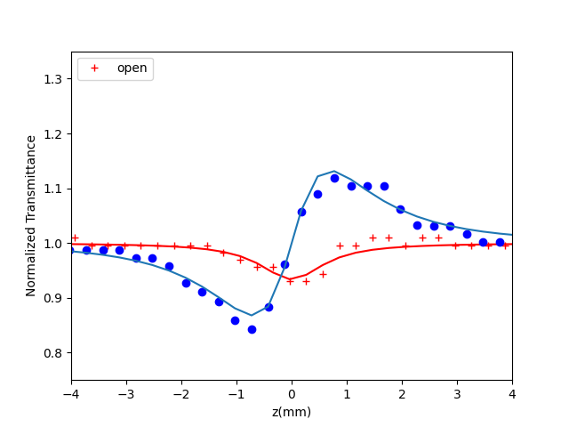

sample toluene c=0.2 energy=200.0

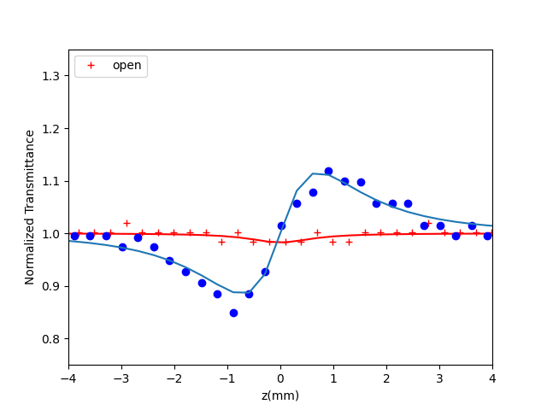

sample 4 c=0.5 energy=392.0

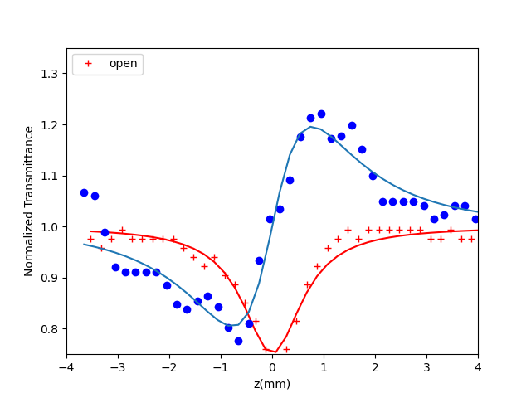

sample 4 c=0.5 energy=392.0

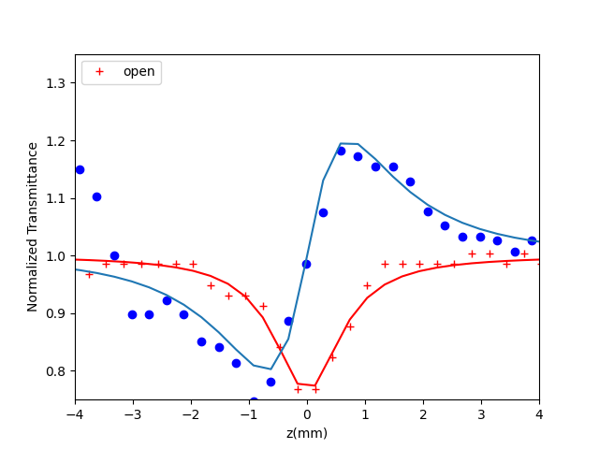

sample 4 c=0.5 energy=308.0

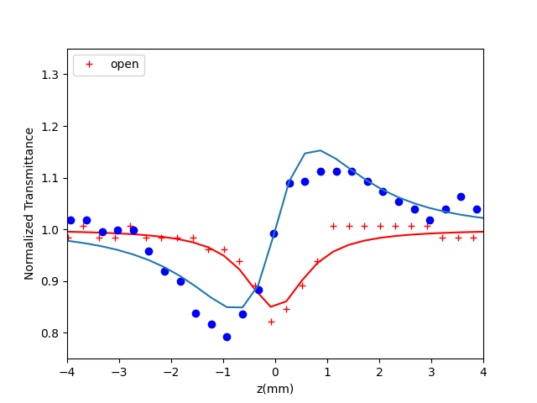

sample 4 c=0.5 energy=308.0

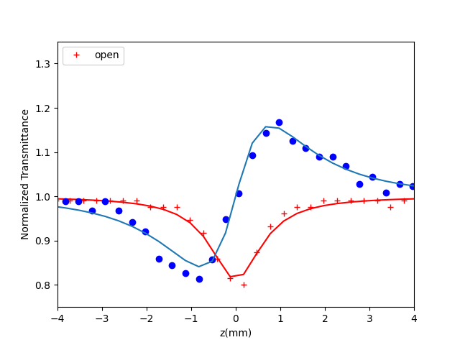

sample 4 c=0.5 energy=88.0

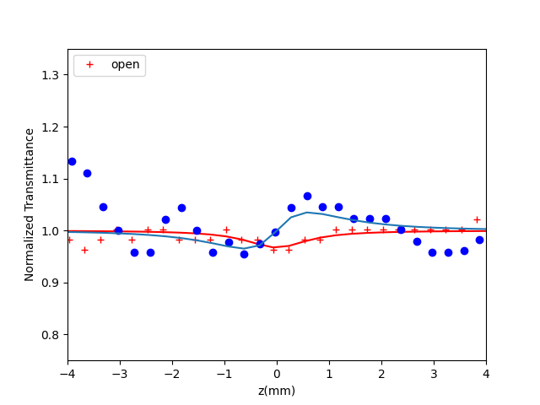

sample 4 c=0.5 energy=200.0

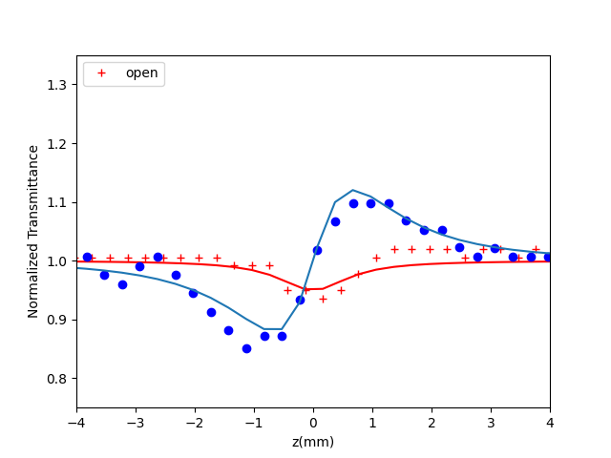

sample 10 c=0.1 energy=330.0

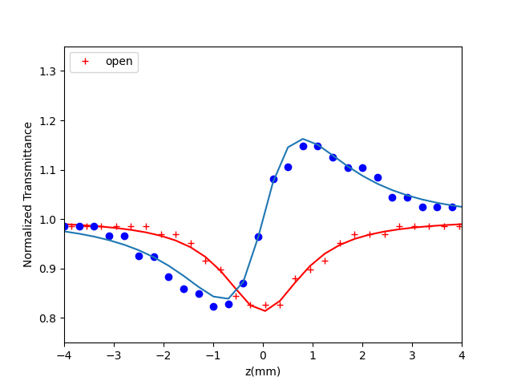

sample 10 c=0.1 energy=240.0

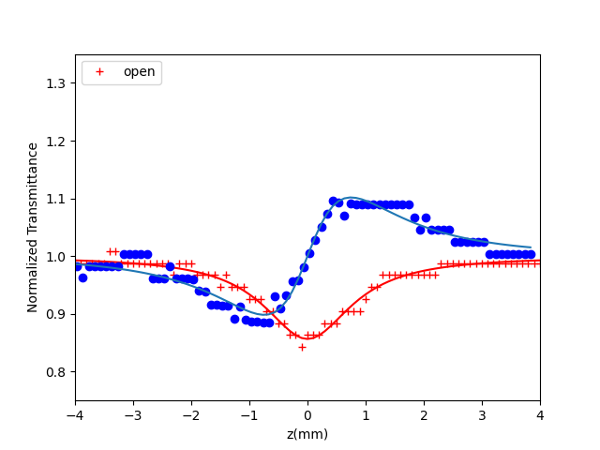

sample 10 c=0.1 energy=124.0

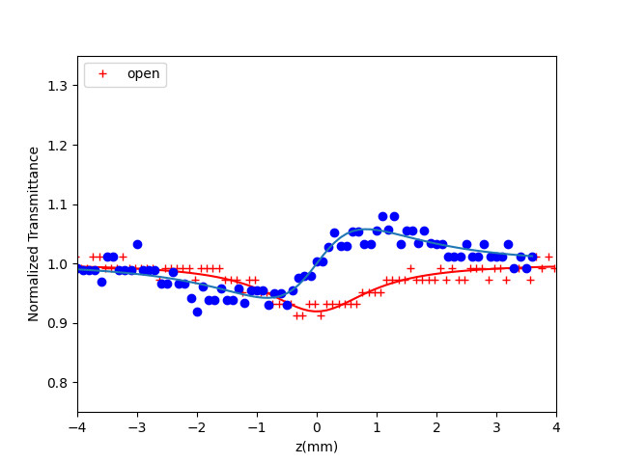

sample 10 c=0.1 energy=124.0

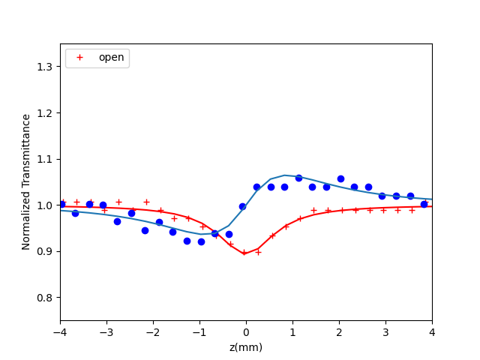

sample 10 c=0.1 energy=200.0

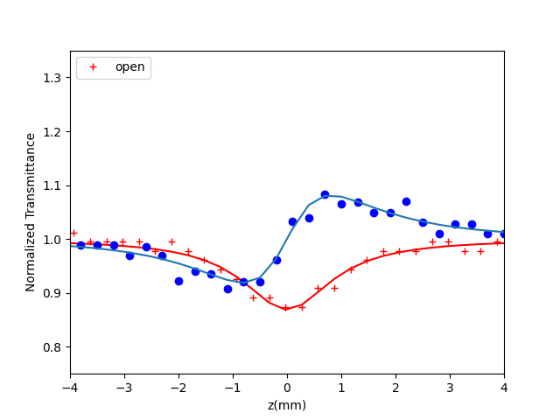

sample 10 c=0.1 energy=200.0

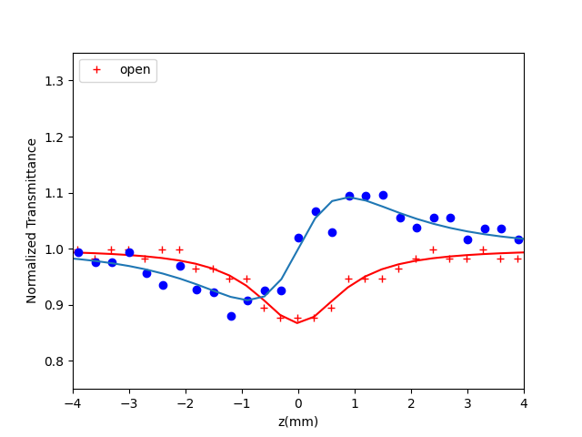

sample 10 c=0.1 energy=166.0

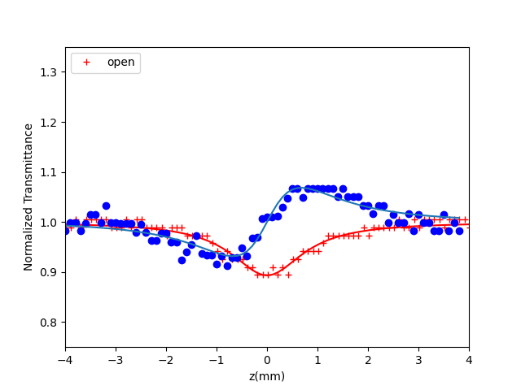

sample 10 c=0.21 energy=330.0

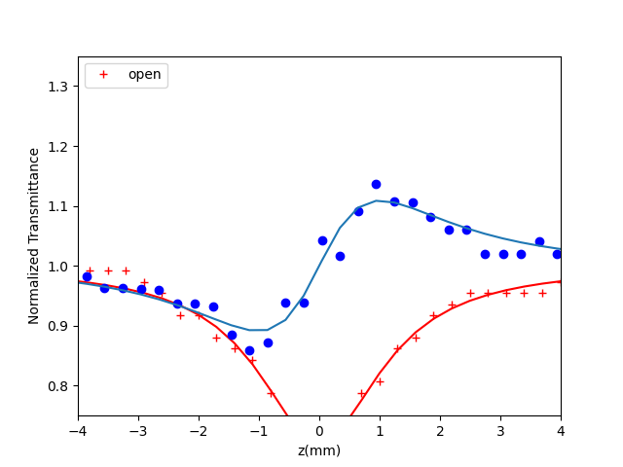

sample 10 c=0.21 energy=200.0

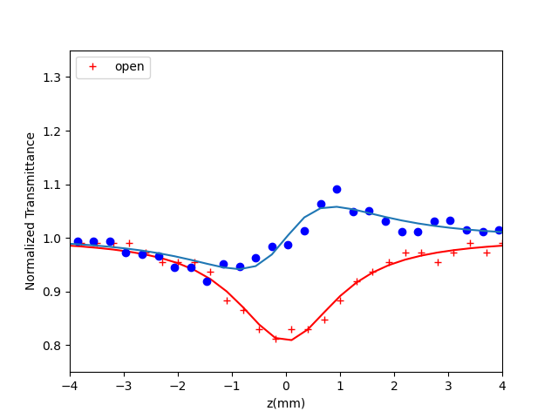

Fig. 1. UV vis spectrum of the molecules

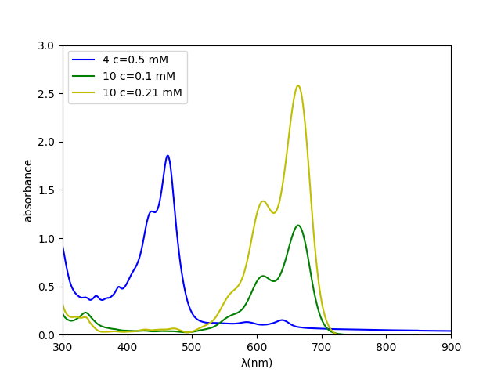

Fig. 2. ΔΤp-v values as a function of the incident laser energy

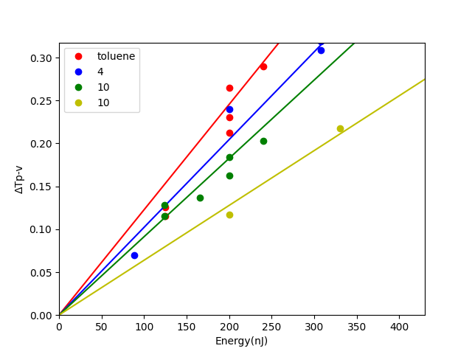

Table 1. Nonlinear optical parameters (Z-scan: 40fs, 800 nm)

|  |  |  |  |  |  |  |  |  |
| --- | --- | --- | --- | --- | --- | --- | --- | --- |
| Samples | Concentration | γ' (10-21m2/W) | Re(x(3)) (10-16 esu) | Reγ (10-33 esu) | β (&10^{-15}& m/W) | Imx(3) (10-16 esu) | x(3) (10-16 esu) | x(3)/c (10-16 esu/mM) |
| toluene | 0.20 | 12.27 | 15.25 | 12.27 | 6.69 | 0.52 | 15.26 | 76.29 |
| 4 | 0.50 | 10.22 | 12.70 | 10.22 | 20.93 | 1.64 | 12.81 | 25.62 |
| 10 | 0.10 | 9.13 | 11.34 | 9.13 | 22.66 | 1.78 | 11.48 | 114.82 |
| 10 | 0.21 | 6.39 | 7.94 | 6.39 | 32.79 | 2.57 | 8.34 | 39.73 |