

CS 319 - Object-Oriented Software Engineering

System Design Report

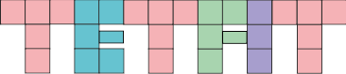

Group 1F

Irmak Akkuzuluoğlu

Irmak Türköz

Mustafa Culban

Yasin Erdoğdu

**1. Introduction** **2**

**1.1 Purpose of the system** **3**

**1.2 Design Goals** **3**

**Trade Offs:** **4**

**Development time vs Complexity** **4**

**Ease Of Use and Ease of Learning vs. Functionality:** **4**

**1.3 Definitions, acronyms, and abbreviations** **5**

**Abbreviations:** **5**

**1.4. References** **5**

**1.5. Overview** **5**

**2.1. Overview** **6**

**2.2. Subsystem Decomposition** **6**

**2.3. Architectural Styles** **6**

**2.3.1 Layers** **6**

**2.3.2 Model View Controller** **6**

**2.3. Hardware / Software Mapping** **6**

**2.4. Persistent Data Management** **6**

**2.5. Access Control and Security** **6**

**2.6. Boundary Conditions** **6**

**3. Subsystem Services** **6**

**3.1. Design Patterns**

**3.1.1 Factory Pattern 6**

**3.2. User Interface Subsystem Interface** **6**

**3.3 Game Management Subsystem Interface** **7**

**3.4 Game Entities Subsystem Interface** **7**

**3.5 Detailed System Design** **7**

# **1. Introduction**

## **1.1 Purpose of the system**

Tetfit is a 2-D tile matching puzzle game, which is intended to entertain users greatly. It has minimalistic graphics, consisting of simple shapes and a user-friendly interface. The gameplay is easy to understand, but the game gets challenging as the player carries on with the game. Tetfit also has different levels of difficulty which gives the players the freedom to choose where to start from, making gameplay more individualistic and enjoyable. It is a skill-based game, it has two different modes that both triggers strategical thinking. Overall, it is a great pastime activity with a pleasing design.

## **1.2 Design Goals**

Below are some important design goals of the system which are proposed to meet non functional requirements of our project, which were mentioned previously in the analysis report.

**Usability:** The ease of use is one of the most important aspects of the system for it is a game aiming to entertain people. In order to provide this, player should be able to get a grip of the system easily. For this purpose, we will provide the user friendly simplistic interfaces, so the user can achieve each and every operation he desires to perform. Moreover, it is decided that the menu operations will be done by mouse clicks and the game will be controlled with the arrow keys for they are the most common and easy ways to control a game.

**Ease of Learning:**  In order to let the user have fun without dealing with confusion we intended to give the game the ease of learning. Tetfit is overall a simplistic game, with an easy main goal. The information about the main goal and how to play the game will be provided by the help document which will can be accessed through the main menu. This documentation will be detailed enough to avoid any kind of confusion. Since the game is already an easy to understand game, we expect the users to learn and play the game easily.

**Extendibility:** Letting the game to extend and change is a crucial point to maintain the interest of the users in general, by adding new components, features to the game. In order to achieve this our system will be open to any kind of change, making it convenient for us to add new functionalities and entities easily to the present system.

**Modifiability**: Extendibility also requires modifiability. Modifiability provides the ease to modify the system to correct faults, improve performance or other attributes, or adapt to a changed environment. Throughout the implementation this specification will be kept in mind so that our system will allow us to improve it.

**Portability:** This is also an important issue for a software system, for it can allow a wide range of users to access it. With this consideration, we decided to implement our system in such manner. Our game will be implemented in Java, because its JVM maintains platform independency, allowing the system to achieve the portability.

**Response Time:** For our project is a game, another crucial goal is to keep a short response time. It is vital to provide quick responses to the users’ requests, in order to maintain a pleasing experience for the users. Our goal is for the system to respond to users’ actions as quick as possible, while also smoothly displaying animations and screening the gameplay.

### **Trade Offs:**

#### **Development time vs Complexity**

For our system has to be completed by the end of this semester, we have a quite limited time to develop and implement our project. We are trying to optimize the usage of time to achieve as much as possible, but still there needs to be a trade off between the development time and the complexity. Our purpose is to provide a high quality game but with a limited amount of variety in the gameplay. We limited our game to 2 different mods which will have different difficulties.

#### **Ease Of Use and Ease of Learning vs. Functionality:**

Our system aims to provide an ease of understanding and usability. Hence, we need to trade off the functionality to keep the game simple. This is planned to be achieved by avoiding complex functions and by not exceeding a certain number of different functional abilities that will be provided to the user. We will keep our minimalistic view, and implement the best possible game which easy to understand and play by sacrificing a bit of the functionality.

1. **Performance vs. Memory:**

In our game, it is vital to provide the player smooth animations, effects, transitions, for an enjoyable gameplay. thus, performance is the primary focus of the system. However, in order to achieve this we had to sacrifice the memory.

## **1.3 Definitions, acronyms, and abbreviations**

### **Abbreviations:**

## **1.4. References**

[1]<http://en.wikipedia.org/wiki/Java_(programming_language)>

[2] <http://www.nada.kth.se/~karlm/prutt05/lectures/prutt05_lec7.pdf>

[3] <https://drive.google.com/file/d/0B9ApNnKlfgcHeUxKbFAyQTNQbE0/view>

[4] <https://drive.google.com/file/d/0B9ApNnKlfgcHYllRbEZEYjFRRzg/view>

[5] <http://www.ieee.org.ar/downloads/Barbacci-05-notas1.pdf>

## **1.5. Overview**

This section, generally summed up the main purpose of the system, that is to provide entertainment to users. In order to meet every intended goal, we defined them clearly, in detail. Our main focus on design goals are usability, ease of learning, extendibility, portability, modifiability and high performance. We are aware that every system requires some trade offs to be made, hence we planned these trade offs to be as favourable as possible for our project. We made some trade offs between development time and complexity, ease of use and functionality, lastly performance and memory.

**2. Software Architecture**

## **2.1. Overview**

The purpose of section to decompose our system into maintainable subsystems. Our software architecture aims to have reduced coupling which measures the dependencies between two subsystems and increased cohesion which measures dependencies among classes within a subsystem. To apply this method most efficiently to our system we will use MVC (Model View Controller) architectural style.

## **2.2. Subsystem Decomposition**

This section will divide system into subsystems with package diagram to organize the design of the project. The subsystems should separate project into independent parts whereas their dependency to each other must be prevented.

Since we use MVC (Model View Controller) Architecture; we designed our subsystems as User Interface which represents View, Game Manager which represents Controller and Game Entities which represents the Model part. Their dependency between each other is lowered which means they are loosely coupled. Moreover, they do not depend on each other with their functionalities which provides sustainable project management as well as projects error management since when a subsystem is corrupted or giving error other systems could still run. For example, when there is an error in the User interface subsystem, the error will occur in that subsystem which would not affect the ”Game Manager”s or the “Game Entities”s functionalities. Also, this way of programming would separate subsystems in such a way that they can be parallely implemented. Figure -1 shows a very rough package diagram of the subsystems.

In Figure 2 and Figure 3 there are more extended versions of our package models. The main purpose of such design was to better understand the game logic, interactions between model, controller and view and the subsystems. It is important to observe that subsystems in the same package has relation between each other whereas they do not directly affect to each other’s functionalities. We designed our system in such a way that it has high cohesion and low coupling.

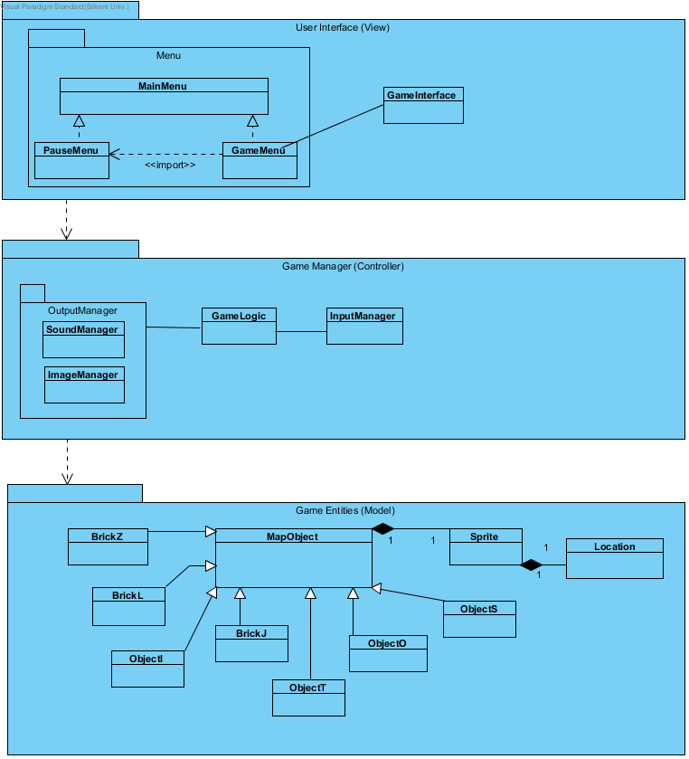

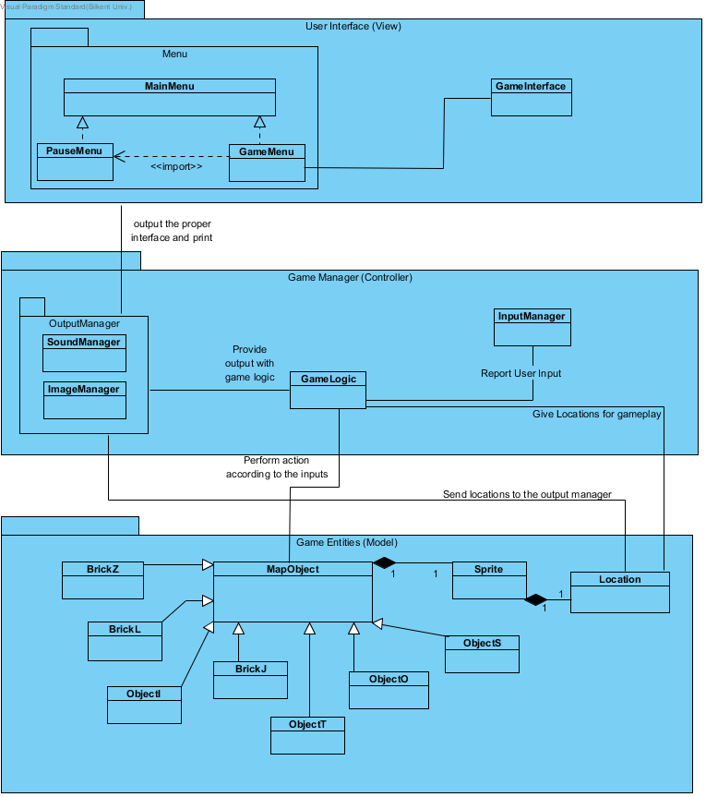

## **2.3. Architectural Styles**

### **2.3.1 Layers**

We decomposes our system into three hierarchical layers during the grouping subsystem which prıvides related services. These layers hierarchically are User Interface, Game Manager and Game Entities. Since our layer architecture is a closed architecture, each layer in our system only calls operations from one layer below. User interface is top at the layer hierarchy, therefore, It depends on below layer results and it ınteracts with user. The middle layer is Gma Manager layer which is responsible for controlling game logic. Game Entities layer exists at the bottom of the hierarchy and ıt holds information about entity objects. Decomposition of our system is as below;

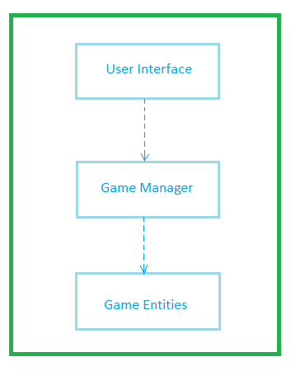

**2.3.2 Model View Controller**

The main point of using Model-View-Controller architectural style is to divide system into three different parts and manage interaction policies these three parts. We grouped classes which are under Game Manager layer into Controller part which is basically the managing part of the system and provide communication between Model and View part. Game entities are grouped into Model part and the classes that are responsible user interaction are grouped into View part. With controller part, View part cannot access directly Model part. By MVC architectural style, it is enabled that any changes comes from user interface do not cause any changes also in domain part of the system, thanks to this, this architectural style is good for the games.

**2.3. Hardware / Software Mapping**

Tetfit is going to be implemented in Java, hence, the latest JDK (1.7) is going to be used for implementation. For hardware configuration, Tetfit needs a basic keyboard inputting for playing the game and also the typing the name for highscores, and mouse for users to go through the menu. Because of the fact that the game is going to be implemented in Java and system requirements are going to be minimal, all it needs is a basic computer with basic softwares installed such as an operating system and a java compiler to compile and run the files. Moreover, Java’s platform independency will be beneficial. Our game will not require internet connection to operate.

## **2.4. Persistent Data Management**

Our project will not require any complicated data storage, therefore, it does not need a complex database system. It will store high score list as a text file in disk. If text file gets corrupted, it will not be effecting in-game issues such as game objects, but of course the scoreboard will be faulty. Furthermore, our plan is to store object images and sound effects in hard disk drive with simple sound and image formats.

## **2.5. Access Control and Security**

As mentioned before, Tetfit does not need any kind of internet connection. Anyone who initializes the game will be able to play the game, if the necessary basic softwares are available. Thus, there will be no restrictions or control for access. Moreover, it will not include any user related data or profile, so, there will not be any kind of security issues.

## **2.6. Boundary Conditions**

### **2.6.1 Execution**

TETFIT will be only requiring Java Runtime Environment on the gamer’s computers. That will be only necessity.

### **2.6.2 First Run**

On first run, TETFIT will start gradually and nothing will be happened on the saving purposes but if user wants to save a game on the startup of the TETFIT , s/he will choose from the menu and after selection, TETFIT will check for the saved games on the directory *svdGames.* If TETFIT Memento pattern handler finds a game in the folder, it will lists all the saved games but if not, TETFIT will ask to user to create new game.

### **2.6.3 Termination**

There are only one chance to exit a game. On every men you should go the Main Menu in order to exit. This was planned because keeping player on the game whether or not he or she wants to close the game. We are trying to take her/him in the game by not allowing him/her to close game in any menu. Also there is X button on every operating system (for Windows, it is on the top and the rightmost button, for MacOS it is on the top left and red button). If user clicks on this button we are again asking whether wants to leave game seriously or not to hold him/her on the game.

# **3. Subsystem Services**

## **3.1. Design Patterns**

In our game we decided to use more than one design patterns to do our complicated jobs in a separated and in an easy way.

### **3.1.1 Factory pattern**

In order to accomplish this pattern, We firstly need to implement a Factory class to create all the pieces in the game that are used. So we create *PieceFactory* class for that purpose. On this case, This class is concerned with creation of the pieces which are derived classes of *Grid*base classes will be created so that *TetrisGame class will not concern with the job that PieceFactory class does.*

### **3.1.2 Decorator Pattern**

In this pattern we are aiming to create popup window messages for example “You win the game” or “ Game is over”. We have *Shape* class for drawing items to the UI. In other words, this class is used for drawing every pieces , every text, every messages etc. to the screen. So decorator Pattern will be using because we are creating messages to the screen. *TextDecorator*  class will be using instance of *Shape* class and *TextDecorator* will be able to write a message every class that is derived from *Shape* class temporarily. *TextDecorator* class will be able to draw a message on the center of the game screen. This can be used with examples that were given below and for example to disable buttons in the games.

### **3.1.3 Memento Pattern**

Inside the game play , at any instance of a time ( except the game over state) game will be able to save and restore the game. Memento Pattern will be sing to satisfy this purpose. Every instance of the game are stored in the *TetrisGame* class , blocks type, their positions, score, fallen blocks etc. So Saving *TetrisGame* class will be sufficient to save the game. So the *Memento* class is taking *TetrisGame* as a target and save it with all its instances. Memento pattern is implemented with 3 objects[1] : originator, caretaker and memento. Originator is *TetrisGame*  in our game , Memento is with a same named class Memento and caretaker is the main game runner class *Tetris.* By encapsulating in this pattern *Tetris*  class won’t consider with saving game in its own and game will be saved and be restored by this Pattern.

## **3.2. User Interface Subsystem Interface**

## **3.3 Game Management Subsystem Interface**

## **3.4 Game Entities Subsystem Interface**

## **3.5 Detailed System Design**

1. https://en.wikipedia.org/wiki/Memento_pattern