-Git is a version control tool

-Git Hub is a web hosting service

Basics Commands:

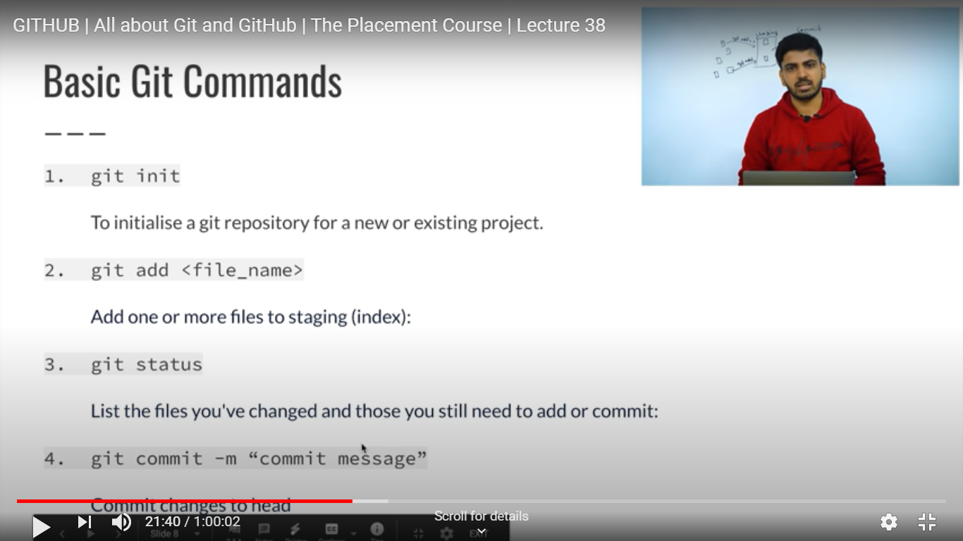

This command adds and commits together : git -am “ ”

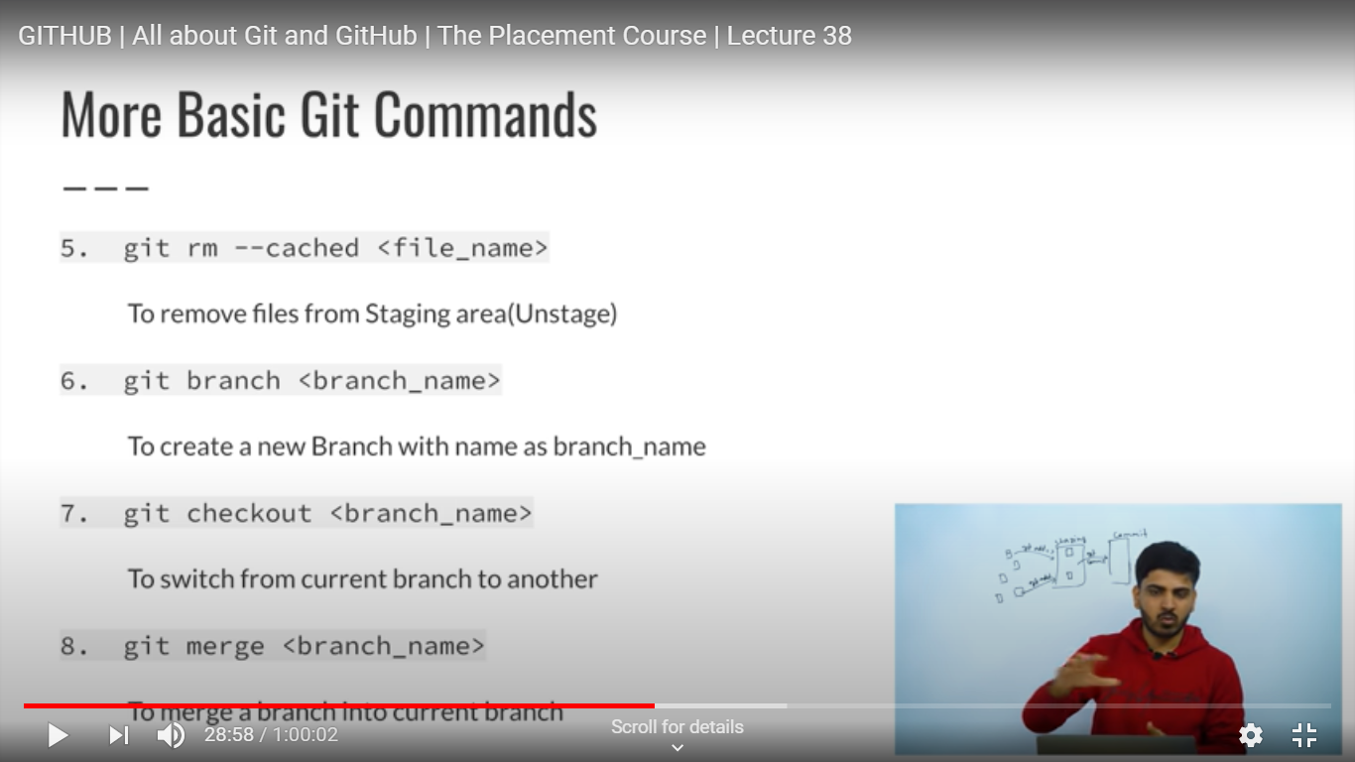

Working Directory:

