KARAN KASHYAP

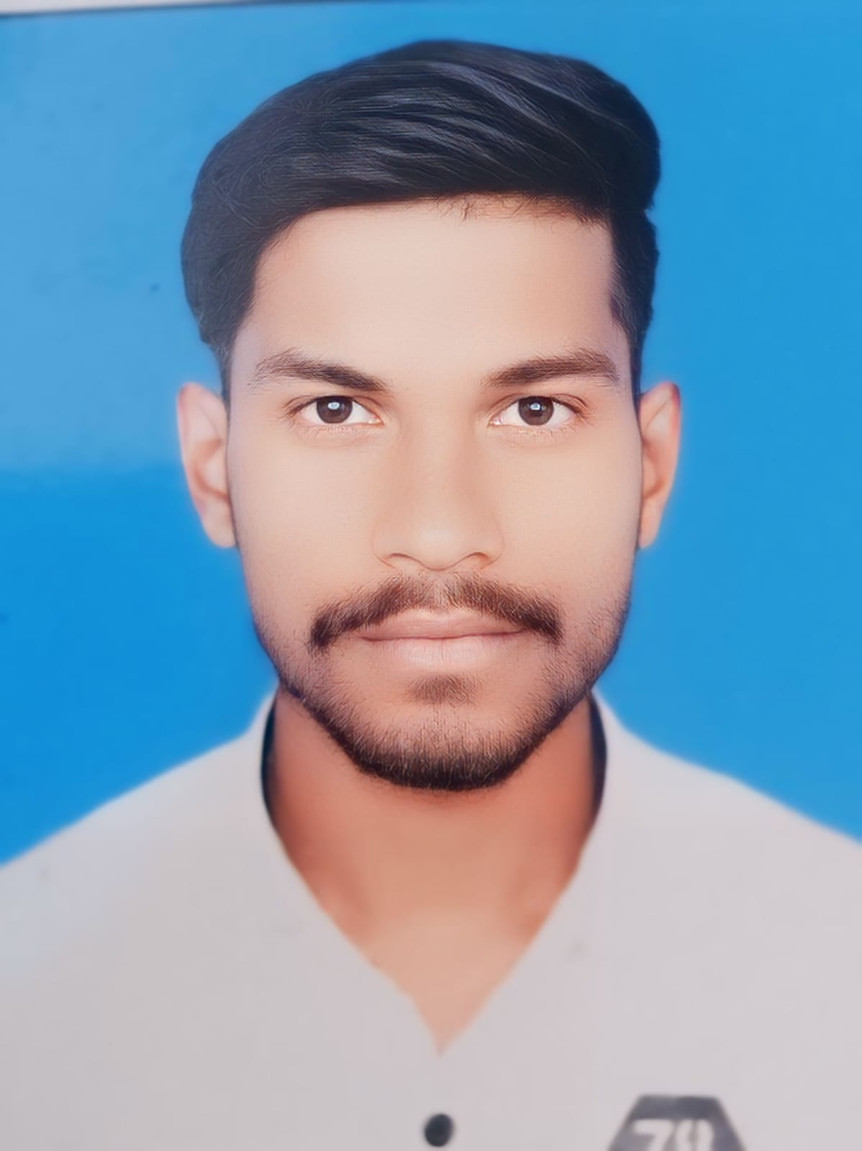

pic.jpeg

* [karanakashyap0555028@gmail.com](mailto:karanakashyap0555028@gmail.com)

• +91-9756986549

# Objective

Motivated and detail-oriented BCA student with a strong interest in backend development. Solid foundation in Java, C/C++(Basic), and data structures. Seeking an entry-level backend developer role to utilize my skills and contribute to building efficient, scalable systems.

# Skills and interests

**Programming Languages Java**, C(Basic),C++(Basic)

**Core Concepts** Data Structures, Algorithms, OOPs

**Frontend Technologies** HTML**,** CSS, Java Swing

**Database** MySQL

**Tools/Software** NetBeans, VS Code

**Version Control System** Git, GitHub

**Other** Computer Basics, Internet Fundamentals

# Education

# **Master of Computer Applications (MCA)**

# **Shri Ram College, Muzaffarnagar**

# **Expected Graduation: 2027**

# **Bachelor of Computer Applications (BCA)**

# **Shri Ram College, Muzaffarnagar**

# **Graduation: 2025**

# **12th (Intermediate, PCM) – 2021**

# **Uttar Pradesh Board**

# Experience

**Fresher**

# Certifications

* Getting Started with Enterprise Data Science
* Journey to Cloud: Envisioning Your Solution

# Projects

**School Management System (Windows & Web Application)**

**Technologies Used: Java /Java Swing and AWT/ MySQL**

* Developed a desktop-based application for managing student, teacher, class, and exam data using Java Swing and AWT.
* Designed user-friendly interfaces for CRUD operations and role-based access, improving administrative efficiency.
* Integrated MySQL for secure, scalable database management, supporting real-time data access and updates.
* Implemented login authentication, session management, and detailed reporting features for school administrators.

# Languages Known

**Hindi**

**English**

# Hobbies and interest

* Solving logic problems
* Exploring new technologies
* Keeping things simple and practical