Security In Computing Practical

Practical 10: Configuring ASA Basic Settings and Firewall Using CLI

Topology:

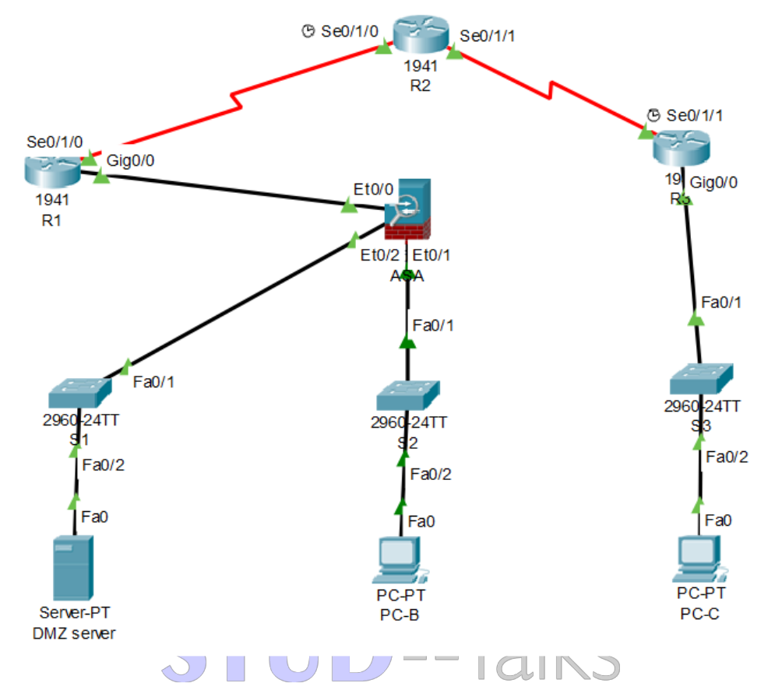

Addressing Table:

Device | Interface | IP Address | Subnet Mask | Default Gateway
 | gig0/0 | 209.165.200.225 | 255.255.255.248 | N/A
R1 | Se0/1/0 | 10.1.1.1 | 255.255.255.252 | N/A
 | Se0/1/0 | 10.1.1.2 | 255.255.255.252 | N/A
R2 | Se0/1/1 | 10.2.2.2 | 255.255.255.252 | N/A
R3 | gig0/0 | 172.16.3.1 | 255.255.255.0 | N/A
 | Se0/1/0 | 10.2.2.1 | 255.255.255.252 | N/A
ASA | VLAN 1 (Et0/1) | 192.168.1.1 | 255.255.255.0 | N/A
ASA | VLAN 2 (Et0/0) | 209.165.200.226 | 255.255.255.248 | N/A
ASA | VLAN 3 (Et0/2) | 192.168.2.1 | 255.255.255.0 | N/A
DMZ Server | NIC | 192.168.2.3 | 255.255.255.0 | 192.168.2.1
PC-B | NIC | 192.168.1.3 | 255.255.255.0 | 192.168.1.1
PC-C | NIC | 172.16.3.3 | 255.255.255.0 | 172.16.3.1

Objectives:

- Verify connectivity and explore the ASA

- Configure basic ASA settings and interface security levels using CLI

- Configure routing, address translation, and inspection policy using CLI

- Configure DHCP, AAA, and SSH

- Configure a DMZ, Static NAT, and ACLs

Part 1: Configure Router

Step 1: Configure secret on router

Execute command on all routers

R(config)# enable secret enpa55

Step 2: Configure console password on router

Execute command on all routers

R(config)# line console 0

R(config-line)# password conpa55

R(config-line)# login

Step 3: Configure SSH login on router

Execute command on all routers

R(config)# ip domain-name ccnasecurity.com

R(config)# username admin secret pa55

R(config)# line vty 0 4

R(config-line)# login local

R(config)# crypto key generate rsa

How many bits in the modulus [512]: 1024

Step 4: Configure OSPF on routers

Execute command on all routers

R1(config)#router ospf 1

R1(config-router)# network 209.165.200.0 0.0.0.7 area 0

R1(config-router)# network 10.1.1.0 0.0.0.3 area 0

R2(config)#router ospf 1

R2(config-router)# network 10.1.1.0 0.0.0.3 area 0

R2(config-router)# network 10.2.2.0 0.0.0.3 area 0

R3(config)#router ospf 1

R3(config-router)# network 172.16.3.0 0.0.0.255 area 0

R3(config-router)# network 10.2.2.0 0.0.0.3 area 0

Part 2: Verify Connectivity and Explore the ASA

Step 1: Verify connectivity.

Send packets from:

PCC -> R1, R2, R3

(Successful)

Send packets from:

PCC -> ASA, PC-B, DMZ server.

(Unsuccessful)

Step 2: Determine the ASA version, interfaces, and license.

Enter privileged EXEC mode. A password has not been set. Press Enter when prompted for a password.

ASA# show version

Step 3: Determine the file system and contents of flash memory.

ASA# show file system

ASA# show flash:

Part 3: Configure ASA Settings and Interface Security Using the CLI

Step 1: Configure the hostname and domain name. ASA (config)#hostname CCNAS-ASA CCNAS-ASA (config)# domain-name ccnasecurity.com

Step 2: Configure the enable mode password. CCNAS-ASA (config)# enable password enpa55

Step 3: Set the date and time. (your current time) CCNAS-ASA (config)#clock set 21:24:00 31 March 2022

Step 4: Configure the inside and outside interfaces.

CCNAS-ASA(config)# int vlan 1

CCNAS-ASA(config-if)# nameif inside

CCNAS-ASA(config-if)# ip address 192.168.1.1 255.255.255.0

CCNAS-ASA(config-if)# security-level 100

CCNAS-ASA(config-if)# int vlan 2

CCNAS-ASA(config-if)# nameif outside

CCNAS-ASA(config-if)# ip address 209.165.200.226 255.255.255.248

CCNAS-ASA(config-if)# security-level 0

Step 5: Check the configurations

CCNAS-ASA# show int ip brief

CCNAS-ASA# show ip address

CCNAS-ASA# show switch vlan

Step 6: Test connectivity to the ASA. (Send packets)

PCB -> ASA

(Successful)

PCB -> R1

(Unsuccessful)

Part 4: Configure Routing, Address Translation, and Inspection Policy Using the CLI

Step 1: Configure a static default route for the ASA.

CCNAS-ASA# show route

CCNAS-ASA(config)# route outside 0.0.0.0 0.0.0.0 209.165.200.225

CCNAS-ASA# show route

Step 2: Test connectivity. (Send packets)

ASA -> R1

(Successful)

Step 3: Configure address translation using PAT and network objects.

CCNAS-ASA(config)# object network inside-net

CCNAS-ASA(config-network-object)# subnet 192.168.1.0 255.255.255.0

CCNAS-ASA(config-network-object)# nat (inside,outside) dynamic interface

CCNAS-ASA(config-network-object)# end

Step 4: Test connectivity.

CCNAS-ASA# show run

PCB -> R1 (Send packets)

(Unsuccessful)

CCNAS-ASA# show nat

Step 5: Modify the default MPF application inspection global service policy.

CCNAS-ASA(config)# class-map inspection_default

CCNAS-ASA(config-cmap)# match default-inspection-traffic

CCNAS-ASA(config-cmap)# exit

CCNAS-ASA(config)# policy-map global_policy

CCNAS-ASA(config-pmap)# class inspection_default

CCNAS-ASA(config-pmap-c)# inspect icmp

CCNAS-ASA(config-pmap-c)# exit

CCNAS-ASA(config)# service-policy global_policy global

Step 6: Test connectivity. (Send packets)

PCB -> R1

(Successful)

Part 5: Configure DHCP, AAA, and SSH

Step 1: Configure the ASA as a DHCP server.

CCNAS-ASA(config)# dhcpd address 192.168.1.5-192.168.1.36 inside

CCNAS-ASA(config)# dhcpd dns 209.165.201.2 int inside

CCNAS-ASA(config)# dhcpd enable inside

Change PC-B from a static IP address to a DHCP client, and verify that it receives IP addressing information.

Step 2: Configure AAA to use the local database for authentication.

CCNAS-ASA(config)# username admin password adminpa55 CCNAS-ASA(config)# aaa authentication ssh console LOCAL

Step 3: Configure remote access to the ASA.

CCNAS-ASA(config)# crypto key generate rsa modulus 1024

Do you really want to replace them? [yes/no]: no

CCNAS-ASA(config)# ssh 192.168.1.0 255.255.255.0 inside

CCNAS-ASA(config)# ssh 172.16.3.3 255.255.255.255 outside

CCNAS-ASA(config)# ssh timeout 10

Step 4: Verify SSH session

PCB>ssh –l admin 192.168.1.1

Password:adminpa55

CCNAS-ASA>exit

Part 6: Configure a DMZ, Static NAT, and ACLs

Step 1: Configure the DMZ interface VLAN 3 on the ASA.

CCNAS-ASA(config)# int vlan 3

CCNAS-ASA(config-if)# ip address 192.168.2.1 255.255.255.0

CCNAS-ASA(config-if)# no forward int vlan 1

CCNAS-ASA(config-if)# nameif dmz

CCNAS-ASA(config-if)# security-level 70

CCNAS-ASA(config-if)# int et0/2

CCNAS-ASA(config-if)# switchport access vlan 3

Step 2: Check the configurations

CCNAS-ASA# show int ip brief

CCNAS-ASA# show ip address

CCNAS-ASA# show switch vlan

Step 3: Configure static NAT to the DMZ server using a network object.

CCNAS-ASA(config)# object network dmz-server CCNAS-ASA(config-network-object)# host 192.168.2.3

CCNAS-ASA(config-network-object)# nat (dmz,outside) static 209.165.200.227

CCNAS-ASA(config-network-object)# exit

Step 4: Configure an ACL to allow access to the DMZ server from the Internet.

CCNAS-ASA(config)# access-list OUTSIDE-DMZ permit icmp any host 192.168.2.3

CCNAS-ASA(config)# access-list OUTSIDE-DMZ permit tcp any host 192.168.2.3 eq 80

CCNAS-ASA(config)# access-group OUTSIDE-DMZ in int outside Step 5: Test access to the DMZ server.

The ability to successfully test outside access to the DMZ web server was not in place; therefore, successful testing is not required. Practical ends here

