Security In Computing Practical

Practical 9: Configure and Verify a Site-to-Site IPsec VPN Using CLI

Topology:
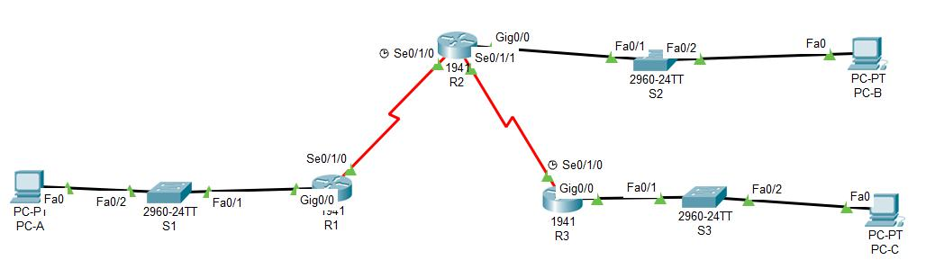

Addressing Table:

Device | Interface | IP Address | Subnet Mask | Default Gateway
 | gig0/0 | 192.168.1.1 | 255.255.255.0 | N/A
R1
R1 | Se0/1/0 | 10.1.1.2 | 255.255.255.252 | N/A
 | gig0/0 | 192.168.2.1 | 255.255.255.0 | N/A
R2 | Se0/1/0 | 10.1.1.1 | 255.255.255.252 | N/A
 | Se0/1/1 | 10.2.2.1 | 255.255.255.252 | N/A
R3 | gig0/0 | 192.168.2.1 | 255.255.255.0 | N/A
 | Se0/1/0 | 10.2.2.2 | 255.255.255.252 | N/A
PC-A | NIC | 192.168.1.3 | 255.255.255.0 | 192.168.1.1
PC-B | NIC | 192.168.2.3 | 255.255.255.0 | 192.168.2.1
PC-C | NIC | 192.168.3.3 | 255.255.255.0 | 192.168.3.1

Objectives:

- Verify connectivity throughout the network.

- Configure R1 to support a site-to-site IPsec VPN with R3.

Part 1: Configure router

Step 1: Configure secret on router

Execute command on all routers

R(config)# enable secret enpa55

Step 2: Configure console password on router

Execute command on all routers

R(config)# line console 0

R(config-line)# password conpa55

R(config-line)# login

Step 3: Configure SSH login on router

Execute command on all routers

R(config)# ip domain-name ccnasecurity.com

R(config)# username admin secret adminpa55

R(config)# line vty 0 4

R(config-line)# login local

R(config)# crypto key generate rsa

How many bits in the modulus [512]: 1024

Step 4: Configure OSPF on routers

R1(config)# router ospf 1

R1(config)# network 192.168.1.0 0.0.0.255 area 0

R1(config)# network 10.1.1.0 0.0.0.3 area 0

R2(config)# router ospf 1

R2(config)# network 192.168.2.0 0.0.0.255 area 0

R2(config)# network 10.2.2.0 0.0.0.3 area 0

R2(config)# network 10.1.1.0 0.0.0.3 area 0

R3(config)# router ospf 1

R3(config)# network 192.168.3.0 0.0.0.255 area 0

R3(config)# network 10.2.2.0 0.0.0.3 area 0

Part 2: Configure IPsec Parameters on R1

Step 1: From PC-A, verify connectivity to PC-C and PC-B.

PCA> ping 192.168.3.3

(Successful)

PCA> ping 192.168.2.3

(Successful)

PCB> ping 192.168.3.3

(Successful)

Step 2: Check if the Security Technology package is enabled R1# show version

Step 3: Enable the Security Technology package.

R1(config)# license boot module c1900 technology-package securityk9

Step 4: Save the running config and reload the router to enable the security license

R1# copy run start

R1# reload

Step 5: Verify the Security Technology package is enabled R1# show version

Step 6: Identify interesting traffic on R1.

R1(config)# access-list 110 permit ip 192.168.1.0 0.0.0.255 192.168.3.0

0.0.0.255

Step 7: Configure the IKE Phase 1 ISAKMP policy on R1.

R1(config)# crypto isakmp policy 10

R1(config-isakmp)# encryption aes 256

R1(config-isakmp)# authentication pre-share

R1(config-isakmp)# group 5

R1(config-isakmp)# exit

R1(config)# crypto isakmp key vpnpa55 address 10.2.2.2

Step 8: Configure the IKE Phase 2 IPsec policy on R1.

R1(config)# crypto ipsec transform-set VPN-SET esp-aes esp-sha-hmac R1(config)# crypto map VPN-MAP 10 ipsec-isakmp R1(config-crypto-map)# description VPN connection to R3 R1(config-crypto-map)# set peer 10.2.2.2 R1(config-crypto-map)# set transform-set VPN-SET R1(config-crypto-map)# match address 110 R1(config-crypto-map)# exit

Step 9: Configure the crypto map on the outgoing interface.

R1(config)# int se0/1/0

R1(config-if)# crypto map VPN-MAP

Part 3: Configure IPsec Parameters on R3

Step 1: Check if the Security Technology package is enabled R3# show version

Step 2: Enable the Security Technology package.

R3(config)# license boot module c1900 technology-package securityk9

Step 3: Save the running config and reload the router to enable the security license

R3# copy run start R3# reload

Step 4: Verify the Security Technology package is enabled R3# show version

Step 5: Configure router R3 to support a site-to-site VPN with R1. R3(config)# access-list 110 permit ip 192.168.3.0 0.0.0.255 192.168.1.0 0.0.0.255

Step 6: Configure the IKE Phase 1 ISAKMP properties on R3.

R3(config)# crypto isakmp policy 10

R3(config-isakmp)# encryption aes 256

R3(config-isakmp)# authentication pre-share

R3(config-isakmp)# group 5

R3(config-isakmp)# exit

R3(config)# crypto isakmp key vpnpa55 address 10.1.1.2

Step 7: Configure the IKE Phase 2 IPsec policy on R3.

R3(config)# crypto ipsec transform-set VPN-SET esp-aes esp-sha-hmac R3(config)# crypto map VPN-MAP 10 ipsec-isakmp R3(config-crypto-map)# description VPN connection to R1 R3(config-crypto-map)# set peer 10.1.1.2 R3(config-crypto-map)# set transform-set VPN-SET R3(config-crypto-map)# match address 110 R3(config-crypto-map)# exit

Step 8: Configure the crypto map on the outgoing interface.

R3(config)# int se0/1/0

R3(config-if)# crypto map VPN-MAP

Part 4: Verify the IPsec VPN

Step 1: Verify the tunnel prior to interesting traffic.

R1# show crypto ipsec sa

Step 2: Create interesting traffic.

PCC>ping 192.168.1.3

(Successful)

Step 3: Verify the tunnel after interesting traffic.

R1# show crypto ipsec sa

Step 4: Create uninteresting traffic

PCB>ping 192.168.1.3

(Successful)

R1#ping 192.168.3.3

(Successful)

R3#ping 192.168.1.3

(Successful)

Step 5: Verify the tunnel.

R1# show crypto ipsec sa

*

