Node+mongo+react connections

1.react code

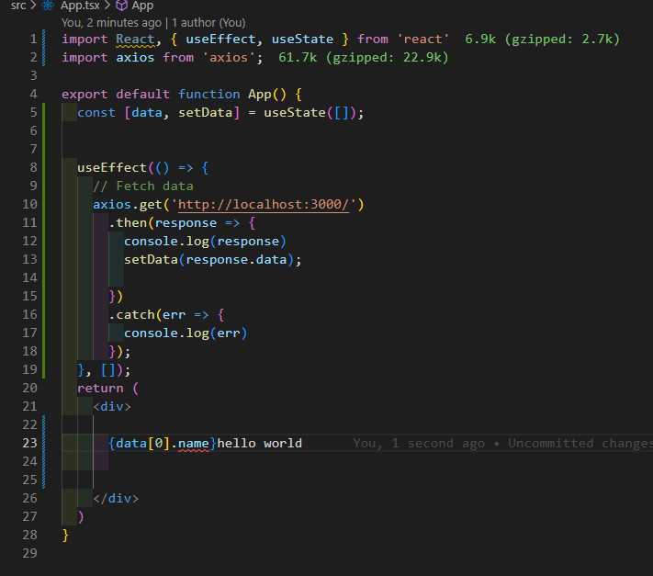

From git just copy the basic code and npm i

2. node

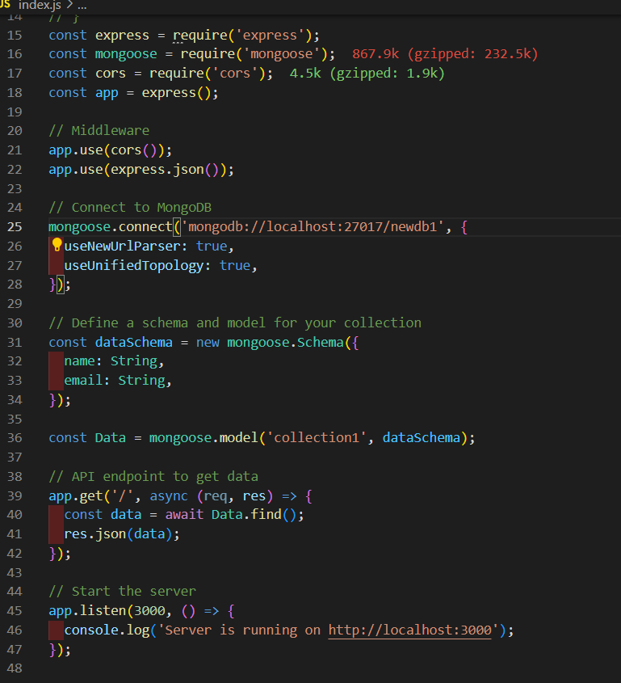

3.mongodb ..

U need to have a database & a collection to connect

