SecureGate
A Project Report
Submitted in partial fulfilment of the
Requirements for the award of the Degree of
BACHELOR OF SCIENCE (INFORMATION TECHNOLOGY)
By
Mr. Karan Ramakant Mondkar
Seat Number :____________
Under the esteemed guidance of
Asst. Prof. S.S. Prabhu

DEPARTMENT OF INFORMATION TECHNOLOGY
SANT RAWOOL MAHARAJ MAHAVIDYALAYA, KUDAL
(Affiliated to University of Mumbai)
KUDAL, 416520
MAHARASHTRA
2025-26

SANT RAWOOL MAHARAJ MAHAVIDYALAYA, KUDAL
(Affiliated to University of Mumbai)
KUDAL-MAHARASHTRA-416520
DEPARTMENT OF INFORMATION TECHNOLOGY


K.M.S.P. MANDAL'S
SANT RAWOOL MAHARAJ MAHAVIDYALAYA,
KUDAL

(NAAC Accreditation "B+" Grade)

CERTIFICATE

This is to certify that the project entitled, "SecureGate",
is Bonafide work of
Mr. Karan Ramakant Mondkar
bearing Seat No. :______________

submitted in partial fulfilment of the requirements for the award of degree of
BACHELOR OF SCIENCE in INFORMATION TECHNOLOGY
from University of Mumbai.

PROJECT GUIDE EXTERNAL EXAMINER HEAD OF DEPARTMENT

DATE:
PLACE: KUDAL

DECLARATION

To,
The Head,
Department of Information Technology,
S. R. M. Mahavidyalaya, Kudal.
Respected Sir,
I hereby declare that the project entitled, “SecureGate” done at Sant Rawool Maharaj Mahavidyalaya, Kudal, has not been in any case duplicated or submitted to any other university for the award of any degree. To the best of my knowledge, other than me, no one has submitted it to any other university.
The project is done in partial fulfilment of the requirements for the award of the degree of BACHELOR OF SCIENCE (INFORMATION TECHNOLOGY) to be submitted as the final semester project as part of our curriculum.

Date:
Place: Kudal ( Mr. Karan Ramakant Mondkar)

ABSTRACT

The SecureGate System is a desktop-based cybersecurity solution designed to monitor, detect, and prevent suspicious activities on servers and personal computers. Developed in Python, it provides administrators with tools to configure request limits, manage IP blocklists/whitelists, and monitor real-time traffic. SecureGate ensures system protection by automatically blocking malicious IPs, diverting repeated attacks to a honeypot, and safeguarding sensitive files from unauthorized access.
The system integrates request logging, geolocation lookup, email alerts, and database storage, offering both transparency and accountability in network security. With its structured monitoring approach, SecureGate enhances data integrity, reduces potential attack surfaces, and ensures timely responses to threats. Built with a focus on usability, security, and scalability, SecureGate is a reliable tool for organizations and individuals aiming to strengthen their system defences against cyberattacks.

Date:
Place: Kudal ( Mr. Karan Ramakant Mondkar)

ACKNOWLEDGEMENT

Many people have helped me during my project and each of their contribution has been valuable. The timely completion of this project is mainly due to the interest and worth helping of Asst. Prof. S. S. Prabhu, Asst. Prof. K. K. Karalkar , Asst. Prof. A. D. Mahakal, Asst. Prof. P. S. Keravadekar and Asst. Prof. K. A. Kubal (HOD, Information Technology) , their help will be remembered forever. I would like to thank them to Guide me during my project work. I would like to thank all those who directly and indirectly helped in Completion of this Project.
Thank You.

Mr. Karan Ramakant Mondkar
Third Year BSc Information Technology

PREFACE

SecureGate is a comprehensive cybersecurity tool developed to monitor, analyse, and protect servers as well as normal PCs. With the increasing complexity of network environments and the growing sophistication of cyber threats, there is a clear need for automated and intelligent system protection. SecureGate addresses this need by providing a structured and reliable solution for maintaining system security and integrity.
The tool is designed to be flexible and configurable, making it suitable for both small-scale servers and larger network infrastructures. By following an evolutionary prototyping approach, the project was developed incrementally, allowing continuous improvement based on testing, feedback, and real-world usage. This approach ensured that the system remained adaptive and capable of evolving with emerging cybersecurity requirements.
SecureGate also offers intuitive dashboards for administrators, providing clear insights into network activity, request patterns, suspicious behaviour, and security actions. Administrators can monitor requests, manage IP blocks, configure security settings, and receive real-time alerts, all from a centralized interface, making system management efficient and effective.
Developing SecureGate has been an enriching experience, enhancing my technical skills and deepening my understanding of cybersecurity principles, Windows Systems, Linux systems, network monitoring, and defensive security strategies. I hope this project serves as a valuable tool for efficient system protection and contributes to the advancement of proactive cybersecurity solutions.

TABLE OF CONTENTS

Table of Contents
Sr. No. | Title |  | Page No.
1. | Introduction |  | 1 - 4
 | 1.1 Background |  | 2
 | 1.2 Objectives |  | 2
 | 1.3 Purpose, Scope and Applicability |  | 3 - 4
 | 1.3.1 | Purpose | 3
 | 1.3.2 | Scope | 3
 | 1.3.3 | Applicability | 3
 | 1.4 Achievements |  | 4
2. | Survey Of Technologies |  | 5 – 13
3. | Requirements And Analysis |  | 14 – 34
 | 3.1 Problem Definition |  | 15
 | 3.2 Requirement Specification |  | 16 – 18
 | 3.3 Planning and scheduling |  | 19
 | 3.4 Preliminary product description |  | 20
 | 3.5 Conceptual Models |  | 21 – 33
4. | System Design |  | 34 – 53
 | 4.1 Basic Modules |  | 35-36
 | 4.2 Data Design |  | 36 – 39
 | 4.2.1 | Schema Design | 37 – 38
 | 4.2.2 | Data Integrity and Constraints | 39
 | 4.3 Algorithm Design |  | 39 - 41
 | 4.4 User Interface Design |  | 42 – 46
 | 4.5 Security Issues |  | 46-48
 | 4.6 Test Cases Design |  | 49 – 53

Table of Contents of Conceptual Models

Sr. No | Title | Page. No
1 | Entity Relationship Diagram | 21
2 | Use case Diagram | 22
3 | Sequence Diagram | 23-24
4 | Activity Diagram | 25 – 26
5 | Class Diagram | 27
6 | Object Diagram | 28
7 | Component Diagram | 28
8 | Data Flow Diagram | 29-31
9 | State Diagram | 32-33

CHAPTER 1
INTRODUCTION

1.1 Background:

SecureGate is a cross-platform security tool developed in Python to safeguard Linux servers, Windows servers, and personal computers against malicious requests and unauthorized access. It continuously monitors incoming network traffic, tracks IP addresses, and enforces configurable request limits. Suspicious IPs are automatically blocked, logged in a database, and reported via alerts to administrators. With features like whitelist and blacklist management, honeypot integration, and file protection, SecureGate provides a lightweight yet effective defence system. By automating monitoring, blocking, and reporting, it enhances system security, resource availability, and operational reliability for both enterprises and individual users.

1.2 Objectives:
- Efficient Request Monitoring
Enable real-time tracking of incoming requests, IP activities, and port usage.
- Automated IP Blocking
Detect and block suspicious IP addresses exceeding defined request limits.
- Configurable Security Settings
Provide flexible options for admins to set request thresholds, allowed ports, and block durations.
- Database Logging & Reporting
Maintain detailed logs of requests, IP activities, and generate reports for analysis.
- Alert Mechanism
Send instant notifications to administrators about suspicious activities via email.
- Honeypot Integration
Redirect persistent attackers to an isolated honeypot system to waste their resources and time.
- Cross-Platform Protection
Ensure security for Linux servers, Windows servers, and personal computers.
- Lightweight & Scalable Security
Implement an easy-to-use, resource-friendly tool that can scale with future needs.

1.3 Purpose, Scope and Applicability:
1.3.1 Purpose:

SecureGate aims to protect servers and personal computers by providing a centralized security tool for monitoring, blocking, and reporting suspicious activities. It enhances efficiency, reliability, and safety in system operations by automating IP monitoring, request analysis, and alert mechanisms. Administrators can configure request limits, block or whitelist IPs, and analyse logs, while the system automatically prevents unauthorized access and redirects persistent attackers to honeypots. Ultimately, SecureGate ensures stronger security, reduced downtime, and better resource utilization for both enterprises and individual users.

1.3.2 Scope:

The scope of SecureGate defines its role as a cross-platform security system designed for Linux servers, Windows servers, and personal computers. It continuously monitors incoming requests, tracks IP activities, and enforces security rules based on configurable thresholds. The system provides administrators with tools to set request limits, manage whitelists and blacklists, and receive alerts for suspicious activities. It also maintains a database for request logs and enables analysis of network behaviour. Additionally, features such as honeypot integration, file protection, and automated reporting extend its capabilities. With a lightweight and scalable structure, SecureGate is built to adapt to future security needs, support additional features, and integrate with enterprise-level monitoring systems.

1.3.3 Applicability:

SecureGate is applicable in scenarios where network security, real-time monitoring, and access control are crucial. It can be used by organizations, system administrators, cybersecurity professionals, and individual users to protect their servers and personal devices. The system helps administrators detect malicious requests, block harmful IPs, and maintain detailed security logs for audits and analysis. Its cross-platform design makes it suitable for enterprises managing multiple systems, hosting providers, educational institutions, and businesses requiring strong yet lightweight security solutions. SecureGate’s scalability and modularity also make it adaptable for both small-scale personal use and large-scale organizational deployments.

1.4 Achievements:

- Real-Time Network Monitoring
Successfully enables continuous monitoring of incoming requests, network activity, and suspicious behaviour.
- Role-Based Access Control
Provides dedicated dashboards and controls for administrators, ensuring secure and organized system management.
- Automated IP Blocking & Request Limiting
Implements dynamic blocking of suspicious IPs and enforces request thresholds to prevent misuse and attacks.
- Comprehensive Logging & Analytics
Stores detailed records of network traffic, request types, and blocked activities, enabling efficient analysis and reporting.
- Enhanced Security & Proactive Defence
Improves system protection by detecting abnormal activity and redirecting repeated attackers to a honeypot environment.
- Secure & Scalable Design
Built with flexibility and scalability in mind, making it adaptable for both small-scale servers and large enterprise environments.
- User-Friendly Dashboards
Developed intuitive dashboards that provide clear insights, easy configuration options, and real-time alerts for administrator

CHAPTER 2
SURVEY OF TECHNOLOGIES

2.1 Introduction:

There are various technologies available for developing a cybersecurity monitoring and protection system, and this section presents a comparative study of different options. It provides an understanding of the chosen technologies and justifies their selection for the development of SecureGate, Windows, Linux-based security tool designed to monitor, analyse, and protect both servers and personal computers.
The selection of appropriate technologies is crucial for ensuring efficiency, scalability, security, and ease of use. By carefully evaluating backend programming, network monitoring, database management, logging, and dashboards, SecureGate adopts technologies that best support real-time monitoring, automated request handling, packet inspection, and system scalability.

2.2 Available Technologies:

For the development of SecureGate, several technologies were considered across different domains, including backend programming, network monitoring, database management, security control, and administrator dashboards. The following technologies were selected and implemented.

2.2.1 Backend & Core Programming:
Python [Chosen]
- Description: Python is a versatile programming language widely used in cybersecurity and system automation. It serves as the backbone of SecureGate, providing a robust environment for implementing network monitoring, request processing, logging, and configuration management.
- Advantages:
  - Cross-platform and easy to integrate with various libraries.
  - Rapid development and debugging.
  - Large community support and extensive library ecosystem.
- Comparison with Other Technologies:
  - C/C++: Faster execution but more complex and time-consuming to develop and maintain.
  - Java: Portable and secure but heavier and requires more resources for system-level tasks.
- Reason for Selection: Python was chosen for its simplicity, flexibility, and strong support for cybersecurity libraries.

2.2.2 Network Monitoring & Traffic Analysis

Scapy [Chosen]
- Description: Scapy is a Python library used for packet sniffing, network monitoring, and traffic analysis. In SecureGate, it enables real-time detection of suspicious requests, protocol analysis, and automated handling of potential threats.
- Advantages:
  - Real-time packet capture and analysis.
  - Supports inspection of protocols, flags, and payloads.
  - Fully programmable to implement custom security logic, including automated request handling.
- Comparison with Other Technologies:
  - iptables / nftables: System-level firewalls, less flexible for Python-based automated analysis.
  - Wireshark/TShark: Excellent for manual monitoring but not directly programmable for automated responses.
- Reason for Selection: Scapy was chosen for its flexibility and seamless integration with Python scripts, enabling automated monitoring and proactive security within SecureGate.

2.2.3 Database Management:
MySQL [Chosen]
- Description: MySQL is a relational database management system used in SecureGate to store structured logs of network requests, blocked IPs, and system activity.
- Advantages:
  - Efficient handling of large structured datasets.
  - Easy integration with Python through connectors like mysql-connector-python.
  - Open-source, reliable, and scalable for future expansion.
- Comparison with Other Technologies:
  - SQLite: Lightweight but not ideal for large or multi-user environments.
  - PostgreSQL: More advanced but heavier and more complex for this project.
- Reason for Selection: MySQL was chosen for its balance of performance, reliability, and ease of integration with Python.

2.2.4 Network Security & Control:

Python & Scapy [Chosen]
- Description: SecureGate relies on Python and Scapy for handling security at the network level. This includes monitoring incoming requests, analyzing suspicious patterns, and automatically blocking or flagging malicious IPs.
- Advantages:
  - Real-time packet inspection and threat detection.
  - Customizable rules for blocking or limiting requests.
  - No dependency on external firewall utilities, ensuring portability.
- Comparison with Other Technologies:
  - iptables: Requires root access and separate configuration; less flexible for custom automation.
  - nftables / firewalld: Linux-specific and harder to integrate with Python-based automation.
- Reason for Selection: Python with Scapy was chosen for its flexibility, programmability, and ability to implement automated network security directly in SecureGate.

2.2.5 Dashboard & Visualization:

Tkinter [Chosen]
- Description: Tkinter is Python’s standard GUI library, used in SecureGate to provide administrators with an interactive dashboard. It allows monitoring of network activity, managing security rules, and configuring system settings in a user-friendly interface.
- Advantages:
  - Lightweight and comes built-in with Python.
  - Easy integration with Python scripts and Scapy logic.
  - Provides interactive elements like buttons, tables, forms, and menus.
- Comparison with Other Technologies:
  - HTML/CSS/JS/Bootstrap: Require a separate web server and more setup, not ideal for a desktop-based tool.
  - PyQt / PySide: More advanced GUI features but heavier and adds complexity.
- Reason for Selection: Tkinter was chosen for its simplicity, responsiveness, and seamless integration with SecureGate’s Python backend, enabling administrators to manage the system efficiently.

2.2.6 Authentication and Security:

Python & MySQL with bcrypt Password Hashing [Chosen]
- Description: SecureGate implements authentication to ensure secure access. User credentials are stored securely in MySQL, and passwords are hashed using bcrypt, preventing unauthorized access. Role-based access ensures only authorized administrators can modify settings or view sensitive data.
- Advantages:
  - bcrypt hashing ensures strong security for stored passwords.
  - Role-based access control prevents unauthorized actions.
  - Integration with Python and MySQL is simple and efficient.
- Comparison with Other Technologies:
  - OAuth: Supports third-party login but unnecessary for a local desktop tool.
  - JWT (JSON Web Token): Suitable for API-based authentication but adds complexity in a desktop environment.
- Reason for Selection: Python with bcrypt hashing and MySQL was chosen for simplicity, security, and seamless integration with SecureGate’s backend, ensuring safe and controlled system access.

2.3 Justification of Technology Selection:

The selection of technologies for SecureGate was based on key factors such as efficiency, scalability, security, ease of development, and flexibility. The comparison with alternative technologies highlights that the chosen stack provides the most practical and effective solution for a cybersecurity monitoring and protection system.
- Python was selected as the core programming language for its simplicity, cross-platform compatibility, and rich library support, particularly in cybersecurity and network monitoring.
- Scapy was chosen for real-time packet sniffing, network analysis, and automated request handling, offering flexibility that system-level firewalls cannot provide directly.
- MySQL was used for structured logging of network requests, blocked IPs, and system activity, enabling efficient data storage and reporting.
- Tkinter was selected to develop an intuitive and lightweight GUI dashboard, allowing administrators to monitor and configure the system easily.
- bcrypt hashing ensures secure storage of user passwords, combined with role-based access control to maintain system integrity and prevent unauthorized actions.
Together, these technologies ensure that SecureGate is robust, secure, and easy to maintain, providing administrators with a reliable tool to monitor and protect servers and personal computers.

2.4 Conclusion:

There are many available technologies for developing cybersecurity tools, and a comparative study was conducted to identify the most suitable options. The chosen technologies—Python, Scapy, MySQL, Tkinter, and bcrypt—were selected for their reliability, ease of implementation, and suitability for a desktop-based security system.
By combining real-time network monitoring, structured logging, secure authentication, and an intuitive dashboard, SecureGate provides a flexible, scalable, and efficient solution for monitoring and protecting both servers and personal computers. The selected technologies collectively contribute to the successful implementation of SecureGate, ensuring it is a powerful and user-friendly cybersecurity tool.

2.5 Software Process Model:

2.5.1 Introduction:

A Software Process Model provides a structured approach to software development, defining how a system is planned, developed, tested, and refined. For SecureGate, the Evolutionary Prototype Model was chosen because it supports iterative development, gradual refinement, and continuous feedback.
This approach is especially suitable for a cybersecurity tool, where features like network monitoring, packet analysis, and automated protections must be tested, evaluated, and improved over time.

2.5.2 Evolutionary Prototype Model

Evolutionary Prototype Model [Chosen]

The Evolutionary Prototype Model emphasizes iterative development, allowing the system to evolve gradually through multiple cycles of prototyping, evaluation, and refinement. The key steps in SecureGate’s development based on this model are as follows:
- Gather Requirements
  - Collected functional and non-functional requirements, such as real-time packet monitoring, automated IP blocking, secure authentication, and a user-friendly dashboard.
  - Identified the target platforms (servers and personal computers) and security needs.
- Quick Design
  - Developed a preliminary system architecture.
  - Designed the database structure in MySQL, packet analysis workflow in Scapy, and the Tkinter dashboard layout.
  - Focused on creating a simple yet functional interface to test core features quickly.
- Build Prototype
  - Created the first working version of SecureGate using Python and Scapy.
  - Implemented initial packet capturing, request logging, and dashboard visualization.
  - Enabled basic user authentication with bcrypt password hashing.
- Customer Evaluation
  - Tested the prototype with administrators and users to gather feedback on functionality, usability, and system performance.
  - Identified areas for improvement, such as UI enhancements, automated blocking rules, and logging efficiency.
- Refine Prototype
  - Iteratively improved the system based on feedback.
  - Enhanced network analysis algorithms, added geolocation lookups, optimized database performance, and refined the Tkinter dashboard.
  - Strengthened security measures, including role-based access and encrypted credentials.

- Deliver the System
  - Delivered a stable, functional, and secure version of SecureGate.
  - Continued monitoring and maintenance ensured the system remained reliable, scalable, and effective in real-world environments.

Reason for Selection: The evolutionary prototype model was chosen because it allows SecureGate to develop progressively, incorporate feedback, and ensure robust functionality and security, making it ideal for a complex cybersecurity tool requiring continuous improvement.

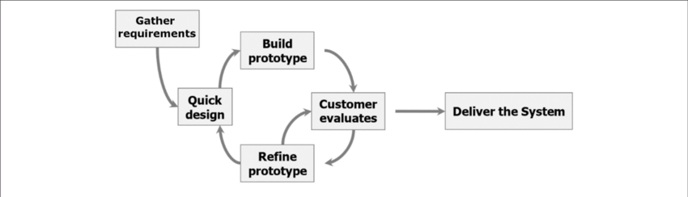

2.5.3 Advantages of the Evolutionary Prototype Model:

- Flexibility & Adaptability: Changes and improvements can be incorporated in each iteration based on testing and user feedback.
- Early Functional Feedback: Users and administrators can evaluate the system early, ensuring features meet real-world requirements.
- Risk Reduction: Potential issues and design flaws are identified and addressed during early prototypes.
- Continuous Testing & Refinement: Each iteration allows testing of network monitoring, packet analysis, and security features, ensuring a stable final system.
- Progressive Enhancement: Features can be gradually improved and expanded without delaying delivery of a working system.

2.5.4 Disadvantages of the Evolutionary Prototype Model:

- Requires Frequent Feedback: Continuous evaluation from administrators is necessary, which may slow development.
- Resource Intensive: Multiple iterations can require more development time and effort compared to a single-pass model.
- Documentation Can Lag: Focus is on evolving functionality, so documentation may need updates alongside prototypes.
- Uncertain Scope at Start: The final system may evolve differently from the initial plan, requiring adaptability from developers.

2.5.5 Alternative Models Considered:

- Waterfall Model
  - Rejected due to its rigid, sequential approach.
  - Not suitable as SecureGate’s requirements evolved during development, especially for testing cybersecurity features.
- Spiral Model
  - Focuses on risk analysis and iterative refinement but is more complex and resource-intensive.
  - The evolutionary prototype model was preferred because it allowed rapid prototyping and progressive refinement with less overhead.

2.5.6 Conclusion:

The Evolutionary Prototype Model proved to be the best fit for SecureGate, supporting iterative development, continuous testing, and gradual refinement. By incorporating feedback from administrators, testing real-time network monitoring, and progressively enhancing features, this model ensured a robust, secure, and user-friendly cybersecurity tool. It allowed SecureGate to evolve effectively, meeting real-world requirements while maintaining flexibility and reliability.

CHAPTER 3
REQUIREMENTS AND ANALYSIS

3.1 Problem Definition:

In the modern digital environment, servers and personal computers face increasing threats from cyberattacks, unauthorized access, and malicious traffic. Traditional security mechanisms, such as static firewalls and manual log monitoring, often fail to provide real-time detection, adaptability, and proactive defense. This creates vulnerabilities for both organizations and individual users.

3.1.1 Key Challenges include:

- Lack of Real-Time Monitoring
Most traditional systems detect threats after they have already caused damage, rather than identifying them in real time.
- Inefficient IP & Request Handling
Manual blocking of suspicious IPs and ports is slow and reactive, leaving systems exposed during critical attack windows.
- Fragmented Logging & Data Management
Security logs are often scattered across different files or systems, making analysis and tracking complex and time-consuming.
- Limited Automation
Existing tools often lack the ability to automatically respond to threats such as repeated suspicious requests, brute-force attempts, or port scanning.
- Poor Usability for Administrators
Security tools can be difficult to configure and monitor, requiring expert knowledge instead of being accessible to all administrators.
- Difficulty in Decision-Making
Without detailed insights into traffic patterns, suspicious activities, and blocked attempts, administrators struggle to make informed security decisions.

3.1.2 Proposed Solution:

To address these challenges, SecureGate – A Cybersecurity Monitoring and Protection Tool has been developed using Python, Scapy, MySQL, and Tkinter.
SecureGate provides:
- Real-time packet sniffing and analysis using Scapy.
- Automated IP blocking/unblocking based on request thresholds and suspicious activity.
- Centralized logging of requests, packets, and blocked IPs in MySQL.
- User-friendly dashboard with Tkinter for monitoring traffic, configuring rules, and managing security.
- Automated alerts and proactive defence mechanisms, reducing reliance on manual intervention.
- Scalable design for both servers and personal systems, ensuring flexibility and adaptability.
By combining automation, real-time monitoring, and user-friendly controls, SecureGate ensures greater efficiency, transparency, and proactive protection against evolving cybersecurity threats.

3.2 Requirement Specification:

The Requirement Specification defines the functional and non-functional requirements essential for the successful development of SecureGate – A Cybersecurity Monitoring and Protection Tool. This section outlines the key requirements in detail.

3.2.1 Functional Requirements:

- User Authentication & Access Control
  - Admins must log in with unique credentials.
  - Authentication handled through hashed passwords (bcrypt).
  - Only authenticated users can configure rules, view logs, or manage blocked IPs.
- Dashboard Management (Tkinter GUI)
  - Admin Dashboard:
    - View real-time traffic logs.
    - Configure request thresholds, allowed ports, and security policies.
    - Manage blocked/unblocked IPs and whitelist/blacklist.
  - Visualization Panels:
    - Display packet details, suspicious activity, and system alerts in a user-friendly format.
- Network Monitoring & Packet Analysis
  - Monitor incoming and outgoing network packets using Scapy.
  - Identify suspicious patterns such as:
    - Excessive requests from a single IP.
    - Malformed packets, port scans, or unusual flags.
  - Log all activity into MySQL for future reference.
- Automated IP Blocking & Unblocking
  - Block IPs exceeding configured request limits.
  - Automatically unblock IPs after a set block duration.
  - Provide manual override for admins to block/unblock IPs.
- Logging & Reporting
  - Maintain structured logs of:
    - Network requests.
    - Blocked IPs and reasons.
    - User actions (admin operations).
  - Support exporting logs into JSON or MySQL reports for further analysis.
- Notification & Alerts
  - Provide real-time alerts on suspicious activity.
  - Email notifications to admins when critical events occur (e.g., repeated intrusion attempts).
- File & System Protection
  - Restrict unauthorized file and uploads to the server.
  - Option to move sensitive files to secure storage (e.g., Google Drive) during attack detection.

3.2.2 Non-Functional Requirements:

- Performance
  - The system should monitor thousands of packets per second without lag.
  - Blocking/unblocking of IPs should happen in real time.
- Scalability
  - SecureGate should work on both small-scale PCs and large servers.
  - Support adding new detection modules and security features in the future.
- Security
  - Passwords must be stored using bcrypt hashing.
  - Only authenticated admins can change configurations.
  - Logs must be protected from tampering.
- Usability
  - The Tkinter dashboard should be intuitive and user-friendly.
  - Visual indicators (colors, alerts) should make monitoring easier for non-expert users.
- Reliability
  - The system must run continuously with minimal downtime.
  - Logs should remain consistent even after crashes or restarts.
3.2.3 Hardware & Software Requirements:
Hardware Requirements:
- Processor: Intel Core i5 or higher.
- RAM: Minimum 8GB.
- Storage: At least 50GB free space (for logs and database).
- Network: Stable internet connection for real-time monitoring and email alerts.
Software Requirements:
- Backend/Core: Python (with Scapy, psutil, bcrypt, mysql-connector).
- Database: MySQL.
- Dashboard/GUI: Tkinter.
- Operating System: Linux/Windows (cross-platform).
- Additional Tools: Email server configuration for alert notifications.

3.3 Planning and Scheduling :

Gantt Chart for SecureGate
A Gantt chart is one of the most popular and useful ways of showing activities (tasks or events) displayed against time. On the left of the chart is a list of the activities, and along the top is a suitable time scale. Each activity is represented by a bar; the position and length of the bar reflect the start and end of the activity.

Gantt Chart for SecureGate – Cybersecurity Tool:-

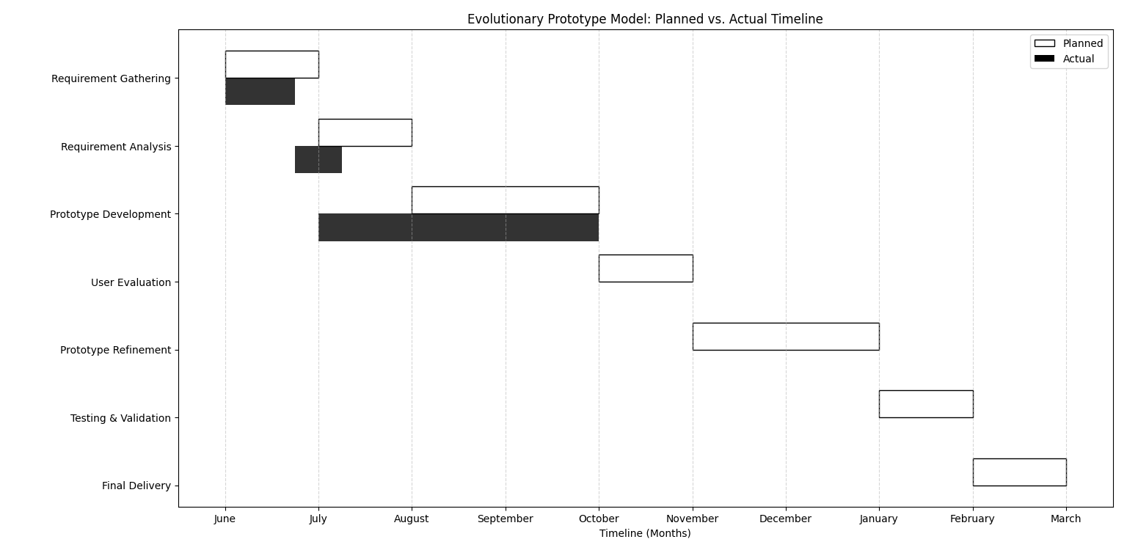

3.4 Preliminary Project Description for SecureGate

3.4.1 Introduction :

SecureGate is a cybersecurity tool designed to protect servers and desktops by monitoring incoming requests, analyzing network packets, and detecting suspicious activity. It provides real-time IP monitoring, automated blocking/unblocking, honeypot diversion, and logging of all activities. SecureGate ensures system safety through proactive defence mechanisms, role-based access, and automated alerts to administrators, making it a reliable solution for server security.
3.4.2 Key Features :
- Efficient Request Monitoring :
Continuously track all incoming requests (IP, port, protocol, timestamp, etc.) in real time.
- Automated IP Blocking & Unblocking :
Automatically block suspicious or limit-exceeding IPs and unblock them after the defined duration.
- Whitelist & Blacklist Management :
Ensure trusted IPs are never blocked, while blacklisted IPs are always denied access.
- Honeypot Diversion :
Divert repeated malicious IPs to a honeypot environment to waste attacker resources.
- Database & Log Management :
Store all activity (requests, suspicious patterns, and blocks) in databases for auditing and analysis.
- Email Alerts & Notifications :
Notify the admin instantly of suspicious or malicious activity.
3.4.3 System Features :
- User Authentication & Role Management :
Secure login system for administrators with access control.
- Admin Dashboard :
Centralized interface for monitoring requests, managing IPs, and reviewing logs.
- Request Monitoring & Analysis :
Captures and analyzes traffic using packet sniffing (Scapy-based).
- IP Blocking & Port Restrictions :
Blocks IPs exceeding limits or performing suspicious actions; restricts access on sensitive ports.
- Honeypot & Diversion Mechanism :
Redirects repeated attackers to a controlled honeypot environment.

  - Conceptual Models :

1. Entity Relationship Diagram :

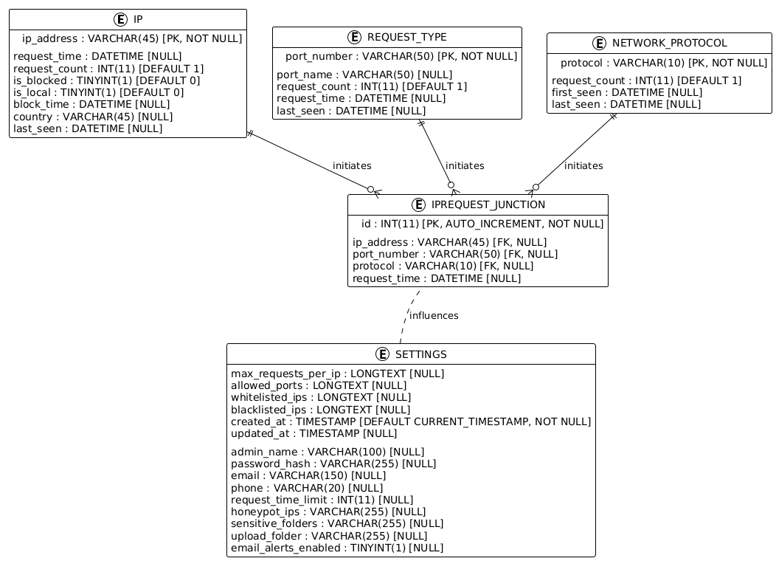

2. Use Case Diagram :

Client Use Case Diagram:

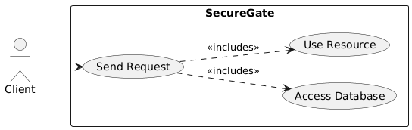

Admin Use Case Diagram:

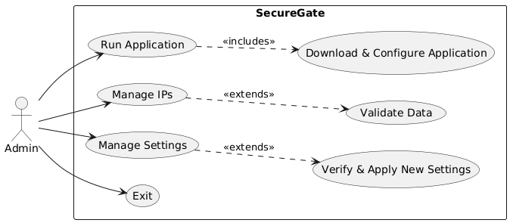

3. Sequence Diagram :

Admin Sequence Diagram:

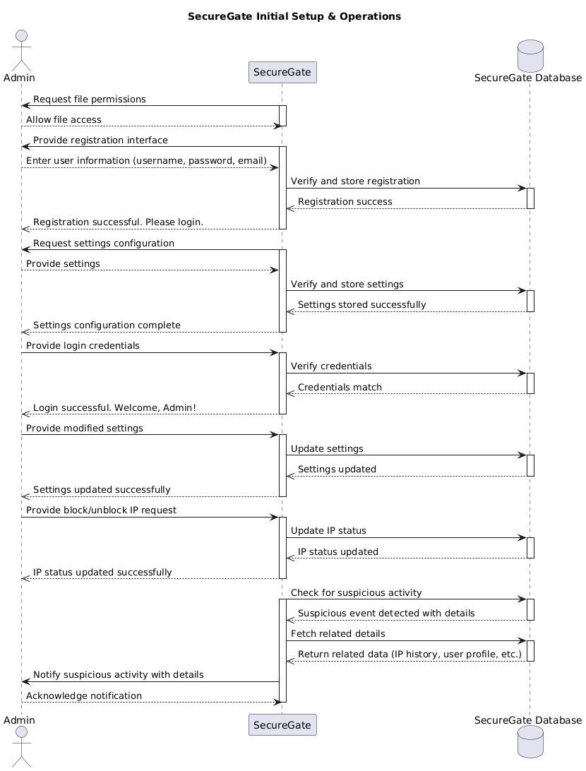

User Sequence Diagram:-

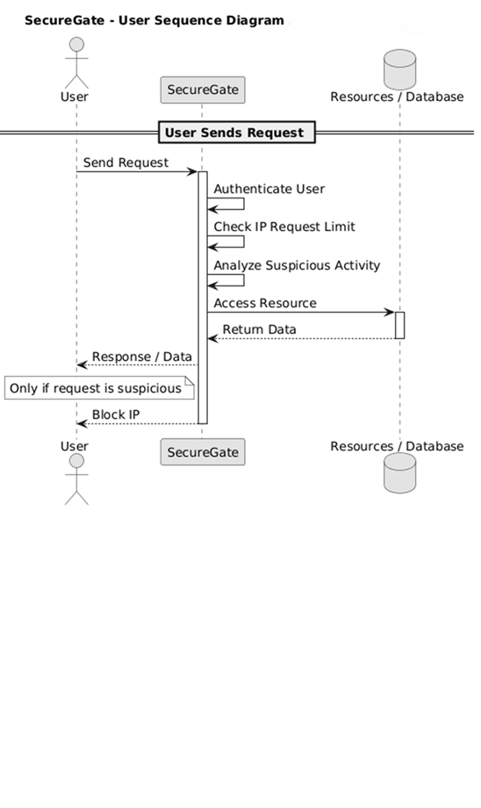

4. Activity Diagram :

Client Activity Diagram:
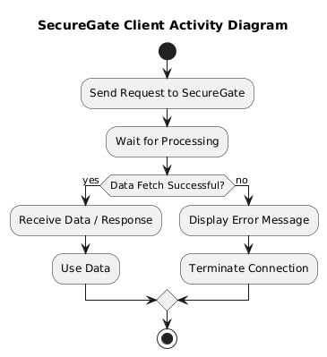

Admin Activity Diagram:-
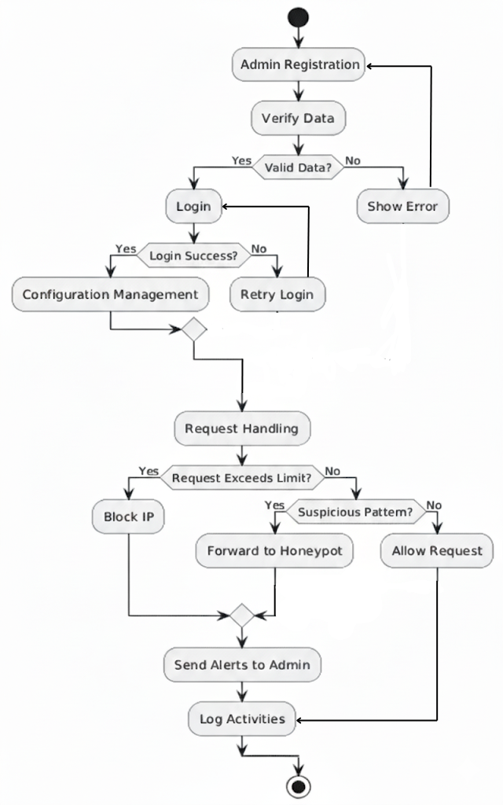

5. Class Diagram:-

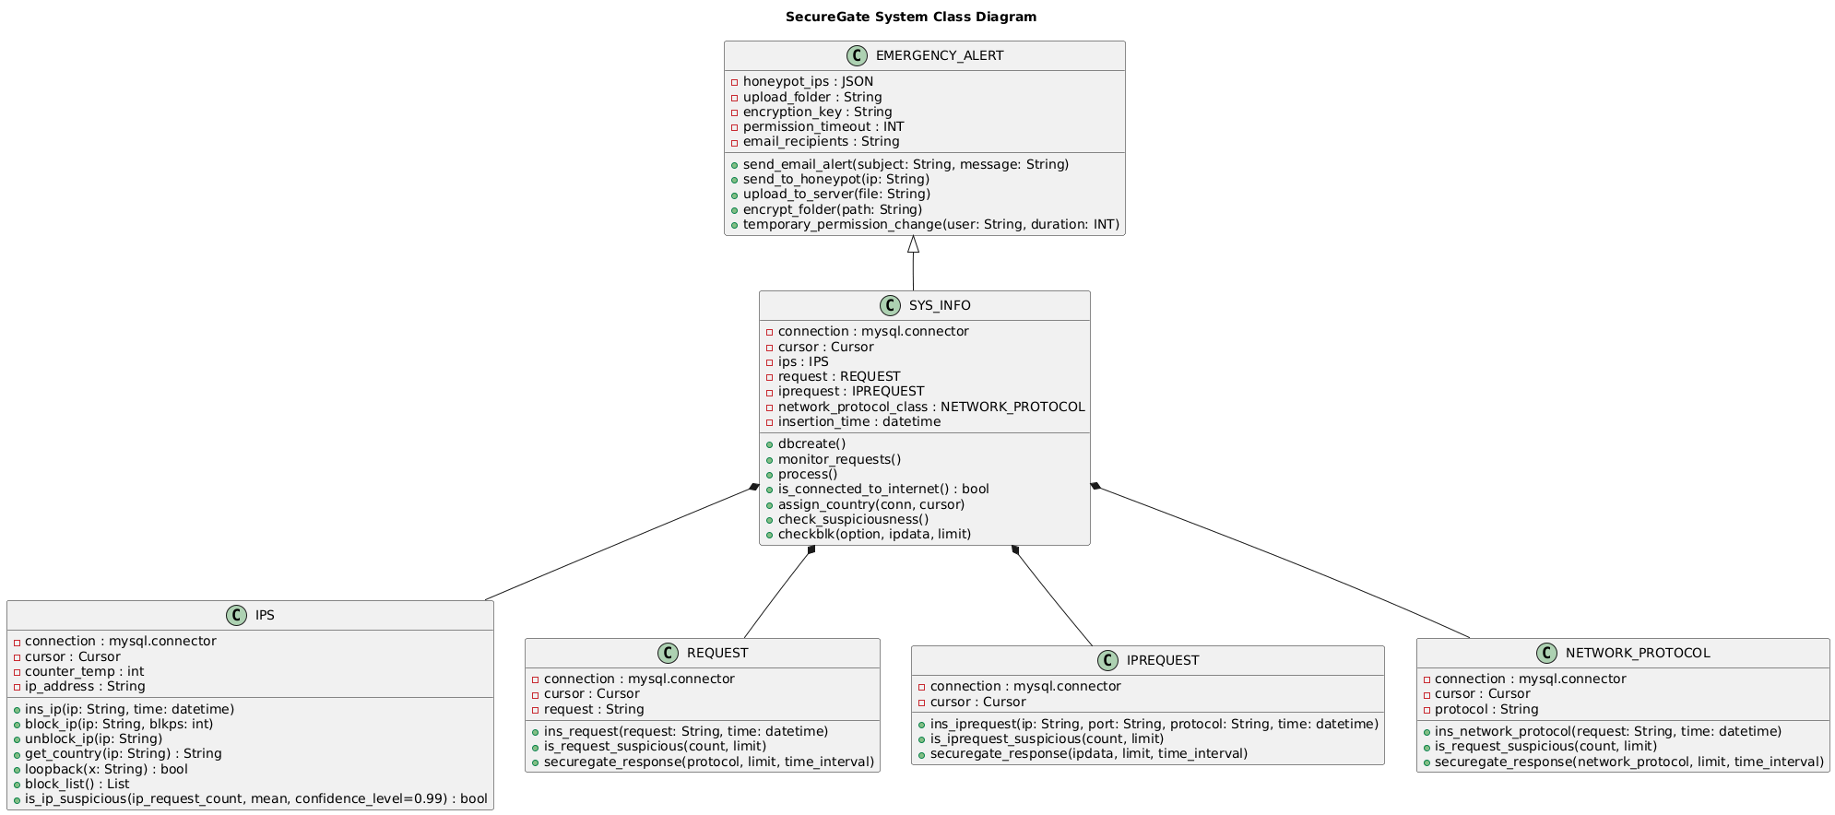

6. Object Diagram:

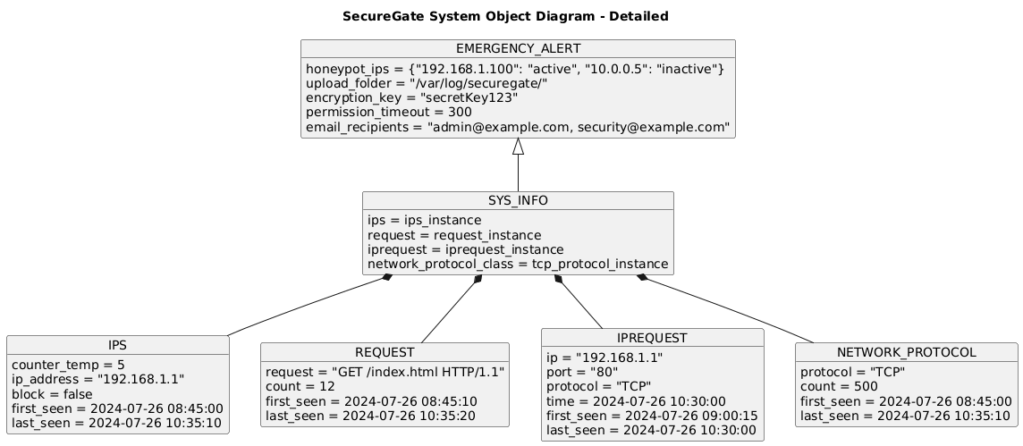

7. Component diagram:

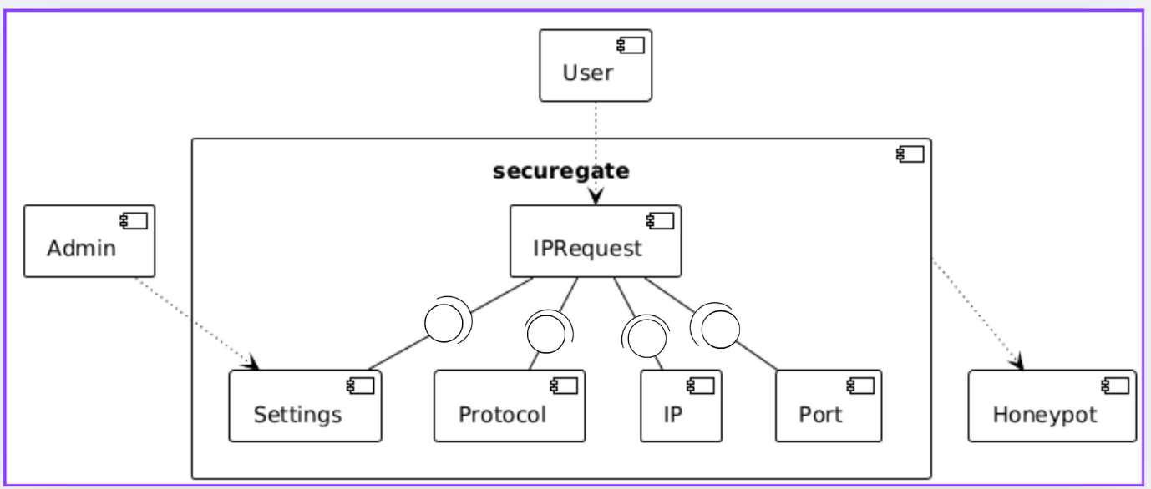

8 .1 Data Flow Diagram(Level 0):

Admin Data Flow Diagram:-

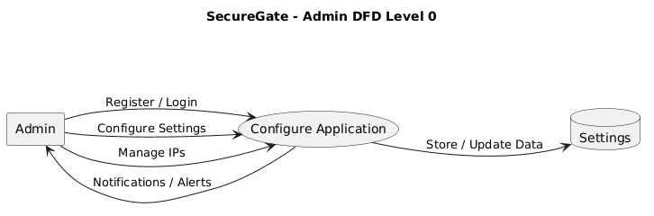

User Data Flow Diagram:

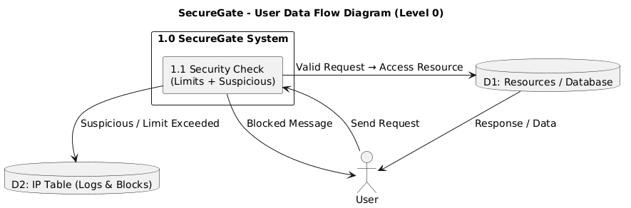

8 .2 Flow Data Diagram(Level 1):

Admin Flow Data Diagram(Level 1):

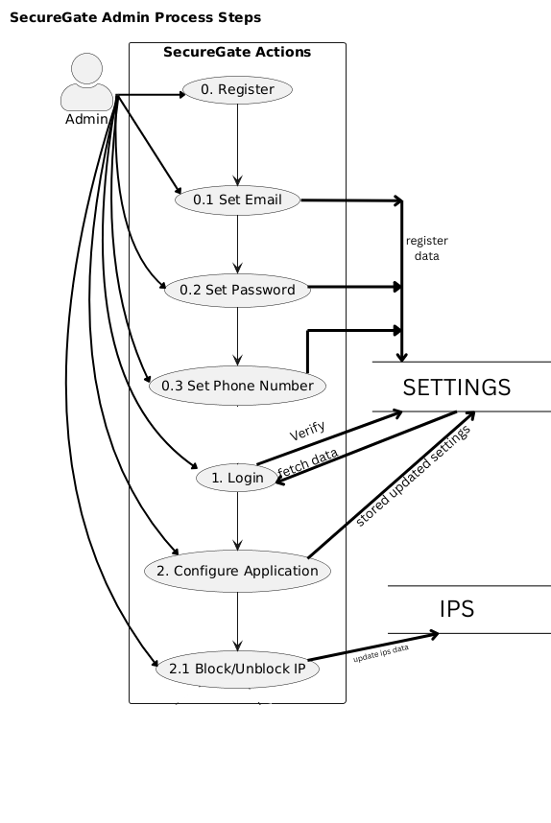

User Flow Data Diagram(Level 1):-

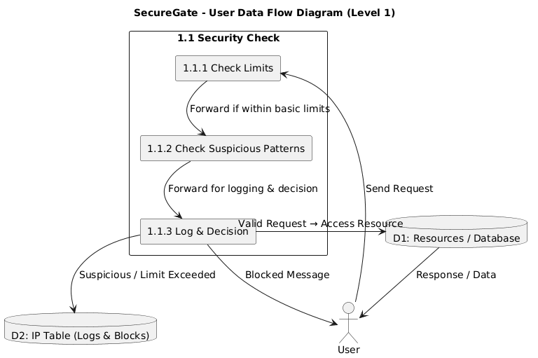

9. State diagram:-

User State diagram:-
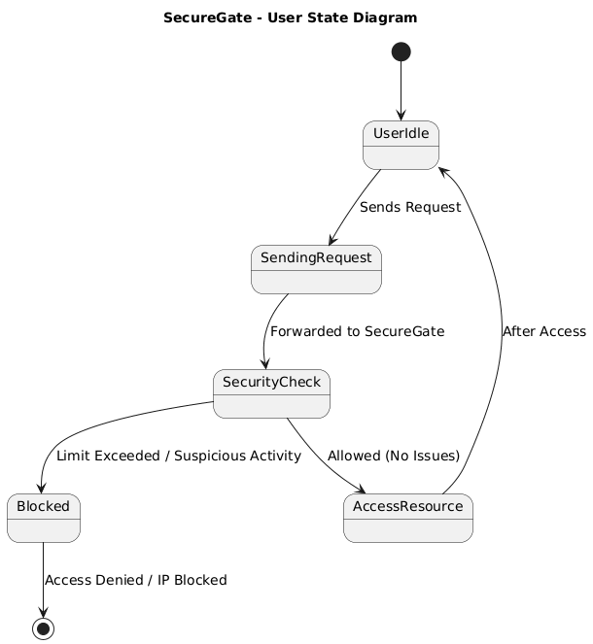

Admin State diagram:-

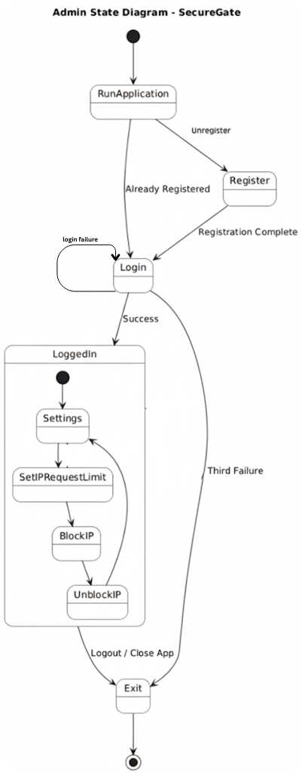

CHAPTER 4
SYSTEM DESIGN

4.1 Basic Modules:

The SecureGate Cybersecurity System is designed to monitor, protect, and secure servers and PCs against suspicious activity. The system is divided into several key modules to ensure security, monitoring, and ease of management.

4.1.1 User Management Module:

- Manages authentication and role-based access for users.
- Users include Admins and Regular Users.
- Admins have full control over system settings, IP blocks, and logs.
- Users can send requests to the server and receive responses, while suspicious activity is monitored.
- Supports secure login and session management to prevent unauthorized access.

4.1.2 Request Monitoring Module:

- Monitors incoming requests to the server in real time.
- Tracks requests per IP, per port, and per hour based on configurable limits.
- Logs all requests with metadata (IP, protocol, payload size, flags, TTL, etc.).
- Detects suspicious patterns or excessive request rates to prevent abuse.

4.1.3 Security & Blocking Module:

- Analyses requests for suspicious activity using predefined rules.
- Automatically blocks IPs that exceed limits or exhibit malicious behavior.
- Sends block notifications to users when an IP is blocked.
- Maintains a whitelist/blacklist for safe and unsafe IPs.
- Integrates honeypot diversion for repeated unauthorized attempts.

4.1.4 Resource & Database Management Module:

- Manages and stores logs, blocked IPs, and system configurations in databases.
- Tracks resource usage for monitoring purposes (e.g., number of requests handled).
- Provides reports on blocked IPs, alerts, and system activity.
- Allows Admins to configure server settings, allowed ports, and alert preferences.

4.1.5 Alert & Notification Module:

- Sends real-time email alerts for suspicious activities or repeated attacks.
- Notifies Admins of system events, blocked IPs, or resource issues.
- Keeps users informed of request responses and block actions.

4.2 Data Design:

The data design for SecureGate focuses on structuring and organizing security-related information efficiently. The database schema is designed to support core functionalities such as user management, request monitoring, IP blocking, system configuration, and alert logging.
To ensure proper data management, normalization techniques are applied to minimize redundancy and maintain consistency. The system follows a well-structured schema where entities like Users, Requests, IP Logs, Blocked IPs, Server Settings, and Alerts are interconnected through primary and foreign keys, ensuring data integrity and smooth retrieval.
The data flow is managed through the application layer, which:
- Processes incoming user requests.
- Validates request information against security rules.
- Logs activity in the database for monitoring and reporting.
Security measures implemented in the data design include:
- Role-Based Access Control (RBAC) to ensure only authorized users can access sensitive data or modify server settings.
- Encryption of sensitive information, such as user credentials and system configurations, to prevent unauthorized access.
- Audit logs to track changes, blocked IPs, and suspicious activity for accountability.
The schema ensures that SecureGate can efficiently monitor requests, block malicious activity, maintain system configuration, and provide accurate reporting to administrators.

4.2.1 Schema Design :-
1) Ip:-
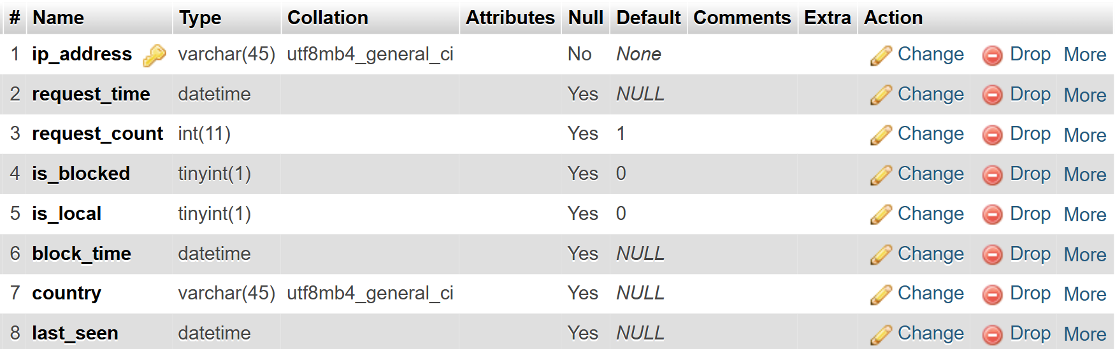

2) Iprequest_junction:-

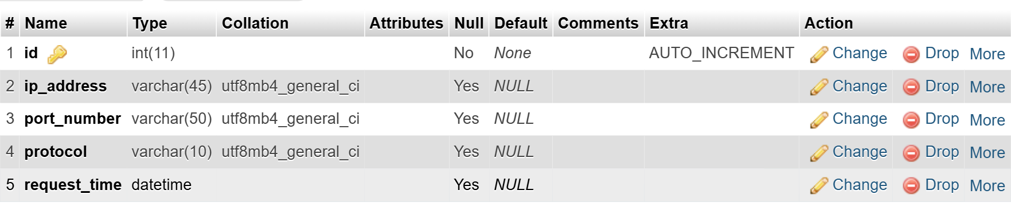

3) Network_protocol:-

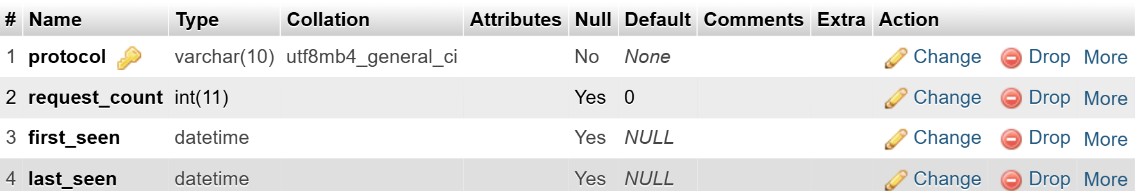

4) Request_type:-
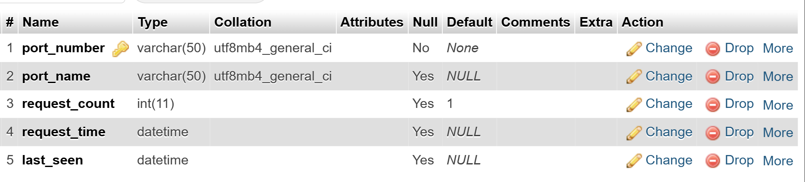
Settings:-

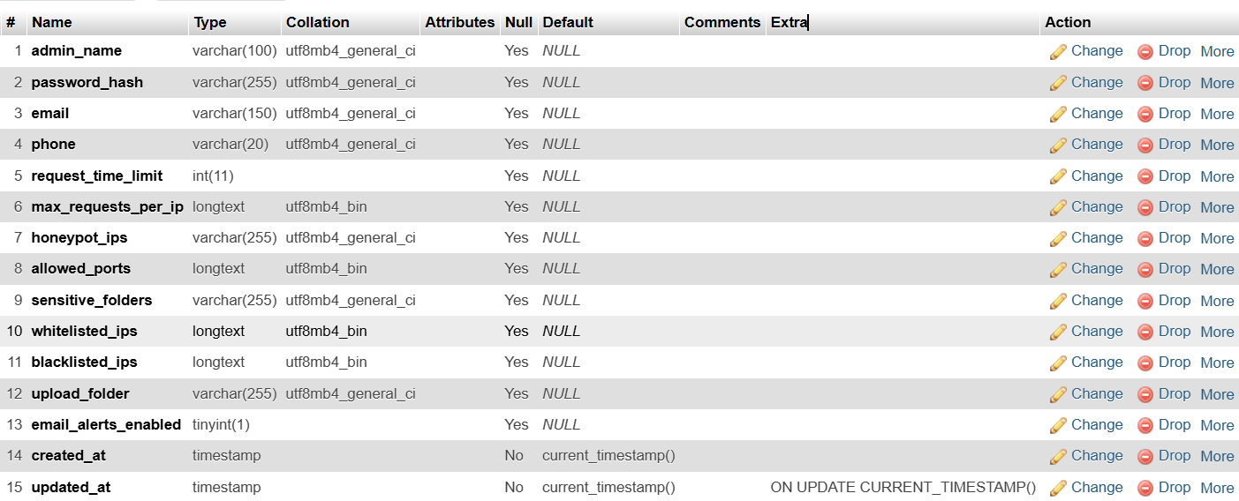

4.2.2 Data Integrity and Constraints:

To ensure the security and reliability of SecureGate, strong data integrity measures and constraints are enforced within the database schema and log management system.
- Primary Keys & Foreign Keys: Applied to IP records, request logs, and user accounts to prevent duplicate or orphaned records.
- Unique Constraints: Enforced on critical fields such as email addresses (for alerts) and IP entries in the whitelist/blacklist to avoid redundancy.
- Check Constraints: Used to validate values, such as ensuring request limits are positive, block duration is non-negative, and ports fall within valid ranges (0–65535).
- Referential Integrity: Maintained across related tables (e.g., blocked IPs referencing request logs) with cascading delete/update actions for consistency.
- Role-Based Access Control (RBAC): Restricts unauthorized users from modifying system settings or altering logs, ensuring that only admins have elevated privileges.
- Transaction Management: Guarantees atomic updates when blocking/unblocking IPs, preventing inconsistencies in logs and IP table entries.
- Audit Trails: Every change to settings, IP lists, or security rules is logged with timestamps and admin details, strengthening accountability.

4.3 Algorithm Design:

The SecureGate Intrusion Detection and Prevention System relies on robust algorithms to monitor traffic, detect suspicious behaviour, block malicious requests, and ensure system stability. These algorithms are designed for efficiency, accuracy, and real-time protection.

4.3.1 Request Monitoring & Logging Algorithm

- Inputs: Incoming Network Packet (Source IP, Port, Protocol, Flags)
- Steps:
  - Capture incoming packet metadata using Scapy.
  - Log packet details (IP, port, protocol, timestamp, payload size) into the request queue.
  - Forward structured data to the MySQL/JSON logs.
  - Increment counters for IP-specific and port-specific requests.
  - Pass data to Security Evaluation Algorithm.
- Output: Logged and classified requests for further analysis.

4.3.2 Security Evaluation Algorithm

- Inputs: IP Request Count, Port Requests, Suspicious Flags (SYN Flood, Abnormal Payloads, Invalid Protocols)
- Steps:
  - Check if request count per IP exceeds configured limit.
  - Detect suspicious behavior (e.g.,port scanning patterns).
  - If suspicious or limit exceeded → Mark IP as malicious.
  - Else, allow normal request flow.
  - Update request status in database (Safe, Suspicious, Blocked).
- Output: Decision whether to allow, monitor, or block request.

4.3.3 IP Blocking & Unblocking Algorithm

- Inputs: Malicious IP, Block Duration Policy
- Steps:
  - Add malicious IP to the blocklist using iptables/firewall rules.
  - Log the block action in MySQL with timestamp and reason.
  - Notify admin via configured email alert.
  - If repeated attempts from the same IP → Increase block duration or divert to honeypot.
- Output: Updated firewall rules and logs for blocked/unblocked IPs.

4.3.4 File Protection & Honeypot Diversion Algorithm:

- Inputs: Unauthorized Access Attempts, Sensitive File Paths
- Steps:
  - Monitor file access requests on the server.
  - If unauthorized user attempts access → Trigger honeypot diversion.
  - Move critical files to secure storage (e.g., Google Drive backup).
  - Redirect attacker to decoy environment with fake files.
  - Log attacker activity for forensic analysis.
- Output: Protected sensitive files and attacker trapped in honeypot.

4.3.5 Alert & Reporting Algorithm:

- Inputs: Blocked IPs, Suspicious Logs, Request Statistics
- Steps:
  - Gather request and block logs from MySQL.
  - Analyze request trends (per IP, per port, per protocol).
  - Generate real-time alerts (email/SMS) for critical incidents.
  - Format security reports with charts (attack patterns, blocked IPs, top protocols).
  - Store reports for admin review and system analytics.
- Output: Real-time alerts and detailed periodic reports.

4.4 User Interface Design :-

Admin Registration:-

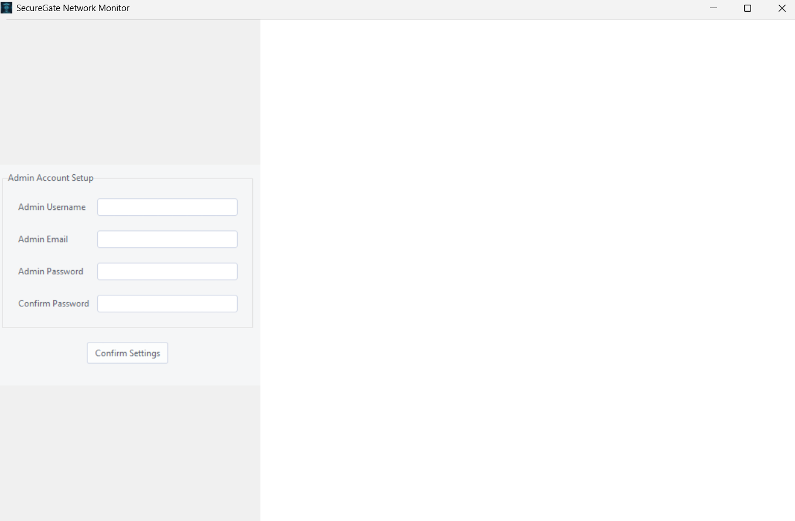

Admin login:-
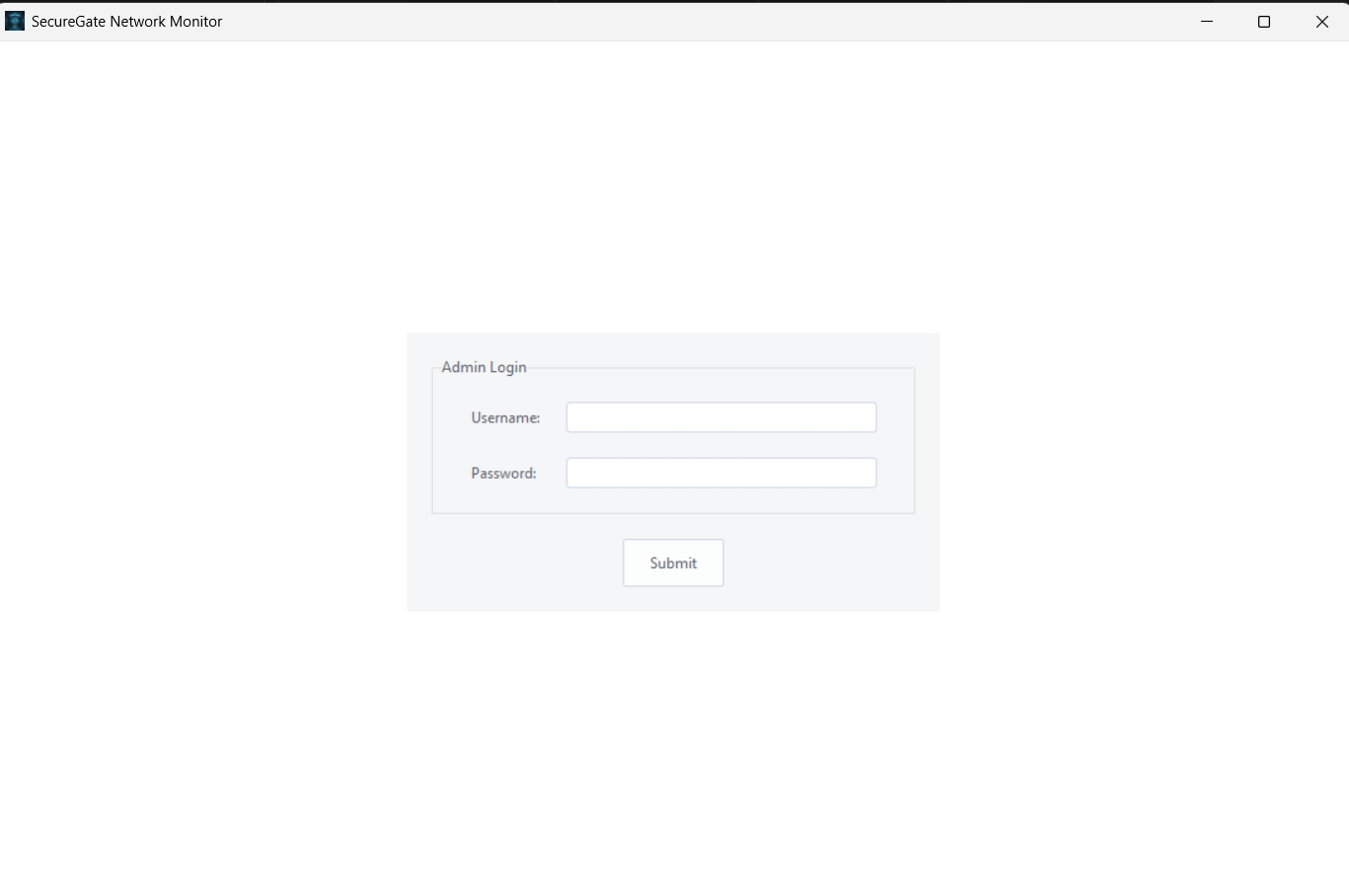

DASHBOARD:-

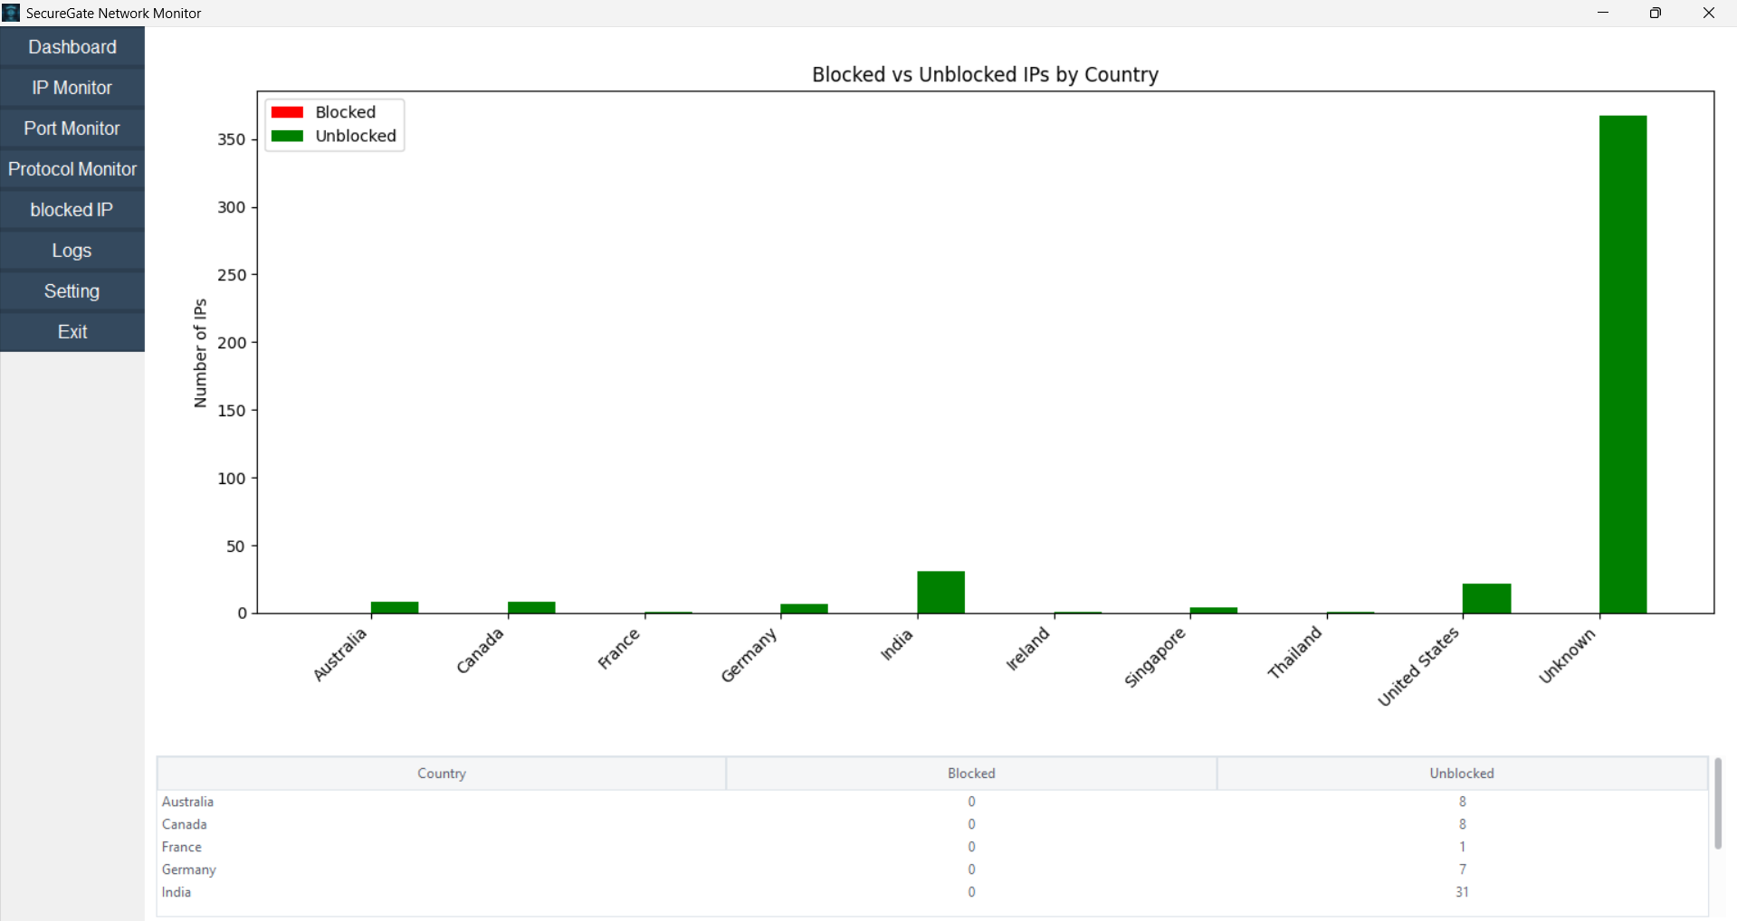

IP MONITOR:-

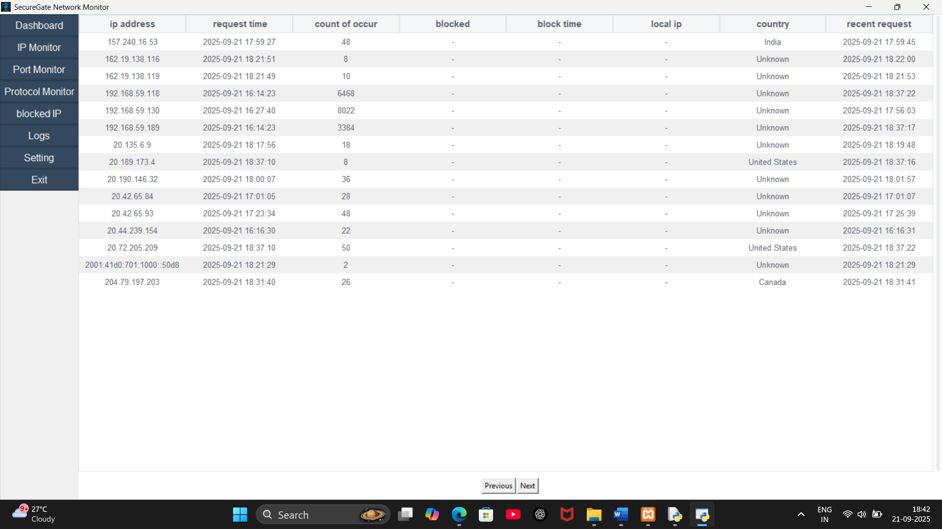

PORT MONITOR:-

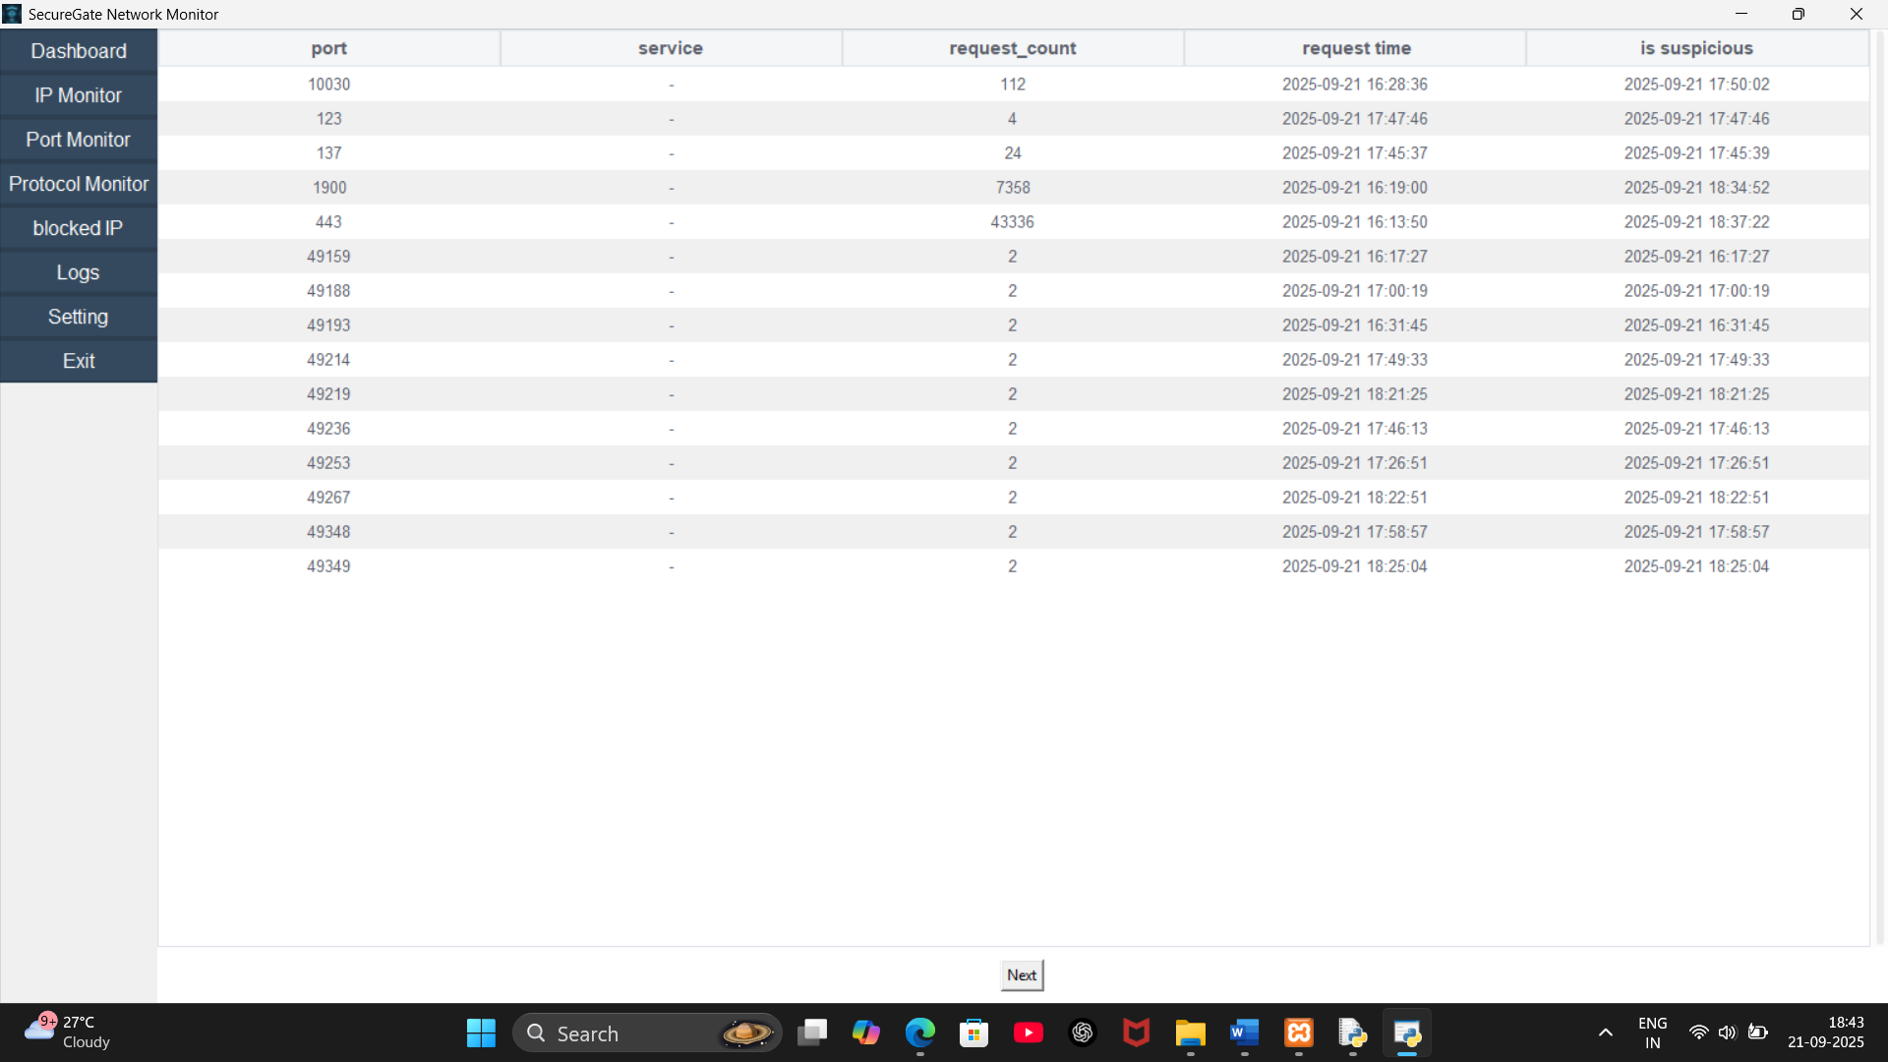

PROTOCOL MONITOR:-

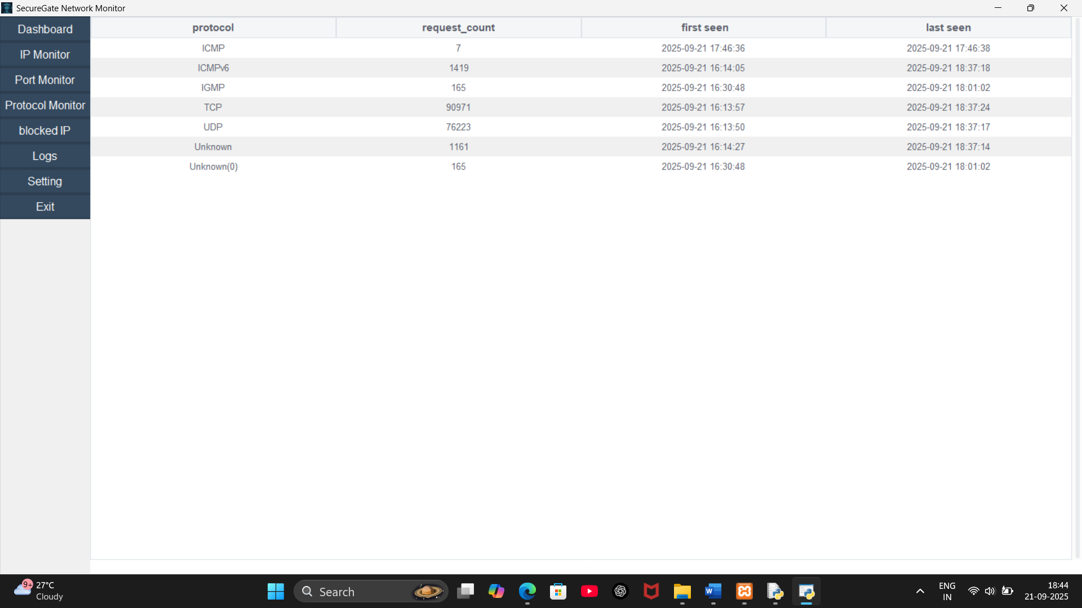

BLOCK IP:-

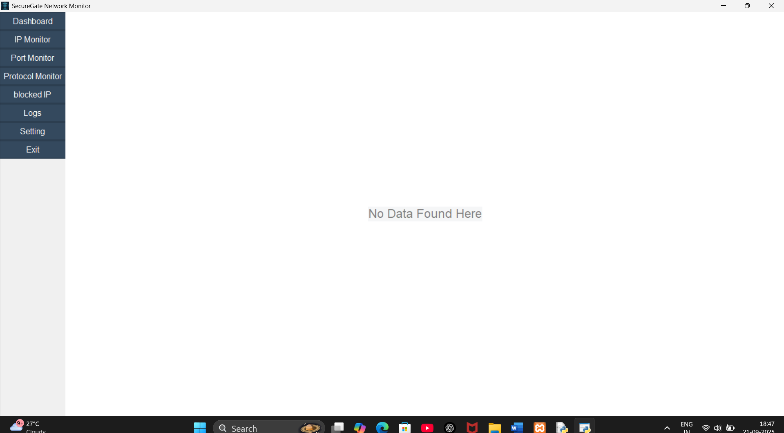

LOGS:-

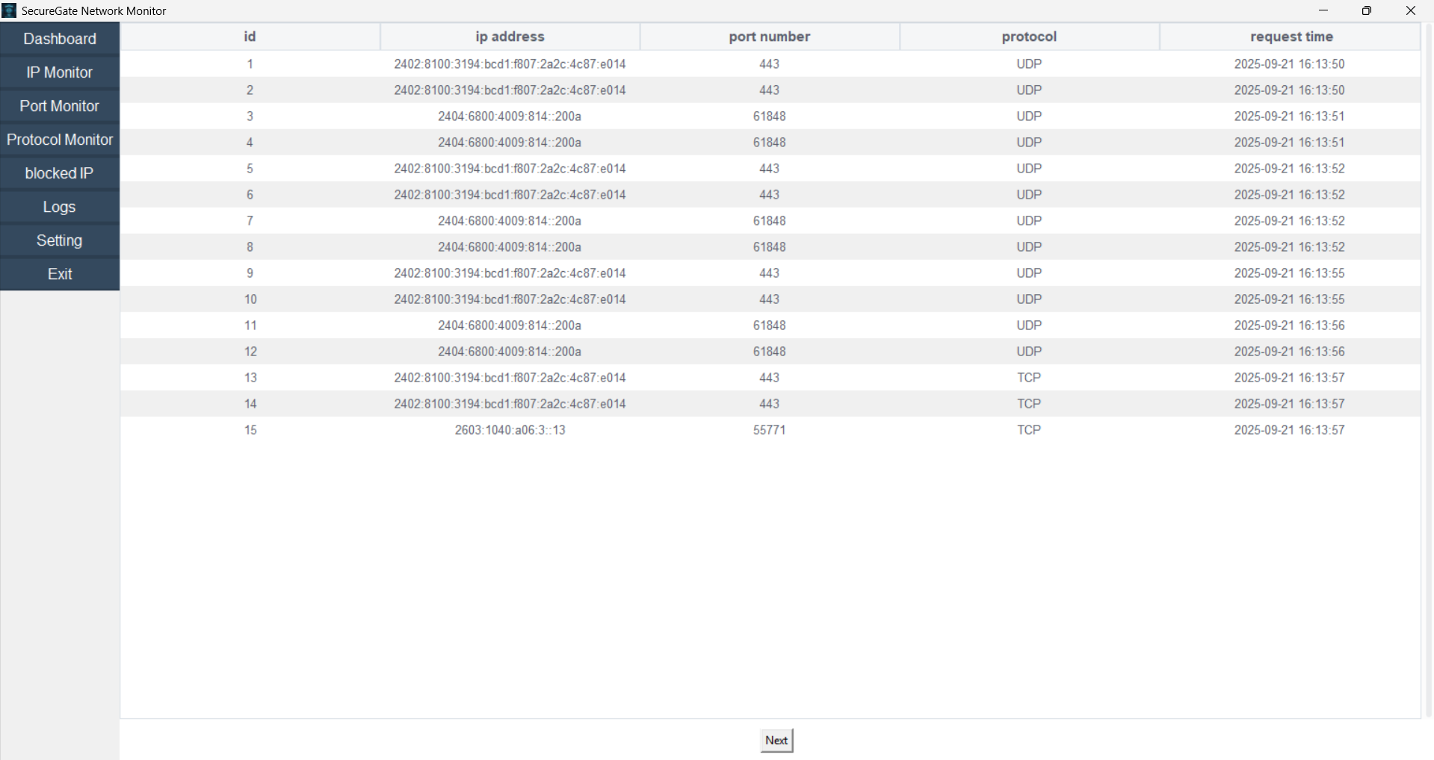

Settings:-

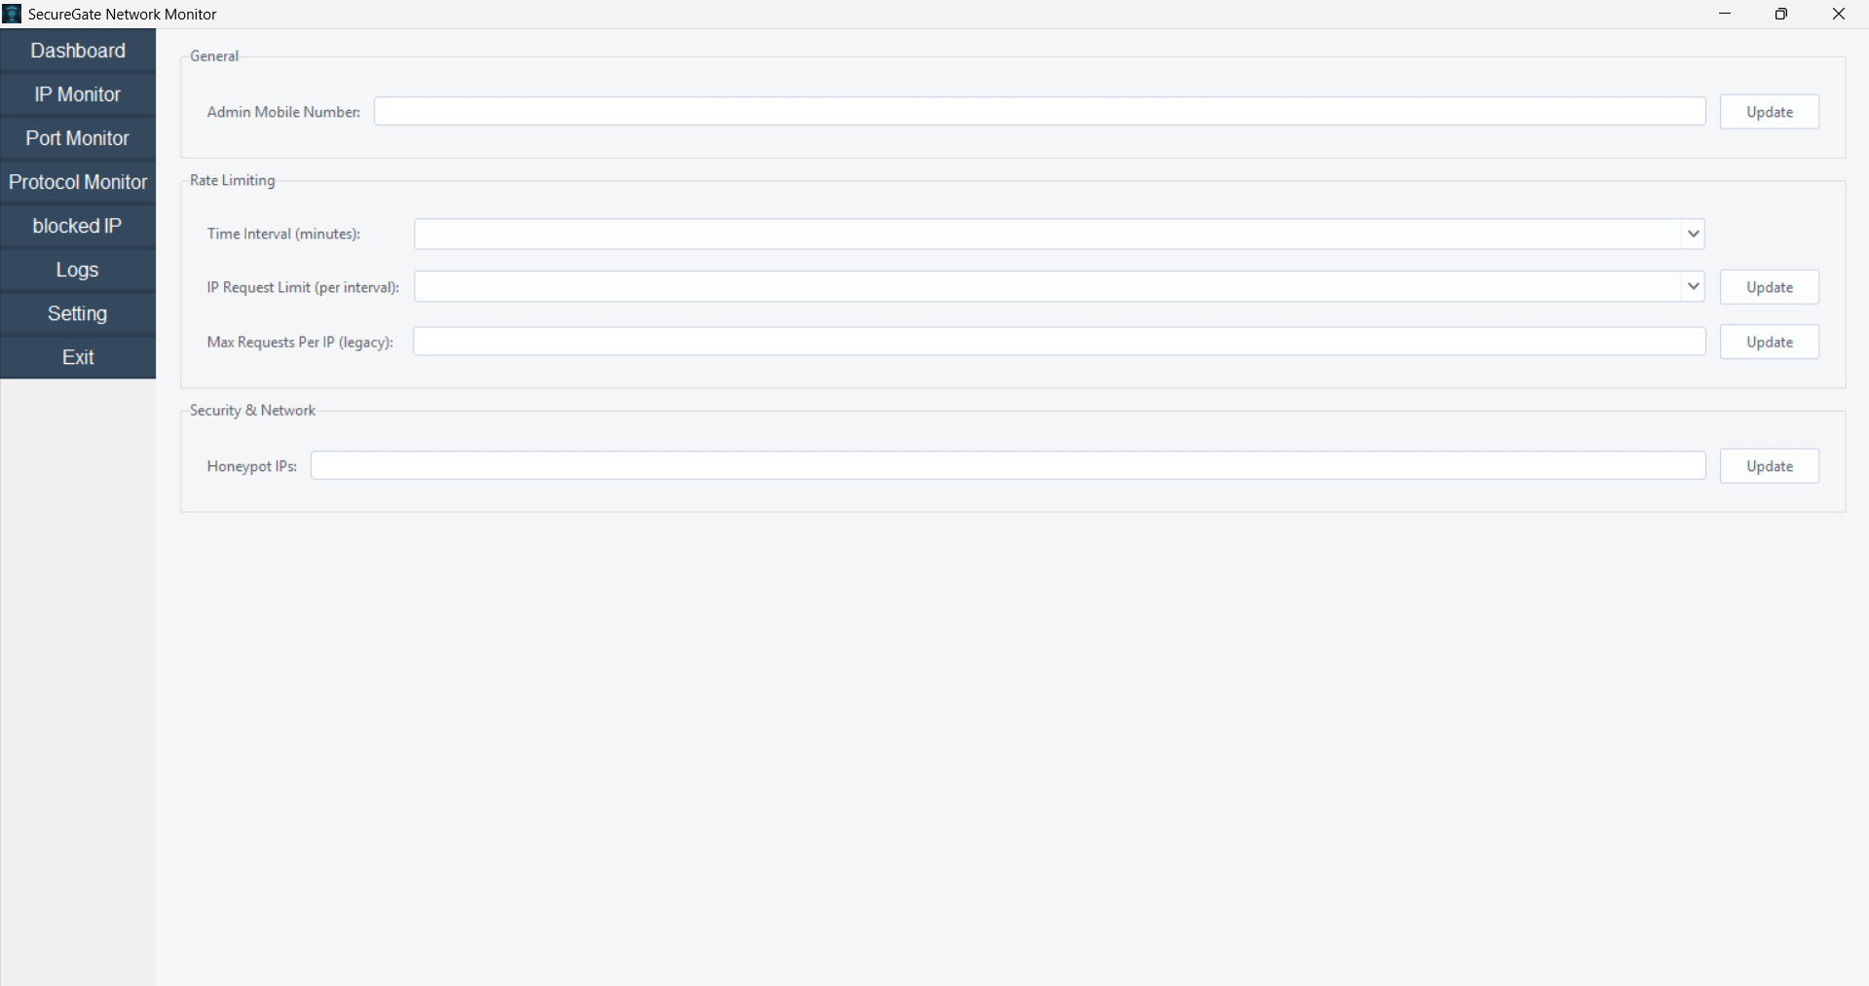

4.5 Security Issues:

SecureGate, being a desktop-based intrusion detection and prevention system (IDPS), must ensure that all collected logs, user configurations, and system resources remain protected against unauthorized access, tampering, or exploitation. The following security measures are applied:

4.5.1 Authentication and Authorization:

- Local Role-Based Access Control (RBAC) to separate Admin users (who configure, block/unblock IPs, manage whitelist/blacklist) from standard operators.
- Enforcing strong password policies for admin access (minimum length, complexity).
- Storing credentials in hashed format (bcrypt) to prevent reverse-engineering even if the local database is accessed.
4.5.2 Data Encryption:

- Password Hashing for Admin Login
The admin’s password is stored in the database in a hashed format (bcrypt) to prevent credential theft and ensure secure authentication.
- Secured Configuration Storage
Sensitive settings like whitelisted IPs, blacklisted IPs, and allowed ports are stored in the database, preventing direct file tampering.
- JSON Log Protection
Log files are protected using file locking mechanisms (via portalocker) to avoid race conditions and unauthorized modifications during runtime.

4.5.3 Secure Session Management

Since SecureGate is a desktop-based security application, traditional session management (as in web applications) is not directly applicable. Instead, the following mechanisms are used to ensure secure operation during runtime:
- Password Protection for Admin Login
The application requires the admin to authenticate at startup using a secure hashed password (bcrypt), ensuring only authorized users can access the system.
- Restricted Access to Critical Modules
Sensitive functions such as IP Blocking, Whitelisting/Blacklisting, and Settings Modification are only accessible after successful admin login.
- Runtime File Protection
Sensitive files such as JSON logs and configuration data are locked during access (using portalocker), preventing simultaneous tampering or unauthorized access while the application is running.
- No Plain-Text Credential Storage
Credentials are never stored in plain text within the application files or configuration; instead, secure hashes are used.
4.5.4 Intrusion Detection and Prevention
- Monitoring all incoming packets through the desktop’s network interface using Scapy.
- Detecting abnormal behaviors such as:
  - Too many requests from one IP (DoS/DDoS attempts).
  - Suspicious port scanning activities.
- Automatically blocking malicious IPs via iptables (Linux) or Windows Firewall rules.
- Diverting repeated attackers into honeypot simulation to waste their resources.

4.5.5 Database Security and Integrity:

- Using local MySQL with strict schema constraints (Primary keys, Foreign keys, Check constraints).
- Preventing duplicate or orphan records in IP logs and requests.
- Restricting direct access to the database — only the SecureGate desktop application can interact with it.

4.5.6 Logging and Audit Trails:

- All incoming requests, blocked IPs, and admin activities are logged into JSON files and the MySQL database.
- Each log entry is stored with a timestamp for tracking and investigation.
- Logs are protected from tampering using file-locking mechanisms.
- Admins can export logs (JSON/DB) for external analysis and reporting.

4.6 Test Case Design :

Test case categories:

i)Functional test case:-

Sr. No. | Test Case ID | Test Case Description | Test Steps | Test Data / Input | Expected Result | Actual Result | Status
1 | AUTH01 | Verify Admin Login with valid credentials | 1. Navigate to the admin login page.  2. Enter a valid admin username. 3. Enter the corresponding valid password. 4. Click 'Login'. | Username: admin; Password: valid_password | Admin is successfully logged in and redirected to the dashboard.
2 | AUTH02 | Verify Admin Login with invalid credentials | 1. Navigate to the admin login page. 2. Enter a valid admin username. 3. Enter an invalid password. 4. Click 'Login'. | Username: admin; Password: invalid_password | Login fails with an error message “Invalid credentials”.
3 | MON01 | Verify that incoming requests are monitored | 1. Send a standard HTTP request to a monitored port. 2. Check the live monitoring dashboard or request logs. | Source IP: 192.168.1.50; Destination Port: 80; Protocol: TCP | All incoming requests are captured with IP, port, protocol, and timestamp.
4 | BLK01 | Verify IP blocking when request limit is exceeded | 1. Configure the request limit to 10 requests per minute. 2. From a single test IP, send 11 requests within 60 seconds. 3. Check blocked IPs. | Request Limit: 10; Test IP: 10.0.0.5; Requests Sent: 11 | The IP 10.0.0.5 is automatically blocked, and an entry is added in the blocked IP list.
5 | BLK02 | Verify automatic unblocking after block duration | 1. Block an IP for 2 minutes. 2. Wait for 2 minutes. 3. Check blocked list. 4. Attempt a new request from the IP. | Blocked IP: 10.0.0.5; Block Duration: 2 minutes | The IP 10.0.0.5 is automatically unblocked after the set time and can make requests again.
6 | LIST01 | Verify that whitelisted IPs are not blocked | 1. Add a test IP to whitelist. 2. Configure a low request limit (e.g., 5). 3. Send more than 5 requests. 4. Check blocked list. | Whitelisted IP: 198.51.100.1; Requests Sent: 10 | The whitelisted IP is never blocked, regardless of request volume.
7 | LIST02 | Verify that blacklisted IPs are always blocked | 1. Add a test IP to blacklist. 2. Send a request from the blacklisted IP. 3. Check if connection is dropped. | Blacklisted IP: 203.0.113.10 | The blacklisted IP is immediately blocked after the first request.
8 | ALRT01 | Verify email alert is sent on suspicious activity | 1. Trigger a suspicious event (exceed request limit). 2. Check configured admin email inbox. | Event: IP block due to high request volume from 10.0.0.5 | Admin receives an email with details (IP, timestamp, type of activity).
9 | LOG01 | Verify that all requests are logged in database | 1. Send several test requests. 2. Query database log table. 3. Verify entries. | Test Requests: 5 HTTP GET requests | All requests are logged in database with correct details.
10 | HPT01 | Verify honeypot diversion for repeated malicious activity | 1. Blacklist an IP. 2. Send multiple requests from it. 3. Check honeypot logs. | Attacker IP: 203.0.113.10; Action: repeated attempts | Requests from attacker IP are redirected to honeypot and logged separately.
11 | BLK03 | Verify blocked IP format (IPv4 and IPv6) | 1. Block an IPv4. 2. Block an IPv6. 3. Verify both are stored and blocked. | IPv4: 192.168.1.10; IPv6: 2001:db8::1 | System correctly stores and blocks IPs in IPv4 & IPv6 formats.
12 | CONF01 | Verify file upload location setting | 1. In settings, define upload directory. 2. Upload a test file. 3. Check file system. | Upload Dir: C:\secure_uploads; Test File: test.txt | Uploaded files are saved only in the defined directory.
13 | CONF02 | Verify email format validation in settings | 1. Go to email alert settings. 2. Save invalid email. 3. Save valid email. | Invalid: admin@domain; Valid: admin@domain.com | Error shown for invalid email, valid email saved successfully.
14 | CONF03 | Verify request per IP setting | 1. Set request per IP limit to 20. 2. Send 21 requests from one IP. 3. Check block list. | Limit: 20; Test IP: 10.0.0.6; Requests: 21 | When limit exceeded, the IP is blocked.
15 | CONF04 | Verify request per port setting | 1. Set request per port limit (e.g., 443 = 15). 2. Send 16 requests. 3. Check block list. | Port: 443; Limit: 15; Requests: 16 | When requests to port exceed limit, the IP is blocked.
16 | PROT01 | Verify sensitive folder protection | 1. Define folder as sensitive. 2. Access/modify file. 3. Check Google Drive backup + alert. | Folder: C:\config_files | Files are moved to Google Drive and an alert is triggered.
17 | MON02 | Verify country lookup for suspicious IPs | 1. Trigger alert from external IP. 2. View log details in admin panel. | Suspicious IP: 8.8.8.8 | Geolocation is fetched and displayed (e.g., United States).
18 | LOG02 | Verify logging format consistency | 1. Generate logs (request, block, alert). 2. Export to JSON. 3. Inspect structure. | Events: request, block, folder access | All logs (DB + JSON) include IP, protocol, port, timestamp, activity type consistently.
19 | LOG03 | Verify export logs feature | 1. Navigate to logs page. 2. Export JSON & CSV. 3. Compare with database. | Action: export last 24h logs | Admin can export logs; data matches DB.
20 | BLK04 | Verify blocked IP persistence | 1. Block an IP. 2. Restart service. 3. Check blocked list. | Blocked IP: 10.1.1.2 | IP remains blocked until duration ends or admin unblocks.
21 | ALRT02 | Verify email alert contains valid details | 1. Trigger alert. 2. Inspect email received. | IP: 8.8.8.8; Attack: brute force | Email includes IP, country, timestamp, type of attack.
22 | CONF05 | Verify settings save functionality | 1. Change a setting (limit 100 → 50). 2. Save. 3. Refresh. 4. Trigger condition. | Old: 100; New: 50 | Changes saved and applied immediately.
23 | SYS01 | Verify system startup monitoring | 1. Configure service auto-start. 2. Reboot server. 3. Send test request. 4. Check logs. | Action: Reboot; Test: HTTP request | SecureGate auto-starts monitoring when system boots.

II)Performance Test Case:-
Sr. No. | Test Case ID | Test Case Description | Test Steps | Test Data / Input | Expected Result | Actual Result | Status
1 | PERF01 | Verify system performance under high request volume | 1. Send maximum configured requests per second to SecureGate.2. Monitor system response and stability. | Max requests/sec: as configured | SecureGate handles maximum requests without crashing or delay.
2 | PERF02 | Verify response time for processing a single user request | 1. Send a single user request.2. Measure processing and logging time. | Request type: HTTP GET/POST | Each request is processed and logged within defined response time (e.g., < 2 sec).
3 | PERF03 | Verify system behavior when multiple IPs send requests simultaneously | 1. Simulate multiple IPs sending requests at the same time.2. Monitor system concurrency handling. | Number of IPs: 50–100; Requests per IP: 5–10 | Requests are handled concurrently without bottlenecks or resource exhaustion.
4 | PERF04 | Verify blocking/unblocking performance under heavy load | 1. Send requests to exceed IP limits.2. Monitor block/unblock timing. | Test IPs: multiple; Requests: exceed limits | IPs are blocked/unblocked within expected time even during high traffic.
5 | PERF05 | Verify database performance with continuous logging | 1. Continuously send requests for 30–60 min.2. Query database for log consistency. | Requests: continuous; Duration: 30–60 min | Request logs are inserted without data loss or significant delay.
6 | PERF06 | Verify system stability during long continuous monitoring sessions | 1. Run SecureGate monitoring for extended period (24–48 hrs).2. Monitor system for crashes or memory leaks. | Duration: 24–48 hrs | SecureGate runs continuously without crashes or memory leaks.
7 | PERF07 | Verify CPU utilization during peak traffic | 1. Generate high request traffic.2. Monitor CPU usage. | Requests: max configured per second | CPU usage remains within acceptable limits without impacting system stability.
8 | PERF08 | Verify memory utilization during continuous request monitoring | 1. Send continuous requests.2. Monitor memory usage over time. | Requests: continuous | Memory consumption stays within limits and does not cause slowdowns.
10 | PERF10 | Verify network throughput | 1. Send high volume traffic.2. Monitor packet handling. | Requests/sec: max | SecureGate handles network traffic efficiently without packet loss.
11 | PERF11 | Verify disk I/O performance during logging and file operations | 1. Perform logging and file move operations under load.2. Monitor disk performance. | File operations: logging, backups | Disk operations do not slow down request processing.
12 | PERF12 | Verify concurrent file upload handling | 1. Upload multiple allowed files simultaneously.2. Monitor system behavior. | File count: multiple; Size: as configured | Multiple users can upload files simultaneously without errors or delays.
13 | PERF13 | Verify alerting and logging under sustained high load | 1. Generate continuous high request volume.2. Monitor alerts and logs. | Requests: high continuous load | Alerts and logs are generated correctly even under sustained high load.

III)Security Test Case:-
Sr. No. | Test Case ID | Test Case Description | Test Steps | Test Data / Input | Expected Result | Actual Result | Status
1 | SEC01 | Verify login with valid credentials | 1. Navigate to login page.2. Enter valid admin username and password.3. Click 'Login'. | Username: admin; Password: valid_password | User (Admin) is successfully logged in and session is created securely.
2 | SEC02 | Verify login with invalid credentials | 1. Navigate to login page.2. Enter valid username and invalid password.3. Click 'Login'. | Username: admin; Password: invalid_password | Login is denied and an error message is displayed without revealing sensitive info.
3 | SEC03 | Verify password encryption in database | 1. Check database for stored password hashes.2. Compare with plain text. | User credentials: admin | Passwords are stored in encrypted/hashed form, not in plain text.
4 | SEC04 | Verify session timeout after inactivity | 1. Log in as Admin.2. Remain idle for configured timeout period.3. Attempt any action. | Timeout: e.g., 15 min | User is automatically logged out after defined idle time.
5 | SEC05 | Verify protection against SQL Injection in login fields | 1. Attempt SQL injection in username/password fields.2. Submit login form.3. Monitor system response. | Payloads: typical SQL injection strings | System rejects malicious SQL queries and logs the attempt.
6 | SEC06 | Verify that whitelisted IPs cannot be spoofed | 1. Send requests with forged whitelisted IPs.2. Monitor system behavior. | Whitelisted IPs: 198.51.100.1 (forged) | Requests with forged whitelisted IPs are detected and blocked.
7 | SEC07 | Verify that blocked/blacklisted IPs cannot regain access | 1. Block or blacklist an IP.2. Attempt to send requests from that IP. | Blocked IP: 203.0.113.10 | Requests from blocked IPs are consistently rejected.
8 | SEC08 | Verify data integrity during request logging | 1. Attempt to modify logged request data directly in DB.2. Check for access control enforcement. | Logs: request database | Logged request data cannot be altered without proper admin privileges.
9 | SEC09 | Verify access control for different roles (Admin/User) | 1. Log in as Admin and User.2. Attempt sensitive operations (block/unblock IPs, access logs, change settings). | Roles: Admin, User | Only Admin can configure settings, block/unblock IPs, and access sensitive logs.
10 | SEC10 | Verify email alerts are securely transmitted | 1. Trigger suspicious activity.2. Capture email transmission (if possible). | Event: IP block, suspicious request | Alerts are encrypted (e.g., TLS) and reach only the registered admin email.
11 | SEC11 | Verify honeypot cannot be detected by attacker | 1. Send repeated malicious requests.2. Attempt to fingerprint honeypot behavior. | Attacker IP: test IP | Attacker cannot differentiate honeypot from the real system.
12 | SEC12 | Verify system against brute force login attempts | 1. Attempt multiple failed logins from same IP.2. Monitor system response. | Username: admin; Password: wrong_password repeated | Multiple failed login attempts trigger account lockout or IP block.

IV)Usability:-
Sr. No. | Test Case ID | Test Case Description | Test Steps | Test Data / Input | Expected Result | Actual Result | Status
1 | USR01 | Verify ease of installation | 1. Run SecureGate installer.2. Follow installation steps.3. Verify installation completes without errors. | Installation package | User can install SecureGate without errors or manual dependency resolution.
2 | USR02 | Verify initial configuration wizard | 1. Launch SecureGate for the first time.2. Complete configuration wizard (set request limits, allowed ports, alert emails). | Initial setup values | User can set request limits, allowed ports, and alert emails easily on first launch.
3 | USR03 | Verify dashboard readability | 1. Open Dashboard.2. Observe display of real-time requests, IPs, alerts. | N/A | Users can view real-time requests, IPs, and alerts in an organized and intuitive manner.
4 | USR04 | Verify navigation between modules | 1. Navigate between Dashboard, Settings, Logs, Whitelist/Blacklist.2. Verify functionality and responsiveness. | N/A | Users can switch between modules easily.
5 | USR05 | Verify adding/removing IPs to/from whitelist | 1. Add test IP to whitelist.2. Remove IP from whitelist.3. Check system response. | Test IP: 198.51.100.1 | Users can manage whitelisted IPs easily, and changes reflect immediately.
6 | USR06 | Verify adding/removing IPs to/from blacklist | 1. Add test IP to blacklist.2. Remove IP from blacklist.3. Check system response. | Test IP: 203.0.113.10 | Users can manage blacklisted IPs easily, and changes reflect immediately.
7 | USR07 | Verify modifying request limits | 1. Update IP and total request limits.2. Save and apply changes.3. Verify effect on request handling. | New request limits | Users can update IP and total request limits, and changes take effect immediately.
8 | USR08 | Verify configuring allowed ports/services | 1. Add or remove allowed ports/services in settings.2. Save and test. | Ports/Services: e.g., 80, 443 | Users can add or remove ports/services easily without confusion.
9 | USR09 | Verify system alerts and notifications | 1. Trigger block or suspicious activity.2. Observe visual and email notifications. | Event: IP block | Users receive clear visual/email notifications for blocked IPs or events.
10 | USR10 | Verify accessing logs | 1. Open log module.2. Filter and view logs in JSON/MySQL format. | Log type: request/block/alert | Users can open, filter, and read JSON/MySQL logs without confusion.
11 | USR11 | Verify UI responsiveness | 1. Use SecureGate interface on different platforms and screen sizes.2. Perform actions like navigation, settings, logging. | Platforms: Windows/Linux; Screen sizes: multiple | SecureGate interface works smoothly across platforms and screen sizes.
12 | USR12 | Verify error messages for invalid actions | 1. Perform invalid actions (e.g., invalid email, exceed request limit).2. Observe displayed messages. | Invalid inputs | Users get clear, understandable error messages without technical jargon.

V)Compatibility:-

Sr. No. | Test Case  ID | Test Case Description | Test Steps | Test Data / Input | Expected Result | Actual Result | Status
1 | COMP01 | Verify SecureGate installation on Windows | 1. Run installer on Windows.  2. Complete installation.  3. Launch SecureGate. | OS: Windows 10/11 | SecureGate installs and launches without errors.
2 | COMP02 | Verify SecureGate installation on Linux | 1. Run installer on Linux. 2. Complete installation. 3. Launch SecureGate. | OS: Ubuntu 22.04/Debian 12 | SecureGate installs and launches without errors.
3 | COMP03 | Verify dashboard display on different screen resolutions | 1. Open SecureGate dashboard. 2. Change screen resolution. 3. Observe layout. | Resolutions: 1024x768, 1920x1080, 2560x1440 | Dashboard adapts correctly; no elements overlap or break.
4 | COMP04 | Verify system behavior on multiple platforms | 1. Launch SecureGate on Windows and Linux. 2. Perform basic operations (block IP, view logs). | Platforms: Windows, Linux | SecureGate functions correctly on all tested platforms.

