**Introduction**

Karan Hayer

My excel program allows the user to import data from the access file, allows for a list of courses to be generated. It also allows creates a word report which reports grade of all the students listed. All of these features are created with individual subroutines which are called when they are chosen in the user form. These subroutines allow for more compact and efficient code when they are called. This also allows the subroutines to be used in multiple parts of the user form and just require a call.

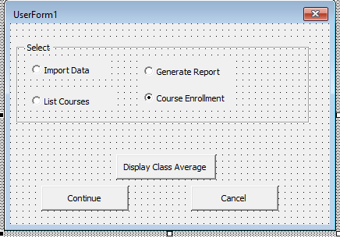

This is the user form that the user sees and makes their decision on what they would like to do with the data.

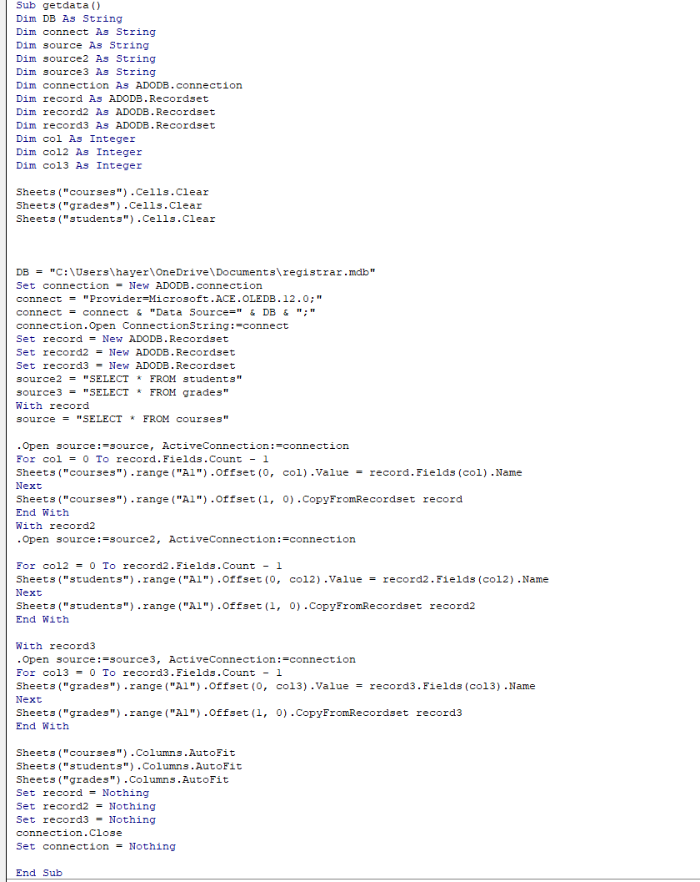

This is the getdata subroutine which is used in the import data function. The import data function takes all the information in the access sheet and puts it into the cells in excel. The information is separated into sheets based upon the type of information it is and where it was stored in access. This function is very useful because it allows the rest of the functions to do their job and use the information in the excel sheet. Without this import, the other function would have no data to use and thus would be useless. This function also uses an autofit to ensure that all of the information looks neat and tidy.