1. Design a slot based timetable for summer semester in VIT University using HTML.

Slot based Time Table – Summer 2014- 15 Semester

|  |  |  |  |  |  |
| --- | --- | --- | --- | --- | --- |
|  | 8.30 – 10.10 | 10.30 – 12.10 | 12.10-1.30 | 1.30-3.10 | 3.30- 5.10 |
| Mon | A | B | Lunch | C | D |
| Tue | B | A | D | C |
| Wed | A | B | C | D |
| Thu | B | A | D | C |
| Fri | TA | TB | TC | TD |

1. Design the following using HTML frames. The content should be for VIT University containing multiple schools and link for each school should contain information about programmes, faculty specialization and photo gallery.

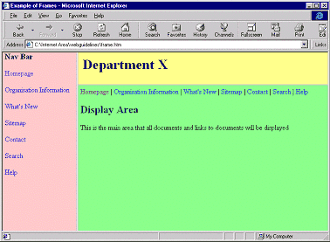

1. Design a HTML form as given below

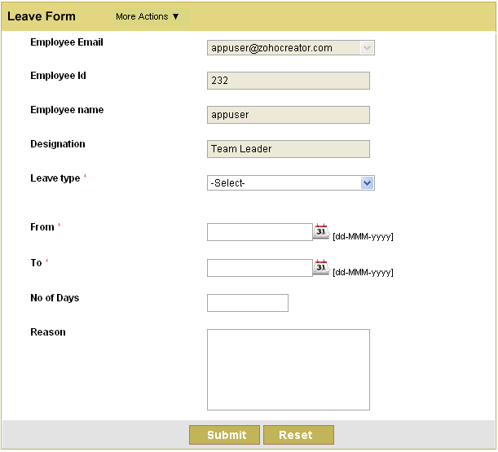

1. Design a HTML form 