Assignment 1 on Processes

1. The critical section in this program is the following line of code -
if (childpid = fork()){
break;
}
2. This code is responsible for the creation of the child process and at the same time, termination of the loop for the parent process. Therefore a chain is created where the parent can only create one child process.
Process ID: 3931
Parent ID: 3930
Child ID: 3932
Process ID: 3930
Parent ID: 2999
Child ID: 3931
Process ID: 3932
Parent ID: 1508
Child ID: 3933
Process ID: 3933
Parent ID: 1508
Child ID: 0
3

4.
#include <stdio.h>
#include <stdlib.h>
#include <unistd.h>

int main(int argc, char *argv[]) {

pid_t childpid = 0;
int i, n;
n = atoi(argv[1]);
for(i = 1;i < n; i++){
if(childpid = fork()){
break;
}
}
int k = atoi(argv[2]), m = atoi(argv[3]);
for(int j = 0;j < k; j++){

fprintf(stderr, "i: %d process ID: %ld parent ID:%ld child ID: %ld\n", i, (long)getpid(), (long)getppid(), (long)childpid);
sleep(m);
}
return 0;
}
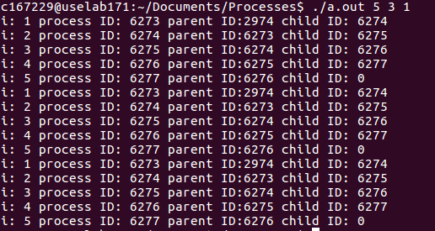
5.
#include <stdio.h>
#include <stdlib.h>
#include <unistd.h>
#include <sys/wait.h>

int main(int argc, char *argv[]) {

pid_t childpid = 0;
int i, n;
if (argc != 2) {
fprintf(stderr, "Usage: %s processes\n", argv[0]);
return 1;
}
n = atoi(argv[1]);
for(i = 1;i < n; i++){
if(childpid = fork()){
break;
}
}
wait(NULL);
fprintf(stderr, "i: %d process ID: %ld parent ID:%ld child ID: %ld\n", i, (long)getpid(), (long)getppid(), (long)childpid);

return 0;

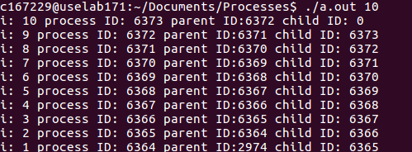
}

6. #include <stdio.h>
#include <stdlib.h>
#include <unistd.h>
#include <sys/wait.h>

int main(int argc, char *argv[]) {

pid_t childpid = 0;
int i, n;
/*
if (argc != 2) {
fprintf(stderr, "Usage: %s processes\n", argv[0]);
return 1;
}
*/
n = atoi(argv[1]);
for(i = 1;i < n; i++){
if(childpid = fork()){
break;
}
}

printf("i : %d", i);
printf("process ID : %ld", (long)getpid());
printf("parent ID : %ld", (long)getppid());
printf("child ID : %ld\n", (long)childpid);
return 0;
}

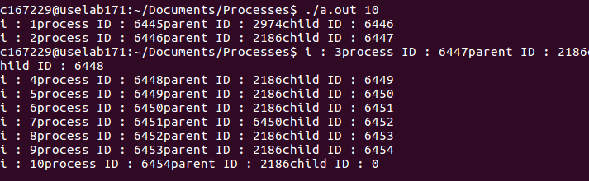
The output of this program is logically same as the original program. Yes, I can tell which process generated which part of the output. There are differences in the order of the printing of the statements in the output.

Assignment 2 on Processes
1.
#include <stdio.h>
#include <stdlib.h>
#include <unistd.h>
#include <sys/wait.h>

int main(int argc, char *argv[]) {

pid_t childpid = 0;
int i, n;
/*
if (argc != 2) {
fprintf(stderr, "Usage: %s processes\n", argv[0]);
return 1;
}
*/
n = atoi(argv[1]);
for(i = 1;i < n; i++){
if((childpid = fork()) <= 0){
break;
}
}

fprintf(stderr, "i: %d process ID: %ld parent ID:%ld child ID: %ld\n", i, (long)getpid(), (long)getppid(), (long)childpid);
return 0;

}
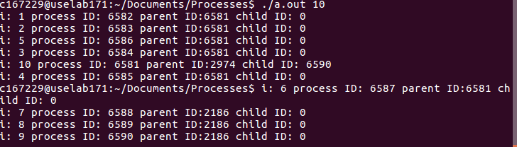
This code makes the parent process run the loop n times and create n children processes. The n children process break out of the loop as soon as they are created and directly print the statement. The output is different every time. The order of the print statements is different every time.
2.
#include <stdio.h>
#include <stdlib.h>
#include <unistd.h>
#include <sys/wait.h>

int main(int argc, char *argv[]) {

pid_t childpid = 0;
int i, n;
/*
if (argc != 2) {
fprintf(stderr, "Usage: %s processes\n", argv[0]);
return 1;
}
*/
n = atoi(argv[1]);
for(i = 1;i < n; i++){
if((childpid = fork()) <= 0){
break;
}
}
while(wait(NULL) > 0);
fprintf(stderr, "i: %d process ID: %ld parent ID:%ld child ID: %ld\n", i, (long)getpid(), (long)getppid(), (long)childpid);
return 0;

}

3. #include <stdio.h>
#include <stdlib.h>
#include <unistd.h>
#include <sys/wait.h>

int main(int argc, char *argv[]) {

pid_t childpid = 0;
int i, n;
/*
if (argc != 2) {
fprintf(stderr, "Usage: %s processes\n", argv[0]);
return 1;
}
*/
n = atoi(argv[1]);
for(i = 1;i < n; i++){
if((childpid = fork()) <= 0){
break;
}
}
while(wait(NULL) > 0);
fprintf(stderr, "i: %d process ID: %ld parent ID:%ld child ID: %ld\n", i, (long)getpid(), (long)getppid(), (long)childpid);
return 0;

}
This code makes the parent process run the loop n times and create n children processes. The n children process break out of the for loop as soon as they are created and proceed to the next statement for execution. Since the children processes have not created any of their own children, it will not enter the while loop because wait(NULL) will return -1 to child processes. It will proceed to print the statement. However, the parent process will wait for all of it’s children processes to terminate because of the while loop that depends on wait() and only after that it will print the statement.
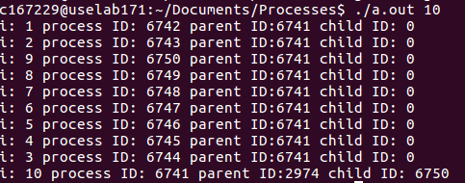

4. #include <stdio.h>
#include <stdlib.h>
#include <unistd.h>
#include <sys/wait.h>

int main(int argc, char *argv[]) {

pid_t childpid = 0;
int i, n;

if (argc != 2) {
fprintf(stderr, "Usage: %s processes\n", argv[0]);
return 1;
}

n = atoi(argv[1]);
for(i = 1;i < n; i++){
if((childpid = fork()) <= 0){
break;
}
}
fprintf(stderr, "i: %d process ID: %ld parent ID:%ld child ID: %ld\n", i, (long)getpid(), (long)getppid(), (long)childpid);
while(wait(NULL) > 0);
return 0;

}
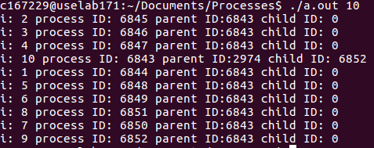

This code makes the parent process run the loop n times and create n children processes. The n children process break out of the for loop as soon as they are created and proceed to the next statement for execution. The parent process will proceed to print the statement. After the print statement, the parent process will wait for all of the children processes to terminate. The children processes will print the statement and then not enter the while loop since they have not created any of their own children processes and wait(NULL) will return -1 to child processes . After all the children processes have terminated, the parent process will also terminate.

5. #include <stdio.h>
#include <stdlib.h>
#include <unistd.h>
#include <sys/wait.h>

int main(int argc, char *argv[]) {

pid_t childpid = 0;
int i, n;

if (argc != 2) {
fprintf(stderr, "Usage: %s processes\n", argv[0]);
return 1;
}

n = atoi(argv[1]);
for(i = 1;i < n; i++){
if((childpid = fork()) <= 0){
break;
}
}
wait(NULL);
fprintf(stderr, "i: %d process ID: %ld parent ID:%ld child ID: %ld\n", i, (long)getpid(), (long)getppid(), (long)childpid);
return 0;

}
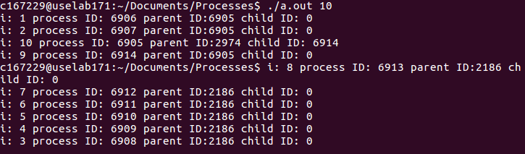
This code makes the parent process run the loop n times and create n children processes. The n children process break out of the for loop as soon as they are created and proceed to the next statement for execution. The parent process will be blocked until one of its child processes exits. After any one child process exits, it resumes it’s execution and prints the statement. The other child processes that had not earlier terminated will continue with their print statements and then finally terminate.
6. #include <stdio.h>
#include <stdlib.h>
#include <unistd.h>
#include <sys/wait.h>
#include <errno.h>

int main(int argc, char *argv[]) {

pid_t childpid = 0;
int i, n;

if (argc != 2) {
fprintf(stderr, "Usage: %s processes\n", argv[0]);
return 1;
}

n = atoi(argv[1]);
for(i = 1;i < n; i++){
if((childpid = fork()) <= 0){
break;
}
}

for( ; ; ){
childpid = wait(NULL);
if((childpid == -1) && (errno != EINTR)){

break;

}

}
fprintf(stderr, "i: %d process ID: %ld parent ID:%ld child ID: %ld\n", i, (long)getpid(), (long)getppid(), (long)childpid);
return 0;
}
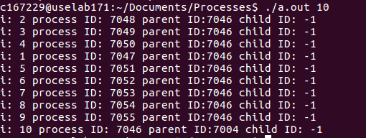
This code makes the parent process run the loop n times and create n children processes. The n children process break out of the for loop as soon as they are created and proceed to the next statement for execution. There’s a for loop running unconditionally that only breaks when the if condition is satisfied. The if condition would be satisfied only when wait returns -1. Wait returns -1 only when there are no child processes running for any given process.
For all the child processes, since they couldn’t create any more child processes, wait returns -1 immediately. But that is not the case with the parent process. For the parent process, wait will keep returning the pid of successive terminated child processes. Only after all it’s child processes are terminated, it will receieve -1. That’s why it’s the last in the order of printing since it terminates only after all it’s children have teminated because of the for loop. Child ID is -1 for all because it’s being over ridden by wait().
7.
#include <stdio.h>
#include <stdlib.h>
#include <unistd.h>
#include <sys/wait.h>
int main(int argc, char *argv[]) {

pid_t childpid = 0;
int i, n;

if (argc != 2) {
fprintf(stderr, "Usage: %s processes\n", argv[0]);
return 1;
}

n = atoi(argv[1]);
for(i = 1;i < n; i++){
if((childpid = fork()) == -1){
break;
}
}

fprintf(stderr, "i: %d process ID: %ld parent ID:%ld child ID: %ld\n", i, (long)getpid(), (long)getppid(), (long)childpid);
return 0;

}
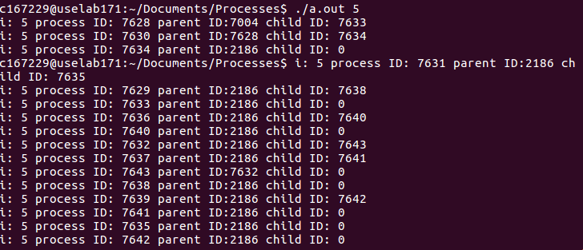
This code makes the parent process run the loop n times and create n children processes. The n children processes go on to create their own processes. Since the for loop starts from i = 1, with n = 5, the loop iterates 4 times.
Process
Process
Process
Process
Process
Process

Assignment 3 on Processes
Zombie Process

#include <stdlib.h>
#include <sys/types.h>
#include <unistd.h>

int main(){
pid_t childid = fork();
if(childid > 0){
sleep(50);
}
else{
exit(0);
}
return 0;
}
sleep() and exit() are responsible for the zombie process. The child finishes its execution using exit() system call while the parent sleeps for 50 seconds, hence doesnt call wait(), and the child process’s entry still exists in the process table.

Orphan Process
#include <stdio.h>
#include <sys/types.h>
#include <unistd.h>
int main () {
int pid = fork();
if( pid > 0) {
printf(“In parent process”);
}
else if( pid == 0){
sleep(30);
printf(“In child process”);
}
return 0;
}
