Threads

1.#include <stdlib.h>
#include <sys/types.h>
#include <pthread.h>
#include <unistd.h>
#include <stdio.h>

#define NUM_THREADS 3

int maximum = -9999, minimum = 99999;
float average = 0;

void * average_runner(void *arg){
char ** arguments = (char **) arg;
int n = atoi(arguments[1]);
int i;
for(i = n + 1; i > 1; i--){
average += atoi(arguments[i]);
}
average /= atoi(arguments[1]);
pthread_exit(0);
}
void * minimum_runner(void *arg){
char ** arguments = (char **) arg;
int n = atoi(arguments[1]);
int i;
for(i = n + 1; i > 1; i--){
if(atoi(arguments[i]) < minimum){
minimum = atoi(arguments[i]);
}
}

pthread_exit(0);
}

void * maximum_runner(void *arg){
char ** arguments = (char **) arg;
int n = atoi(arguments[1]);
int i;
for(i = n + 1; i > 1; i--){
if(atoi(arguments[i]) > maximum){
maximum = atoi(arguments[i]);
}
}

pthread_exit(0);
}

int main(int argc, char* argv[]){
if (argc < 2){
fprintf(stderr, "Usage: %s number_of_integers integer integer integer ...\n", argv[0]);
return 1;
}
int n = atoi(argv[1]);
printf("%d \n" , n);
pthread_t WORKERS[NUM_THREADS];
pthread_attr_t attr;
pthread_attr_init(&attr);
pthread_create(&WORKERS[0], &attr, average_runner, argv);
pthread_create(&WORKERS[1], &attr, minimum_runner, argv);
pthread_create(&WORKERS[2], &attr, maximum_runner, argv);
int i;
for(i = 0; i < NUM_THREADS; i++){
pthread_join(WORKERS[i], NULL);
}
printf("Maximum: %d \n",maximum);
printf("Average: %f \n", average);
printf("Minimum: %d \n", minimum);
return 0;
}
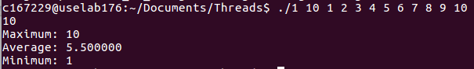
2.
#include <stdlib.h>
#include <sys/types.h>
#include <pthread.h>
#include <unistd.h>
#include <stdio.h>
#include <math.h>

void * prime_runner(void *arg){
int* n = (int *) arg;
float square_root = sqrt(*n);
int prime = 1;
int i;
for(i = 2; i <= square_root; i++){
if(*n % i == 0){
prime = 0;
break;
}
}
if(prime){
printf("Prime : %d\n", *n);
}
pthread_exit(0);
}

int main(int argc, char* argv[]){
if (argc < 2){
fprintf(stderr, "Usage: %s number...\n", argv[0]);
return 1;
}
int n = atoi(argv[1]);
printf("%d \n" , n);
pthread_attr_t attr;
pthread_attr_init(&attr);
pthread_t WORKERS[n+1];
int i;
int a[n+1];
for(i = 0; i < n + 1; i++){
a[i] = i;
}
for(i = 2; i <= n; i++){
printf("%d\n", a[i]);
pthread_create(&WORKERS[i], &attr, prime_runner, &a[i]);
}

for(i = 0; i < n+1; i++){
pthread_join(WORKERS[i], NULL);
}

return 0;
}
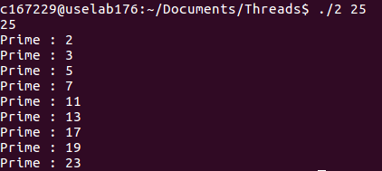

3.
#include <stdlib.h>
#include <sys/types.h>
#include <pthread.h>
#include <unistd.h>
#include <stdio.h>
#include <math.h>

int* a;

void * fibonacci_runner(void *arg){
int n = *(int*)arg;
printf("%d \n" , n);
if(n == 1){
a[0] = 0;
}else if(n == 2){
a[0] = 0;
a[1] = 1;
}else{
a[0] = 0;
a[1] = 1;
for(int i = 2; i < n; i++){
a[i] = a[i-1] + a[i-2];
}
}
pthread_exit(0);
}

int main(int argc, char* argv[]){
if (argc < 2){
fprintf(stderr, "Usage: %s number_of_fibonacci \n", argv[0]);
return 1;
}
int n = atoi(argv[1]);
pthread_attr_t attr;
pthread_attr_init(&attr);
pthread_t t;
int i;
a = malloc(n * sizeof(int));

pthread_create(&t, &attr, fibonacci_runner, &n);

pthread_join(t, NULL);

for(i = 0; i < n; i++){
printf("%d\n",a[i]);
}

return 0;
}
