LAB ASSIGNMENT 2

Submitter’s Details :

Name: Karanpreet Singh

Enrollment Number : 18114036

Class : B.tech , CSE 2nd year

Email: ksingh2@cs.iitr.ac.in

Phone – 9530894998

Link to my github repository : https://github.com/karan0299/CSN-261-ASSIGNMENT

PROBLEMS

PROBLEM-1
In this Problem, you have to implement a simple transposition cipher, where this cipher encrypts and decrypts a sequence of characters by dividing the sequence into blocks of size n, where n is specified by the encryption key. If the input text has a length that is not a multiple of n, the last block is padded with null characters ('\0'). In addition to n, the key also specifies two parameters a andb. For each block, the i-th output character, starting from 0 as usual, is set to the j-th input character, where j = (ai + b) mod n. For appropriate choices of a and b, this will reorder the characters in the block in a way that can be reversed by choosing a corresponding decryption key (n, a′, b′).

Data Structures Used: i) Array 1d and 2d

Algorithms Applied : i) Encryption
ii) Finding Modular Inverse
iii)Decryption Key Generation

ScreenShots:

inputFile :
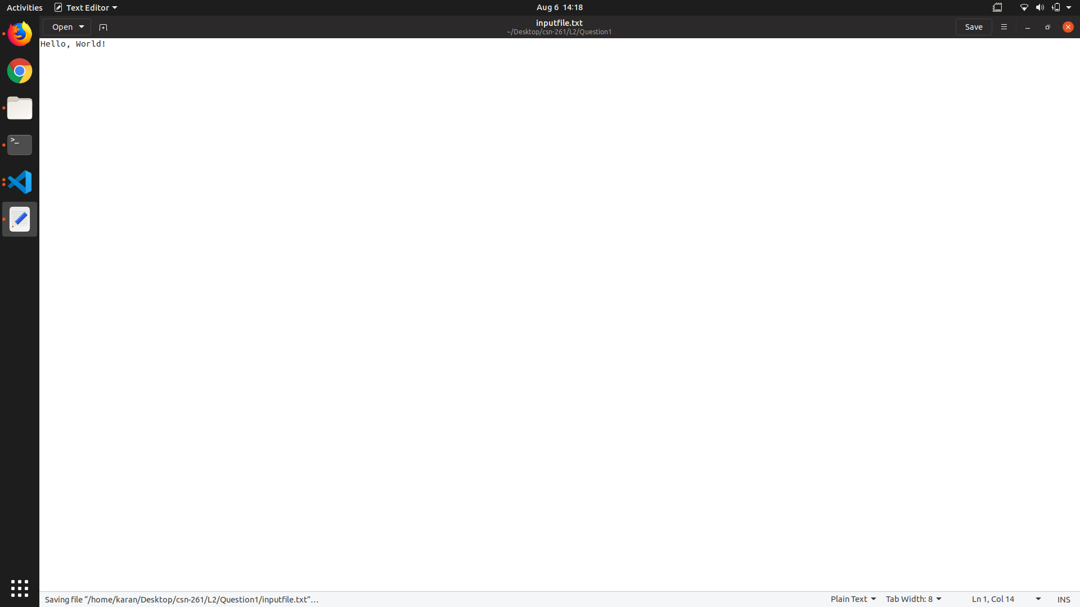

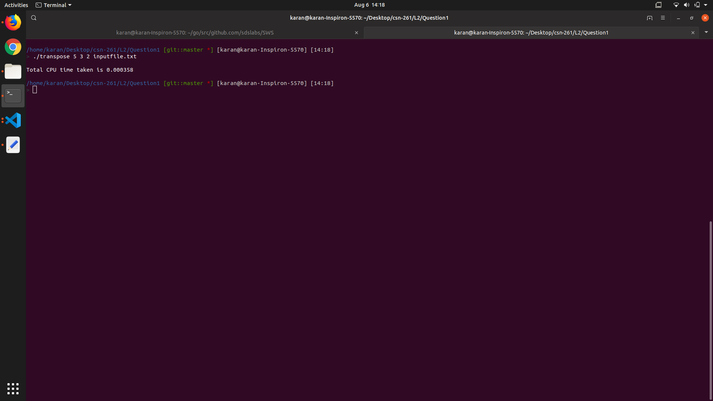

Outputfile
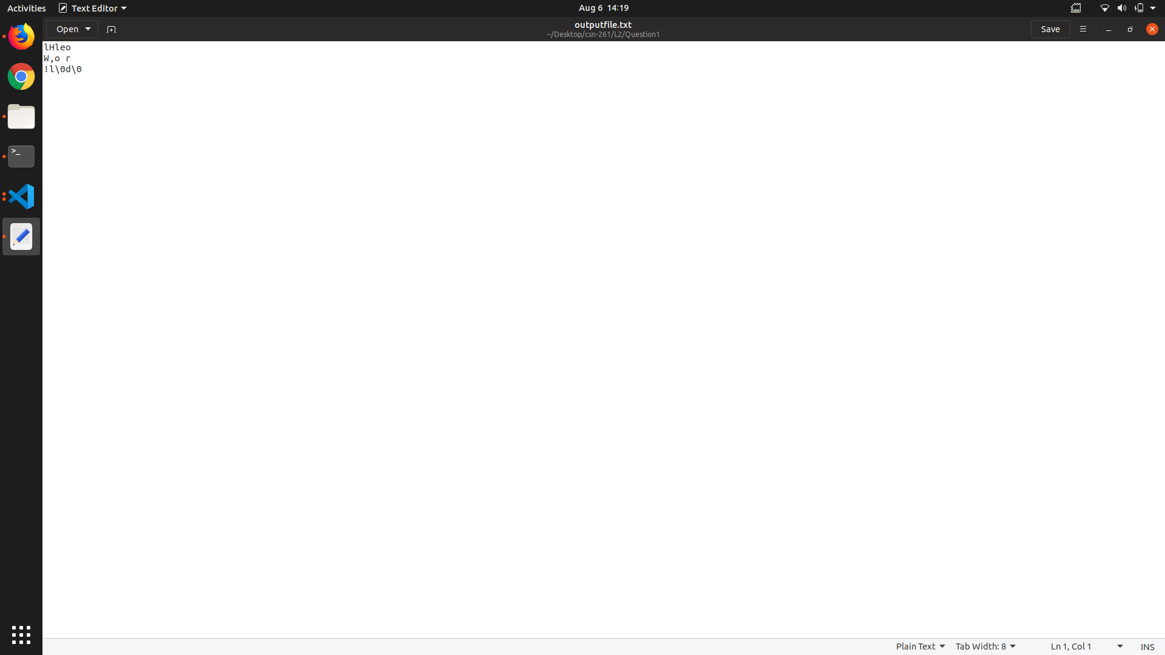

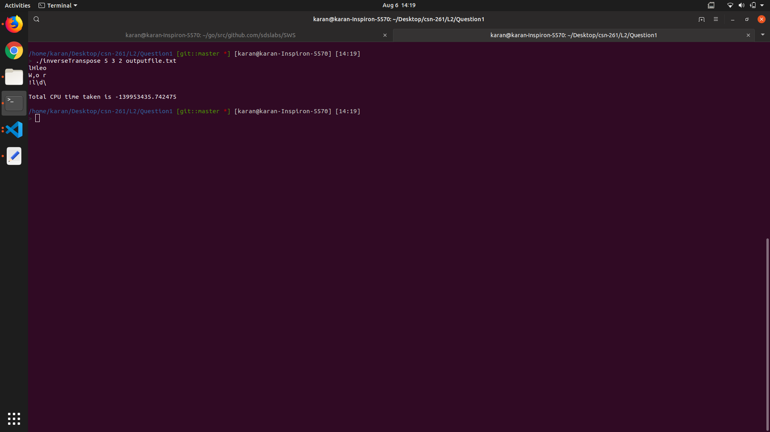

decryptedoutputfile
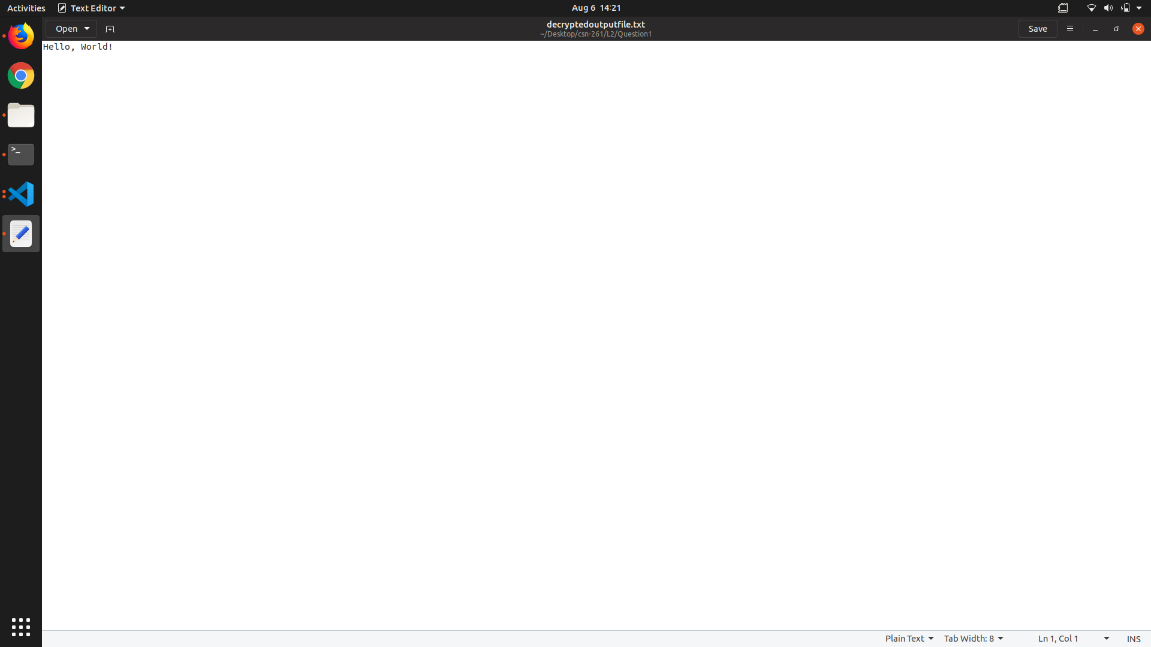

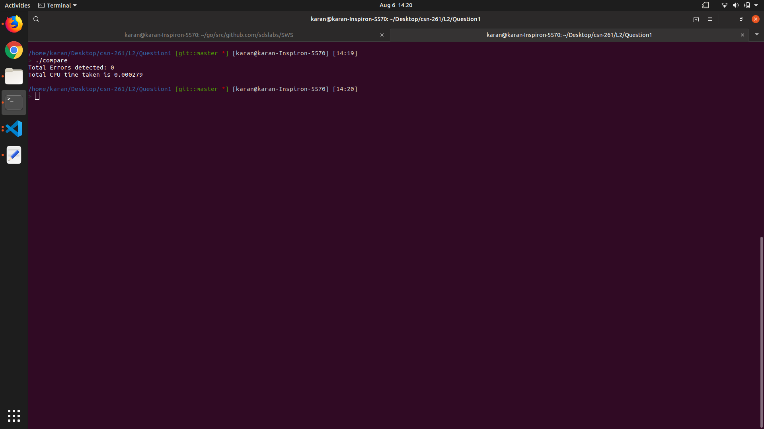

PROBLEM-2
A region can be represented either by its interior or by its boundary. Here we represent the region by its interior using one of the most common methods called image array. In this case we have a collection of pixels. Since the number of elements in the array can be quite large, the main objective is to reduce its size by aggregating equal-valued pixels.
Write a C program, MAT.c to represent any region (in image array representation), into its quadtree form.

Data Structures Used: i) Array 1d and 2d
ii) Quad Tree

Algorithms Applied : i)Mapping Area to Tree
ii) Recursive Generation of Tree

ScreenShots:

sampleInput

