TITLE PAGE

Submitter’s Details :

Name: Karanpreet Singh

Enrollment Number : 18114036

Class : B.tech , CSE 2nd year

Email: ksingh2@cs.iitr.ac.in

Phone – 9530894998

Github repository : https://github.com/karan0299/CSN-261-ASSIGNMENT

Q1.Given the set of integers, write a C++ program to create a binary search tree (BST) and print all possible paths for it. You are not allowed to use subarray to print the paths. Convert the obtained BST into the corresponding AVL tree for the same input. AVL tree is a self-balancing binary search tree. In an AVL tree, the heights of the two child subtrees of any node differ by at most one; if at any time they differ by more than one, rebalancing is done to restore this property.Convert the obtained BST into the corresponding red-black tree for the same input.
Write a menu driven program as follows: 1. To insert a node in the BST and in the red-black tree 2. To create AVL tree from the inorder traversal of the BST3. To print the inorder traversal of the BST/AVL/red-black tree4. To display all the paths in the BST/AVL tree/red-black tree 5. To print the BST/AVL tree/red-black Tree in the terminal using level-wise indentation (print color for red-black tree) 6. Exit

Data Structures used :
i) Binary Search Tree
ii) AVL tree
iii)Red Black tree
iv)Stack
v)Map

Algorithms used :
i) Insertion in AVL by rotations
ii) Insertion in RedBlackTree

Screenshots :

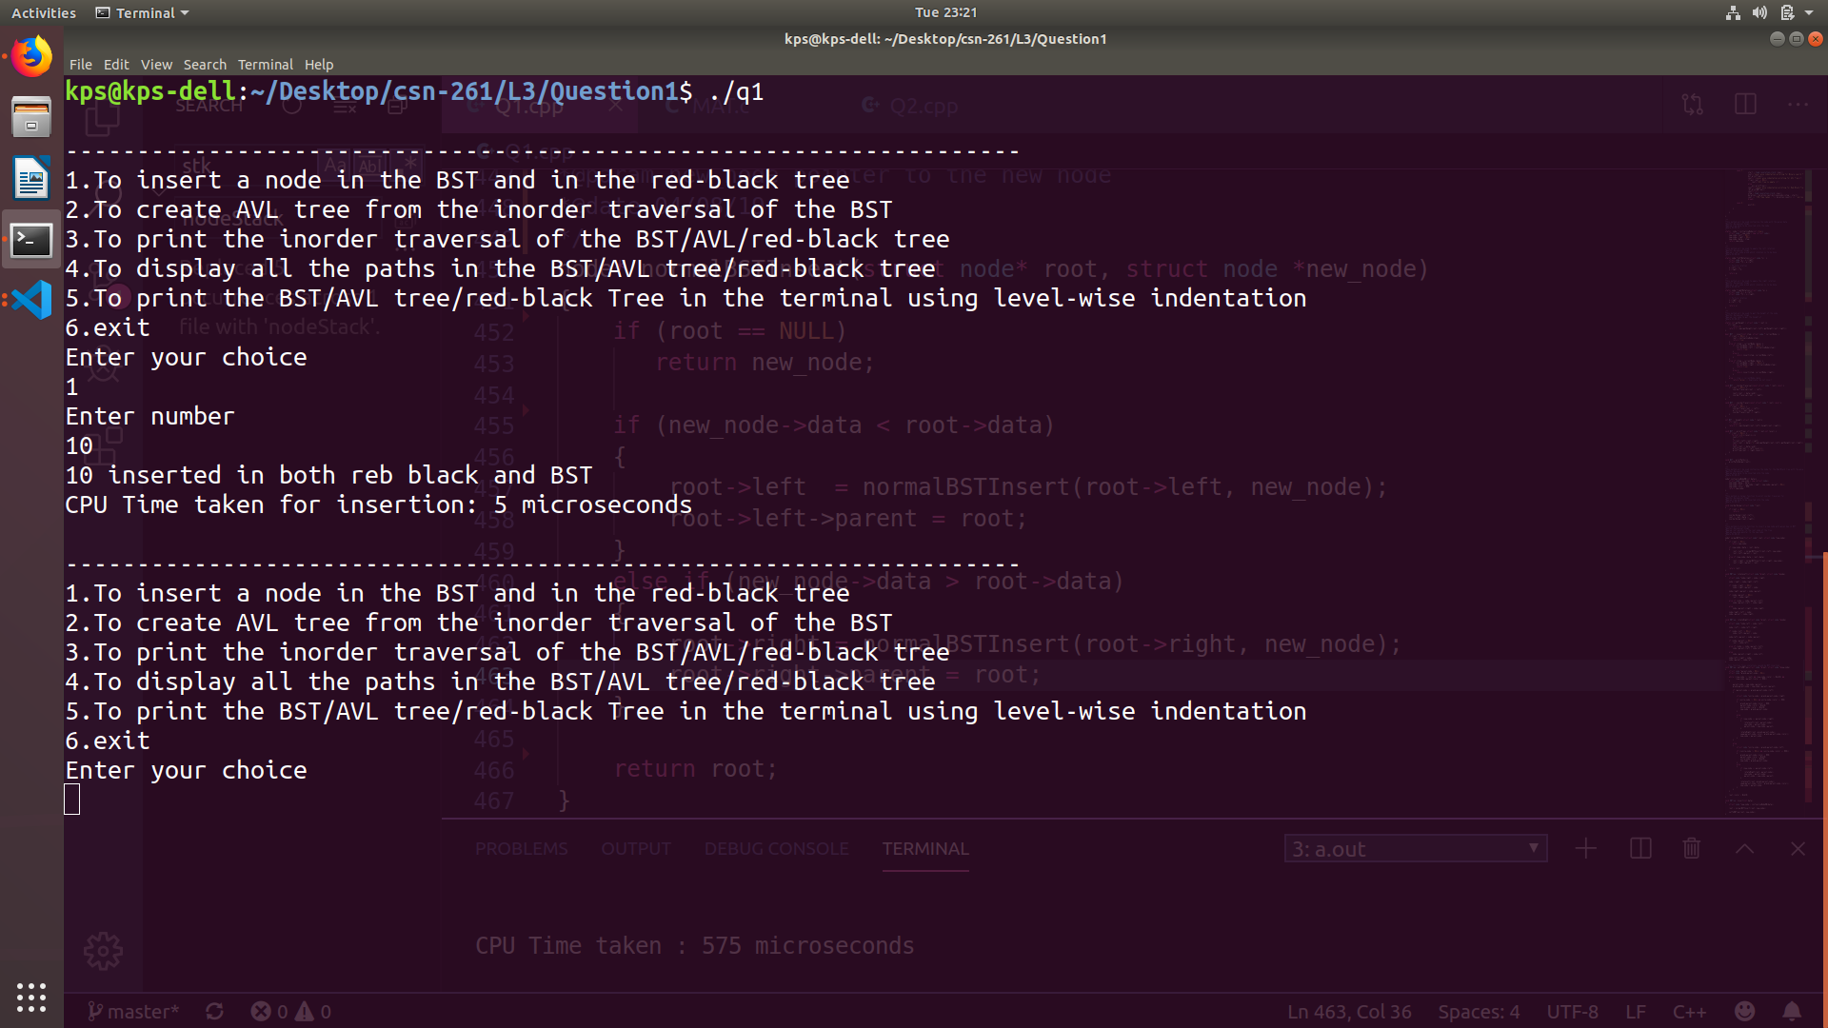

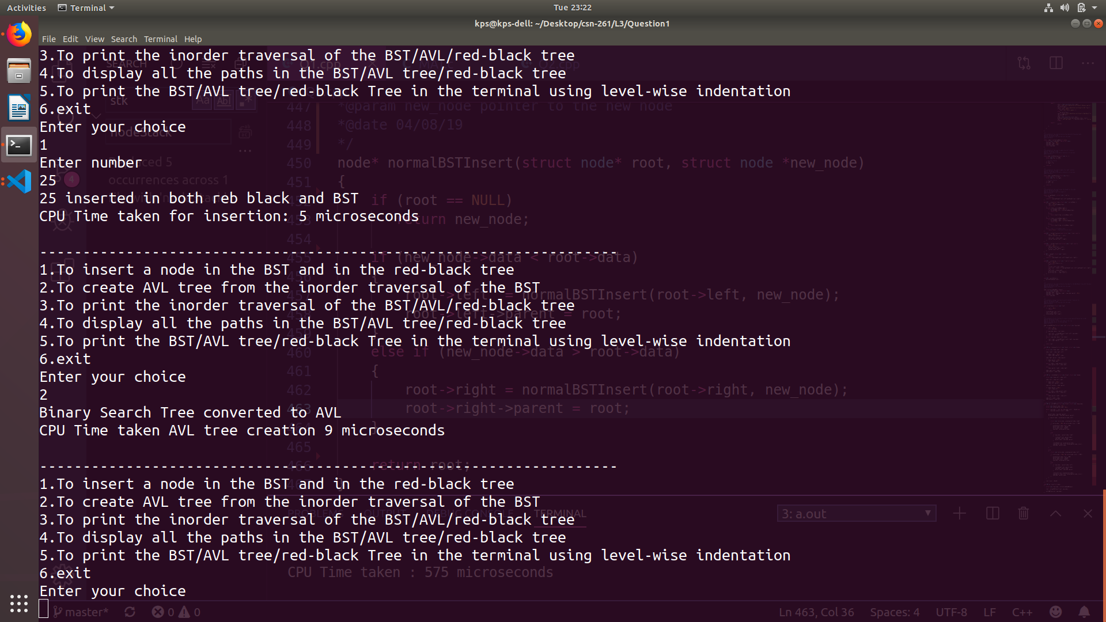

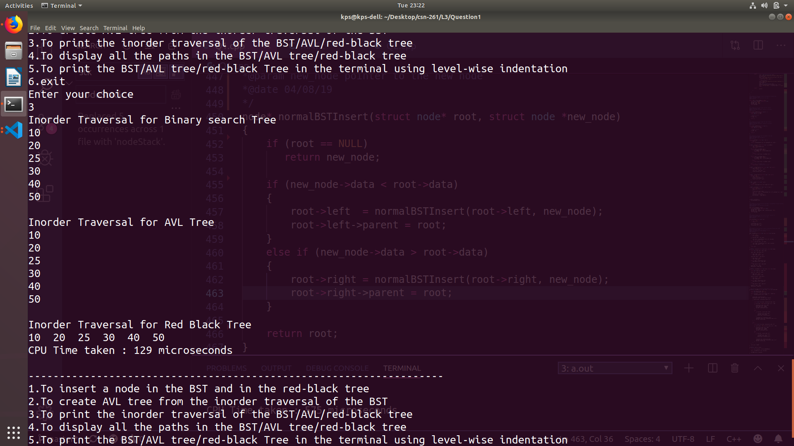

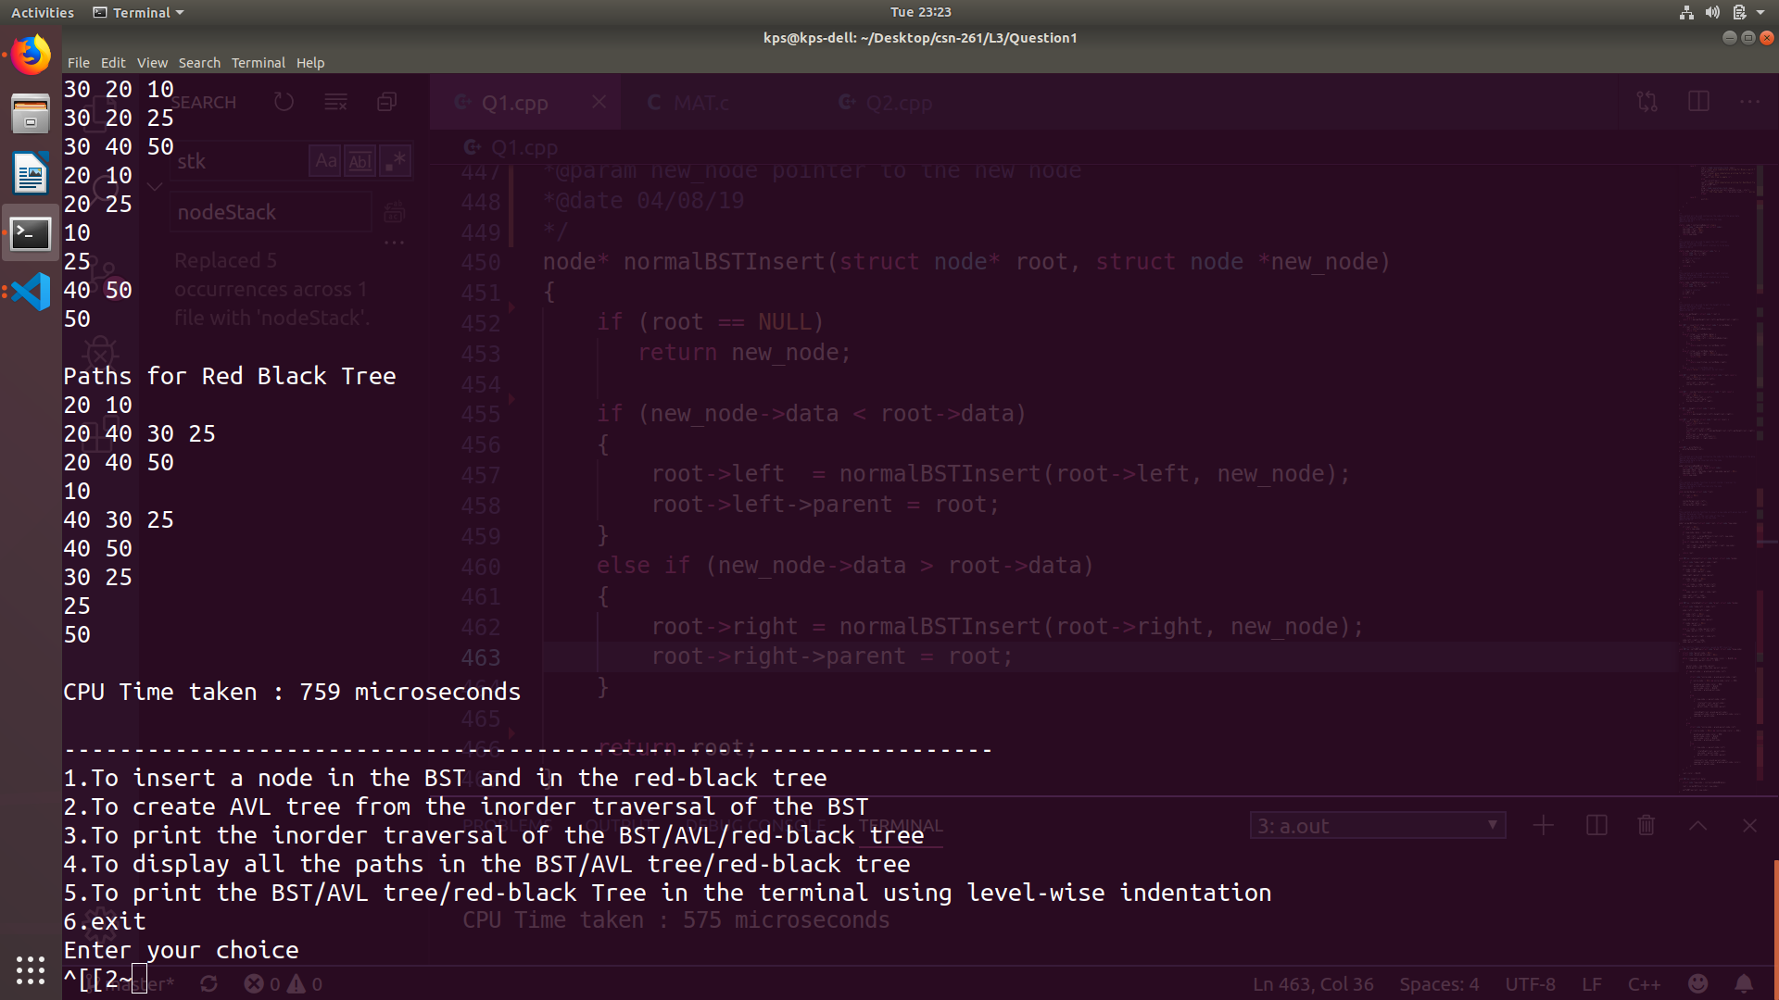

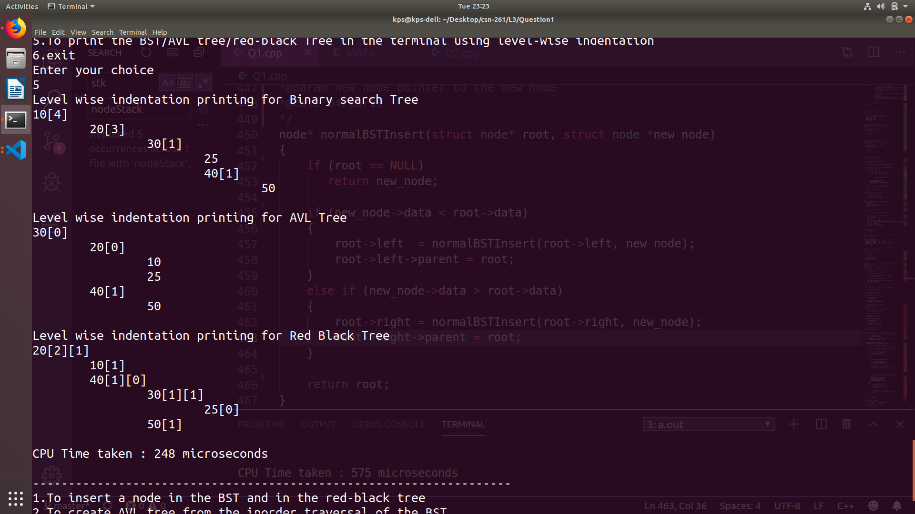

Q2.For a given sequence of positive integers A1, A2, ..., AN in decimal, find the triples (i, j, k), such that 1 ≤ i < j ≤ k ≤ N and Ai⊕Ai+1⊕...⊕Aj−1 = Aj⊕Aj+1⊕...⊕Ak, where ⊕ denotes bitwise XOR. This problem should be solved using dynamic programming approach and linked list data structures

Data Structures used :
i) 2D linked list
ii) 1D linked list
iii) vector

Algorithms used :
i) Dynamic programming

Screenshots :

