Major Project – Developing a Business System
[Group 2]
[ADITYAKUMAR PATEL] - [9007105]
[UJAS MEHTA] - [8999696]
[KARAN PATEL] - [9054498]

Computer Applications Development
ACSIT, Conestoga College

INFO8003: Systems Concepts, Analysis, and Design Course

Prof. Meyer Tanuan
[2025-04 -13]

Table of Contents
1. Using a Collaborative Tool......................................................................................................................3
2.FormingDevelopmentTeam................................................................................3
3.PreliminaryResearch..........................................................................................6
4.Brainstorming....................................................................................................7
5.ResearchWebMarketAnalysis.............................................................................11
6.Description........................................................................................................18
7.TechnicalRequirements......................................................................................23
8.Personas............................................................................................................27
9.UseCases...........................................................................................................30
10.UseCaseActivityDiagram....................................................................................32
11.Entities..............................................................................................................35
12.ContentPlans.....................................................................................................37
13.Prototypes.........................................................................................................38
14.ClassDiagram....................................................................................................39
15.ImplementationDevelopingtheAgilePlan.............................................................40
16.Presentation.....................................................................................................41
References.............................................................................................................43

Forming a Development Team
Project Title: Nonprofit Management System (NMS)
Team Name: NMS Innovations
Description:
The team operates as a startup startup to build an adaptable efficient user-focused system management solution for nonprofit entities. Members of our team offer exclusive capabilities which support the system development for design and planning across various system aspects. The project follows Agile Scrum development methodology and contains established team member roles and planned sprints.

Team Members and Their Core Responsibilities
Name | Primary Roles | Key Skills
Adityakumar Patel | Product Owner, Full-Stack Developer | Software Design, Programming (PHP, JavaScript), QA
Karan Patel | Scrum Master, UX/UI Designer, Documentation Lead | User Experience Design, Research, Wireframing, Writing
Ujas Mehata | Developer, QA/Test Engineer, Database Designer | Backend Dev, Testing, Database Modeling (ERD, SQL)

Detailed Task Assignments

Project Task | Assigned Team Members | Details
Brainstorming | Adityakumar, Karan, Ujas | Collaborative idea generation through mind maps and team meetings. Digital solutions evaluation for nonprofit challenges occurred within this project.
Research | Karan (Lead), Ujas | The team performed web analysis while evaluating competitors' features including Bloomerang and Salesforce NPSP and conducted a feature gap analysis.
Business Model | Adityakumar (Lead), Karan | The project included value proposition definition combined with user segmentation and revenue streams explanation. A lean canvas model served to assess long-term sustainability.
Market Analysis & Personas | Karan (Lead), Ujas | A user analysis led to the development of four operational profiles (Manager, Volunteer, Donor, Grant Officer) that reflect actual organizational needs.
Use Case Design | Adityakumar (Lead), Ujas | The team identified principal operational requirements throughout their documentation of user actions and system interaction sequences. Developed use case scenarios.
Entity Relationship Diagram (ERD) | Ujas (Lead), Adityakumar | A relational database structure included tables named Users, Events, Donations, Grants and their associated attributes together with cardinality relationships.
Class Diagram (UML) | Ujas (Lead), Adityakumar | The UML design depicts an object-oriented structure using inheritance where the User class extends into Admin, Volunteer and Donor classes.
Content Plans (Page Text & Controls) | Karan (Lead), Adityakumar | The team created established screen plans that included design elements for text elements along with labels, forms together with navigation menus.
Prototype Mockups | Karan (Lead) | I designed professional wireframes at high-definition levels through Figma software for crucial application screens (Event Signup and Donor Dashboard). Followed accessibility guidelines.
Code Development (Front-end/Back-end) | Adityakumar (Front-end), Ujas (Back-end) | The application received architecture setup along with MongoDB integration while APIs and basic UI elements were developed.
Testing (All types) | Ujas (Lead), Adityakumar (Support) | A testing approach including unit tests along with integration and regression tests and acceptance testing strategies underwent design and planning. Used AI-based test suggestions where appropriate.
Documentation | Karan (Lead), Adityakumar (Proofreader) | The team member generated project documentation as well as diagrams and user instructions through collaborative platforms while documenting development processes.

Scrum Development Roles

Scrum Role | Assigned Member | Responsibility Description
Product Owner | Adityakumar Patel, Karan | Specifies and prioritizes product backlog, verifies features against user needs, is the voice of the customer.
Scrum Master | Ujas Mehta, Karan | Helps with sprint planning, daily stand-up planning, clears blockers, ensures agile principles are followed by the team.

Collaboration Tools & Workflow
We're using GitHub as our primary version control and collaborative development tool. Each team member is responsible for:
- taking branches for his/her individual task
- making commits with informative messages
- merging pull requests after peer review
- tracking progress on GitHub Projects Kanban board
- documentation stored in shared Google Drive with version history
In addition to that, we used Trello for task breakdown and sprint planning, and Figma for UI mock-ups.

Preliminary Research (10 Marks)
1. Introduction
We did basic primary research on NMS major features to find the best practices and emerging trends in nonprofit technology. We used artificial intelligence tools such as ChatGPT to review available solutions as well as key features such as event management, volunteer management, donor tracking, grant applications, and impact reporting. Our findings will inform the NMS design in a manner that the NMS is not just effective but also efficient to utilize for nonprofit organizations.
2. Research Findings
Below are the key topics we covered, along with the results and conclusions derived using AI tools:
2.1 Event Management in Nonprofits
- Research Question: "What are the most event management software tools utilized by nonprofit organizations to plan and coordinate events? How do these systems differ from those utilized by businesses?"
- AI Insights: AI pointed out that among the most widely used event management tools for nonprofits are Eventbrite, Cvent, and Volunteer Local. All these applications help nonprofit organizations to plan events, handle registrations, track attendance, and accept donations at events. The only distinction between nonprofit and business event systems is that nonprofit systems are more interested in volunteer management and fundraising features.
- Adaptation: This comes with our system's need to integrate event creation with volunteer sign-ups and donation tracking. We will make sure that the system will easily post events and accept volunteer involvement.

2.2 Coordination of Volunteering at Nonprofits
- Research Question: "What are the best volunteer management systems for nonprofits? How do they schedule, track, and communicate?"
- AI Insights: Software like VolunteerHub, SignUpGenius, and Better Impact were considered top solutions. These applications allow volunteers to sign up for shifts, track their hours, and communicate with event coordinators. These solutions also provide volunteer appreciation and automation of scheduling features.
- Adaptation: We plan to add a volunteer management module that accommodates like functionality. Volunteers will be allowed to register, subscribe to events, log hours, and obtain certificates of attendance.
2.3 Donor Management
- Research Question: "What software applications do nonprofit organizations use to track donor gifts, manage relationships, and report on fundraising?"
- AI Insights: Boomerang, Donor Perfect, and NeonCRM are donor management systems that are popular among nonprofits. They allow nonprofits to track donation history, divide donors by campaign, and print receipts for donations. Many of these software programs also feature in-built reporting functionality that allows nonprofits to view their fundraising in a visual format.
- Adaptation: We will incorporate a donor management module that tracks donation histories, provides detailed reports, and allows automatic receipt generation. The system will help nonprofits maintain a transparent relationship with donors.

2.4 Grant Application Management
- Research Question: "What are the nonprofits' processes with regard to grant applications and fund tracking? How do some software solutions assist them?"
- AI Insights: Grant management systems including Foundant, GrantHub, and Fluxx were mentioned to be used to help nonprofits in managing grant applications. These programs help organizations manage deadlines, document storage, co-editing of applications, and monitoring the status of grants submitted.
- Adjustment: Our system shall include a module of grant management that tracks deadlines, status of application, and includes reminders in order to not delay the submissions.
2.5 Impact Reporting in Nonprofits
- Research Question: "What are the tools and methodologies being utilized by nonprofit organizations to measure and report their social impact? How do these tools assist in impact reporting?"
- AI Insights: A few of the impact measurement tools that nonprofits use that were enumerated are Social Value UK, SurveyMonkey, and Logic Models. These tools measure social outcomes by collecting data from events, volunteers, and donors and consolidating this data in the form of reports. SROI (Social Return on Investment) was also enumerated as a methodology used to measure the social impact in financial terms.
- Adaptation: Our site will include a customizable reporting dashboard that allows nonprofits to see event attendance, donations collected, volunteer engagement, and other KPIs, thus ensuring transparency and ease of impact reporting.

3. Appendix: Research Questions
Below is the list of AI prompts utilized to gather data for this preliminary research:
1. "What are the best event planning systems used by nonprofits to organize and plan events? How do these differ from those used by businesses?"
2. "What are the best volunteer management tools for nonprofits? How do they organize, track, and communicate?"
3. "What computer software solutions are nonprofits using to track donations from donors, track relationships, and report on fundraising activities?"
4. "How do nonprofits manage grant applications and track funding? What computer software solutions assist with this?"
5. "What methods and tools are being used by nonprofits to track and report social impact? How do the tools assist in impact reporting?"

Brainstorming (10 Marks)
In this section, we will outline the potential benefits of our Nonprofit Management System (NMS) and describe how the application might function to address the needs of nonprofit organizations. This brainstorming process will help us lay the foundation for the system and guide its development to ensure it provides maximum value to users.

1. Benefits of the Nonprofit Management System (NMS)
1.1 Improved Operational Efficiency
- Benefit: The NMS will remove much of the manual labor including event registration, volunteer rostering, donation tracking, and report writing, with a resulting time saving and reduced administrative burden.
- How: Through the consolidation of nonprofit management, everyone will be able to find everything in one place. The system will automate tasks and allow nonprofit staff to focus on their mission rather than bureaucratic administrative processes.
1.2 Enhanced Volunteer Coordination
- Benefit: The system will streamline the recruitment, management, and communication of volunteers and will result in a better volunteer experience.
- How: Volunteers can sign up on the platform, join events, log their hours, and receive notifications. Admins can just assign tasks, track contributions, and send reminders for upcoming shifts or events.
1.3 Comprehensive Donor Management
- Benefit: Nonprofits will enjoy better donor relationships, leading to greater donor retention and opportunities for repeat giving.
- How: The NMS will capture donor information, donation history, and preferences. It will facilitate personalized communication, generate automated thank-you letters, and deliver transparent reporting on how money is spent.
1.4 Simplified Event Planning
- Advantage: Planning and hosting events will be simplified, allowing nonprofits to host more successful and effective events.
- How: The event management module will allow users to create, post and manage events. Donors and volunteers can RSVP, track event timelines, and be sent notifications. Admins will also be able to make attendance and post-event comment reports.
1.5 Seamless Grant Application Tracking
- Advantage: Nonprofits will be in a better position to track and manage grant applications, improving their chances of securing funding.
- How: The system will maintain information regarding active grants, deadlines, and status of applications. Grant officers will be able to work together and track application statuses, with reminders so that deadlines are never overlooked.
1.6 Transparent Impact Reporting
- Benefit: Nonprofits will be able to demonstrate their impact to stakeholders (donors, volunteers, board members) in transparent, data-driven reports.
- How: The effect reporting module will provide real-time analysis in the form of visual dashboards and reports on fundraising, event results, and volunteer activity. This will increase accountability and establish trust with stakeholders.

2. How the Application Might Work
The following outlines how the Nonprofit Management System (NMS) might function and how users will interact with it:

2.1 User Authentication and Roles
Description: There will be multiple user roles within the system, including Admins, Volunteers, Donors, and Grant Officers. Each will have access to specific features.
- Admins can manage events, volunteers, donors, and reports.
- Volunteers may register, sign up for events, record hours, and print certificates.
- Donors can donate, view donation history, and receive impact reports.
- Grant Officers can monitor and keep track of grant applications and deadlines.
• How: Users will log in or register using secure authentication protocols, for instance, OAuth or JSON Web Tokens (JWT). Upon login, they'll be redirected to a role-specific dashboard.

2.2 Event Management
Description: Admins can add events, invite donors and volunteers, and monitor event attendance.
- Why: Admins will input event details such as title, description, date, time, location, and amount of volunteer spots available. They can publish the event, which will then appear on the calendar.
- Volunteers can browse events, RSVP for open spots, and be reminded before the event. Event details will also include donation opportunities for attendees.
2.3 Volunteer Management
Description: Volunteers can register, create profiles, and select areas of interest.
- How: Volunteers will undergo a sign-up process and be able to enter their information and preferences (e.g., event type, hours available). They'll be invited to events based on their preferences and availability.
- The ability to track volunteer hours, delegate tasks, and remind will be available to admins.
2.4 Donor Management
- Description: The system will manage donor profiles and track donations over time.
- How: Donors can establish profiles containing contact information, donating history, and preferences. Options for multiple gift types will include one-time donations or repeated giving.
- Automated Receipts: A thank-you letter, and receipt will automatically be sent after each donation. Donors are also able to view their history of donations as well as impact reports.
2.5 Grant Application Management
- Description: Nonprofits can track grant opportunities and deadlines, as well as manage application documents.
- How: Grant Officers and Admins will have a centralized grant management dashboard. They can upload documents, track submission statuses, and receive automatic reminders for upcoming deadlines.
- Collaborative Features: Team members can add notes, change statuses, and collaborate on each grant application.

2.6 Impact Reporting
- Description: The system will give customizable reports that reflect the impact of the nonprofit.
- How: The system will track KPIs such as funds raised, volunteer hours, attendance at events, and grant success rates. Admins can generate reports and export them as PDFs or send them to stakeholders as shareable links.
- Data Visualization: The reports will include charts, graphs, and other visualization tools to make the data more readable.

3. Summary of Ideas
- Application Concept: NMS is designed to provide a single, one-stop integrated solution for nonprofits to manage events, volunteers, donors, grants, and impact reporting.
- Benefits: Improved operational efficiency, improved coordination, increased donor involvement, and increased transparency.
- How it Works: The system will have role-based access, scheduling of events, volunteer tracking, tracking of donors, tracking grant applications, and impact reporting.
- Target Audience: Nonprofit organization Admins, Volunteers, Donors, and Grant Officers.

Research – Web Market Analysis (10 Marks)
In this chapter, we will examine existing web applications and platforms for managing nonprofits. We aim to evaluate existing solutions, their features, and determine whether there are shortcomings that our Nonprofit Management System (NMS) can address. We shall also examine similar applications available in the market, how users utilize them, and outline how our proposed application would stand out and bring value to the users.

1. Existing Applications in the Nonprofit Management Field
There are several platforms already present that address the needs of nonprofit organizations. These offerings present various tools to manage operations such as event management, volunteer management, donor management, and reporting. Some of the most well-known ones are given below:
a. Bloomerang
- Overview: Bloomerang is a popular donor management tool that is used extensively and is primarily utilized to build stronger donor relationships. It includes donation tracking, donor profile, sending personalized communications, and analysis of donor engagement.
- Key Features:
  - Donor profiles with giving history and preferences.
  - Automated thank-you notes and receipts.
  - Real-time reporting and analytics
  - Integrated email campaigns for donor engagement
- Link: https://bloomerang.co/

b. Salesforce Nonprofit Cloud
• Overview: Salesforce offers a highly customizable nonprofit management system. It combines donor management, event tracking, and volunteer coordination within one system. Yet, being too complex, it may require heaps of training to use optimally.

- Key Features:
  - Donor and volunteer management
  - Customizable reporting and dashboards
  - Fundraising campaign management
  - Grant tracking
- Link: https://www.salesforce.org/nonprofit/
c. NeonCRM
Overview: NeonCRM provides an all-in-one platform designed to help nonprofits handle donors and events. It includes event registration, email marketing, and donation tracking.
- Key Features:
  - Donor management with segmentation
  - Event management with ticketing and registration
  - Email campaigns and communication tools.
  - Integrated payment processing for donations
- Link: https://www.neoncrm.com
d. DonorPerfect
- Overview: DonorPerfect is a robust donor management system that helps nonprofits manage fundraising, communication, and donor relationships. It provides tools for segmentation and reporting but lacks features for broader nonprofit operations.
- Key Features:
  - Fundraising campaign management
  - Recurring donation tracking
  - Customizable reports and dashboards
  - Mobile app for on-the-go access.
- Link: https://www.donorperfect.com

e. Eventbrite (for Event Management)
- Overview: Eventbrite is an events management platform widely used by nonprofits to plan and promote events. It is geared toward ticketing, RSVPs, and event marketing but lacks robust volunteer management and donor tracking.
- Key Features:
  - Event ticketing and registration
  - Event promotion and social sharing
  - Payment processing for ticket sales
- Link: https://www.eventbrite.com

2. Market Gap Analysis and How NMS Is Different
Although the above uses address some aspects of nonprofit management, none are an all-in-one solution that integrates event management, volunteer coordination, donor management, grant application tracking, and impact reporting into one system. Let's talk about the gaps and how NMS will fill them in:

Feature | Existing Solutions | Nonprofit Management System (NMS)
Event Management | Available on sites like NeonCRM and Eventbrite, but not yet linked to the balance of nonprofit activities. | Centralized event organization with volunteer sign-ups, RSVPs, and reminder functions built-in along with donation and reporting modules.
Volunteer Coordination | Typically requires third-party tools like Google Sheets or spreadsheets to monitor, or has restricted functionality in tools like Salesforce. | Fully integrated volunteer management system with task assignment, hours tracking, role-based scheduling, and recognition systems.
Donor Management | Available in platforms like Bloomerang, Salesforce, and DonorPerfect, but sometimes lacks advanced segmentation and reporting. | Refined donor segmentation, targeted communication, and concise impact reporting functions to support improved donor retention and activism.
Grant Management | Some systems (e.g., Salesforce) offer basic grant tracking, but it does not have collaboration capabilities and a formal workflow. | A complete module dedicated to tracking pending grants, handling applications, and enabling collaboration among non-profits with auto reminder.
Impact Reporting | Certain platforms offer generic reporting, yet without real-time analysis and configurable dashboards. | Real-time, visual impact reporting with customized KPIs, export features, and stakeholder transparency (donors, volunteers, and board members).
Grant Management | Some systems (such as Salesforce) provide simple grant tracking, but it is usually not a collaboration-oriented or workflow-based tool. | A dedicated module for the management of available grants, processing applications, and facilitating collaboration between nonprofit teams with automated reminders.
Impact Reporting | Some websites provide basic reporting but lack adequate real-time metrics and customized dashboards. | Real-time, visual impact reporting with customizable KPIs, exportability, and stakeholder transparency (donors, volunteers, and board members).
Affordability | Tools such as Salesforce and NeonCRM are pricey for small nonprofits, with a high learning curve. | Designed for small to medium-sized nonprofits with an easy-to-use interface and affordable pricing tiers that can fit into organizations with limited budgets.

How NMS Is Different:
- One-Stop Solution: NMS will offer a single stop where event management, volunteer management, donor management, grant tracking, and impact reporting come together in a single easy-to-use system. This will reduce the need for nonprofits to use more than one tool and cope with scattered data.
- Cost: NMS will be priced competitively to be within reach of small and mid-sized nonprofits, where larger and more expensive solutions are not feasible.
- User-Friendliness: As compared to more complicated systems such as Salesforce, NMS will focus on a neat interface, intuitive navigation, and speedy onboarding to make sure that all users, whether technical or not, can effectively utilize the platform.
- Enhanced Reporting: NMS will provide customizable reports and visual data analysis to allow nonprofits to display their impact in real-time, promoting transparency with stakeholders, volunteers, and donors.

3. Why Does It Make Sense to Develop This App?
Increasing Demand for Nonprofit Digital Solutions:
Several nonprofit organizations are adopting digital solutions to better organize, but most available solutions are either too complex or too costly for small nonprofits. Our application bridges the gap by providing an easy, low-cost, and full-featured solution that simplifies the management of nonprofits.
Efficiency and Scalability
The NMS will save time and resources by streamlining operations and providing a unified platform to perform critical functions. As nonprofits grow, the scalability of the app's architecture will allow them to continue utilizing the same system with new features and customizations as needed.
Increasing Focus on Transparency:
Donors and stakeholders are now calling for transparency. NMS's impact reporting features will allow nonprofits to easily monitor and report their outcomes, fostering trust and persuading them to continue giving.
Volunteer Support Organizations:
Nonprofits are often volunteer-based, and successful volunteer management is crucial to success. NMS will make this easier by allowing volunteers to sign up easily, assign tasks, and track hours, keeping volunteers motivated and engaged.

Description (10 Marks)
Nonprofit Management System (NMS) is a comprehensive, one-stop-shop system that enables the operation of nonprofit organizations. The system was designed to enable nonprofits to organize key elements of their operations, such as event planning, volunteer management, donor tracking, grant application management, and impact reporting. NMS is designed with the aim of making it simpler to manage nonprofits, reduce administrative expenses, and enhance donor, volunteer, and stakeholder transparency and engagement.
The platform will help nonprofit organizations manage their resources more effectively, so they can focus on their main mission – making a positive impact in their communities and the world. It will have an intuitive interface that is accessible to both tech-savvy and non-tech-savvy users and will be affordable enough for small and mid-sized nonprofits that may struggle with the cost and complexity of larger systems like Salesforce or Bloomerang.

Refined Description:
The Nonprofit Management System (NMS) is a cloud-based solution aimed at simplifying and integrating the various functions that nonprofit organizations rely on to operate effectively. It provides a centralized platform where nonprofits can:
1. Manage Events: Plan and promote fundraising events, volunteer sign-up, ticket sales, and RSVP management.
2. Organize Volunteers: Track volunteer hours, scheduling, and assignment of tasks to individuals or groups.
3. Track Donors and Donations: Maintain detailed records of donors, such as a donation history, their interests, and engagement metrics. It will allow nonprofits to send focused messages and monitor campaigns.
4. Grant Management: Track available grants, administrate applications and deadlines and reporting of usage of the grants.
5. Impact Reporting: Create live visual reports that highlight the organization's impact, making it easier to share progress with donors, volunteers, and stakeholders.

Preliminary List of Desirable Features:
1. User Profiles:
- Multiple user roles (admin, volunteer, donor)
- Customization of user permissions and access
2. Event Management:
- Registration and creation of events
- Ticketing and donation for events
- Volunteer sign-up and scheduling for events.
3. Donor Management:
- Donor profiles with donation history and preferences
- Automated donation receipts and thank-you emails.
- Advanced reporting on donations and donor engagement
4. Volunteer Coordination:
- Volunteer sign-ups for events and tasks.
- Time tracking and reporting for volunteer hours
- Volunteer role assignments and scheduling.
5. Grant Management:
- Tracking of available grants and deadlines
- Grant application management provision with reminders and status updates
6. Reporting Impact:
- Customizable data visualization dashboards
- Live reporting on fundraising and event figures
- Capacity to provide downloadable reports for stakeholders.
7. Mobile Access:
- A mobile app for volunteers and donors to access key features like sign-ups, event information, and donation tracking while mobile.
8. Fundraising Tools:
- Capacity to create online donation pages.
- Peer-to-peer fundraising functionalities for supporters to raise money on behalf of the organization.
- Social media integration for campaign sharing

Possible Revenue Streams:
Whereas the application is increasingly focused on nonprofit organizations (most of which have exceedingly small budgets), there are several revenue streams upon which it can rely to remain financially viable:
1. Subscription Model:
- Freemium: free version with features limited to smaller nonprofits and fee-based versions that offer more enhanced features (to larger nonprofits).
- Monthly/Annual Subscriptions: different tiers depending on the scale of the nonprofit and the functionality they need (e.g., 1-10 users, 11-50 users, 51+ users).
2. Transaction Fees:
- Charging a small percentage per transaction of donations received using the platform (e.g., a percentage for each donation).
3. Sponsored Content/Partnerships
- Partnership with service organizations for nonprofits (e.g., grant-writing tools or fundraising consultants) to display their content or ads within the site.
4.Custom Features/Consulting:
- Providing paid customizations of the site or consulting services for large nonprofits that need customized solutions for their specific needs.
5.Marketplace for Nonprofit Services:
- One-stop shop wherein nonprofits can find vetted suppliers (e.g., print establishments, event supplies, or volunteer staffing agencies), and earn a commission on sales generated through the platform.

Future Goals and Expansion:
Although the primary focus of the Nonprofit Management System (NMS) is to help nonprofit agencies manage more effectively, some future goals and extensions can be envisioned to render it more useful and comprehensive:

1. Extension to Other Industries:
- a Charities and Foundations: The system can be tailored for use by charity organizations and foundations that need to handle fundraising, donations, and program distribution.
- Corporate Social Responsibility (CSR): Companies looking to track and manage their CSR projects can use the system for event organization, volunteer coordination, and reporting on the impact of their donations.
2. Integration with Other Platforms:
- Developing APIs to allow NMS to integrate with other popular solutions like QuickBooks for finance, MailChimp for email marketing campaigns, or social media sites for event promotion and fundraising.
3.AI-Powered Features:
- Leveraging AI-based tools to aid in predicting donation trends, identifying possible major donors, or generating automated personal thank-you messages based on donor activity.
4.Multi-language and Multi-currency Support:
- Expanding the scope of the platform by adding multi-language and multi-currency features, making it available to nonprofit organizations worldwide.
5.Advanced Analytics and Machine Learning:
- Adding more advanced analytical features for forecasting fundraising patterns, donor retention, and optimizing event planning through historical data.
6.Peer-to-Peer Fundraising:
- Adding functionality that allows supporters to create personal fundraising pages associated with the nonprofit campaigns, further allowing the widening of fundraising scope.

Relationship to the Theme:
The development of the Nonprofit Management System (NMS) is part of the general theme of enabling organizations to optimize their activities to generate greater social impact. By developing a system that automates and integrates various nonprofit functions, NMS allows these organizations to focus on what matters most: their social mission. Whether it is coordinating a fundraising event, organizing volunteers, or tracking donor gifts, NMS enables nonprofits to operate more efficiently, openly, and with greater scope. This is critical to being able to continue serving their communities and making a positive impact on the world.

Technical Requirements (10 Marks)
1. Device Hardware Features:
As the Nonprofit Management System (NMS) is primarily an internet-based system, hardware requirements are minimal. There are, however, considerations if we were to deploy the system as a mobile app or if there were hardware components needed:

- Mobile Devices: If the app is made mobile-friendly (or a native mobile app is developed), it will require:
  - GPS and Location Tracking: Similar to GPS devices non-tracking services can aid in volunteer check-ins during events and event attendance can be monitored based on location proximity such as volunteer and donor check-ins when they reach an event.
  - Camera Access: The system enables users to read event registration QR codes and barcodes as well as process volunteer monitoring through barcodes or track donations through receipt scanning or photo documentation.
  - Push Notifications: The application requires support for mobile device push notifications that deliver important alerts and scheduling reminders to users.
- For Web Access: The web application does not rely on the specific hardware functionality but should be usable through commonly used devices like desktops, laptops, tablets, and smartphones if only they have internet access and current browsers.
2. Special Input Controls:
- The Nonprofit Management System (NMS) would require certain input controls in order to provide the best possible user experience, that is, ease of use by technical as well as non-technical nonprofit staff. Below are significant input controls:
- Drag-and-Drop Interfaces:
  - For scheduling events (dragging events to a calendar view)
  - For planning volunteer tasks (dragging tasks or shifts onto volunteer profiles)
  - For managing grant applications (dragging documents to upload sections)

- Dynamic Form Inputs:
  - The program would allow dynamic form fields to be presented based on user choices (e.g., adding a new donor profile, a form can vary based on the type of donor: individual or corporation). This would simplify data entry and only present relevant fields.
- Date and Time Pickers:
  - The program will need to have correct date and time selection for event scheduling and volunteer hour tracking. Calendar-style inputs would be needed to offer user-friendly and accurate scheduling.
- Multi-Select Dropdowns:
  - For event types filtering (e.g., fundraising events, community events, training sessions).
  - For selecting grant opportunities, as users may want to filter by region, deadlines, or funders.
- Search Bar and Auto-Suggestions:
  - Robust search bar with auto-suggest functionality for quick access to events, donors, volunteers, or grant prospects. This input control would need to handle large sets of data efficiently in order to allow users to get to what they need in a timely fashion.
- File Uploads:
  - The simplicity of uploading reports, images, or documents, particularly for event materials, donor acknowledgments, or grant proposals.

- Interactive Dashboards and Data Visualizations:
  - Instead of static reports, interactive graphs, and charts (with drill-down functionality) to see trends in donations, volunteer time, or event attendance. These would be a more intuitive means to browse key data.

3. Constraints and Advantages of Context:
Advantages:
- Cloud-Based Accessibility:
  - As it is a web-based system, the NMS can be accessed easily from anywhere with any device connected to the internet. Nonprofits can access the system wherever they are, which is especially beneficial for distributed teams working from various locations or working remotely.
- Affordable and Scalable:
  - The cloud-based nature of the system provides scalability to accommodate the needs of small as well as large nonprofits without paying unnecessary expenses for scaling up.
- Data Security and Backup:
  - Data security is achievable through industry-standard encryption and backup procedures with cloud storage, making sensitive donor and volunteer information secure.
- Integration with Other Tools:
  - The application can be integrated with other commonly used cloud-based tools that nonprofits leverage (e.g., Google Calendar, MailChimp, Stripe for donations), ensuring a smooth experience without having to jump between platforms.

Constraints:
- Internet Access:
  - Since the NMS is web-based, reliable internet connectivity is necessary. This could be a limiting factor where the internet connection is poor or negligible.
- Device Compatibility:
  - While the application will be developed to be responsive, users may experience minor variation in user interface functionality across devices, especially with older phones or lower-ability browsers.

- User Technical Proficiency:
  - While the platform is designed to be intuitive, there is still a learning curve for those unfamiliar with web-based platforms. Nonprofit staff may not be as technologically advanced, and this could impact adoption rates. Comprehensive tutorials, customer support, and onboarding materials would need to be provided to help with this.

- Complexity of Customization:
  - Although the app is designed to be flexible, some larger nonprofits might have more complex workflows or integrations that the standard setup does not accommodate. In this case, the app may require either custom development or more advanced subscription levels, which would be difficult for less well-off smaller nonprofits.

Other Contextual Factors:
- Volunteer and Donor Demographics:
  - The website should be able to serve a wide variety of users with varying levels of technological competence. Donors and volunteers may be from different age groups and geographical locations with differing levels of tech awareness. Simplicity, accessibility, and ease of use are therefore top design priorities.
- Diverse Nonprofit Operations:
  - Nonprofits vary in size, mission, and scope, and thus the app needs to incorporate customizable features to allow flexibility in use (e.g., customizable reporting forms, volunteer task establishment, or event management). This will allow the system to be flexible for a range of nonprofit types, from small grassroots to other larger charitable organizations.

Personas :
For the Nonprofit Management System (NMS), we have developed three distinct user personas of key stakeholders to be utilizing the system. The personas represent the different user objectives, issues, and user roles within nonprofit organizations.

Persona 1: Alex – Nonprofit Operations Manager
- Age: forty-two
- Role: Operations Manager at a local nonprofit
- Background: Alex has over 10 years of background experience in the nonprofit sector. They oversee all day-to-day operations of the organization, including event planning, volunteer management, and donor management. They possess technology knowledge but are interested more in people and process processing than technology.
Goals:
- Plan and coordinate various nonprofit events like fundraising events, community events, and volunteer events.
- Manage volunteers efficiently and assign roles during events.
- Track donations, report on fundraising, and offer due recognition to donors.
Frustrations:
- Inability to handle several spreadsheets to track events and volunteers.
- Time-consuming manual processes for tracking donors, event planning, and volunteer allocation.
- Lack of a centralized dashboard to monitor everything in one location.
How NMS Helps:
- Centralized dashboard with real-time access to event details, volunteer registrations, and donation status.
- Event management module to plan and track events, and volunteer and donor integration.
- Live reporting to track the movement of events, volunteers, and funds raised.

Persona 2: Riya – University Student and Active Volunteer
- Age: twenty-three
- Role: Volunteer
- Background: Riya is a college student who is actively involved in volunteering within her community. She volunteers at various local charities and events. While she is tech-savvy with apps and technology, her ultimate goal is to maximize her volunteer hours and give her time to the causes she believes in.
Goals:
- Easily discover and sign up for volunteer opportunities.
- Track her volunteer hours and be incentivized for her work.
- Stay up to date on upcoming events and receive reminders for her commitments.
Frustrations:
- Difficulty finding events that match her interests or availability.
- No way to log hours and be rewarded in a formalized system.
- Poor communication and notification of upcoming volunteer events.
How NMS Helps:
- Volunteer module with calendar view, with easy sign-up for events and activities.
- Personal volunteer profile where Riya can log her hours and receive electronic certificates or badges for her service.
- Reminders and notifications for upcoming events she has signed up for, as well as available events aligned with her interests.

Persona 3: James – Philanthropist and Monthly Donor
- Age: fifty-six
- Role: Donor and Philanthropist
- Background: James is an entrepreneur who gives to nonprofits regularly. He desires transparency and must be able to see that his gifts are being used. He is technically savvy but desires an easy and hassle-free experience when handling charities.

Goals:
- Be able to easily give to the causes he supports and see the impact of his gift.
- Obtain transparency as to how nonprofit money is spent.
- View receipts and reports for taxation purposes and to know the nonprofit's progress.
Frustrations:
- Difficulty in keeping a record of previous donations and getting receipts timely.
- Lack of transparency in how donations are spent.
- Little communication or feedback from nonprofits regarding the effects of his donations.
How NMS Helps:
- Donor management module wherein James can view his donation history, track donation trends, and get tax receipts easily.
- Automated thank-you letters and receipts immediately after donation with explicit breakdowns for how the funds will be spent.
- Impact reporting module that offers graphical reports of money raised, project progress, and success stories so that James can see the direct results of his donations.

USE CASES
Use Case 1. Volunteer Management in the application:
Description : Allows volunteers to sign up in the application and manage their choices for volunteer in the application, track hours, and receive certificates. Admin assigns roles and reviews contributions of each team member.

Use Case2. Donor Management steps in the application:
Description: Donors can make contributions, track their donation history, and receive receipts. Admins can manage donor data and other important records.

Use Case 3. Event Management Use in the application:
Description: Admins can create and manage events. Volunteers and donors can view events detail with location information.

Use Case 4: Grant Management Use Case Diagram
Description: Enables the creation, tracking, and status monitoring of grant applications and also have history for all grants in the application.

Use Case 5: Impact Reporting Use Case Diagram
Description: Provides reporting and data visualization to track outcomes, donation and other important information.

Use Case 6: Notification System Use Case Diagram
Description: Sends reminders or alerts based on user roles and upcoming events in the application.

Use Case: Donor Management steps in the application.
Description: This use case is design for registered donor to give funds to a organization through a secure way. The donor selects a campaign, enters the donation amount, provides payment details with proper bank information, and submits the transaction. Once the payment is successfully processed, the system automatically generates a digital receipt and sends it to the donor’s email. The donation is also added to the donor’s history for future reference and impact tracking in the application. If payment fails, the system prompts the donor to retry with an alternate method. This use case ensures smooth, secure, and trackable donations, enhancing donor trust.

Diagram:
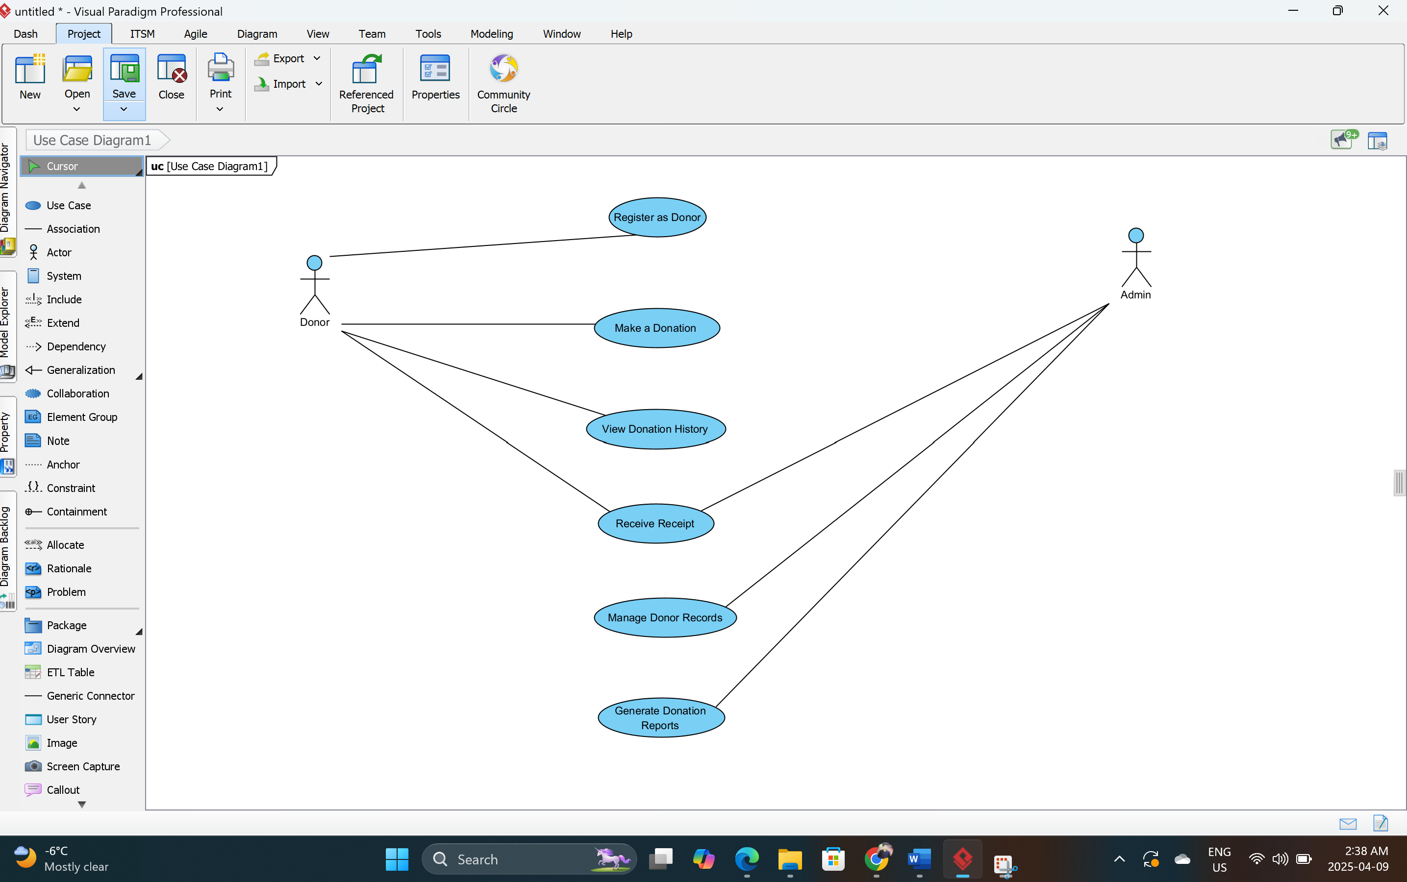

Use Case 2: Grant management in the application
Description: This use case allows Grant Officers and Admins to track and manage grant opportunities in the application. Users can add new grants, monitor submission deadlines, upload required documents, and update the status of applications. The system sends reminders for approaching deadlines and provides view of all ongoing or completed grant applications. Admins can review submissions, assign team members to tasks, and export application data if needed. This use case simplifies collaboration, ensures nothing is missed, and increase the success rate of acquiring funding. It provides transparency and structured workflow in an otherwise complex grant submission process in the application.

Diagram:
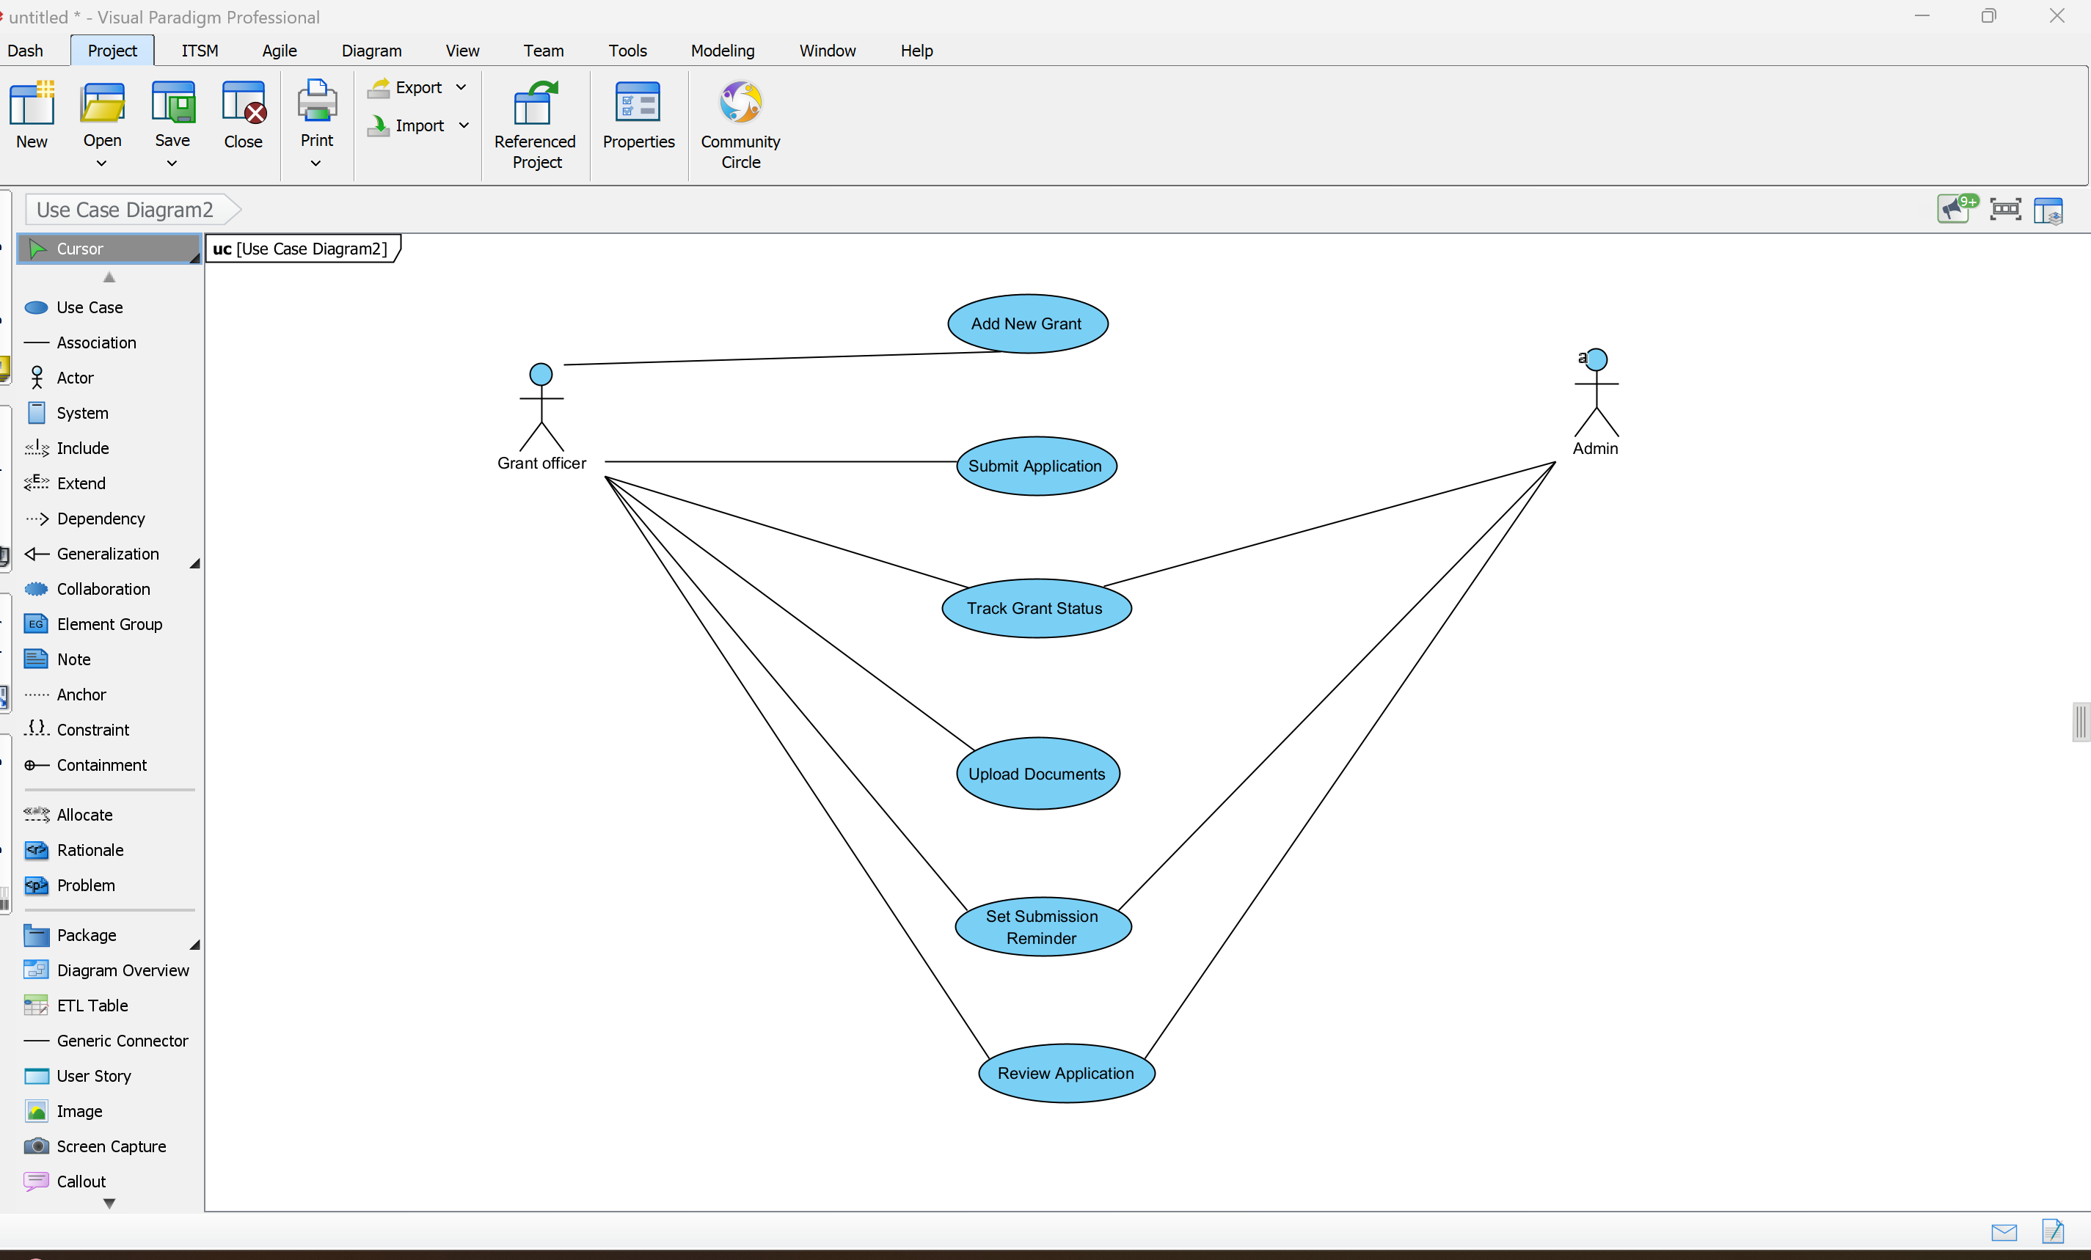

Business entities for the application:
Entity Name | Attributes
User | UserID (PK), FullName, Email, Password, Role Admin, Volunteer, Donor, GrantOfficer, Phone, CreatedAt
Event | EventID (PK), Title, Description, Date, Time, Location, CreatedBy , VolunteerSlots, DonationGoal
VolunteerEvent | VolunteerEventID (PK), VolunteerID (FK to User), EventID (FK to Event), Status ,SignedUp, Attended, HoursLogged
Donation | DonationID (PK), DonorID (FK to User), Amount, Date, PaymentMethod, Campaign, ReceiptID
Receipt | ReceiptID (PK), DonationID (FK), IssuedDate, PDFLink
Grant | GrantID (PK), Title, Funder, Deadline, Status (Open, Submitted, Approved, Rejected), CreatedBy
ImpactReport | ReportID (PK), GeneratedBy (FK to User), Date, Metrics (JSON/CSV), PDFLink

Content Plans:
Page 1: Volunteer Management Dashboard :
Text Description :
- Volunteer Management
Dashboard
- Events, Volunteers, Certificate, Sidebar ,Navigation
- Volunteer 1
- Event name

Features:
- Sidebar navigation menu
- List of assigned events
- Access reports and certificates

Input Controls:
Label | Control Type | Description
Events List | Button. | Displays available volunteer events
Report | Button | View volunteer report

Page 2: Volunteer Sign Up Page
Text:
- Volunteer Sign Up.
- Dashboard, Events, Volunteers, Reports
- Event discovery and Statics

Features:
- Discover available events in the application.
- View and accept volunteering requests in the application.
- Access notifications about the events.

Input Controls:
Label | Control Type | Description
Event Discovery | Button | Search and view upcoming events.
Statics | Button | View volunteering statistics
Event Requests | List with Buttons | View list of event participation requests.
Page 3: Volunteer Dashboard Page

Text:
- Volunteer Dashboard
- Dashboard, Events, Volunteers, Reports, Sidebar ,Navigation
- Volunteer Recommendations
- Upcoming Volunteer Events
- Volunteer Hours
- Donatebutton

Features:
- View personalized volunteer recommendations in the application.
- Check upcoming events.
- View total volunteer hours.
- Download certificates.
- Donate to the cause.

Input Controls:
Label | Control Type | Description
Volunteer Recommendations | Button | View suggested volunteering opportunities.
Upcoming Events | Button | See next volunteer events.
Volunteer Hours | Button | Displays total logged hours.
Download Certificate | Button | Download volunteering certificate.
Donate | Button | Open donation form.

Page 4: Admin Dashboard Page:
Text:
- Admin Dashboard
- Dashboard, Events, Volunteers, Reports
- April 2025 calendar

Features:
- View monthly calendar for event planning
- Enter dates for scheduling or reporting
- Create reports or events
Input Controls:
Label | Control Type | Description
Calendar | Calendar Component | Displays current month with events
Create | Button | Submit creation of  New report.

Activity Diagram:
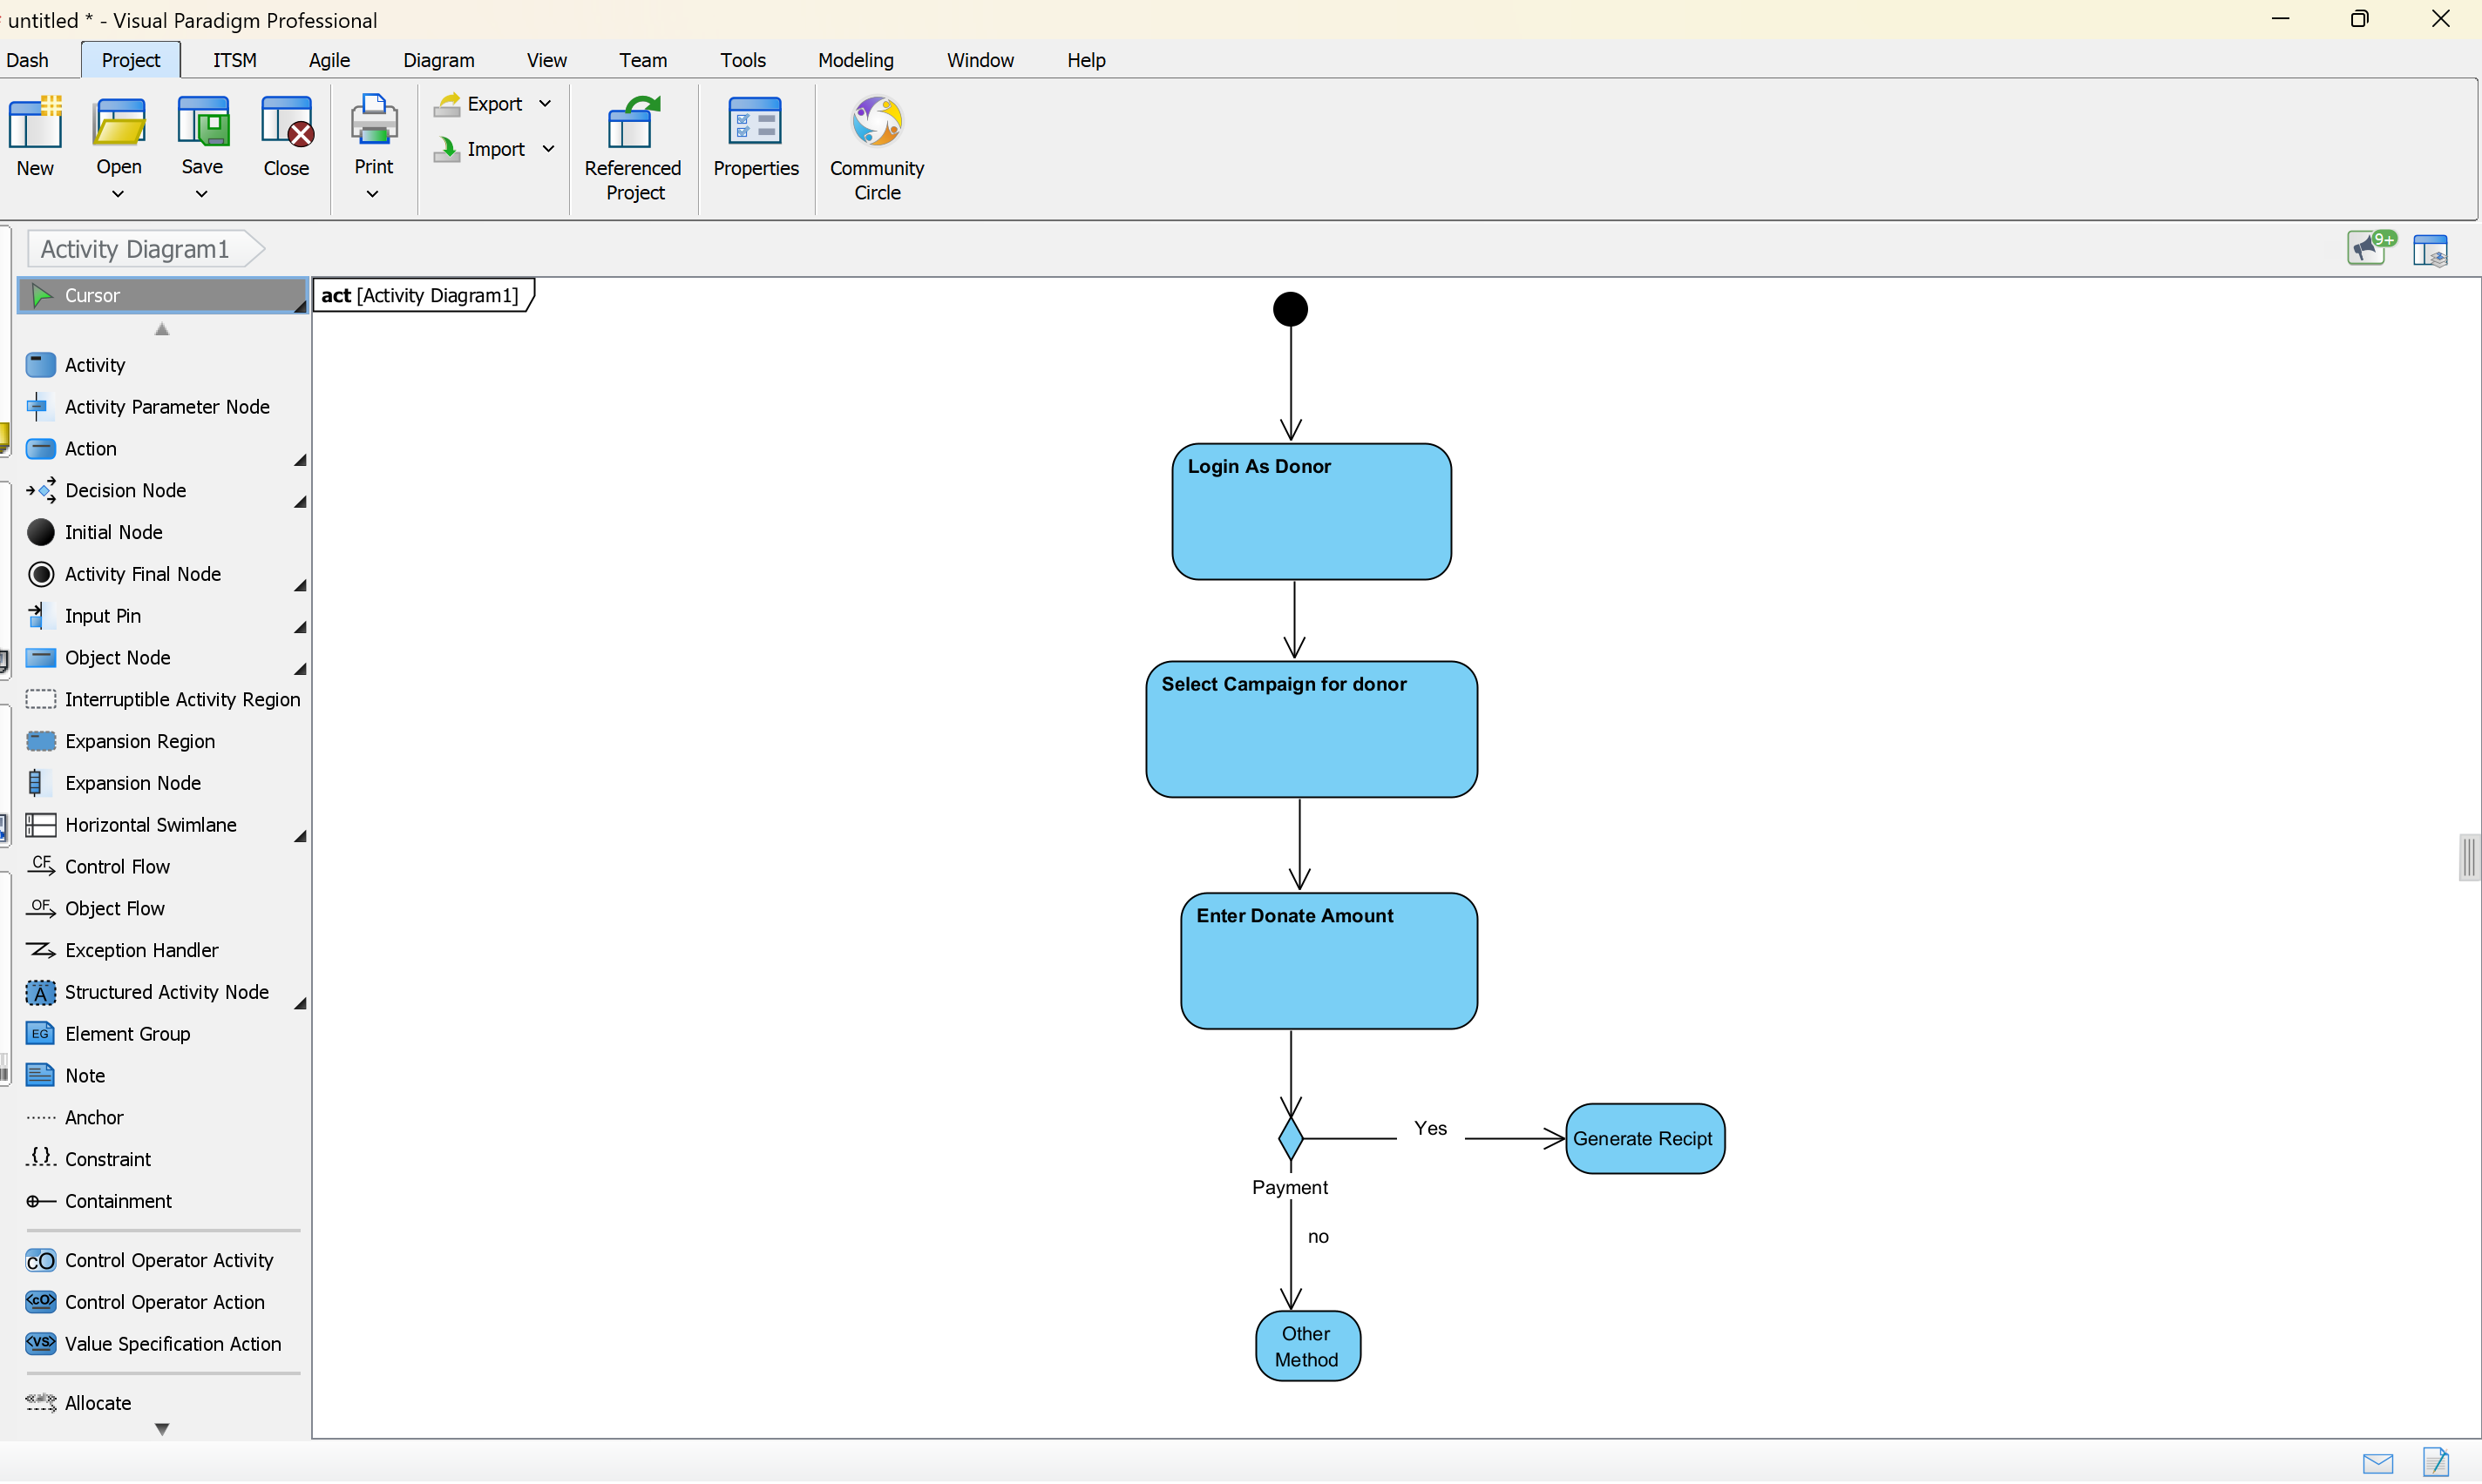

Class Diagram:
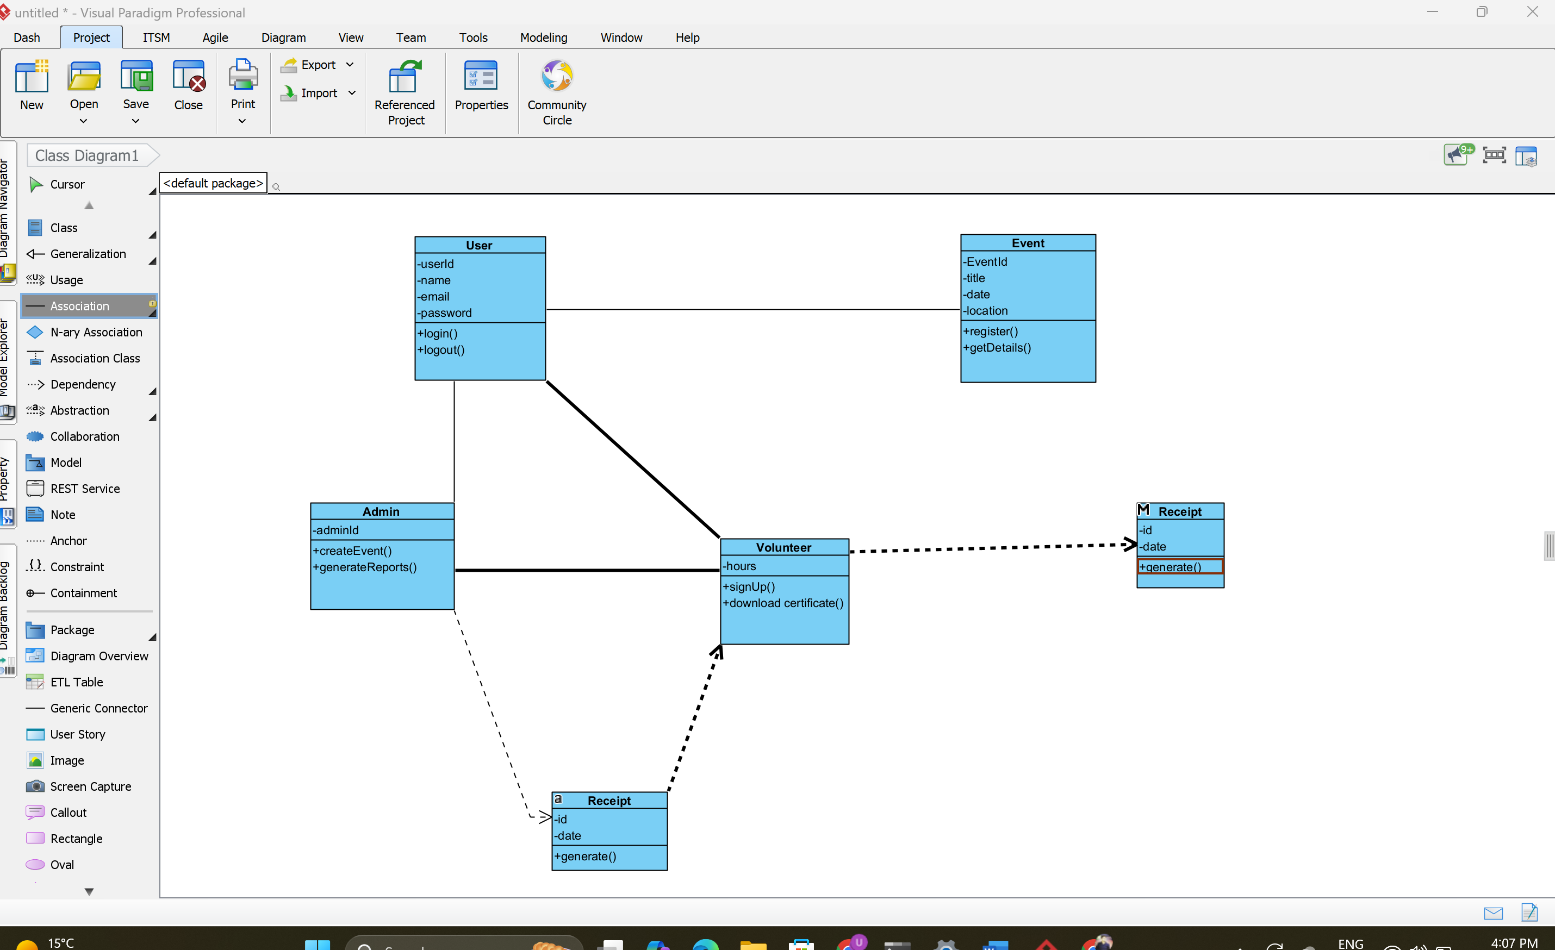

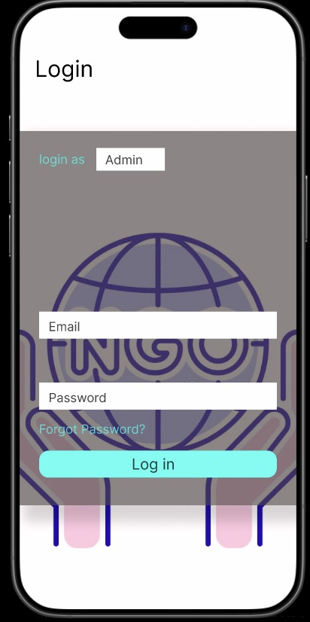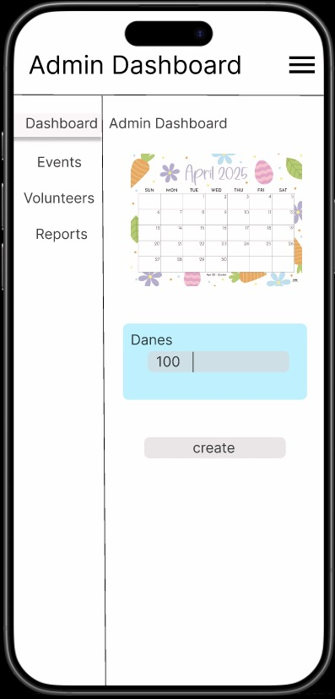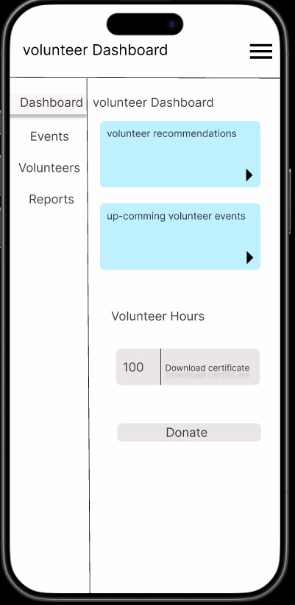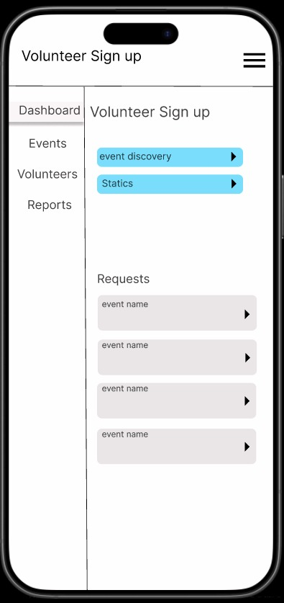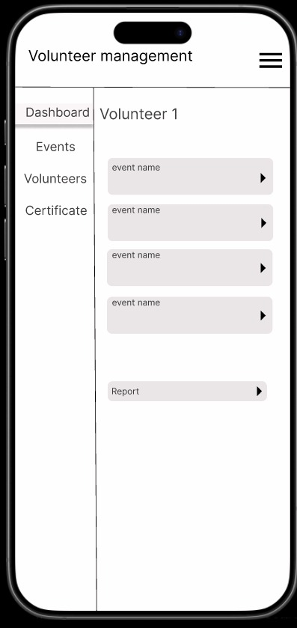

REFERENCES:
- https://capacitycanada.ca/wp-content/uploads/2014/09/Effective-Capacity-Building-in-Nonprofit-Organizations.pdf
- https://www.bridgespan.org/insights/nonprofit-management-tools-and-trends-report-2015
- https://www.bonterratech.com/blog/nonprofit-staffing
- https://anserj.ca/index.php/cjnser/article/view/270
- https://anserj.ca/index.php/cjnser/article/view/270
- https://www.bridgespan.org/insights/nonprofit-leadership/how-nonprofit-leadership-development-sustains-organizations-and-their-teams

