**PROGRESS REPORT - 1**

GROUP 3

|  |  |
| --- | --- |
| Name | ID |
| Zalika Shameem | S11195942 |
| Karan Parmar | S11198967 |
| Savindya Fernando | S11199815 |

PROGRESS

* All the dependencies were successfully installed (tensorflow).
* The raw_image dataset was successfully preprocessed and resized to 32 $×$ 32 dimensions.
* The images dataset was able to successfully load into the source code.
* The CNN and SVM algorithm are currently up and running, progressing through its tasks. ViT algorithm is able to read
* SVM algorithm gives an accuracy close to 70% (Refer Figure 1).
* CNN algorithm gives an accuracy of above 90% for each Epoch (Refer Figure 2).
* SVM - Organized image data into folders by category (e.g., "cats" and "dogs").
* ViT- Organized images into folders by category (2 classes for now- “cat” and “lynx”)
* ViT- code is able to read from file path and output image (To see if it reads). See figure 3.
* ViT- Input images are being split into patches.

ISSUES

* Two warnings in CNN Algorithm related to outdated or deprecated method being used to define the input shape of a layer in a Sequential model.
* Understanding how to flatten images into feature vectors for SVM input.
* ViT- running on cpu. Taking long to even output image.

NEXT STEPS

* CNN - Organizing image data into folders by category (e.g., "cats" and "dogs").
* Flatten images into feature vectors for SVM.
* Begin training the first SVM model with initial settings.
* Work further in ViT to train the model and test for accuracy.
* Installing CUDA to use GPU instead of CPU.

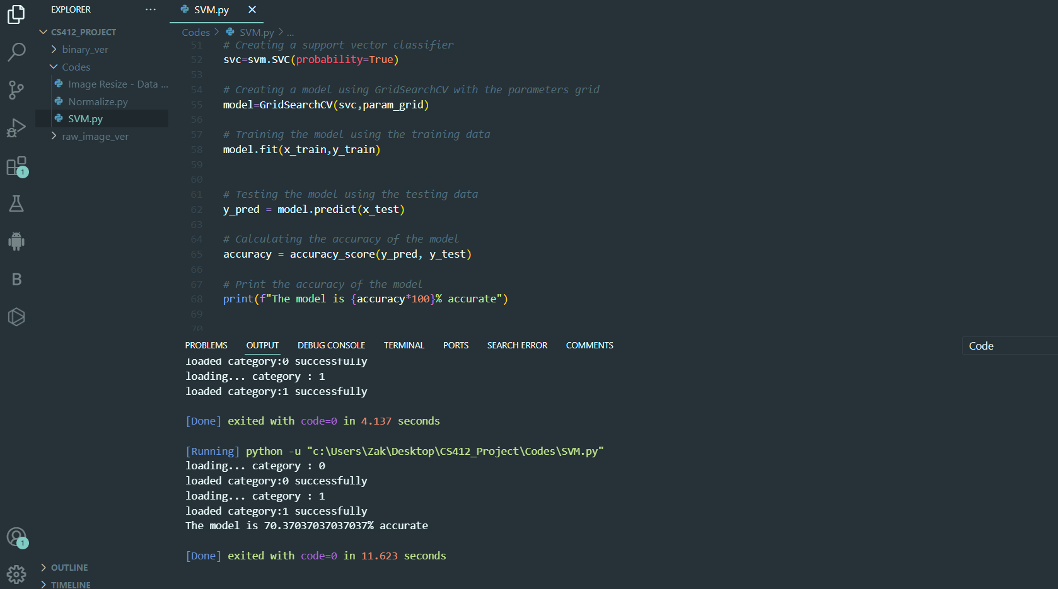

Figure 1

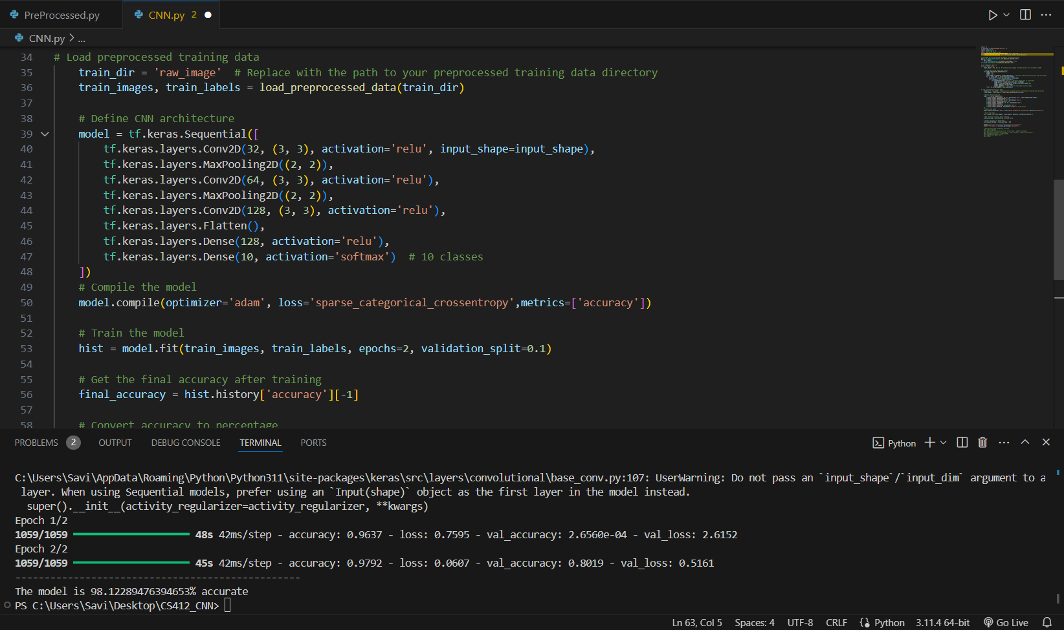

Figure 2

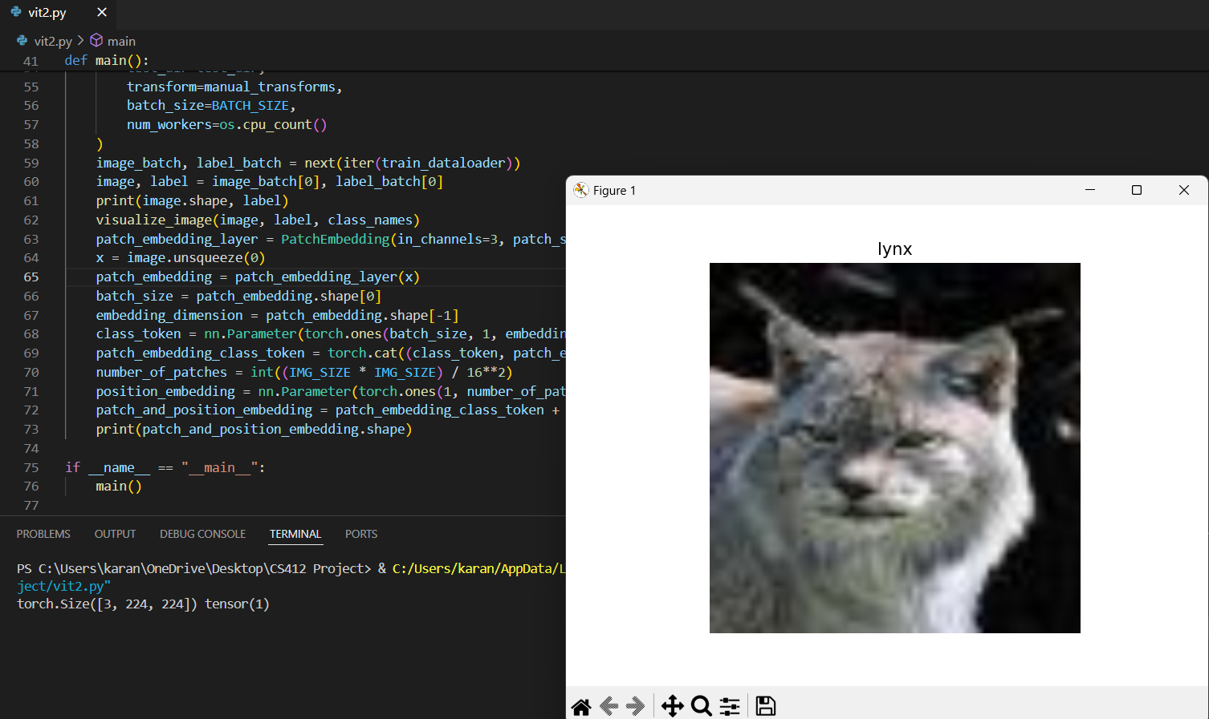

Figure 3