

**P.E.S University, Bangalore-560085**

**Department of Computer Science & Engineering**

**Web Technologies-1 UE17CS204**

**Mini Project**

**“PESU Scholar”**

|  |  |  |  |  |
| --- | --- | --- | --- | --- |
| **Sl.No** | **USN** | **Name** | **Semester** | **Section** |
| 1 | PES1201700954 | Salman Ahmed Fairoze | 3 | D |
| 2 | PES1201701142 | Karan Panjabi | 3 | D |
| 3 | PES1201701002 | Mainaki Saraf | 3 | D |



**Project Description**

**Objective:**

The objective of this project is to create a website which serves as a unified platform of research and for PES University irrespective of the branch or department.

**Technologies used:**

We have used basic html, CSS, JavaScript and PHP in this website.

**Description:**

Our project uses html, CSS, JavaScript and PHP. HTML forms the structure and major aesthetic work is done using CSS only. JavaScript is mainly used for hashing the passwords. The backend is done using PHP which plays a major role in our project. Our database maintains users’ basic info and their research/project works. The discussion forum is the point of attraction of our websites to many users.

**GitHub Repo Link:** <https://github.com/karan20000000000/PESU_Scholar>



**Screen Shots from the Website:**

The Index/Homepage looks as shown below

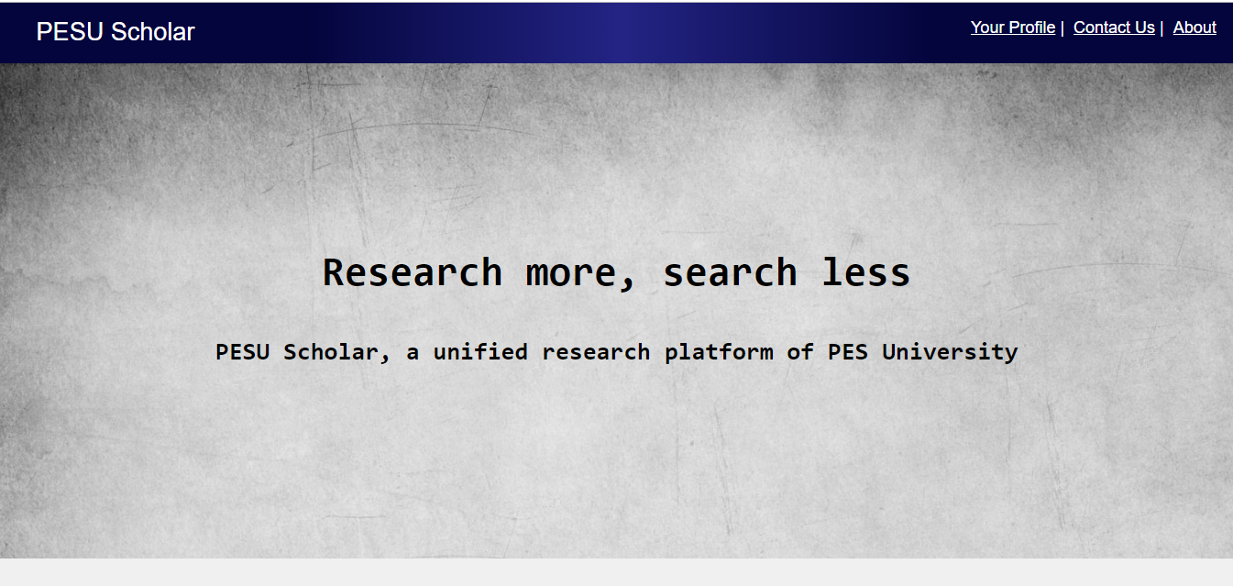



**The Login Page:**

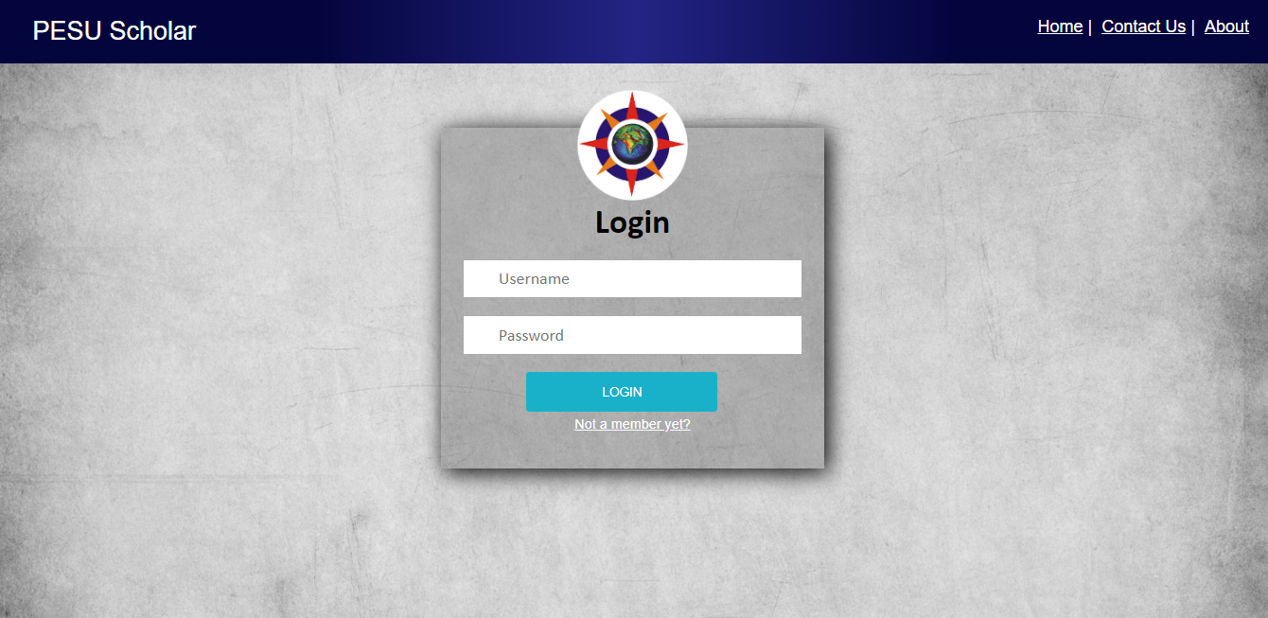



**The Profile Page:**

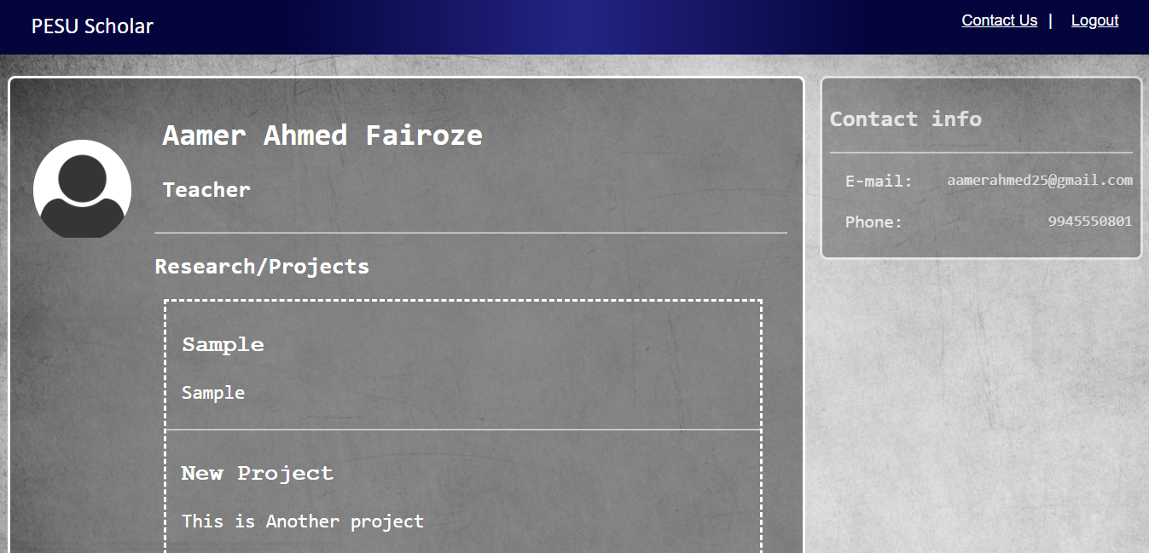

**The Discussion Forum:**

