Meeting log for Team: [**Harkey-Dan Sp22-1**]

DevConnect

Members:

Karan Pinakinbhai Jariwala

Danesh Vijay Dhamejani

Harshala Ashok Doiphode

Yusuf Juzar Soni

1. Team Meeting [30 August 2022]

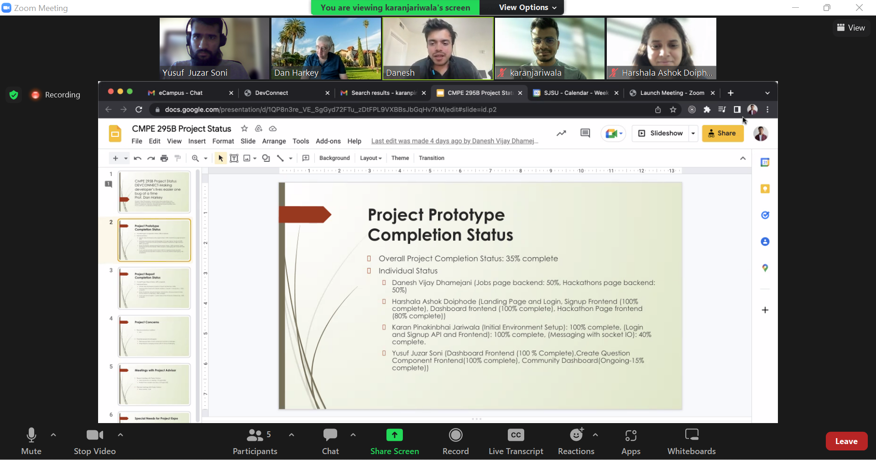

1. Team Meeting with Advisor [20 September 2022]

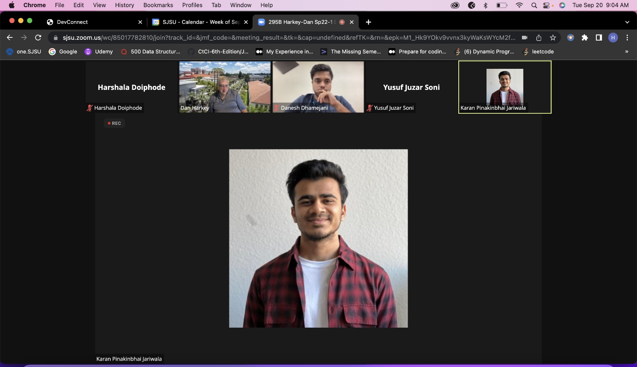

1. Team Meeting with Advisor [4 October 2022]

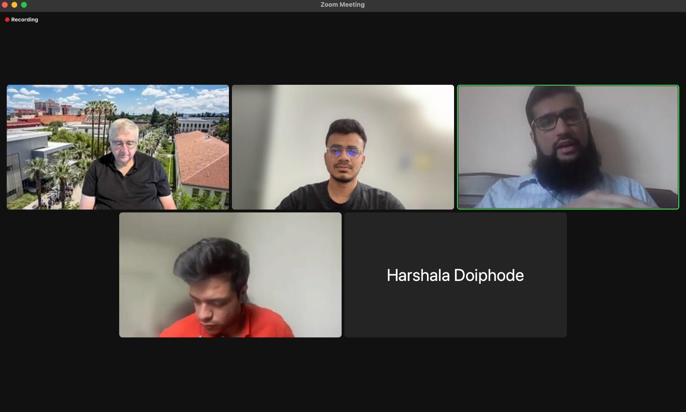

1. Team Meeting with Advisor [18 October 2022]

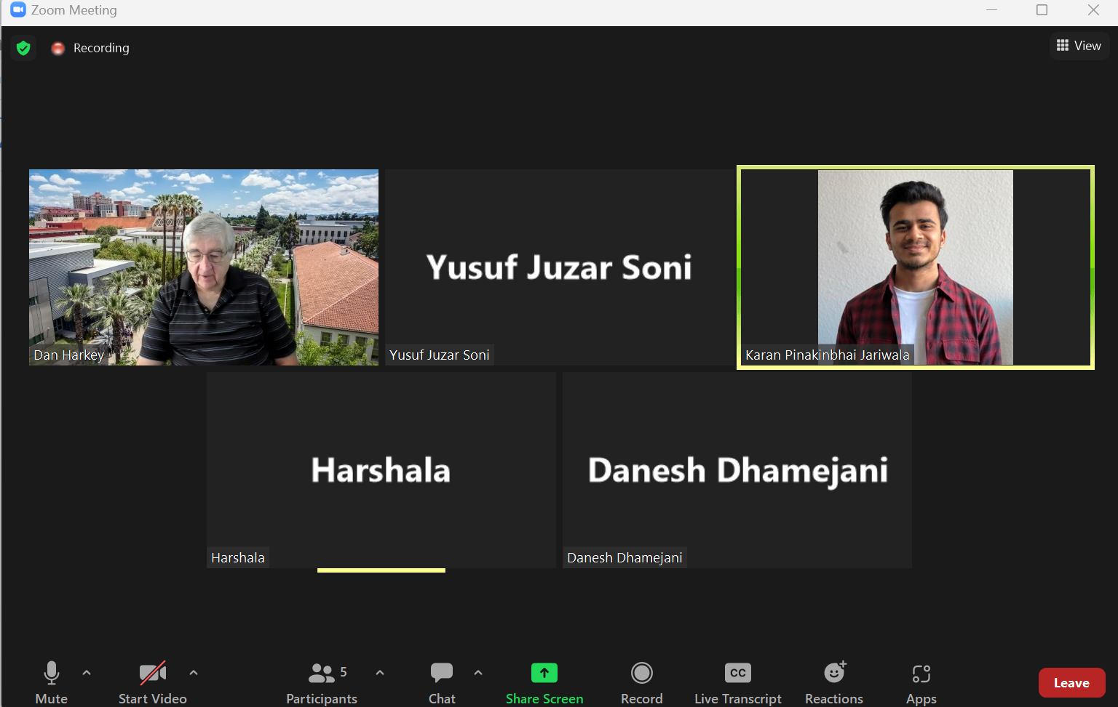

1. Team Meeting with Advisor [25 October 2022]

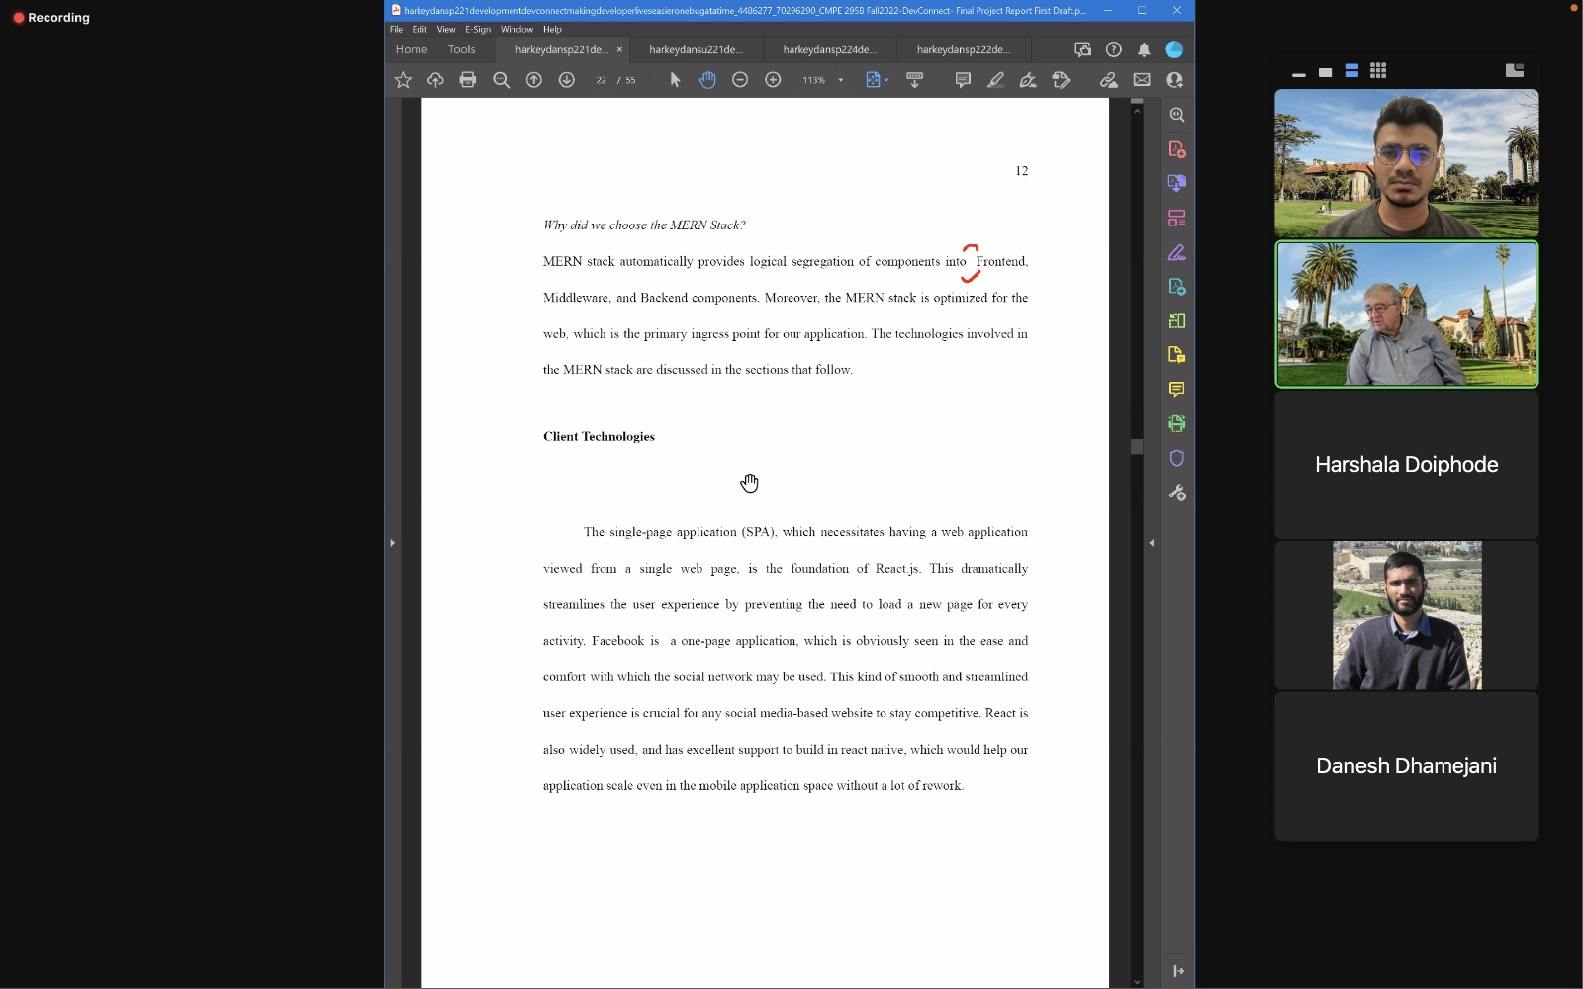

1. **Team Meeting [1 november]**

