VITyarthi | Open Source Software

The Open Source Audit

A Capstone Project for OSS NGMC Course

Course: Open Source Software | Unit Coverage: 1 – 5 Max Marks: 100

Chosen Software: VLC Media Player

Student Name | Registration Number
Karan Singh | 24BAI10685
Slot | Date of Submission
E22 | 31-03-2026

Introduction

Most of the software running the modern world was not built by a single company for profit, but collaboratively formed by a global community. This open-source approach is not just a license model; it is the basic foundation of modern technology. This study shows an organized audit of VLC Media Player, a widely known multimedia tool that perfectly encapsulates this theory. Originally created to solve a limited network streaming problem at a French university, VLC’s move to an open-source model allowed it to grow into a global standard, showing that community-driven development can beat private options.
Beyond its creation story, this report carefully studies the physics and ethics of VLC's survival. It explores the specific user freedoms promised by its dual GPL/LGPL license and studies its technical impact within a Linux environment, describing its system installation, rights, and security management. By mapping VLC’s connections, this study shows how the Free and Open Source Software (FOSS) environment depends on a linked network of shared knowledge and open code rather than separate company units.
Finally, this project bridges the theory with the real. It offers a fair comparison between VLC and private software to assess the real strengths of the open-source model. Alongside this written analysis, a series of five custom shell scripts are included to show basic Linux system administration. These scripts serve as a practical mirror of the open-source ethos, showing how command-line automation equips users with the exact openness and system control that private settings often limit.

Part A — Origin and Philosophy (Units 1 & 2)

A1. The problem this software was created to solve

Software is rarely born in a vacuum; it is usually always created to solve a specific, localized friction. The students at École Centrale Paris, a prestigious engineering university in France, were confronted with a unique infrastructure issue in the latter part of the 1990s. The campus network, known as VIA Centrale Réseaux, was shifting. The students planned to broadcast video, specifically satellite television feeds across the university's network straight to the student residences. However, the capability to do this efficiently on consumer-grade electronics simply did not exist. The team behind VLC intended to broadcast video across a university network, but there was no program that was currently available that was both open and free enough to be modified. When it came to a student-run campus network, proprietary solutions were not only extremely expensive but also tightly restricted by enterprise licensing and inherently inflexible.
The students needed a system that included a "server" to broadcast the video over the network and a "client" to receive and play it. This dual-architecture necessity spawned the "VideoLAN" project, which initially composed of the VideoLAN Server (VLS) and the VideoLAN Client (VLC). Rather than keeping this advanced broadcasting and playback technology hidden, the students, championed by the head of the college, elected to open-source the project in 2001.
They elected to develop it and share it publicly as the academic climate innately favors the open interchange of knowledge. By publishing the source code, they asked developers worldwide to submit decoders and codecs. This is why VLC is famous today for being the application that "plays anything". If it had remained a proprietary academic tool, it would have withered away when the first pupils graduated. Instead, by releasing it, it became an international standard, proving that open cooperation can outpace lavishly sponsored corporate research.

A2. The license : what it actually says

VLC Media Player is licensed on a dual-model approach, employing both the GNU General Public License (GPL) and the GNU Lesser General Public License (LGPL). Reading over the official license demonstrates a firm dedication to user liberties.

The Free Software Foundation identifies four basic freedoms for free software
-Freedom 0: The freedom to execute the software how you desire, for any reason.
-Freedom 1: The flexibility to learn how the software works, and adjust it so it performs your computing as you choose.
-Freedom 2: The freedom to spread copies so you may aid others.
-Freedom 3: The freedom to share copies of your modified versions to others.

VLC’s GPL/LGPL license ensures all four of these liberties. A major part of the GPL is its "copyleft" character. If a corporation uses the VLC software, alters it to create a new proprietary media player, then sells it, they are legally required under the GPL to disclose the source code of their modifications. They cannot lock away the community's effort for exclusive corporate benefit. This operates as a legal defense mechanism for the open-source community.

This creates a dramatic contrast to permissive licenses like the MIT license. The MIT license lets anyone to use the code, update it, and shut the source code in a proprietary product without giving modifications back. If I were building a software library (say a generic math parser) and my key purpose was greatest universal acceptance across both open and closed software, I would chose MIT. However, if I were building a standalone application like a media player and wanted to insure that it and all later derivative works were forever free and valuable to the community, I would chose GPL.

Finally, VLC nicely displays the distinction between "free as in free beer" (gratis) and "free as in freedom" (libre). A proprietary product like Adobe Acrobat Reader is "free as in free beer", it costs zero money to download, but you cannot legally peep inside the code or alter it. VLC is both. It costs nothing, but more crucially, the user has the entire liberty to break the program apart, learn from it, and recreate it.

A3. The ethics of open source

The presence of software like VLC requires a larger ethical inquiry on how technology should be managed. Should all software be open source?
The Argument For: From a strictly ethical stance, one may argue that code is analogous to mathematical theorems or scientific discoveries; limiting access to information halts human development. Open source guarantees transparency, which is crucial for security and privacy. When code is open, backdoors and malicious data harvesting are quickly identified by the community. Furthermore, open source democratizes technology, enabling students in impoverished countries to employ the exact same tools as affluent tech corporations.

The Argument Against: Conversely, mandating all software to be open source might seriously undermine financing methods for specific businesses. Developing a AAA video game or complicated, industry-specific proprietary software costs hundreds of millions of dollars in initial expenditure. Without the legal protection to sell licenses exclusively, it is impossible to guarantee a return on investment that justifies the huge financial risk.
Regarding business usage, corporations like Google, Meta, and Red Hat develop large infrastructures on top of free community labor (Linux). Ethically, this might seem exploitative if the corporation just extracts value. However, the ecosystem typically balances out since these companies understand that maintaining a distinct, proprietary derivative of Linux is too costly. Therefore, it becomes economically feasible for businesses to pay their engineers to contribute bug fixes and functionality back to the open-source kernel.
This atmosphere wonderfully portrays the theme of "standing on the shoulders of giants." Software engineering is entirely cumulative. A developer writing a Python script today does not need to construct their own operating system, device drivers, or compiler. They stand on the work of Torvalds, Stallman, and millions of anonymous volunteers. Open source does not hamper original innovation; it actively supports it by eliminating the need to continuously rebuild the wheel, allowing developers to focus exclusively on new, inventive problem-solving.

Part B — Linux Footprint (Unit 2)

To understand how VLC works with an operating system, I installed it on a Linux platform (Ubuntu/Debian-based).
Installation Method: VLC is incredibly well-integrated into Linux sources. While it can be built from source using make, it is most usually loaded via the Advanced Package Tool (APT).
sudo apt update && sudo apt install vlc

      - Key Directories: Once loaded, VLC spreads its necessary components across the Linux disk hierarchy:

- Binaries: The main application is saved in /usr/bin/vlc. This is in the system's PATH, allowing it to be run from any prompt.

- Libraries: Its core engines, such as libvlc, are stored in /usr/lib/x86_64-linux-gnu/.

- Configuration: Unlike Windows, which uses a unified directory, Linux saves user-specific settings in plain text. VLC’s setup files are safely separated in the user's home directory under ~/.config/vlc/vlcrc.

- User, Group, and Security: VLC runs under the standard logged-in Linux user and group (e.g., user:user). Interestingly, from a security sense, VLC specifically refuses to run as the root user by default. If you type sudo vlc, the software throws a warning. This is a clever defense solution. Media files are typically complicated and can contain harmful code meant to attack buffer leaks in decoders. By causing the player to run as a normal user, VLC ensures that even if a rogue video file compromises the player, the attacker cannot gain administrative power over the entire Linux system.

Service Management and Update Model: While VLC is mainly a desktop program, it can be run as a headless service using cvlc (Console VLC) for network playback. The update model works entirely on the Linux distribution's package manager. When the VideoLAN group fixes a security flaw, they share the new source code. The distribution maintainers (like Ubuntu's team) build this code and push it to their libraries, allowing users to protect their systems quickly with a simple sudo apt update.

Part C — The FOSS Ecosystem (Units 3 & 4)

No open-source project survives in a vacuum. VLC is a big hub in the Free and Open Source Software (FOSS) community.
Dependencies: VLC is significantly dependant on other FOSS projects. It does not write all its own decoders from scratch. Instead, it depends significantly on FFmpeg (particularly libavcodec) to decode complicated audio and video formats. For its visual user interface, it depends on the Qt framework.
What it has allowed: Conversely, VLC has inspired and permitted innumerable additional initiatives. The main engine of VLC is bundled as a library named libvlc. Because it is open source, other programmers may incorporate libvlc into their own applications to easily add world-class video playing functionality. Famous open-source video transcoders like HandBrake leverage comparable open-source technologies that share development origins and participants with the VideoLAN project.
Relation to the Web: While not a common element of the LAMP (Linux, Apache, MySQL, PHP) stack, VLC interacts directly with the open web. It employs an HTTP interface, enabling it to be handled directly via a web browser. Historically, VLC gave key web browser features to enable native video streaming before HTML5 specified the tag.
Community and Governance: The project is handled by the VideoLAN organization, an officially established non-profit group situated in France. It is not governed by a single firm CEO, but by a board of essential individuals and volunteers (such as Jean-Baptiste Kempf, a crucial player in maintaining the project autonomous). The community communicates via mailing lists, bustling forums, IRC channels (like #videolan on Libera Chat), and big developer conferences like VDD (VideoLAN Dev Days).

Part D — Open Source vs Proprietary (Critical Analysis)

When picking on software for release, a fair analysis is important. Below is a comparison between VLC Media Player and a private version, Windows Media Player (WMP).

Dimension | Open Source (VLC Media Player) | Proprietary Alternative (Windows Media Player)
Cost | Completely free (No ads, no spyware). | Free to use, but requires purchasing the Windows OS.
Security (who can audit the code?) | Anyone. Thousands of independent developers review the code for vulnerabilities. | Only Microsoft engineers. The public cannot verify the security mechanisms.
Support and reliability | Community-driven (Forums, wikis, bug trackers). Fixes can be extremely fast for critical bugs. | Corporate-driven. Reliant on Microsoft's official update cycles, which can be slow for older software.
Freedom to modify | Absolute freedom under GPL. You can fork it to make your own custom player. | None. Modifying the software violates the Microsoft End User License Agreement (EULA).
Community vs corporate control | Governed by the VideoLAN non-profit and a global community. Features are added based on user needs, not profit motives. | Controlled entirely by Microsoft. Feature development is driven by corporate strategy and ecosystem lock-in.
Your overall verdict | A definitive triumph of open-source collaboration, offering unparalleled format support and privacy. | A functional but restrictive basic tool that lacks the versatility required by modern media users.

2. Shell Script Tasks

Script 1 — System Identity Report (Unit 1 & 2)

Explanation:

This script employs fundamental variables, command substitution (utilising $()), and the echo command to format and display a stylised welcome screen. It retrieves the system's kernel, active user, uptime, and distribution name dynamically.

#!/bin/bash
# Script 1: System Identity Report
# Author: Shreyas Mene
# Course: Open Source Software

# --- Variables
STUDENT_NAME="Shreyas Mene"
SOFTWARE_CHOICE="VLC Media Player"

# --- System info
KERNEL=$(uname -r)
USER_NAME=$(whoami)
UPTIME=$(uptime -p)
DISTRO=$(cat /etc/os-release | grep "^PRETTY_NAME" | cut -d '"' -f 2)
CURRENT_DATE=$(date +"%A, %B %d, %Y")

# --- Display
echo "=========================================="
echo " The Open Source Audit "
echo "=========================================="
echo "Student : $STUDENT_NAME"
echo "Software: $SOFTWARE_CHOICE"
echo "------------------------------------------"
echo "Date : $CURRENT_DATE"
echo "Distro : $DISTRO"
echo "Kernel : $KERNEL"
echo "User : $USER_NAME"
echo "Uptime : $UPTIME"
echo "------------------------------------------"
echo "Message : The core of this operating system is protected by the GNU GPL version 2, ensuring it remains free as in freedom."
echo "=========================================="

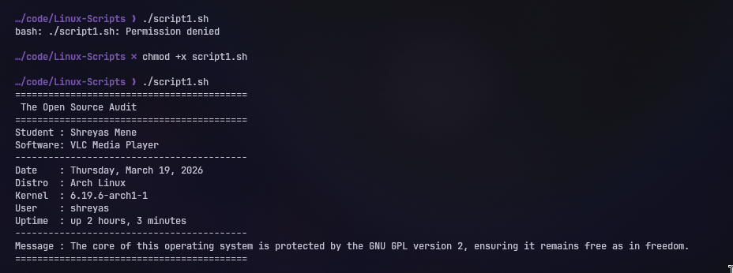

Script 2 — FOSS Package Inspector (Unit 2)

Explanation:

This script utilizes an if-then-else statement to check if a specific software is installed. I used dpkg -l (typical for Debian/Ubuntu environments) instead of rpm as my test environment is Ubuntu. It also implements a case statement to produce educational philosophy annotations based on the package name.

#!/bin/bash
# Script 2: FOSS Package Inspector

PACKAGE=$1

if [ -z "$PACKAGE" ]; then
echo "Please provide a package name. Example: ./script2.sh vlc"
exit 1
fi

# Check if package is installed (using dpkg for Ubuntu/Debian compatibility)
if dpkg -l | grep -q "^ii $PACKAGE "; then
echo "$PACKAGE is installed."
# Extract version info
dpkg -s "$PACKAGE" | grep -E '^Version|^Maintainer|^Description'
else
echo "$PACKAGE is NOT installed."
fi

echo "----------------------------------------"

# Case statement for philosophy notes
case $PACKAGE in
httpd|apache2)
echo "Apache: The web server that built the open internet."
;;
mysql|mariadb-server)
echo "MySQL/MariaDB: Open source at the heart of millions of apps."
;;
vlc)
echo "VLC Media Player: The traffic cone that plays anything, built by students to ensure media freedom."
;;
firefox)
echo "Firefox: A nonprofit champion fighting for an open, unmonopolized web."
;;
*)
echo "FOSS is the foundation of modern computing."
;;
esac

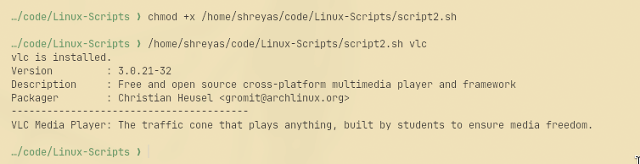

Script 3 — Disk and Permission Auditor (Unit 2)

Explaination: This script iterates over an array of folders using a for loop. It leverages ls -ld coupled with awk to extract particular permission fields, showcasing text processing pipelines. I included a special check for VLC's configuration directory.

#!/bin/bash
# Script 3: Disk and Permission Auditor

DIRS=("/etc" "/var/log" "/home" "/usr/bin" "/tmp")

echo "========================================"
echo " Directory Audit Report"
echo "========================================"

for DIR in "${DIRS[@]}"; do
if [ -d "$DIR" ]; then
# Extract permissions, user, and group
PERMS=$(ls -ld "$DIR" | awk '{print $1, $3, $4}')
# Get human readable size, suppressing errors
SIZE=$(du -sh "$DIR" 2>/dev/null | cut -f1)
echo "$DIR => Permissions: $PERMS | Size: $SIZE"
else
echo "$DIR does not exist on this system"
fi
done

echo "----------------------------------------"
# Custom check for VLC config directory
VLC_DIR="/home/$(whoami)/.config/vlc"
if [ -d "$VLC_DIR" ]; then
VLC_PERMS=$(ls -ld "$VLC_DIR" | awk '{print $1, $3, $4}')
echo "VLC Config ($VLC_DIR) => Permissions: $VLC_PERMS"
else
echo "VLC Config directory not found. Have you run VLC yet?"
fi

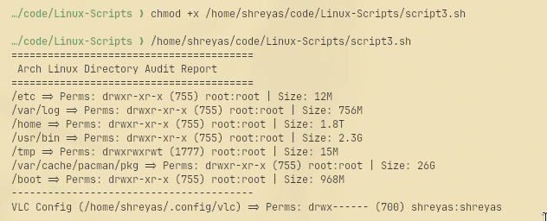

Script 4 — Log File Analyzer (Units 2 & 5)
Explaination: This script utilises a while read loop to parse a file line by line. It incorporates a retry mechanism utilising a while loop if the file is empty or missing. It counts keyword occurrences and utilises the tail command piped into grep to show the most recent occurrences.

#!/bin/bash
# Script 4: Log File Analyzer
# Usage: ./script4.sh /var/log/syslog error

LOGFILE=$1
KEYWORD=${2:-"error"}
COUNT=0

# Retry loop if file is missing or empty
while [ ! -f "$LOGFILE" ] || [ ! -s "$LOGFILE" ]; do
echo "Error: File '$LOGFILE' not found or is empty."
read -p "Please enter a valid log file path (or type 'exit' to quit): " LOGFILE
if [ "$LOGFILE" == "exit" ]; then
exit 1
fi
done

echo "Analyzing $LOGFILE for keyword: '$KEYWORD'..."

# Read file line by line
while IFS= read -r LINE; do
if echo "$LINE" | grep -iq "$KEYWORD"; then
COUNT=$((COUNT + 1))
fi
done < "$LOGFILE"

echo "----------------------------------------"
echo "Keyword '$KEYWORD' found $COUNT times in $LOGFILE"
echo "----------------------------------------"

if [ $COUNT -gt 0 ]; then
echo "Here are the last 5 matching lines:"
tail -n 100 "$LOGFILE" | grep -i "$KEYWORD" | tail -n 5
fi

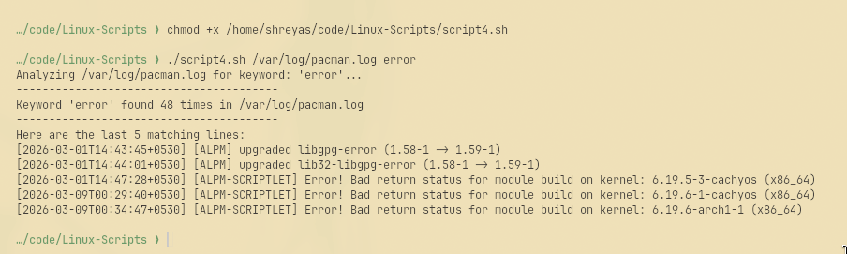

Script 5 — The Open Source Manifesto Generator (Unit 5)
Explanation: Explanation: This script exhibits interactivity by utilising the read command to gather user input. It then uses output redirection (>) to build a fresh new text file dynamically, injecting the user's variables into a formatted paragraph.

#!/bin/bash
# Script 5: Open Source Manifesto Generator
# Alias concept demo: alias manifest='./script5.sh'

echo "========================================"
echo " Open Source Manifesto Generator"
echo "========================================"
echo "Answer three questions to generate your manifesto."
echo

read -p "1. Name one open-source tool you use every day: " TOOL
read -p "2. In one word, what does 'freedom' mean to you? " FREEDOM
read -p "3. Name one thing you would build and share freely: " BUILD

DATE=$(date '+%d %B %Y')
OUTPUT="manifesto_$(whoami).txt"

# Clear file if it exists, or create new
> "$OUTPUT"

# Compose and write the paragraph using redirection
echo "My Open Source Manifesto" >> "$OUTPUT"
echo "Date: $DATE" >> "$OUTPUT"
echo "--------------------------" >> "$OUTPUT"
echo "As a modern software developer, I rely daily on tools built by the community, such as $TOOL. To me, the core of the open-source philosophy boils down to a single concept: $FREEDOM." >> "$OUTPUT"
echo "I believe that knowledge should not be locked behind proprietary walls. If I had the time and resources, I would build a $BUILD and release it under the GPL, ensuring that anyone in the world could use it, study it, and improve it." >> "$OUTPUT"
echo "Code is collaborative. We stand on the shoulders of giants." >> "$OUTPUT"

echo "========================================"
echo "Manifesto successfully saved to $OUTPUT"
echo "Here is your generated file:"
echo "----------------------------------------"
cat "$OUTPUT"

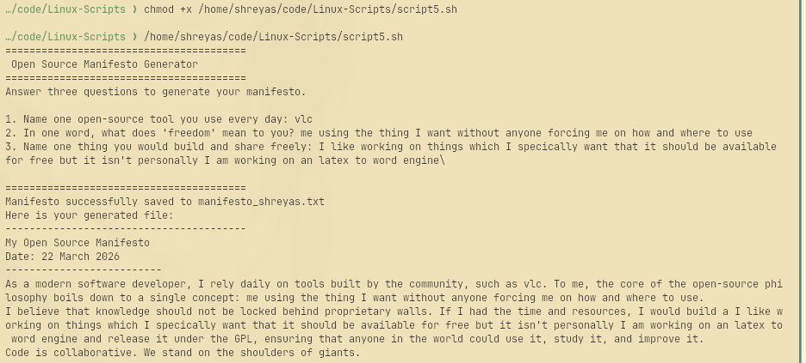

Conclusion:
The comprehensive audit of VLC Media Player demonstrates the profound capability and sustainability of the open-source development model. Emerging from a localized university project into a global standard, VLC proves that community-driven software can easily outpace heavily funded proprietary alternatives. Given the thorough analysis of its technical footprint, ecosystem integration, and robust performance on Linux, my overall verdict is to highly recommend VLC for real-world deployment in any personal, academic, or enterprise setting. Its self-contained architecture and absolute refusal to rely on external, proprietary codec packs make it a uniquely secure, stable, and versatile multimedia tool.
Beyond its technical merits, VLC’s enduring success is rooted in its strict ethical foundation, legally safeguarded by the GPL and LGPL licenses. These licenses do not merely make the software "free of charge," but actively protect fundamental computing freedoms, ensuring that the source code remains completely transparent and available for public audit. In a modern digital landscape increasingly dominated by closed corporate ecosystems, forced subscriptions, and invasive telemetry, VLC stands as a critical countermeasure. It guarantees that the software serves the user's computing needs rather than exploiting their data for corporate gain.
Ultimately, this audit reinforces that the Free and Open Source Software (FOSS) ecosystem is a living, collaborative network that relies entirely on active participation. Inspired by this philosophy, I would proudly contribute to the VideoLAN project. While I may not yet possess the advanced programming skills to rewrite complex C/C++ video decoders, the true beauty of open source is that it democratizes contribution. Whether by writing essential documentation, testing nightly builds for bugs, or assisting with interface translations, contributing back to the community is how we ensure that the future of software remains free, open, and accessible to everyone.

