BUSINESS ANALYSIS REPORT
Hospital Inpatient Web Portal
Market Opportunity, Competitive Intelligence & Sustainability Assessment
Prepared for | Date
Healthcare Software Development Team | June 2026
Document Type | Classification
Business Analysis & Market Intelligence | Confidential — Internal Use Only

EXECUTIVE SUMMARY

The Hospital Inpatient Web Portal represents a compelling opportunity in the rapidly growing digital health market. This report provides a detailed analysis of the business concept, market landscape, competitive positioning, pricing intelligence, financial projections, and strategic recommendations. The patient portal market is valued at $4.8B–$6.5B in 2024 and is projected to reach $15B–$20B by 2033, with a CAGR of 17–19%. This product targets an underserved mid-market segment of Ontario community hospitals that require modern inpatient coordination tools but cannot afford tier-1 EHR implementations. Its distinctive family-access credential model, deliberate publish-gate architecture, and PHIPA-native design create a defensible market position.

Table of Contents

1. Business Concept Overview

1.1 Product Description
The Hospital Inpatient Web Portal is a secure, role-based web application designed exclusively for hospital-side operations. Unlike conventional patient portals that focus on patient self-service, this platform is a clinician-first coordination tool where authorized hospital staff enter, manage, and curate inpatient data — which then flows in a controlled manner to a companion patient/family-facing application or portal.

Core Product Identity
A hospital-side inpatient care coordination platform with a two-sided information model: full clinical workflow management for staff (doctors, nurses, coordinators, diagnostics, reception) on one side; curated, publish-gated daily health updates for authorized patients and family members on the other.

1.2 Key Features Defined in Requirements
Module | Key Requirements | Business Value
Authentication | Role-based access for 7 staff roles; SSO; session timeout; break-glass access; head admin account creation workflow | Controls PHI access precisely; eliminates unauthorized data viewing
Dashboard | Live patient lists; task worklists; alert center; vital monitoring schedules; priority patient lists; discharge follow-up scheduling | Staff see actionable priorities instantly; reduces missed tasks
Admission Management | Full demographic capture; duplicate detection; bed conflict blocking; family credential generation (Patient ID + random password) | Clean admission records; automated family portal onboarding
Clinical Notes | Chronological progress notes with author/timestamp; internal vs. patient-facing visibility toggle; sign-off workflow; addendum-only editing after sign-off | Immutable audit trail; prevents accidental PHI disclosure
Medication Workspace | Prescription entry with schedules; PRN rules; food/caution instructions; interaction/allergy warnings; administration log with exception reason capture | Medication safety with full administration accountability
Diagnostics & Reports | Test ordering; status workflow; file upload/preview; doctor review gate before patient release; abnormal result flagging | Prevents premature release of sensitive results to patients
Scheduling | Consultant visit management; doctor availability calendar; follow-up booking; reschedule/cancel workflow | Reduces scheduling conflicts; patient-facing appointment visibility
Discharge Planning | Discharge readiness checklist; discharge summary generation; patient handoff publishing; post-discharge reminders | Safer discharge; reduced readmission risk; post-care continuity
Document Center | File repository with category classification; patient-visibility settings; version control | Centralized, governed clinical document management
Audit & Governance | Full audit trail; access logs; role administration; data export controls; PHIPA/PIPEDA and HL7 alignment | Compliance-ready from day one; supports privacy investigations

1.3 Unique Value Propositions
- UVP 1: Family/Caregiver Credential System: Auto-generated secure login credentials per patient for authorized family members, enabling daily health updates — a feature largely absent from enterprise EHR portals.
- UVP 2: Deliberate Publish-Gate Model: Patient visibility is an explicit publishing workflow (Draft → Reviewed → Published → Withdrawn), not an automatic side effect of staff entry. This reduces accidental PHI disclosure.
- UVP 3: Integrated Post-Discharge Continuity: Follow-up scheduling, medication reminders, and discharge instructions are built in, not bolted on — addressing the continuity gap that drives costly hospital readmissions.
- UVP 4: PHIPA-Native Architecture: Designed from day one for Ontario's Personal Health Information Protection Act, with PIPEDA and HIPAA crosswalk controls for future cross-border deployments.
- UVP 5: Mid-Market Pricing: Targeting hospitals with 50–300 beds that are systematically underserved by Epic ($10M–$30M) and Oracle Health ($2M–$5M). SaaS per-bed pricing keeps costs 95% below tier-1 competitors.

2. Market Analysis

2.1 Global Market Size & Growth
The patient portal and health coordination software market is one of the fastest-growing segments in healthcare IT. Multiple independent research sources consistently project a CAGR of 17–19% through 2033, driven by accelerating EHR adoption, government digitization mandates, rising patient engagement expectations, and the growing demand for care coordination platforms.

Market Size 2024  $4.8B  Patient portal software global | Projected 2033  $19.3B  At 17.1% CAGR | Growth Rate  17–19%  CAGR 2025–2033 | EHR Adoption  68%+  Hospitals with digital portals

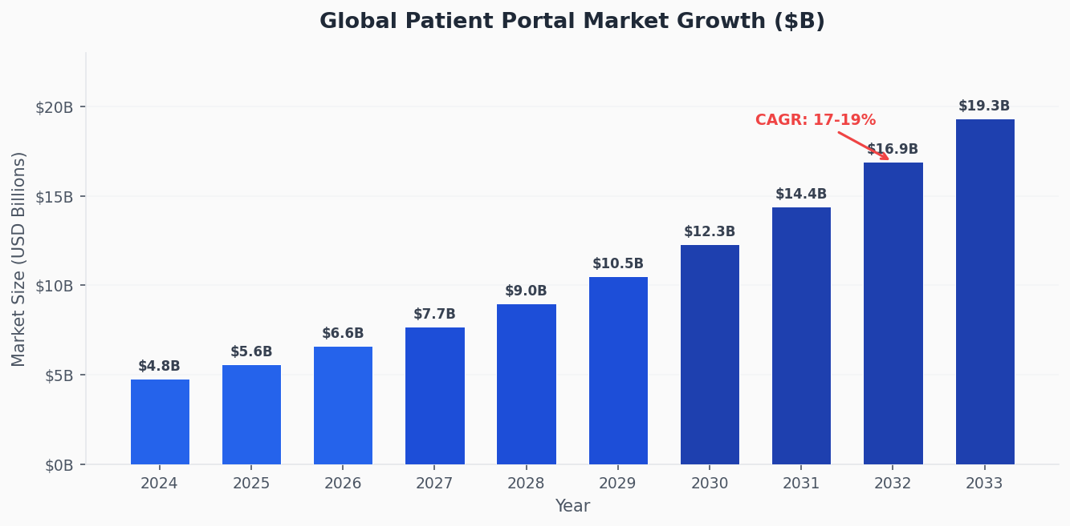
Figure 1: Global Patient Portal Market Growth 2024–2033 (USD Billions)

2.2 Market Drivers
- Regulatory push: Government mandates: Canadian provinces and the U.S. (21st Century Cures Act) are legislatively accelerating digital health infrastructure and patient data access rights.
- Demand shift: Post-pandemic patient expectations: Patients and families now expect digital access to health information as a baseline standard of care, not a premium feature.
- Cost pressure: Readmission reduction pressure: Canadian hospitals face financial penalties and performance scrutiny for preventable readmissions. Integrated discharge planning and post-care coordination tools directly reduce this risk.
- Workforce: Staff shortages: Nursing and clinical staff shortages make low-friction digital coordination tools a necessity rather than a convenience. Effective task management and alert systems directly support understaffed wards.
- Mid-market gap: EHR fatigue in mid-market: Community hospitals are increasingly frustrated with the complexity and cost of enterprise EHR implementations. Purpose-built coordination tools that complement — rather than replace — existing EHRs are gaining traction.

2.3 Ontario & Canadian Market Specifics
Ontario is Canada's largest province by healthcare spending and hospital infrastructure. It represents the optimal beachhead market for this product due to regulatory alignment (PHIPA), concentration of community hospitals, and growing provincial investment in digital health through Ontario Health.

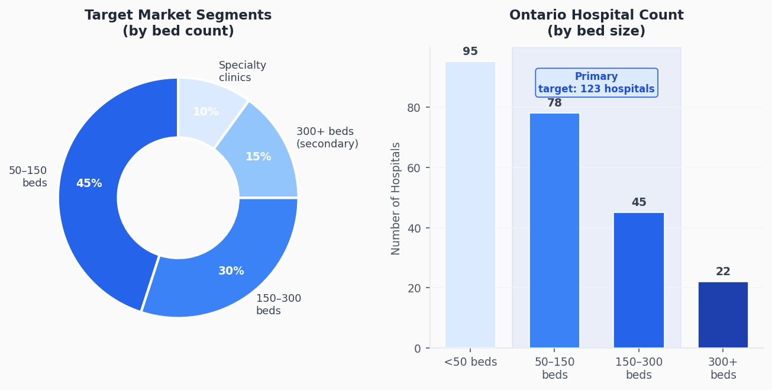
Figure 2: Ontario Hospital Landscape and Target Market Segmentation

Ontario Market Opportunity
Ontario has approximately 240 hospitals. Of these, roughly 123 fall in the 50–300 bed range — the primary target segment. At a conservative 10% penetration over 5 years (12 hospitals), and an average of 150 beds at the Professional tier ($90/bed/month), this represents approximately $1.9M ARR. Full 30% penetration yields $5.8M ARR from Ontario alone — before Canada-wide or U.S. expansion.

3. Competitive Analysis

3.1 Competitive Landscape Overview
The patient portal and inpatient coordination market is dominated by large EHR vendors whose products are expensive, complex to implement, and designed for enterprise-scale health systems. This leaves a significant gap for purpose-built, affordable coordination tools targeting community hospitals. The five primary competitive categories are analyzed below.

3.2 Feature Capability Comparison
The following heatmap scores each competitor across key capability dimensions on a scale of 1 (low) to 10 (high). This product is highlighted in blue.

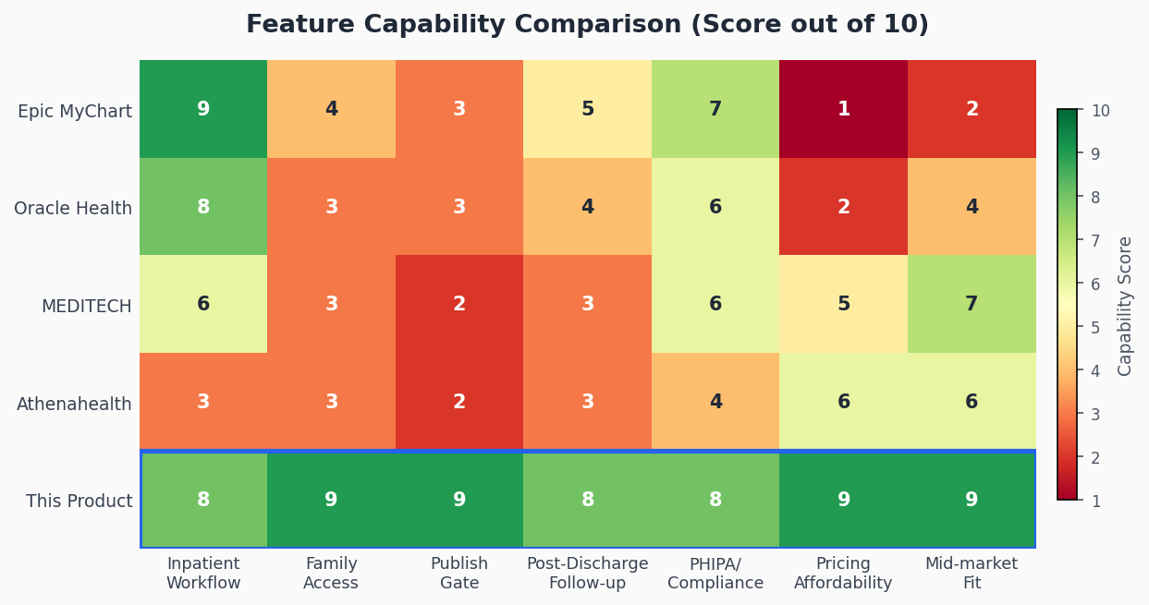
Figure 3: Feature Capability Heatmap (Score /10) — This Product Highlighted

3.3 Detailed Competitor Analysis
Feature / Dimension | Epic MyChart | Oracle Health | MEDITECH | Athenahealth | This Product
Inpatient Clinical Workflow | ★★★★★ Best-in-class | ★★★★ Strong | ★★★ Moderate | ★ Outpatient only | ★★★★ Purpose-built
Family/Caregiver Access | ★★ Proxy (limited) | ★★ Basic proxy | ★ Very limited | ★ Minimal | ★★★★★ Core feature
Publish-Gate for Patient Data | ★★ Timer-based | ★★ Partial | ★ Manual | ★★ Basic | ★★★★★ Full workflow
Post-Discharge Follow-up | ★★★ Available | ★★★ Available | ★★ Basic | ★★ Basic | ★★★★ Integrated
PHIPA/Canada Compliance | ★★★ Adaptable | ★★★ Adaptable | ★★★ Available | ★★ Limited Canada | ★★★★★ Native
HL7 FHIR Integration | ★★★★★ Leader | ★★★★ Strong | ★★★ Standard | ★★★ Cloud-native | ★★★ Planned
Pricing Affordability | ★ $10M–$30M+ | ★★ $2M–$5M | ★★★ $800K–$2M | ★★★ % of collections | ★★★★★ SaaS /bed
Implementation Speed | ✗ 12–24 months | ✗ 9–18 months | ⚠ 6–12 months | ✓ 3–6 months | ✓✓ 4–8 weeks
Mid-Market Fit (50–300 beds) | ✗ Too large | ⚠ Possible | ✓ Designed for this | ⚠ Outpatient focus | ✓✓ Primary target
Medication Safety Workflow | ★★★★★ Best-in-class | ★★★★ Strong | ★★★ Good | ★★ Basic | ★★★★ Comprehensive
Audit & Compliance Tools | ★★★★★ Full | ★★★★ Strong | ★★★ Standard | ★★★ Standard | ★★★★ Built-in
Role-Based Access Control | ★★★★★ Granular | ★★★★ Granular | ★★★ Standard | ★★★ Standard | ★★★★ 7 role types

3.4 Competitor Deep Dives

Epic MyChart
Epic Systems' MyChart is the market leader for large hospital systems with a KLAS 2024 score of 90.1. Its implementation costs of $10M–$30M+ and deployment timelines of 12–24 months effectively exclude it from the community hospital market. MyChart's inpatient capability is comprehensive but requires the full Epic EHR ecosystem. Family proxy access exists but is designed for outpatient scenarios, not daily inpatient updates. Epic targets health systems with 300+ beds and significant IT infrastructure.

Oracle Health (Cerner Millennium)
Oracle Health, following its $28.3B acquisition of Cerner in 2022, is the second-largest player with approximately 21–25% of the U.S. hospital EHR market. A 150-bed hospital typically pays $2.5M–$4M over three years. Post-acquisition KLAS satisfaction scores have declined, and the platform faces strategic uncertainty as Oracle migrates Cerner to its cloud infrastructure. This creates a rare window where existing Cerner customers may be receptive to supplementary coordination tools.

MEDITECH Expanse
MEDITECH is the most direct structural competitor — it targets small-to-medium hospitals under 200 beds and offers a cloud-based EHR called Expanse with patient engagement focus. However, MEDITECH's family communication and post-discharge capabilities are limited. Its 2025 estimated revenue of $376–393M reflects a company with slower innovation velocity. This product can be positioned as a complementary coordination layer for existing MEDITECH hospitals.

Athenahealth (AthenaOne)
Athenahealth is primarily an outpatient/ambulatory platform with a unique success-based pricing model (4–7% of collections). Its inpatient capabilities are weak, and its Canadian market presence is limited. Not a direct competitor for inpatient coordination, but relevant as a benchmark for cloud-native, affordable healthcare SaaS pricing models.

Oneview Healthcare
Oneview Healthcare is the closest inpatient-focused niche competitor, providing digital care platforms for inpatient experience including patient-family communication. However, Oneview focuses on the bedside digital experience (entertainment, education, communication) rather than the clinical workflow and coordination layer. It lacks the clinical depth (medication administration, diagnostics workflow, discharge planning) described in the requirements. A potential integration partner rather than a direct competitor.

4. Pricing Intelligence & Revenue Model

4.1 Competitor Pricing Benchmarks
Healthcare IT pricing is largely opaque — most enterprise vendors require custom quotes. The following figures are derived from publicly reported case studies, analyst estimates, and procurement disclosures.

Platform | Model | First-Year Cost | Annual Ongoing | Best For
Epic MyChart | Custom enterprise | $10M–$30M+ | $3M–$5M/yr | Large health systems 300+ beds
Oracle Health (Cerner) | Quote-based / ~$25/user/mo | $2M–$5M (200-bed) | $400K–$900K/yr | Mid-large hospitals
MEDITECH Expanse | Quote-based | $800K–$2M | $200K–$400K/yr | Community hospitals <200 beds
Athenahealth | 4–7% of collections | $150K–$500K | $120K–$350K/yr | Ambulatory / outpatient
Oneview Healthcare | Quote / per bed | $300K–$1M | $100K–$250K/yr | Inpatient bedside experience
This Product (proposed) | SaaS per bed/month | $54K–$162K (100-bed yr1) | $54K–$162K/yr ongoing | Mid-market Ontario hospitals 50–300 beds

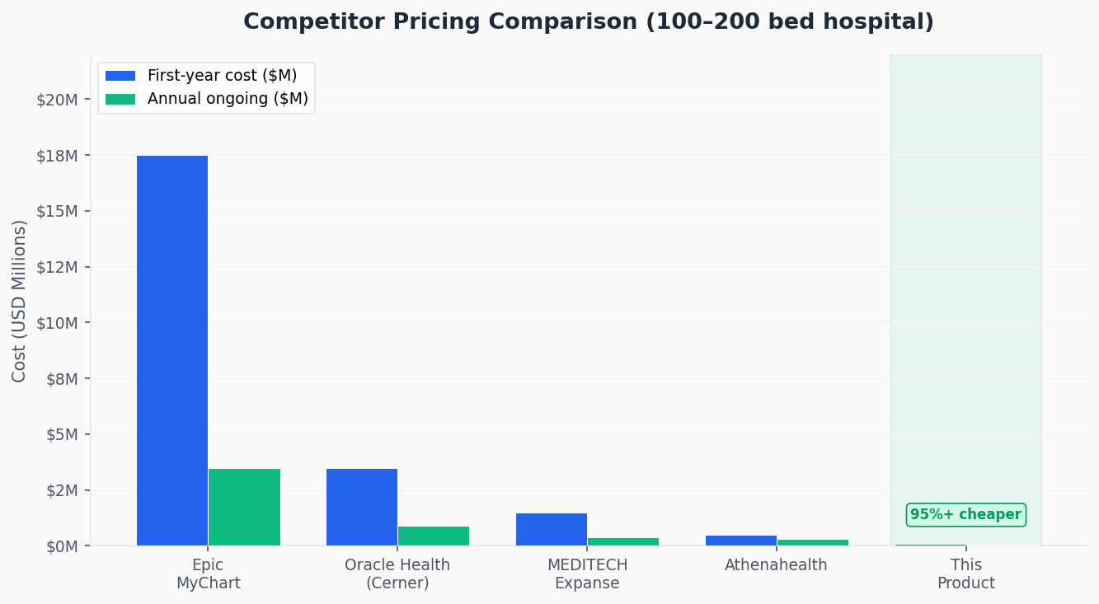
Figure 4: Competitor First-Year vs. Annual Ongoing Cost Comparison (100–200 Bed Hospital)

4.2 Proposed Revenue Model
The recommended pricing model is a SaaS subscription charged per licensed bed per month. This model aligns with hospital operational budgeting cycles, scales naturally with hospital size, and provides predictable recurring revenue. Three tiers are proposed:

Tier | Price/Bed/Month | Target Size | Example ARR (100 beds) | Included Modules
Starter | $50 | Up to 50 beds | $60,000/yr | Admission, clinical notes, family access, basic dashboard
Professional | $90 | 50–200 beds | $108,000/yr | All starter features + medication, diagnostics, scheduling, discharge, HL7 integration
Enterprise | $130+ | 200+ beds | $234,000+/yr | All professional features + multi-department, custom integrations, dedicated support, full audit suite

Pricing Advantage Summary
A 100-bed hospital on the Professional tier pays $108,000/year — compared to $400,000–$900,000/year for Oracle Health maintenance alone, and $3M–$5M/year for Epic. This represents a 75–98% cost reduction versus enterprise alternatives, making the value proposition straightforward for budget-constrained community hospital procurement teams.

4.3 Additional Revenue Streams
- Services revenue: Implementation services: One-time onboarding, data migration, and staff training — $10,000–$50,000 per hospital depending on complexity.
- Integration services: HL7/FHIR integration work: Custom integration with existing EHR/LIS/PACS systems — $15,000–$80,000 per integration project.
- Premium modules: Compliance & audit modules: Premium add-on for advanced PHIPA reporting, breach investigation tools, and regulatory export packages.
- Patient app: Patient-side portal (B2B2C): White-label patient and family-facing mobile app licensed separately or bundled at a higher tier.
- Analytics: Analytics dashboards: Operational analytics for hospital administrators — ward utilization, discharge planning efficiency, medication compliance metrics.

5. Financial Projections

5.1 Revenue Growth Scenarios
Revenue projections assume a SaaS model with primary revenue from per-bed monthly subscriptions. Three scenarios are modeled: conservative (slower hospital sales cycles, cautious adoption), target (realistic base case), and optimistic (strong Ontario market penetration plus early expansion). Customer acquisition assumes a 12–18 month sales cycle for hospital procurement.

Scenario | Year 1 | Year 2 | Year 3 | Year 4 | Year 5
Conservative | $50K | $200K | $550K | $1.1M | $2.0M
Target (Base Case) | $70K | $300K | $850K | $1.8M | $3.5M
Optimistic | $100K | $450K | $1.2M | $2.5M | $5.0M
# Hospitals (Target) | 1–2 | 3–5 | 8–12 | 16–22 | 28–38

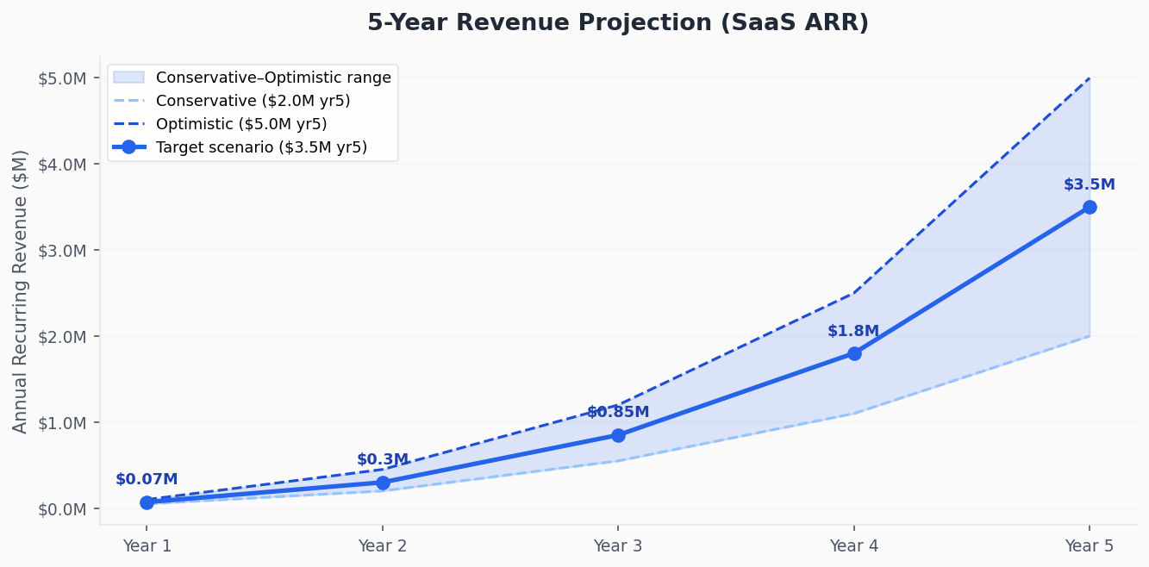
Figure 5: 5-Year ARR Projection with Conservative, Target, and Optimistic Scenarios

5.2 Key Financial Assumptions
- Average hospital size: 120 beds on the Professional tier ($90/bed/month = $129,600/year)
- Sales cycle: 12–18 months from first contact to contract signing
- Annual churn rate: 5% (healthcare SaaS churn is typically low once integrated into workflows)
- Customer Acquisition Cost (CAC): $40,000–$80,000 per hospital (enterprise sales model)
- Build cost for MVP: $300,000–$600,000 (estimated 6–12 month development with a team of 5–8)
- PHIPA compliance and security audit: $50,000–$120,000 one-time, plus ongoing monitoring
- Break-even: Approximately 4–6 hospitals on the Professional tier

6. Business Sustainability Assessment

6.1 Viability Scorecard
The following radar chart and scoring table evaluate the business across seven key sustainability dimensions. Scores above 7/10 indicate strong viability. Scores below 7/10 highlight areas requiring active mitigation.

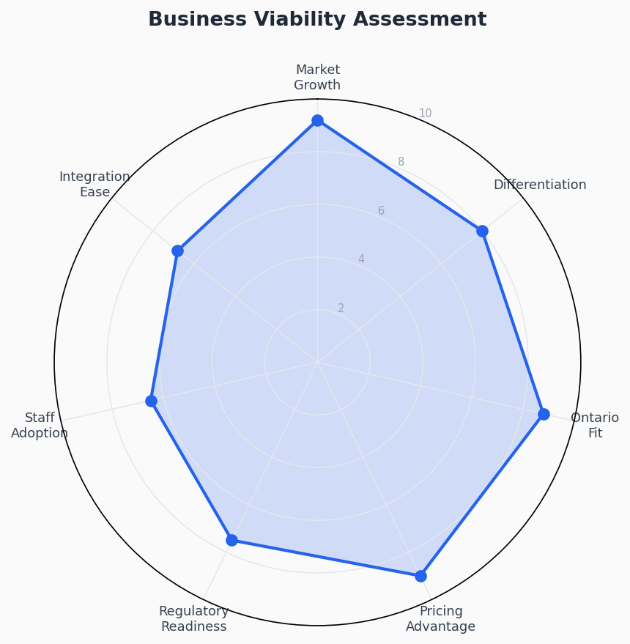
Figure 6: Business Viability Radar — Multi-Dimensional Sustainability Assessment

Dimension | Score /10 | Analysis | Verdict
Market Growth | 9.2 | Patient portal market growing at 17–19% CAGR through 2033. Regulatory tailwinds from PHIPA, provincial digitization funding, and post-pandemic demand for digital health. | Strong — Tailwind
Differentiation | 8.0 | Family credential system and publish-gate model are genuinely absent from competitor platforms. Post-discharge integration adds further distance from point-solution alternatives. | Strong — Clear moat
Ontario Market Fit | 8.8 | PHIPA-native design, Canadian data residency, and Ontario Health alignment make this a natural fit for Ontario community hospitals facing digital transformation pressure. | Excellent — Home advantage
Pricing Advantage | 9.0 | SaaS per-bed model delivers 75–98% cost reduction versus enterprise alternatives. Value proposition is immediately quantifiable for hospital procurement teams. | Excellent — Compelling ROI
Regulatory Readiness | 7.5 | Requirements reference PHIPA, PIPEDA, HL7, and HIPAA crosswalk — demonstrating awareness. Actual compliance audit and Privacy Impact Assessment must be completed pre-launch. | Good — Requires investment
Staff Adoption Risk | 6.5 | Clinical staff resistance to new tools is a known challenge. UX quality and workflow integration depth are critical adoption drivers. Training investment is mandatory. | Moderate — Manage proactively
EHR Integration Ease | 6.8 | Most Ontario hospitals have existing EHRs. HL7 FHIR integration capability is listed as a requirement but its depth and timeline need clarification. Standalone-first strategy is safer for MVP. | Moderate — Phase carefully

7. Risk Analysis & Mitigation

7.1 Risk Register
Risk Area | Severity | Description | Mitigation Strategy
Hospital Sales Cycle | High | Hospital procurement in Ontario typically takes 12–24 months, requiring RFP responses, security assessments, clinical sign-off, and procurement committee review. | Secure a design-partner hospital early (at discounted or zero cost). Build reference customer for future sales. Budget 24 months runway before first revenue.
PHIPA Compliance Cost | High | Privacy Impact Assessments, Canadian data residency, consent management, breach notification workflows, and regular compliance audits are non-negotiable for Ontario hospital contracts. | Engage a PHIPA-specialized legal/compliance consultant from day one. Integrate privacy-by-design into architecture. Allocate $50K–$120K for initial compliance certification.
EHR Integration Complexity | High | Hospitals with existing EHRs (Cerner, MEDITECH, Telus Health) will demand integration or clear standalone justification. Poorly executed integration destroys adoption. | Launch standalone-first with manual data entry. Build HL7 FHIR APIs in Phase 2. Communicate clearly as a coordination layer, not an EHR replacement.
Clinical Staff Adoption | Medium | Doctors and nurses already burdened with documentation will resist tools that add steps without clear workflow benefit. Poor UX kills clinical software. | Invest heavily in UX research with frontline nurses and ward staff. Target 2-click task completion for common actions. Measure adoption rates in pilot hospitals monthly.
Competitive Response | Medium | MEDITECH or a well-funded startup could develop similar family engagement features. Epic could add deeper Ontario localization. | Move fast in Ontario. Build deep local relationships and PHIPA credentials that take years for outsiders to replicate. Consider IP protection for the publish-gate workflow design.
Data Security Breach | Medium | A PHI breach in a healthcare SaaS platform destroys reputation, triggers regulatory investigation, and may result in substantial fines under PHIPA. | Mandatory penetration testing before launch. Encryption at rest and in transit. Role-based data minimization. Cyber insurance. Incident response plan documented pre-launch.
Revenue Concentration | Medium | Early-stage SaaS with 1–5 hospital customers has dangerous revenue concentration. Losing one customer represents 20–100% revenue loss. | Diversify geography (multiple Ontario regions) and hospital type (general, specialty, rehabilitation) from Year 2. Multi-year contracts with renewal incentives reduce churn risk.
Build Cost Overrun | Low | Healthcare software is complex. The requirements document describes 18+ modules. Scope creep is a real risk for an MVP timeline. | Ruthlessly prioritize MVP features: admission, clinical notes, family access, medication, and basic dashboard. Defer diagnostics, scheduling, and discharge to Phase 2.

8. Strategic Roadmap

8.1 Phase-Based Development & Go-to-Market Plan

Phase | Timeline | Key Activities | Success Metrics
Phase 0  Foundation | Months 1–3 | PHIPA compliance architecture; legal counsel; design partner hospital identification; UX research with clinical staff; MVP feature prioritization | Design partner signed; PHIPA counsel engaged; MVP scope locked
Phase 1  MVP Build | Months 4–10 | Build: Authentication, Dashboard, Patient Admission, Clinical Notes, Family Credential System, Basic Medication, Daily Activity Timeline. Security audit and penetration testing. | MVP feature-complete; security audit passed; pilot hospital onboarded
Phase 2  Pilot & Iterate | Months 11–18 | Pilot with 1–2 design partner hospitals; iterative UX improvement based on staff feedback; add: Diagnostics & Reports, Scheduling, Discharge Planning. PHIPA Privacy Impact Assessment completion. | NPS > 7 from clinical staff; 0 PHIPA incidents; 2 paying hospitals
Phase 3  Grow Ontario | Months 19–36 | Expand to 8–15 Ontario hospitals; launch HL7 FHIR integration module; build partner channel (healthcare IT consultants, hospital associations); develop patient-side mobile app. | $500K–$1M ARR; HL7 integration live; 3+ reference case studies
Phase 4  Scale Canada | Months 37–60 | Expand to Quebec, British Columbia, Alberta; pursue provincial digital health procurement frameworks; explore U.S. market entry with HIPAA crosswalk activation; consider Series A fundraising. | $2M–$5M ARR; 25+ hospital customers; Series A closed

8.2 Strategic Recommendations

Recommendation 1: Lead with Family Access
Position family/caregiver daily health updates as the primary market entry story. This is emotionally resonant, universally understood, and entirely absent from existing platforms. It bypasses the clinical IT gatekeepers and creates demand from hospital patient experience and communications teams, who are easier to access than CIOs.

Recommendation 2: Standalone First, Integration Second
Do not let EHR integration complexity delay your MVP. Launch as a standalone coordination tool that hospitals can adopt independently. Build a manual or file-based import option for patient demographic data. Offer HL7 FHIR integration as a premium Phase 2 service. Hospitals will adopt a well-designed standalone tool faster than waiting for a complex integration.

Recommendation 3: One Design Partner, Not a Hundred Features
The requirements document defines 18+ modules with hundreds of fields. For MVP, focus on: Authentication, Admission (with Family Credential Generation), Clinical Notes (with visibility toggle), Basic Medication, and Dashboard. Everything else is Phase 2. A focused tool that staff actually use in one hospital is worth more than a comprehensive tool that lives in a slide deck.

Recommendation 4: Price Below Procurement Thresholds
Ontario hospital procurement rules often allow department-level purchasing below $75,000–$100,000 without a full RFP process. Pricing the Starter tier at $50/bed/month means a 50-bed hospital pays $30,000/year — well below most procurement thresholds. This dramatically accelerates sales cycles for smaller hospitals and creates a lower-risk entry point.

Recommendation 5: Build for Ontario Health Certification
Ontario Health (the provincial health authority) certifies and recommends digital health tools for Ontario hospitals. Achieving Ontario Health certification or listing dramatically increases credibility and can create inbound leads from hospitals seeking provincially endorsed tools. Engage with the Digital Health Strategy team at Ontario Health early in development.

9. Conclusion
The Hospital Inpatient Web Portal is a well-conceived, well-timed business opportunity. The global market is growing at 17–19% annually, driven by regulatory mandates, patient engagement expectations, and healthcare digitization. The Ontario community hospital segment represents a systematically underserved market where enterprise EHR vendors are too expensive and generic patient portals are too shallow.

The product's three defining differentiators — the family/caregiver credential system, the deliberate publish-gate model, and integrated post-discharge continuity — are genuinely absent from competing platforms. These are not incremental features; they are architectural decisions that create a meaningfully different product and a defensible market position.

The financial model is viable. Breaking even on 4–6 Professional-tier hospitals represents a realistic 18–30 month target. The SaaS per-bed pricing model is immediately understandable and quantifiably compelling versus enterprise alternatives. At full Ontario penetration (30%), this represents a $5.8M ARR business before any national or international expansion.

The primary risks — long hospital sales cycles, PHIPA compliance investment, and clinical staff adoption — are well-understood and manageable with the right strategic approach. None of them are fatal. All of them have clear mitigation paths documented in this report.

Overall Verdict: PROCEED — HIGH VIABILITY
The Hospital Inpatient Web Portal scores 8.2/10 on our overall business viability framework. The market opportunity is real and growing. The competitive gap is genuine. The pricing advantage is overwhelming. The path to sustainability is clear. The recommendation is to proceed to Phase 0 (Foundation) immediately: engage PHIPA counsel, identify a design-partner hospital, and lock MVP scope. Time is the asset most at risk — not technical feasibility or market demand.

— End of Report —

