ConnectBack Portal – Requirement & Design Document

# Document History

|  |  |  |  |
| --- | --- | --- | --- |
| Version | Date | Author | Description |
| 1.0 | 2025-07-15 | Tallam Mohan Krishna | Initial draft with requirements, architecture, and design |

# Table of Contents

1. Objective

2. Functional Requirements

2.1 Login Screen

2.2 Signup Screen

2.3 Dashboard Page

3. Technical Solution Overview

4. Architectural Design

5. Deployment (Local for Asset Creation)

6. Future Enhancements

ConnectBack Portal – Requirement & Design Document

# 1. Objective

To develop a secure, user-friendly web application for ex-employees to access important documents and view their employment history with Argano.

# 2. Functional Requirements

## 2.1 Login Screen

Input Fields:  
- Employee ID (Argano Employee ID)  
- Password

Behavior:  
- Validates credentials against backend service  
- Navigates to Dashboard upon successful login

## 2.2 Signup Screen

Input Fields:  
- First Name  
- Last Name  
- Phone Number  
- Email ID  
- Argano Employee ID  
- Password

Behavior:  
- Captures data and triggers OTP  
- Displays input for OTP verification  
- On correct OTP, registers user into the system

## 2.3 Dashboard Page

Displayed after successful login.

Personal Details:  
- Name (e.g., TALLAM MOHAN KRISHNA)  
- Designation (at time of resignation)  
- Joining Date  
- Last Working Day

Downloadable Documents:  
- Form 16  
- Pay Slips  
- Relieving/Experience Letter

# 3. Technical Solution Overview

Frontend:  
- ReactJS (v18)  
- Routing with react-router-dom  
- Axios for API integration

Backend:  
- Spring Boot 3.3.13  
- REST APIs for login, signup, OTP, and document retrieval

Database:  
- MongoDB 6.x (LTS)  
- Collections: Users, OTP Logs, Document Metadata

# 4. Architectural Design

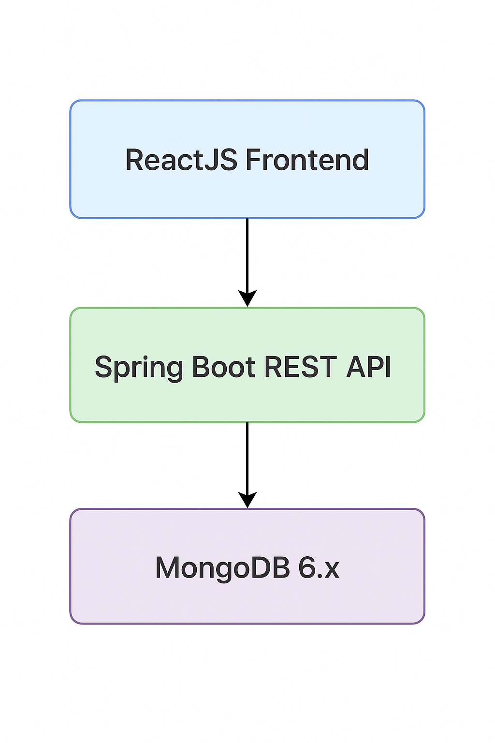

# 5. Deployment (Local for Asset Creation)

MongoDB running as Windows service  
React app run via npm start  
Spring Boot backend as standalone jar

# 6. Future Enhancements

JWT-based secure login  
Admin portal for document uploads