Experiment 2

Student Name: Karan UID: 23BCS11811
Branch: BE CSE Section/Group: KRG 3A
Semester: 6th Date of Performance: 19/01/26 Subject Name: Full Stack Development Subject Code: 23CSH-309

Aim:
To implement Single Page Application (SPA) navigation in the EcoTrack application using React Router, secure application routes using context-based authentication, and extend nested dashboard routing through follow-up enhancements.

Objective:
After completing this experiment and its follow-up tasks, the students will be able to:
- Configure client-side routing in a React application using React Router
- Implement SPA navigation without full page reloads
- Design and apply protected routes using route-guard patterns
- Manage shared authentication state using React Context API
- Implement nested routing to build dashboard-style layouts
- Extend existing nested routes by adding new dashboard sections
- Implement logout functionality by updating shared context state
- Analyze route access behavior and explain redirection logic
- Understand the role of Context API in shared state management and its comparison with Redux at an introductory level

Implementation/Code: Dashboard.jsx:
import { logs } from "../data/logs"; import { Link, useNavigate } from "react-router-dom"; import { useAuth } from "../context/AuthContext";

const Dashboard = () => {
const totalCarbon = logs.reduce((total, log) => total + log.carbon, 0); const highCarbonActivities = logs.filter(log => log.carbon > 4);
const lowCarbonActivities = logs.filter(log => log.carbon <= 4);
const { logout } = useAuth(); const navigate = useNavigate();

const handleLogout = () => {
logout();
navigate("/login");
};

return (
<div>
<h2 style={{ color: "green" }}>Dashboard</h2>

<nav>
<Link style={{ color: "blue", marginRight: "10px" }} to="/overview"> Overview
</Link>
<Link style={{ color: "blue", marginRight: "10px" }} to="/reports"> Reports
</Link> <button
onClick={handleLogout}
style={{ color: "red", marginLeft: "10px" }}
>
Logout
</button>
</nav>

<p style={{ color: "purple" }}>
Total Carbon Footprint: {totalCarbon} Kg
</p>

<h3>All Activities</h3>
<ul>
{logs.map(log => ( <li key={log.id}>
{log.activity}: {log.carbon} Kg
</li>
))}
</ul>
<h3 style={{ color: "red" }}>High Carbon Activities (&gt; 4 Kg)</h3> <ul>
{highCarbonActivities.map(log => (
<li key={log.id}>
{log.activity}: {log.carbon} Kg
</li>
))}
</ul>

<h3 style={{ color: "green" }}>Low Carbon Activities (≤ 4 Kg)</h3>
<ul>
{lowCarbonActivities.map(log => (
<li key={log.id}>
{log.activity}: {log.carbon} Kg
</li>
))}
</ul>
</div>
);
};

export default Dashboard;

Login.jsx: import { useAuth } from "../context/AuthContext";
import { useNavigate } from "react-router-dom";

const Login = () => { const { login } = useAuth();
const navigate = useNavigate();

const handleLogin = () => { login();
navigate("/dashboard");
}; return (
<div>
<h2>Login</h2>
<button onClick={handleLogin}>Login to EcoTrack</button> </div>
);
};

export default Login;

ProtectedRoute.jsx: import { Navigate } from "react-router-dom"; import { useAuth } from "../context/AuthContext";

const ProtectedRoute = ({ children }) => {
const { isAuthenticated } = useAuth();

return isAuthenticated ? children : <Navigate to="/login" />;
};

export default ProtectedRoute;

Output:

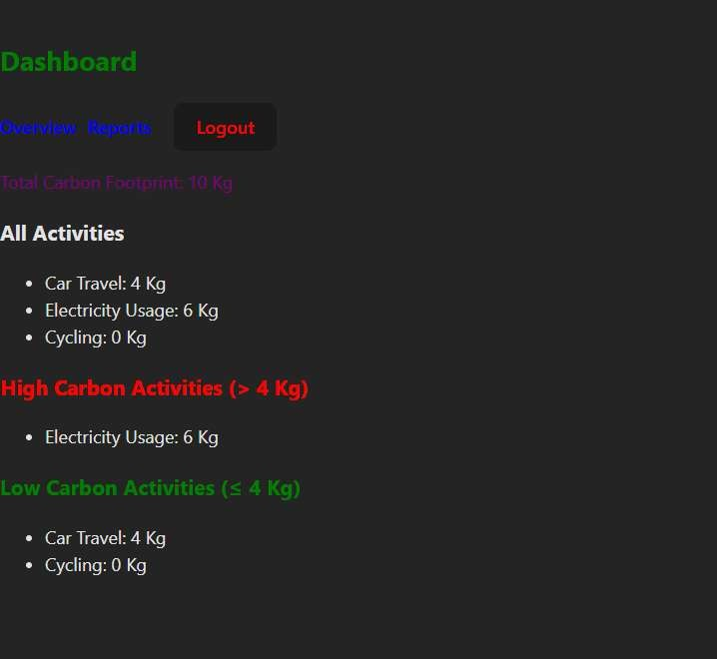

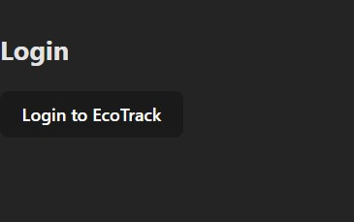


Learning Outcome:
- Implement SPA navigation in React using React Router without full page reloads.
- Design and apply protected routes using authentication state with Context API.
- Manage shared authentication state and implement login/logout functionality.
- Build and extend nested dashboard routes for modular layouts.
- Filter, display, and analyze data dynamically while understanding route access behavior.

