Experiment 3

Student Name: Karan UID: 23BCS11811
Branch: BE CSE Section/Group: KRG 3A
Semester: 6th Date of Performance: 27/01/26
Subject Name: Full Stack Development Subject Code: 23CSH-309

Aim:
To implement centralized state management in the EcoTrack application using Redux Toolkit and to handle asynchronous data operations using Redux async thunks with proper loading and error states.

Objective:
After completing this experiment and its follow-up task, the student will be able to:
- Configure a Redux store in a React application using Redux Toolkit
- Create and integrate Redux slices for managing application data
- Implement asynchronous actions using Redux async thunks
- Manage loading, success, and error states during asynchronous operations
- Connect React components to Redux state using React-Redux hooks
- Trigger asynchronous data fetching through Redux actions from UI components
- Use Redux state to derive filtered views without modifying the global store
- Enhance user experience by handling refresh actions and improving async UI feedback

Implementation/Code: logsSlice.js:
import { createSlice, createAsyncThunk } from "@reduxjs/toolkit"; import { logs as logsData } from "../data/logs";

export const fetchLogs = createAsyncThunk(
"logs/fetchLogs", async () => {
await new Promise(resolve => setTimeout(resolve, 1000)); return logsData;
}

);

const logsSlice = createSlice({ name: "logs", initialState: { data: [], loading: false, error: null,
}, reducers: {}, extraReducers: builder => {
builder
.addCase(fetchLogs.pending, state => {
state.loading = true; state.error = null;
})
.addCase(fetchLogs.fulfilled, (state, action) => {
state.loading = false;
state.data = action.payload;
})
.addCase(fetchLogs.rejected, state => { state.loading = false;
state.error = "Failed to fetch logs";
});
},
});

export default logsSlice.reducer;

store.js:
import { configureStore } from "@reduxjs/toolkit";
import logsReducer from "./logsSlice";

export const store = configureStore({
reducer: { logs: logsReducer,
},
});

Main.jsx: import React from "react"; import ReactDOM from "react-dom/client"; import App from "./App"; import { BrowserRouter } from "react-router-dom"; import { AuthProvider } from "./context/AuthContext"; import { Provider } from "react-redux"; import { store } from "./redux/store"; import "./index.css";

ReactDOM.createRoot(document.getElementById("root")).render(
<React.StrictMode>
<Provider store={store}>
<BrowserRouter>
<AuthProvider>
<App />
</AuthProvider>
</BrowserRouter>
</Provider>
</React.StrictMode>
);

Output:

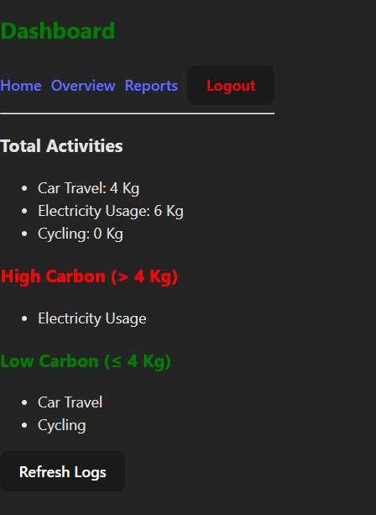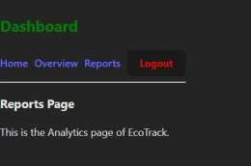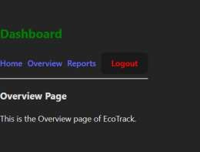

Learning Outcome:
- Configured and integrated a Redux store in a React application using Redux Toolkit.
- Created Redux slices to manage centralized application state efficiently.
- Implemented asynchronous data fetching using Redux createAsyncThunk.
- Handled loading and error states to improve user experience during async operations.
- Connected React components to Redux state using React-Redux Provider and hooks.

