**Final Project Proposal & Documentation**

**CLASSIC INDIAN RESTAURANT**

**Project Topic:**

We are creating a website based on Indian Restauarant. We are using Angular, Express, Node, MongoDb, Bootsrap, and CSS.

**Web Pages:**

Our project contains five web pages Home Page, About Page, EditMenu Page, Details Page and ContactPage. We have implemented CRUD operations in REST API, so that admin can create, read, update and delete the document. We have generated components with Angular commands.

**DATABASE:**

Our Database name is ‘food DB’ and our collection name is ‘food’. The document consists of five values id, name, type, price and description.

All fields are declared in string datatype.

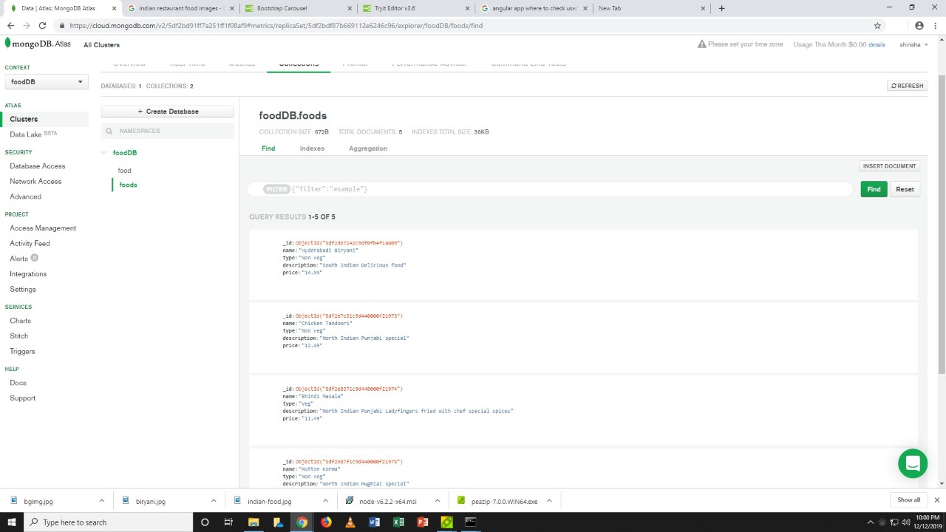

**Wireframe of Home page:**

Home page will contain navigation bar, that will further display the tabs for the next pages. The Restaurant home page displays information about the website, and what is it about. And, the images will show 3 different categories of the cuisines. The footer is set at the bottom.

Header

Home Image

Some Text

Some categories

Footer

**Conclusion:**

To sum up, this project will take the orders from the customers online, showing them the total cost of the expenses. In future, we would implement the Delivery plan in the same project to create a live example.

**Group Members:**

* Divya Gupta
* Karan Anand Shukla
* Shirisha Suruguru