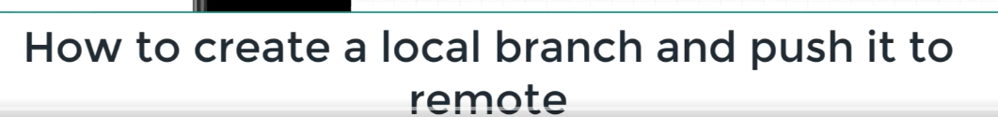

# To check how many branches are there-

# Create branch-

Star means our working copy is pointing to master branch.

# Checkout and check branch-

Open the ide.

Refresh the project or right click on project -> close and open the project.

We can see the branch name is updated next to the project.

# Code added-

Made changes and committed.

Always push the code to the same branch in remote side.

don’t push from cart to master.

Refresh gitlab-

Branches updated-

We can see the code once we are in cart branch.

Try to change master branch and we get code from master area-

# Added more code-

Question mark in project explorer means the file is untracked.

Orange box means already committed and in remote repo.

We can push as many times to the same branch as and when we are changing the code.

Refresh gitlab and code present-

We can see commit history-

Change branch from the drop down in the above screenshot, and see that the code for that branch will be seen.

Click on any commit id-

# More code added-

Refresh and code seen-

“Plus” sign means insertion. “Minus” sign means removal.