Note-

We can merge any branch with any branch in real time.

# See how merge works in animation-

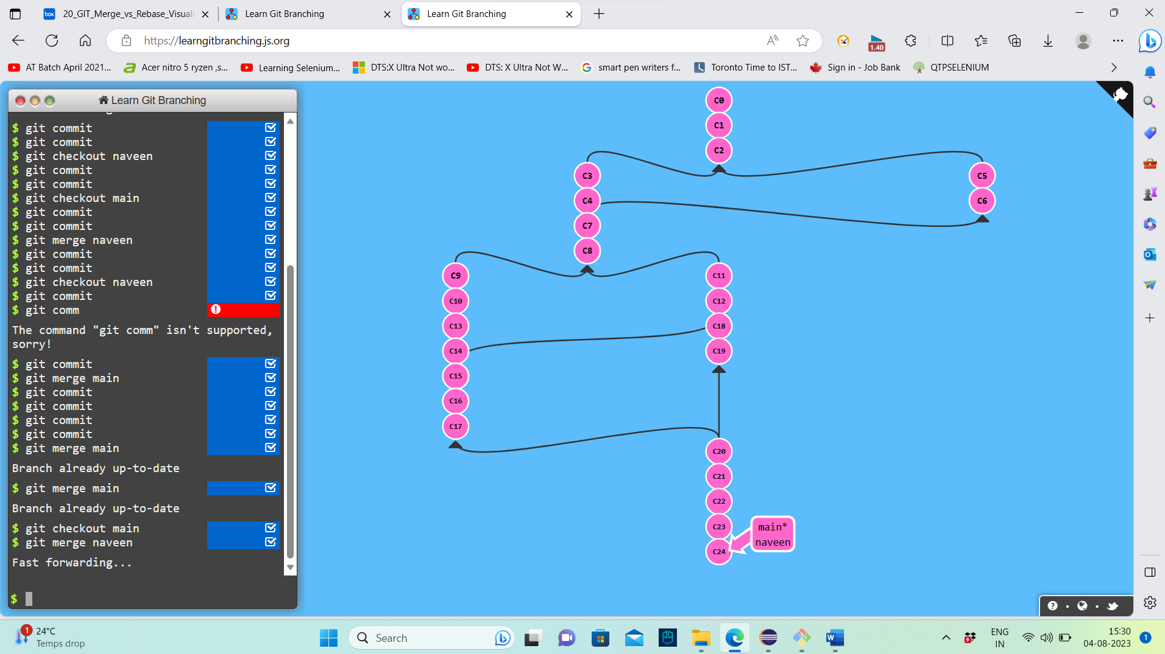

The above merge is also known as fast forward merge.

Git log – will show all the commits, even the greyed out ones.

Rebase used when it is a one person team, and he or she is working on multiple features within a branch.

We can also work on multiple feature branches.

When multiple people are working and they do rebase, when one of them wants to check history, then the ones with hash code will be seen.

This will create confusion as to from where they started and where they are now.

Rebase is very dangerous. Does not maintain proper branching.

Multiple devs – better to use merge.

Note-

Multiple dev- same feature -same branch – always use merge.