Note-

The project name in ide and the repo name need not match.

When we try to paste the name with space we need to include single quote-

Go to project location-

# Dir command-

Shows all directories in the path.



# Git init-

Git initialization. We need to register our local repo with “.git”.



By default master branch will be created after this command.

# Open config and see what is there-

All configuration present here in form of key-value pair.

# To exit vi-

Press “escape :wq!”.

# Go back to the project or one level-

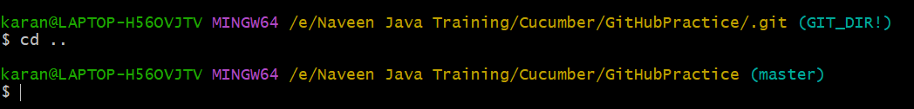

# Add remote connection between local folder and remote –

Now when we open config, we get the remote urls-

# Git status-

Untracked files when moved to stage or index area are not deleted from working copy.

Even files in stage/index are untracked.

Similarly copy of files is created in local repo after commit. There is no deletion happening anywhere in working copy or stage or index or local repo. These become tracked files once they are committed.

Note-

We have to always move/push the src code, not hidden files or no dot files or no garbage files, no reports, no screenshots, no npm modules etc. we have to add these files into “.gitignore”.

# This is the complete list of all items in gitignore file-

Can make this as standard list which should always be ignored.

|  |
| --- |
| allure-results/  screenshots/  screenshot/  test-output/  build/  application.log  ##############################  ## Java  ##############################  .mtj.tmp/  *.class  *.jar  *.war  *.ear  *.nar  hs_err_pid*  activityLog.log  ##############################  ## Maven  ##############################  target/  pom.xml.tag  pom.xml.releaseBackup  pom.xml.versionsBackup  pom.xml.next  pom.xml.bak  release.properties  dependency-reduced-pom.xml  buildNumber.properties  .mvn/timing.properties  .mvn/wrapper/maven-wrapper.jar  ##############################  ## IntelliJ  ##############################  out/  .idea/  .idea_modules/  *.iml  *.ipr  *.iws  ##############################  ## Eclipse  ##############################  .settings/  bin/  tmp/  .metadata  .classpath  .project  *.tmp  *.bak  *.swp  *~.nib  local.properties  .loadpath  .factorypath  ## OS X  ##############################  .DS_Store |

So basically, only the code from src folder should be added and pushed into git. Rest all will go into git ignore.

We can see all the files are present in “.gitignore” and only wanted files from “src” are there. All the files inside “.gitignore” wont participate in git processes.

# Tree-

Tree command is little different in windows. Type few characters like “tre” and then Tab and then we get the “tree.com”.

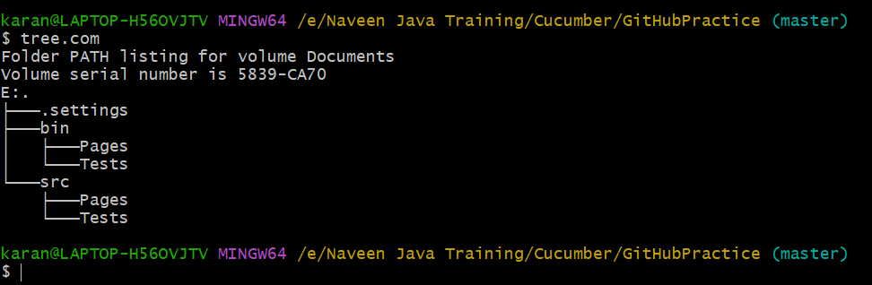

This will show the folder level.

The below command will show the files and folders-

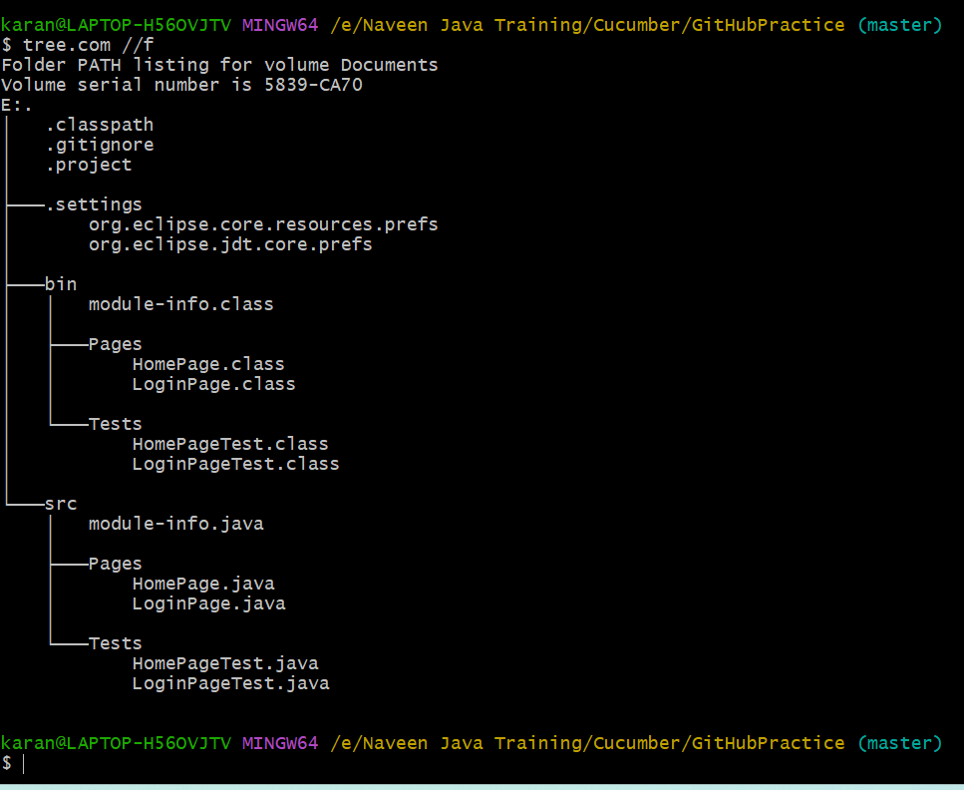

We are only concerned about “.java” files.

The below command is similar-

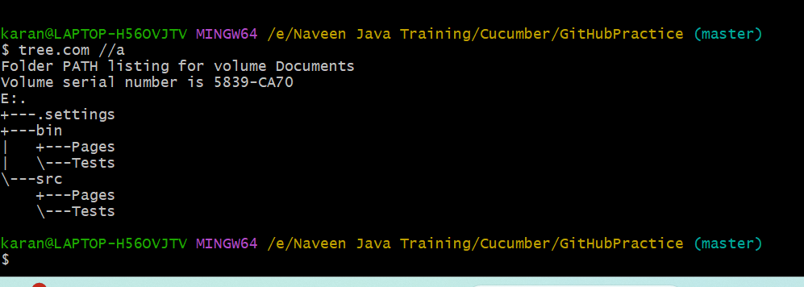

This is to show ascii lines but not needed for us.

Go to this website for solution on tree-

[How to add the 'tree' command to git-bash in Windows? - Super User](https://superuser.com/questions/531592/how-to-add-the-tree-command-to-git-bash-in-windows)

I deleted the module-info manually and again did git add to keep it updated. This is not mandatory step, you can delete the file, do git status, it will show file removed in untracked area, then we can just commit to local repo and do git status.A screen shot of a computer program

All yellow highlighted are important ones-

Commit id to master branch.

How many files changed.

How many insertions done into file.

Random memory or index allocated to different files.

Once all committed then the branch is clean-

# Git branch-

To see how many branches are there.

# Git push-

By default the first code we write is always on local master branch in local repo. First push will always be from local master to remote master.

Compression done.

We have pushed our code from local master to remote master.

url for remote git is also present.

We are pushing code into the origin (origin also known as remote side) to a branch called master.

Code pushed-

Play around.

# Number of branches can be found from the drop down-

# Commit reason which we wrote-

# Click on commit link-

Click first commit.

You can see the changes made.

# Just remember this steps and stages-

Wc means working copy of the code or the code which we write. Here we use IDE’s to write the code.

By default master branch is created and pushed the first time.

# To know upto which level we need to select the project-

File -> open projects from file system -> directory -> select the directory upto the first level as seen below (it should be one level above the src folder).

# Eclipse workspace-

Here we need to give path till the folder under which the project has to be created.

