# Code changes we are making-

Code is currently not updated in github.

# Changes done-

Deleted home page test-

Added search page class.

Made code changes to login page class.

We can use git add and then add specific file, folder or directory, or entire project.

Good practice is to add the files individually, so as not to mess the remote and local repo.





To come out of any command press “control+c”.

We need to add the deleted file also, this will inform that the same file has to be deleted from remote also.

It says what has happened with the files as seen in picture above.

3 files changed.

12 lines of code added.

9 lines of code deleted.

Login page was already committed once so not seen in the above picture. Login page is only an update. Home page is coming as it is removed. Search page is totally new.

Refresh gitlab-

# To see the commit history-

Click highlighted.

Click split and see the old changes and new changes.

Click on this commit.

We can see the commit history:

Commit id is seen in right hand side.

Which is same in gitlab.

# To see the commit history-

This is from git.

If you are stuck with any command, press “q” to exit.

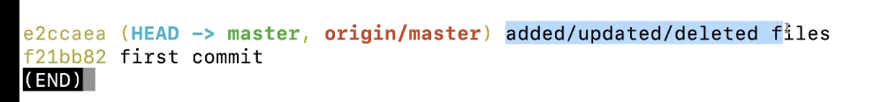

# To see full description of the commit history-

This is from git.

