**Notes-**

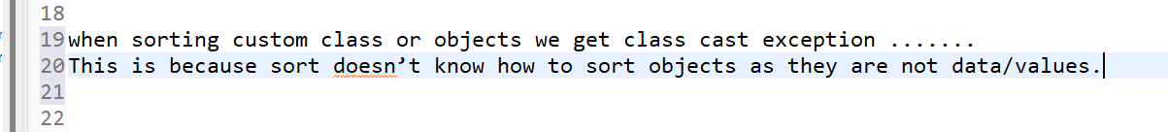

**What this.instance versus object.instance does-**

**Tostring()-**

Object class method. Gets result in a format we like.



**More notes-**

**Comparator based on name:**

Employee class:

**Compareto()** has to be used. This method can compare and sort any data type on this planet.

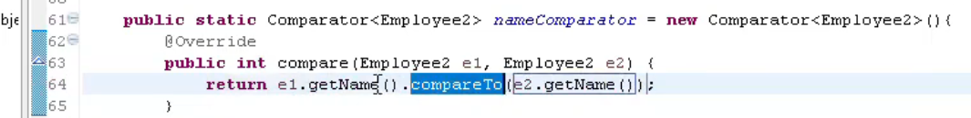

Main class:





**We can implement both interfaces at a time.**



**What if two objects have same value when comparing-**

**Enum cannot have number in it-**

