**Compare notes-**



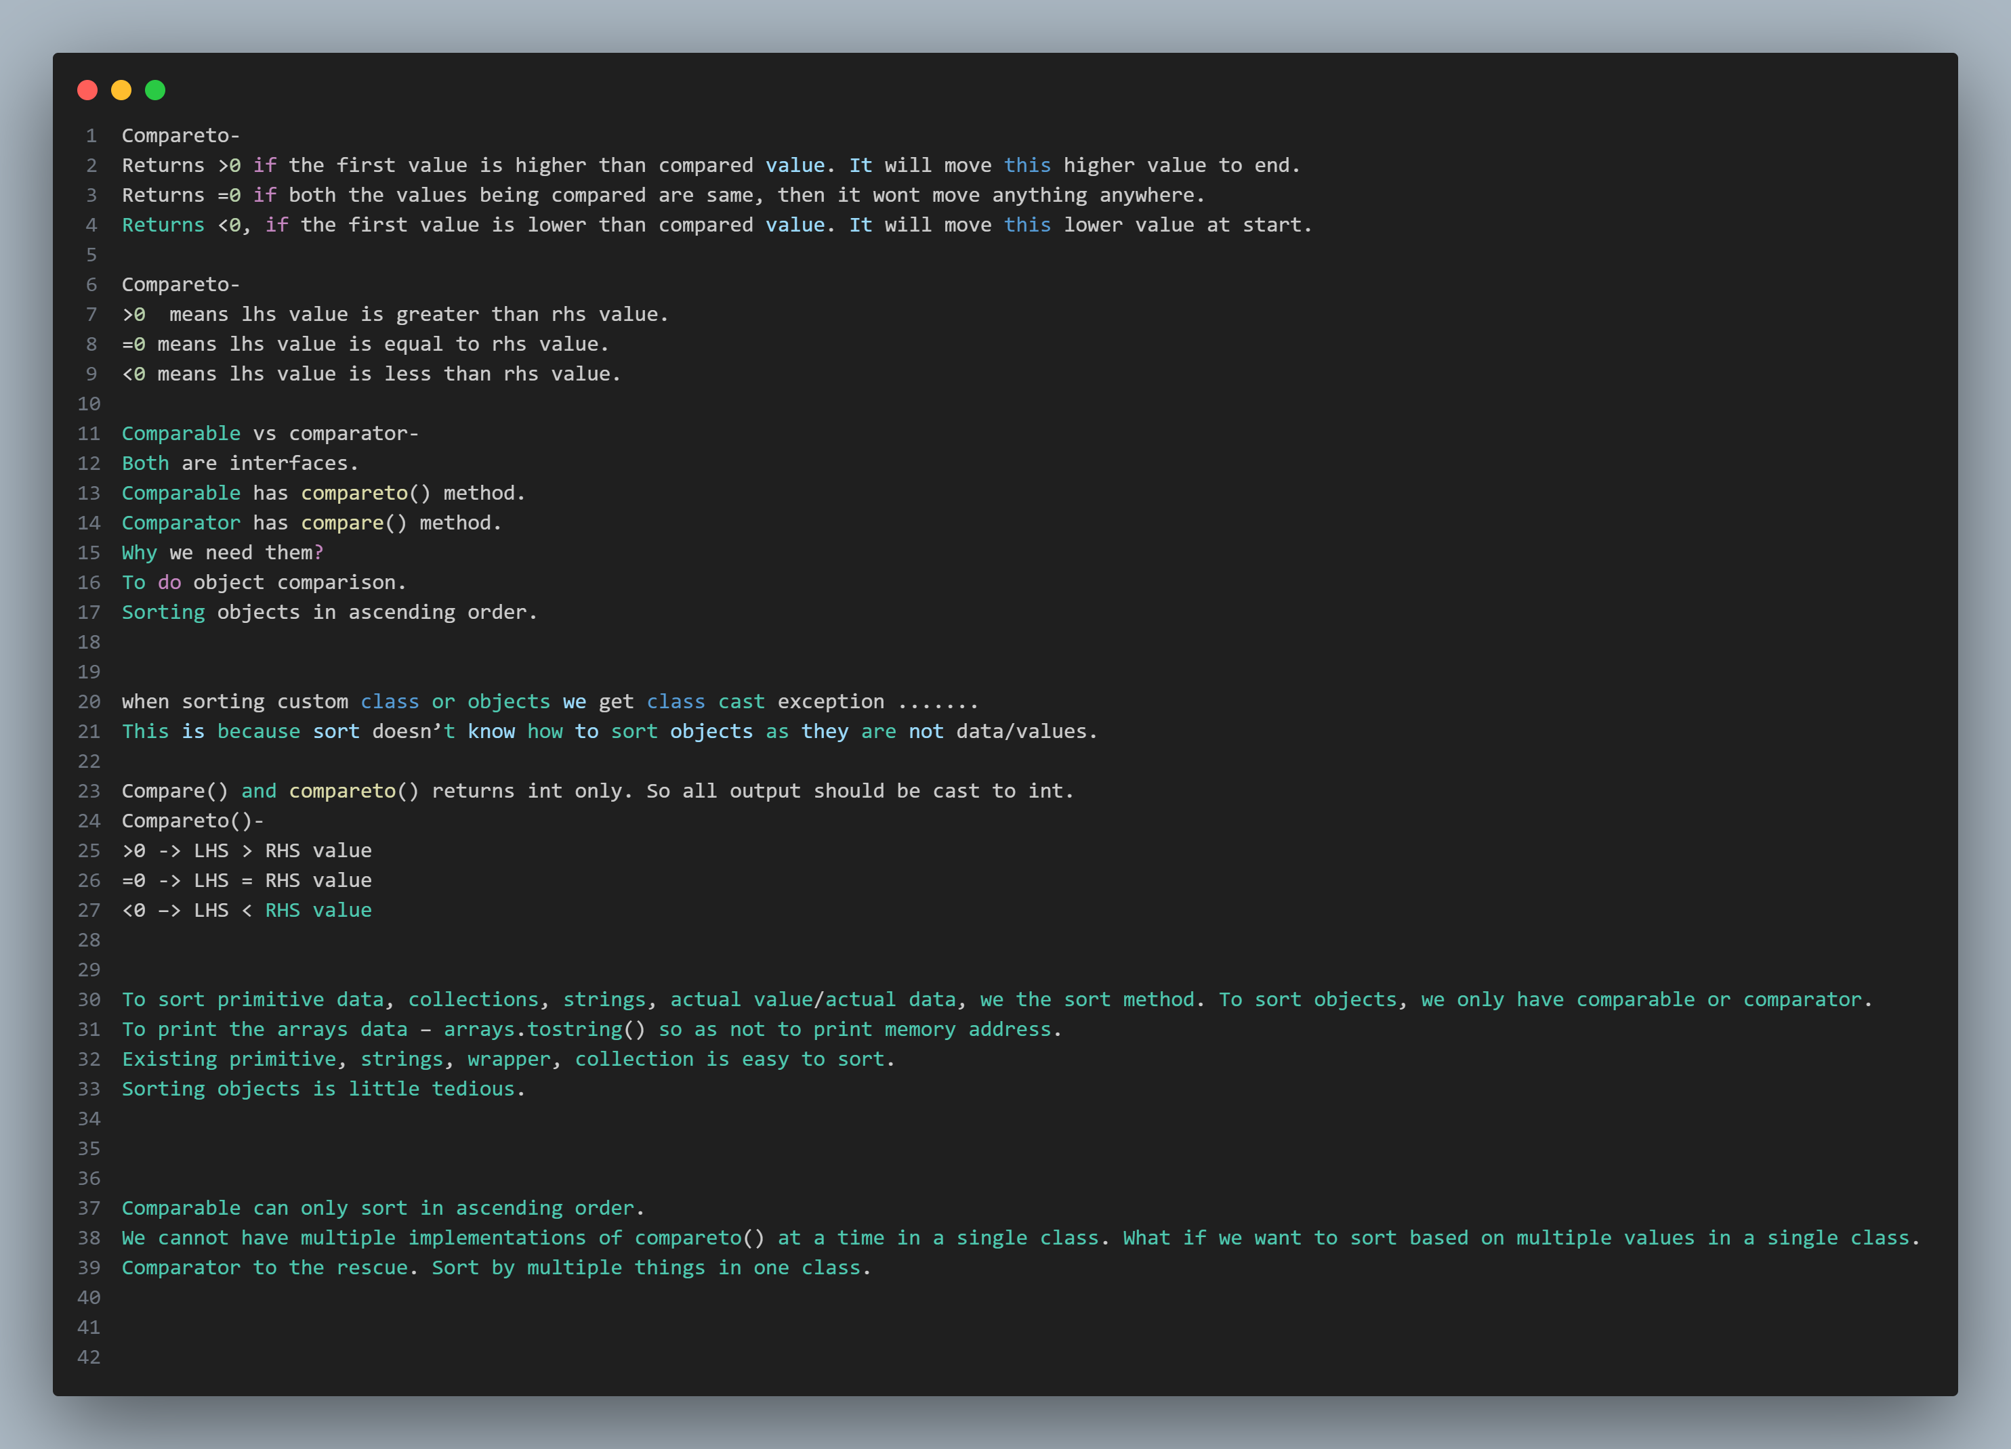

**When we do not use tostring() in the employee clas we get memory address-**



**More notes on compare-**

