**Sort values notes-**



Added **line 12-**



Added **line 12-**

Added **line 11 –**

**Tostring() notes-**

Added **line 30-**

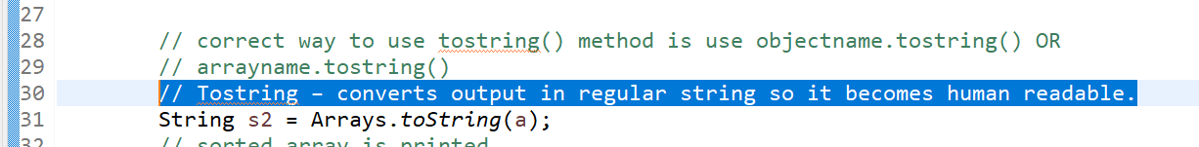

Added **line 32-**

Added these **lines 58, 59, 60-**

**Compare notes-**

Added **line 13-**

**Compare notes-**

Added **line 58, 59-**

Added **line 64,65,66-**

**Check how to compare strings using comparator:**





**Enum notes-**

Added **line 7-**

Added **line 8 to line 17-**

**Enum can be alphanumeric-**

