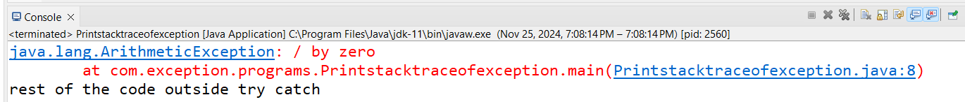

Just get the message-



