Different ways to avoid null pointer exception-

Compare strings-

Weird working when comparing reverse way-



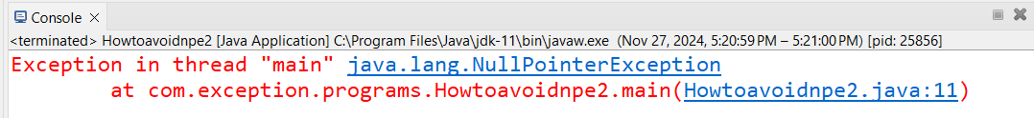

Best way to check for null value and then do required operation-

Another best way to check for null value and then do the required operation-

Java ternary to check for null-

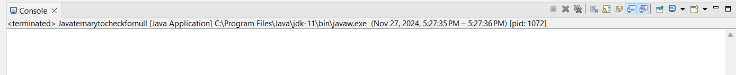

Multiple exceptions in one catch block-



Try adding master exception together and see error.

