To enable assertion-

For value greater than 18-

For value equal to 18-

Count arguments-

Less than 5 –

try more than 5 –

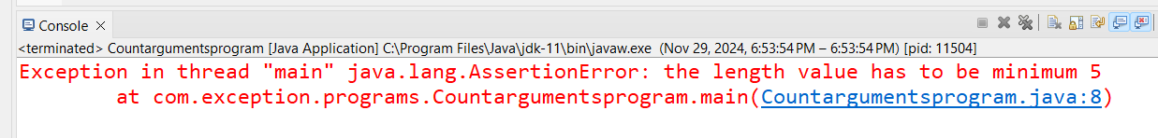

We can have any value inside arguments list-

We can have any data type inside arguments-

See how to pass arguments.

