**Advantages of generics-**

**When generics not there we get type safety errors-**

**With generics see how we can declare, and error gone-**

**Without casting and without generics cannot get value-**

When generics was not there, we had to cast before getting or printing values.

How to do casting-



With generics no casting needed-

**How to use generics-**

**Notes-**



**Set notes-**

**Generics methods-**

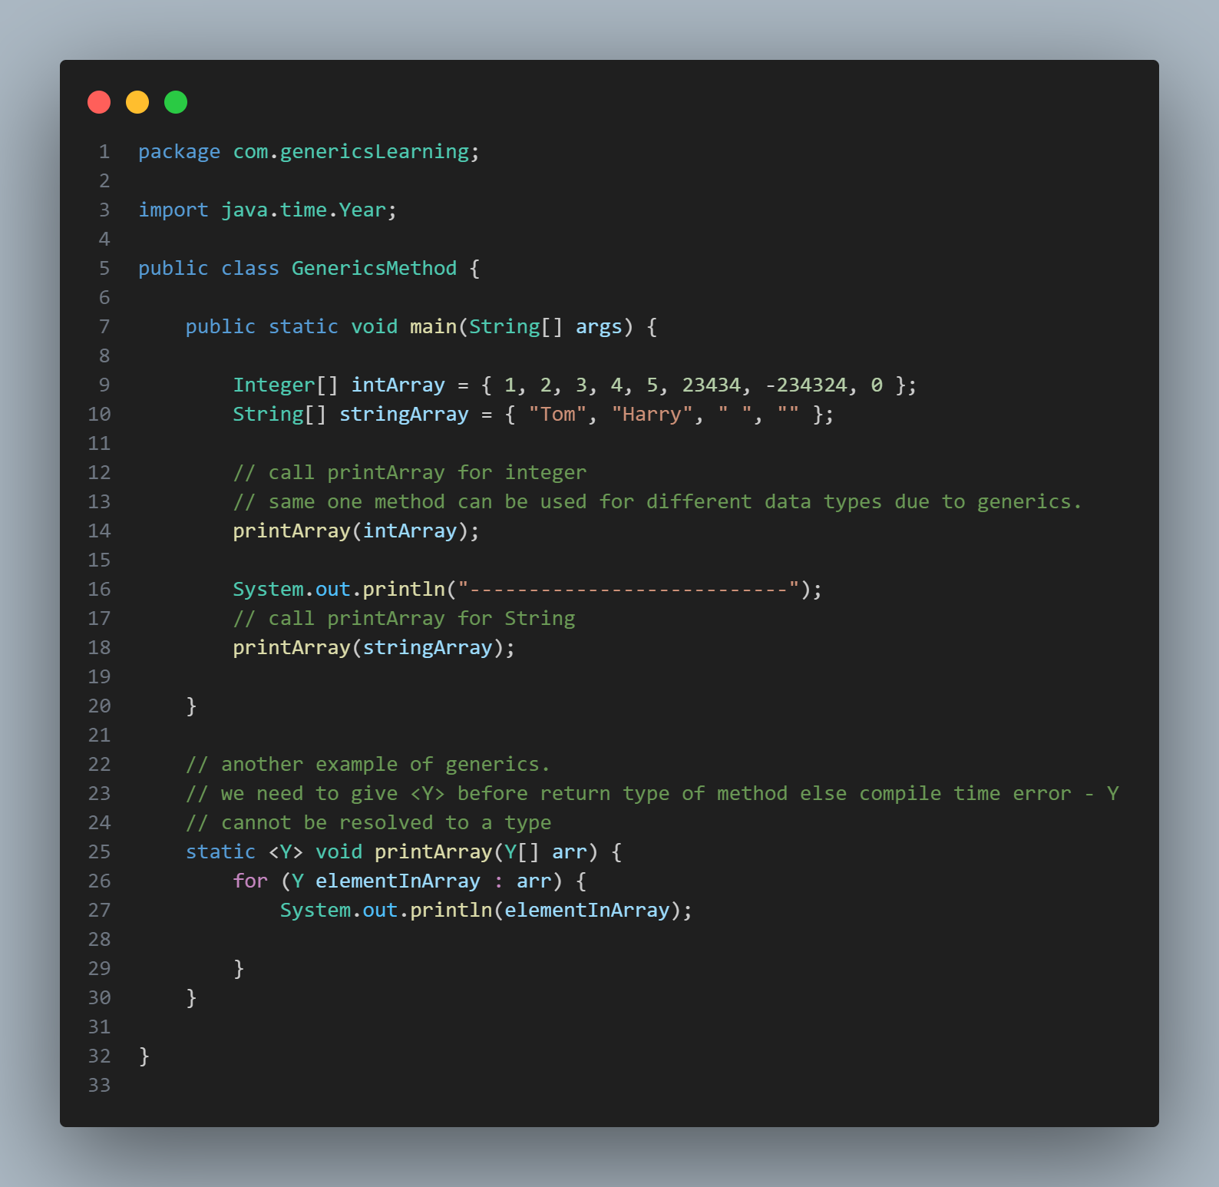

***Wild cards-***

***Lower bound wild card-***



Final code-

***When we try to print out the list3, see the error.***

Output:

***What will happen if I give Integer instead of object in for each loop-***

We get error.

***Another thing-***

Only integer type is allowed. If we select float or any other type see the error:

***Upper bounded wild card-***



