**Performance check-**

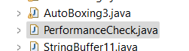

**Create immutable class-**

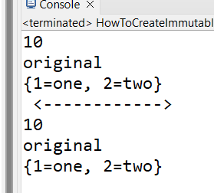

**String tokeniser-**

**To see the thing on which string is broken give third parameter-**

