~~

~~

~~

~~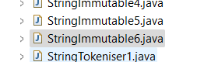~~

~~

~~

Added **line 14 and line 15-**

**Line 12** edited-

~~

Added **line 40-**

~~

~~

~~

~~

~~

~~

~~

~~

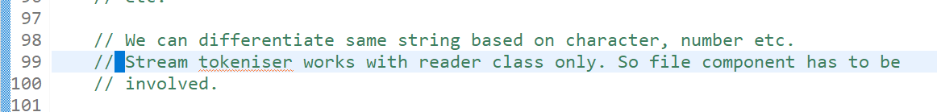

See below example of sir, even he has got **“*”** at start due to the usage of **objectinputstream** and **objectoutputstream.**

