Topic – java io package part 1 🡪

**If you want to write the buffered reader or writer statement in one line –**



**If you did not have the file at the location we get this error –**

**File names need not be case sensitive-**

File name in caps in code –



But if you do not use the same convention in computer, it will still work.

file name in small case in computer.

**BufferedWriterWorking-**

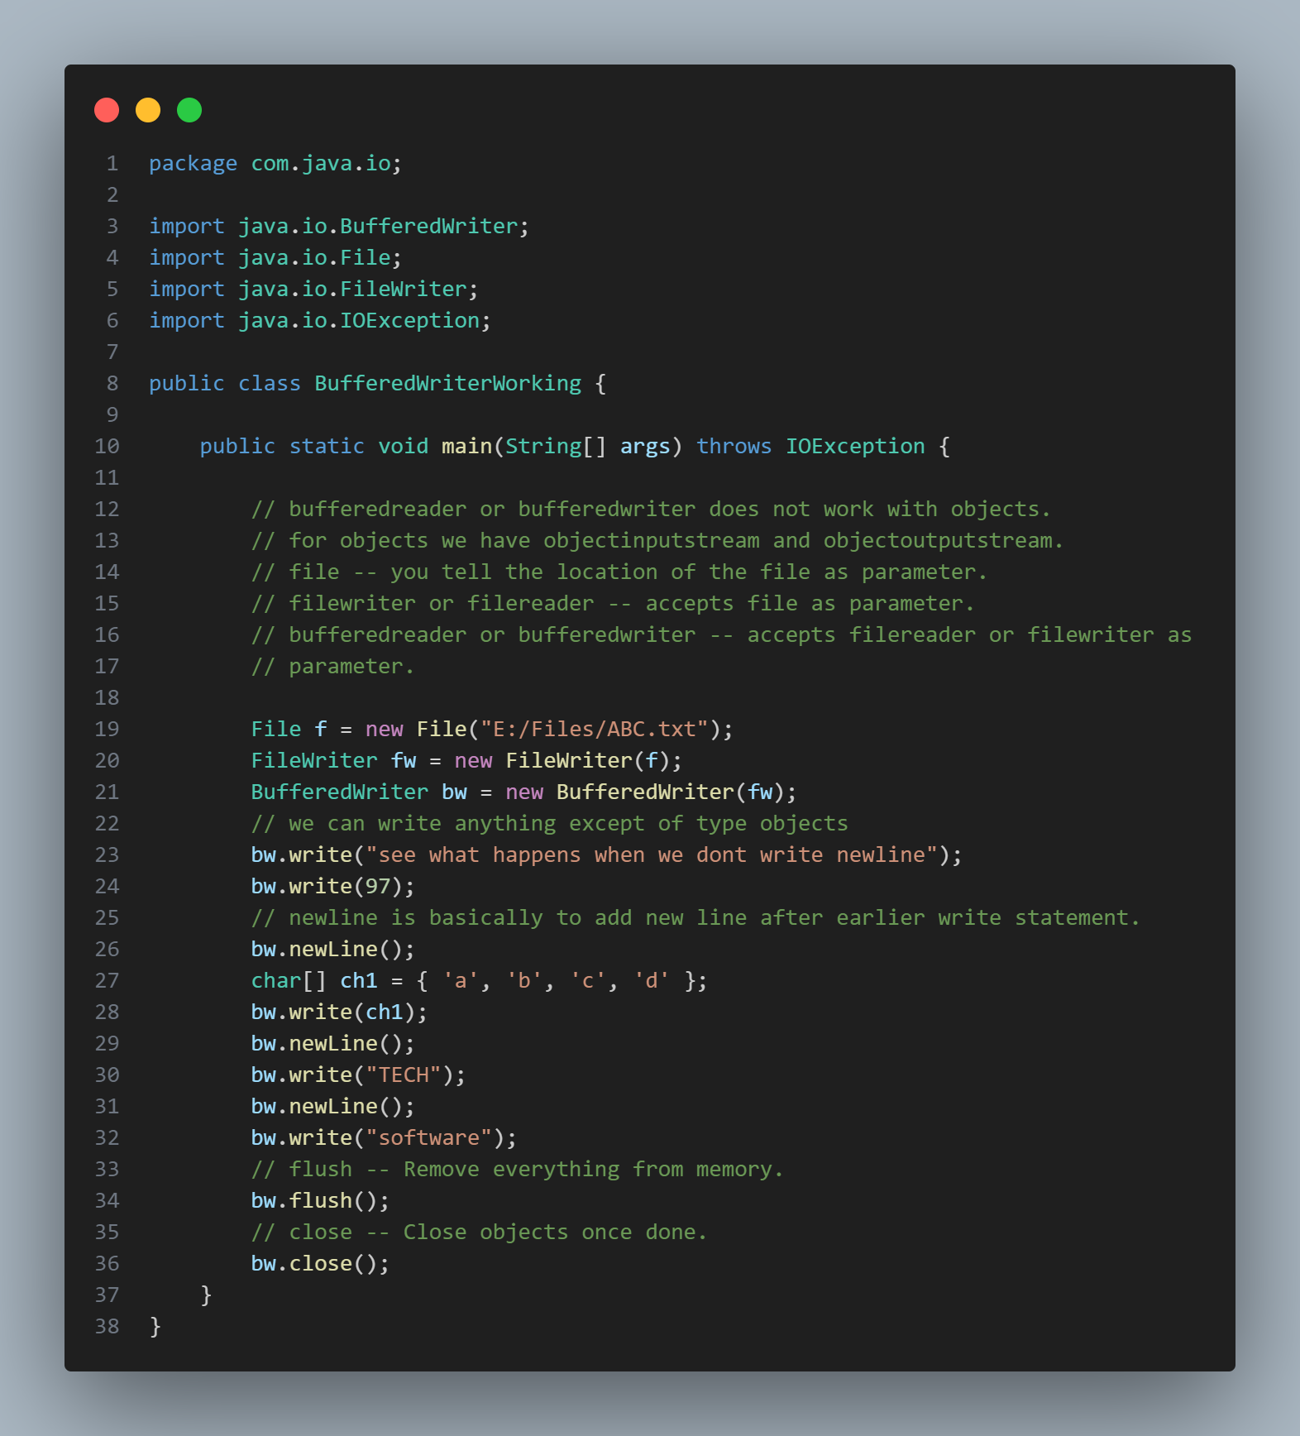

Open the file **abc.txt** now.

See the first line, it will print in same line.

**97** is **ascii** code of **a.**

**Buffered reader working-**



**Buffered reader working second example-**

**Object output stream working-**



**Object input stream working-**

Second way to read—

But we get EOF exception.

Read this article for why we are getting this –

[Java FileInputStream ObjectInputStream reaches end of file EOF - Stack Overflow](https://stackoverflow.com/questions/2626163/java-fileinputstream-objectinputstream-reaches-end-of-file-eof)

**Input stream reader-**

