Topic – io package part 2 🡪

**Input stream reader with try catch-**

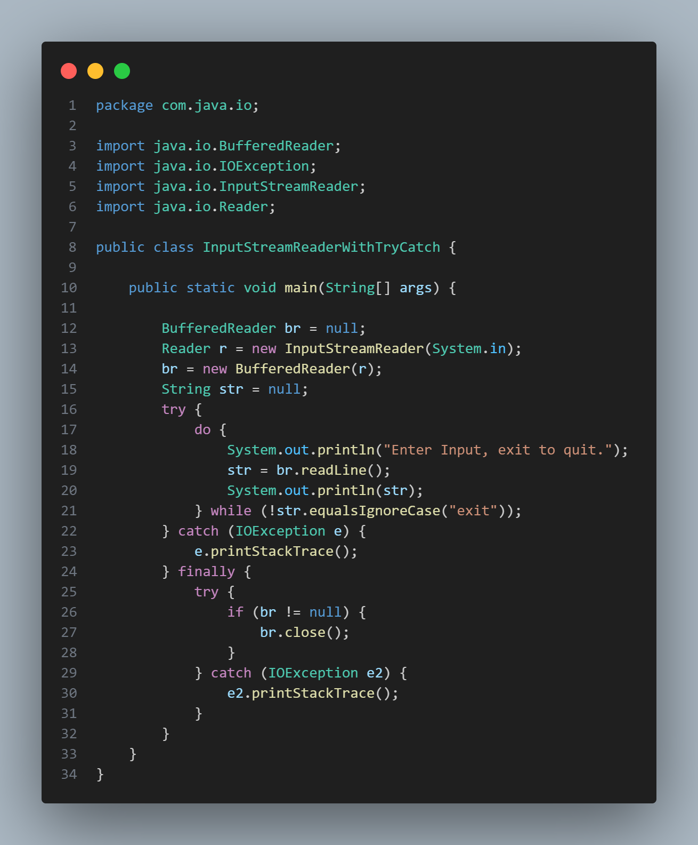

**InputStreamReaderWithCatchBlocks-**

**System.in –**

**System.in** cannot be passed to file reader.

It can be passed to input stream reader only. See the error when we try to pass:

