Topic – java time part 2 🡪

**Another example of date time-**

**Check year is leap or not –**

**Check if date is before or after another date--**

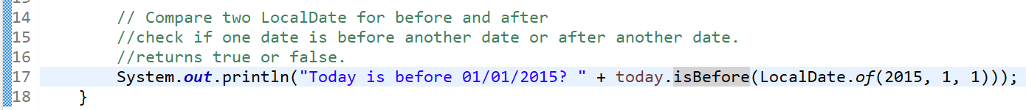

**Gives current date and time –**

**Plus and minus operations—**

**Above codes in one short –**

**With local date time class—**

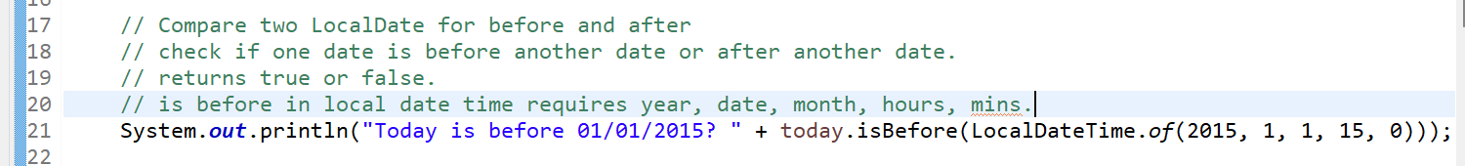

**Above codes in one short –**

**Temporal adjusters with local date time –**

**Above code in one short –**

**Temporal adjuster with local date –**

**Temporal with local time –**

