Topic – java time part 3 🡪

**Instant class—**

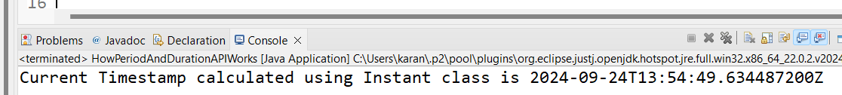

**Epoch –**

**Duration –**

More duration examples –

**Java date time class—**

**Date to instant date –**

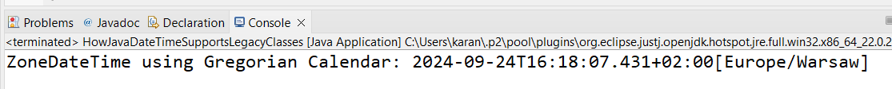

Note-

**Instant Class** is for backward compatibility for **date** objects and **calendar** objects.