Java time part 4 🡪

**HowDateAndTimeAPIWorks-**

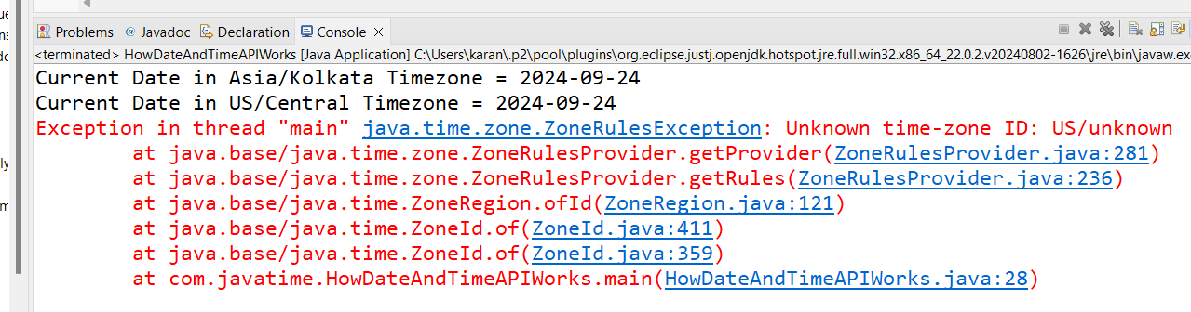

**Go to this link for all the valid timezones if you need –**

[Joda-Time - Java date and time API - Time Zones (sourceforge.net)](https://joda-time.sourceforge.net/timezones.html)



