Topic – jdbc basics part 1 🡪

Install oracle sql developer.

Install database called as **oracle xe.** When installing this we need to give the password, username is **SYS** or **SYSTEM** or **PDADMIN.**

**First time when you run in eclipse, you get this:**

|  |
| --- |
|  |

To solve the above error-

Install **ODBC driver** from Oracle.

Right click project 🡪 properties 🡪 java build path 🡪 libraries 🡪 classpath 🡪 add external jars 🡪 add the ODBC 🡪 refresh project and run 🡪 it should work.

**Now run and we get this new error:**

To debug run the query in oracle sql developer-

Same error in db.

Remove **not null from id** and it works-

**When table already exist, we get the below error-**

**When we try to drop table which does not exist-**

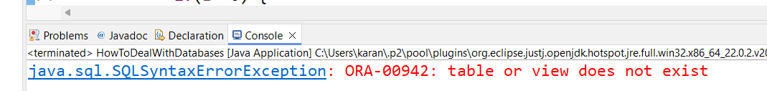

**First working code-**

Table created in database also-

Added 80-87:

If we do not write **line 82,** then **line 86** is the output-

When we check db its blank-

This is because the code is not committed.

Added **89-90-**



