Topic – result set part 1 🡪

**WhatAreResultSetTypes-**

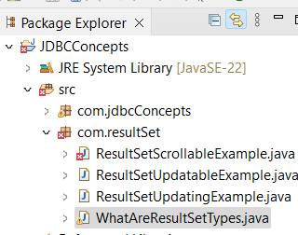

Fetch third row, we see the options with result sets—

