Topic – result set part 2 🡪

**Update example using result set-**

We get this error:

Adding **line 42** did not solve it:

Add **line 24:**

First execute the query and then move to the first record before doing any updates.

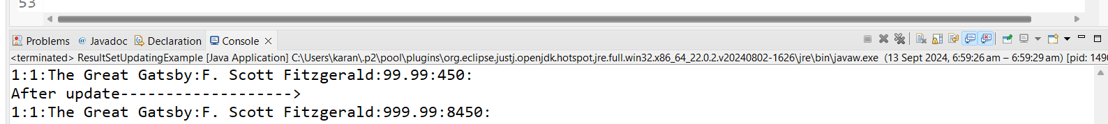

If **conn.autocommit(false)** is not written, then commits happen automatically.

And we get this error when we try to write **conn.commit(); when conn.autocommit(false) is not written.**

**So, we go to the first record, get the values, update the first row, get the new values, then delete the first row, then use move to insert and update the values in the first row –**

